## Copyright @2024

ISBN: 978-81-951593-4-5

**Title: Training Manual on Sexual and Reproductive Health and Rights for Girls and Women with Deafblindness and Multiple Disabilities**

Author: **Sense International India**

First published in India in 2024

This book is published, produced, and distributed

by Sense International India.

Sense International India

2nd Floor, Admin Block

Andhjan Mandal Campus

Vastrapur, Ahmedabad 380 015

Tele: +91 79 26301282 Website: www.senseintindia.org.in

Email: [info@senseintindia.org](mailto:info@senseintindia.org)

**All Rights Reserved**

No part of this book may be reproduced or used in any form or by any

means (graphics, electronic, mechanical, photocopying, recording, taping,

web distribution, information storage and retrieval systems or otherwise)

without prior written permission of the publisher.

Printed in India

**FOREWORD**

In pursuit of equality and dignity for all, it is imperative that we extend the principles of accessibility and empowerment to persons with disabilities, including Persons with Deafblindness (PwDb) and Multiple Disabilities. Within this context, the publication in your hand represents a significant step forward in our collective endeavour to ensure that girls and women with deafblindness and multiple disabilities can understand the need of sexual and reproductive health and rights (SRHR).

The journey towards inclusive SRHR practices for girls and women with deafblindness and multiple disabilities has been marked by numerous challenges, chief among them being the pervasive stigma and lack of awareness. Too often, girls and women with deafblindness and multiple disabilities are overlooked or marginalized when it comes to discussions and initiatives surrounding sexuality and reproductive health.

Yet, the fundamental principles enshrined in the Universal Declaration of Human Rights, as well as more recent legislative frameworks such as the Rights of Persons with Disabilities Act-2016, assert definitively that every individual, irrespective of disability, possesses the right to access comprehensive sexual and reproductive health information, services, and education without discrimination.

The "Training Manual on Sexual and Reproductive Health and Rights" serves as a testament to our commitment to holistic empowerment of girls and women with deafblindness and multiple disabilities. The manual is tailored for girls and women with deafblindness and multiple disabilities. It presents a vital resource for promoting awareness, training methods, knowledge, and understanding of SRHR issues and the unique needs of girls and women with deafblindness and multiple disabilities with regards to sexuality.

Through this training manual, we have strived to break down the barriers and foster a culture of inclusivity and empowerment by equipping parents, caregivers, and special educators with the necessary information and tools to navigate sensitive SRHR topics and to develop the skills to educate every girls and women with deafblindness and multiple disabilities with confidence and respect.

As we embark on this journey towards inclusive SRHR practices, let us remain resolute in our commitment to challenging societal norms, promoting awareness, and advocating for the rights of PwDb. Together, let us strive to create a world where everyone, regardless of disability, can exercise their sexual and reproductive health and rights with dignity and autonomy.

In order to ensure that the contents of the module are adapted to the learner’s unique needs, we must identify core areas/themes considered by the professionals as crucial for achieving the final goal. Since the professionals working in this field are very heterogeneous in terms of their educational background, the module is developed in a flexible way, allowing adaptations to accommodate different levels of knowledge.

**A photograph of Akhil Paul,  
Founder Executive Director 
Sense India  **

**Akhil Paul, Founder Executive Director Sense India**

**Acknowledgment for the “Training Manual on Sexual and Reproductive Health and Rights for Girls and Women with Deafblindness** **and Multiple Disabilities”.**

We extend our heartfelt gratitude to the numerous individuals and organizations whose unwavering support made the creation of the Sexual and Reproductive Health and Rights (SRHR) Training Manuals possible. This endeavour would not have been successful without the collaborative efforts and contributions of a diverse group of people.

It is our hope that these resources contribute significantly to advancing the understanding and promotion of sexual and reproductive health and rights in girls and Women with deafblindness and multiple disabilities, their caregivers and special educators.

First and foremost, we express our deepest appreciation to PwDb, their parents, family members, and special educators for the willingness to share their experiences and insights. Their unique perspectives have provided a valuable foundation for understanding the challenges and SRHR needs of PwDb.

We would like to acknowledge the wholehearted support of our partners in 24 states of India, which has enriched the content of this publication.

Special recognition goes to Mr. Sachin Rizal and Ms. Vruddhi Patel for their dedicated and constant efforts in developing the content of this training module. Their expertise and commitment to the cause have been crucial in structuring the material into coherent and comprehensive chapters.

We acknowledge the efforts of Mr. Uttam Kumar and Mr. Akhil Paul in enhancement of the script and their guidance for elevating overall quality and impact. The bulk of credit for this publication is due to the ungrudging efforts put in by the entire team of Sense International India.

The Training Manual on Sexual and Reproductive Health and Rights for Girls and Women with Deafblindness and Multiple stands as a testament to the collective commitment of everyone involved.

We acknowledge the valuable contributions of Ms. Mercy Chingnunmuang, Mr. Rashmikant Mishra, Mr. Srinivasan Prasannan, Ms. Bhavika Shah and Ms. Shrutilata Singh. Special recognition goes to Mr. Shivkumar Sharma for his outstanding work in designing this training manual.

Finally, we extend our sincere thanks to Ms. Vina Lakhumalani and Ms. Viveka Chattopadhyay for their exceptional contributions to this SRHR Training Manual.

**TABLE OF CONTENTS**

**CONTENTS** **PAGE**

GUIDELINES FOR FACILITATING THE TRAINING ON SRHR 6

A. INTRODUCTIONS

Icebreaker Exercises - Ball of String Game & About Me 9

WHAT THIS PROGRAM IS ABOUT 10

Pre-Test 11

B. GROWING UP: MAGICAL BODY

Visible Body Parts 13

Body Systems 15

Private Body Parts 17

Consent: ‘We are in charge of our bodies’ 20

Comfortable & Uncomfortable Touch 21

Private & Public Places and Behaviour 24

Adolescence: Helen Begins a New Journey 25

Drawing changes in Puberty 26

Summarization Growing Up: Magical Body 27

C. SEXUAL AND REPRODUCTIVE HEALTH

Energizer 28

Recap previous unit 28

Female Sexual Reproductive System 32

1. External Female Sexual & Reproductive System 33
2. Internal Female Sexual & Reproductive System 34
3. Vaginal Discharge 37

Understanding Mensuration 38

Menstrual Cycle 42

Menstrual Management & Hygiene 43

D. UNDERSTANDING GENDER

Gender Education 47

1. Gender Roles & Expectations 47
2. Defining Gender Terms 48

E. ADOLESCENT ISSUES

1. Body Image 50
2. Peer Pressure 51
3. Relationship with Parents & Caregivers 52
4. Choices We Make (Decision-Making) 53

F. ANNEXURE

Additional Resources 55

Breasts 59

Relationships 61

Comprehensive Evaluation Tool- For Girls and Women with Deafblindness and Multiple Disabilities 63

*References/work-cited/ Bibliography:* *68*

GUIDELINES FOR FACILITATING THE TRAINING ON SRHR

Training Manual on Sexual and Reproductive Health and Rights for Girls and Women with Deafblindness and Multiple Disabilities

People with disabilities may struggle with sexual and reproductive health not because of their disability, but due to a lack of attention, legal protection, and support. Many face difficulties in getting basic information about their sexual health, leaving them unaware of their bodies and rights.

This training guide aims to equip trainers with the tools and skills needed to conduct effective workshops on Sexual and Reproductive Health and Rights (SRHR). However, it is important to note that this manual serves as a flexible guide. Each training session should be adaptable to meet the unique needs of participants, considering various factors that may impact learning.

**Key Components of Training:**

1. **Rationale of the Training:** At the beginning of each session, clearly state the purpose of the training. This ensures that both trainers and participants understand the goals and processes involved. It also establishes the scope and limitations of the training, making it clear that it may not cover everything but has specific goals.
2. **Trainer Skill Set:**
   1. **Self-awareness:** Trainers should be aware of their biases that might influence the training. While having personal perspectives is fine, if biases could impact certain topics, it is advisable to assign another trainer for those sections.
   2. **Knowledge of Topics:** Trainers should possess basic knowledge of the curriculum topics to answer questions effectively.
   3. **Communication and Facilitation Skills:** Effective training requires strong communication skills. Trainers should be adept at managing discussions, rephrasing statements for clarity, and summarizing discussions.
   4. **Group Work Skills:** Since the curriculum involves group activities, trainers should have basic skills in group management, role plays, and other techniques to facilitate effective group learning.
   5. **Information about Peer Education Resources:** Trainers should be familiar with additional resources that complement their understanding of SRHR issues. This includes knowledge of other training modules and resources, allowing them to adapt the curriculum based on the evolving needs of trainees.

Remember, this guide is a starting point. Adaptability and a clear understanding of the participants' needs are crucial for a successful SRHR training session, especially when working with a specific target audience like girls with disabilities.

NOTES FOR THE FACILITATOR

**USING THE MANUAL**

Here are a few guidelines to help facilitators use the manual effectively.

**In general:**

* It is important to follow the order of the activities, without skipping any, because each activity leads to the next.
* Work with a group size of approximately 15 adolescents.
* While forming groups, young people of similar age groups can be put together; for example, 10- to 14-year-olds in one group and 15 to 17-year-olds in another group.
* Floor seating in a circular/oval arrangement - as the facilitator can see everyone and this is the most effective way of conducting the training. This will encourage participation from all young people and make the facilitator and participant relationship more equal. Ensure that the interpreters get enough time to interpret.
* Sometimes it may be necessary to extend the time limit of a session so that a crucial discussion can be concluded properly.

**Before the sessions start**:

* Ensure that you have undergone training on the issue and how to use the manual.
* Do a baseline survey (Pre-Test) with participants to get an idea of existing knowledge and attitudes.

**During each session**:

* Start the session by setting some ground rules, so the group can work together comfortably. The ground rules can include: giving everyone a chance to participate; respecting each other’s opinions; confidentiality; and so on. Please ensure as much as possible that the ground rules come from the participants themselves.
* Ensure interpreters are engaging the participants.
* Remind the participants that no question or thought that they would like to share is bad, funny, or wrong.
* Everyday, do a quick verbal recap to remind participants of the last day’s sessions.

**After each session**:

* Conclude by asking the group what the learning points for the session were.
* After the entire training, do an end-line survey to measure the shift in participants' knowledge and attitudes.
* Revisit areas that need further clarification.

ROLE OF THE FACILITATOR

* **Be a “friend”** rather than a teacher: This will enable young people to be more open and share their doubts and concerns frankly.
* **Provide accurate information** and options to the girls. This will enable them to make informed choices, help them be responsible and stay safe in their personal lives.
* **Avoid imposing personal values** on the group. This will enable participants to share their own views and values more freely.
* **Be credible**: Often the facilitator becomes a **role model** for young people. The facilitator’s credibility depends on whether his or her actions outside the sessions echo the messages given during the sessions.
* **Maintain confidentiality:** If participants share personal information, the facilitator should be careful to not break the young person’s trust.
* **Refer**: If a young person shares a problem that is beyond the capacity of the facilitator, he/she should refer the young person to a more credible professional help, for example- a medical doctor or a counsellor.
* **Do not Worry**: The facilitator need not worry if he or she does not have the answer to all the queries. If necessary, the facilitator can do some research from a reliable source and address the queries in the next session.
* **Keep it Simple**: It is also important for the facilitator to present the information simply and avoid using technical terms and unnecessary details. Information overload may confuse participants and result in them forgetting even the basics.
* **Make it fun**: Enjoy the sessions and make them interesting and memorable for the participants.

## Icebreaker Exercises Ball of String Game & About Me

|  |  |  |
| --- | --- | --- |
| **Session 1: Activity 1**  **Icebreaker Exercises**  **Ball of String Game & About Me** | **Objective**   * Introductions * Getting to know one another * Become familiar with each other * Setting ground rules | **Issues/Information**   * Self-awareness * Interpersonal communication * Respect for each other |
| Time: 45 mins | Material required: A ball tied to a long string (rope/thick thread) | Facilitator can choose to either do one icebreaker or both depending on available time. |

1. **INTRODUCTIONS**

**ACTIVITY 1: Introductions**

1. All participants sit in a circle.
2. The facilitator welcomes everybody and introduces the session. Explain that the group may know each other a little bit, but through the sessions today we are going to get to know each other better.
3. Below are some different games and activities that you can use to help the group get to know each other.

**Icebreaker 1: Name Game- The Ball of String (20 mins)**

1. Everyone is sitting/standing in a circle. The facilitator starts the introduction process. He/she holds the ball of string and introduces self along with one positive quality that would best describe them. For example: *“I am kind Krishna”* or *“I am amazing Asha*.”
2. He/she holds one end of the string and hands over the ball of string to B (preferably someone standing/sitting in front of them in the circle, who gives her introduction), holds on to the string and gives it to C and so on. This continues till all participants are introduced. And everyone is part of the group, linked by strings.

**Icebreaker 1- Debrief**

The facilitator can end this session by telling everyone that they are all connected to each other just like this matrix here and that they can reach out to anyone here for any assistance or help during the entire training process.

**Icebreaker 2: About Me (20 mins)**

1. Ask the participants to find a partner. Someone they do not know from before or know little.
2. Once the participants are in pairs. Each person introduces themselves to the partner and, in turn, shares the following information:

* where they live
* their favourite food
* their favourite song
* their favourite hobby
* their favourite sports star & movie star

After the pair has exchanged information, ask questions like, who loves Virat Kohli? Who loves talking? Who likes chat papri? etc. *We are all so different and similar in so many ways.*

**Icebreaker 2- Debrief:**  
**Facilitator says**: We are all here together, with lots of positive energy between us. Let us make the most of this opportunity. To work effectively together let us set some ground rules that we can all agree to.

**GROUND RULES: To set the ground rules, encourage participants to list few and best is if they come up with these pointers.**

Everyone can brainstorm. Some examples of ground rules can be:

* Let us respect each other’s views and opinions.
* Let us be punctual.
* Switch off the cell phones.
* Confidentiality – everything that happens in the group is kept private. Information can be shared outside the group but not stories or names.
* Ask to slow if the session is going fast, leaving no time to interpret.
* Interpreters to interpret in exact same language, not bringing bias or judgement. Interpret questions/queries as asked without editing information.

**Facilitator’s Sum up:** *This will be a forum where you can speak your mind and don’t have to worry about being ridiculed or questioned.*

**SESSION 1- ACTIVITY 2: WHAT THIS PROGRAM IS ABOUT**

1. Give a brief overview of the education sessions and your goals for the program.
2. Explain that the purpose of this program is to:
   * help them understand the changes that they are going through in adolescence
   * provide them with accurate information about sexuality and reproductive health
   * help them to learn new skills for making good decisions and protecting their health
3. Ask the group to Brainstorm a list of “what they hope to gain or learn from the education sessions”.   
   Give examples if the group is having difficulties – e.g. “to learn about my body” etc.
4. Write their ideas on whiteboard if available. Read each item out loud and ask: - Was anything left out? - Would anyone like to add something?
5. Explain how the group’s goals will be covered by the topics in the education sessions planned.
6. Share day-wise plan with the participants.

Or

ASK THESE QUESTIONS

**THREE EXPECTATIONS YOU HAVE FROM THIS TRAINING**

|  |
| --- |
| 1.  2.  3. |

**THREE CONCERNS YOU HAVE ABOUT THIS TRAINING**

|  |
| --- |
| 1.  2.  3. |

**SESSION 1- ACTIVITY 3: PRE-TEST\***

**PRE-POST TEST*: Adolescent Reproductive and Sexual Health Training Program**

**Participant Information:**

**Name:**

**Age:**

**Grade/Class:**

1. **Is adolescence the stage between childhood and adulthood?** Yes/No
2. **Puberty comes under which age group?**
3. 8-10 years
4. 8-15 years
5. 10-19 years
6. 19-35 years
7. **All adolescents do not undergo physical, mental, and emotional changes during adolescence?** Yes/No
8. **What are visible body parts?**
9. Parts covered by clothes
10. Parts that can be seen
11. Internal organs
12. **Is it important to understand and respect private body parts because they have a role in reproduction?** Yes/No
13. **Where is it appropriate to display public behaviour?**
14. At home
15. In a classroom
16. In a park
17. Both b and c
18. **Which of the following is an example of a "good touch"?**
19. A pat on the back from a friend
20. Unwanted advances from a stranger
21. Hitting someone in anger
22. Taking someone's belongings without permission
23. **Is the kidney an internal reproductive organ in females?** Yes/No
24. **Does the uterus hold and nourish the developing baby during pregnancy?** Yes/No
25. **Is it okay to touch someone's private body parts without their permission?** Yes/No
26. **Can you trust a teacher to help you if something is making you feel uncomfortable or scared?** Yes/No
27. **Should you tell a trusted adult if someone makes you feel uncomfortable with a touch?** Yes/No
28. **Is the menstrual cycle a normal part of female reproductive health?** Yes/No
29. **Menstrual hygiene is neither required nor important to prevent infection and promote overall health of females?** Yes/No
30. **Does body image influence self-esteem in adolescents?** Yes/No
31. **How do you think societal expectations and roles related to gender might affect individuals?**
32. They have no impact
33. They can influence how people are expected to behave
34. They only affect adults
35. **What is peer pressure?**
36. Positive influence from friends
37. Negative influence from friends
38. Ignoring friends
39. **What part of the female reproductive system is involved in the menstrual cycle?**
40. Fallopian tubes
41. Ovaries
42. Uterus
43. Vagina
44. All the above
45. **The external privates of the female reproductive system called Vulva?** Yes/No
46. **Do you think it's important to love and appreciate your body just the way it is?** Yes/No

**Answer Key:**

1. Yes. 2. b. 3. No. 4. b. 5. Yes 6. d.

7. a. 8. No. 9. Yes 10. No. 11. No. 12. Yes

13. Yes 14. No. 15. Yes 16. b. 17. b. 18. e.

19. Yes. 20. Yes.

# B. GROWING UP ‘MAGICAL BODY’

## Icebreaker Exercises Ball of String Game & About Me

|  |  |  |
| --- | --- | --- |
| **Session 2: Activity 1**  **Visible Body Parts** | **Objective**   * Understand how the body works. * Name and functions of different body parts. | **Issues/Information**   * This basic anatomical knowledge is fundamental to understanding how their bodies work. |
| Time: 20 mins  *Can do both or just one | Material required: Not required | Games/Rhymes  Activity 1: Simon says  Activity 2: Head, Shoulders, Knees & Toes |

**Facilitator’s Tips**

Try to give directions or sing the song slowly, repeat and give participants lots of time to process. You may want to focus on one or two songs only.

**Activity 1:** Use a variety of songs, music and games to help reinforce the understanding of different body parts and positions.

**Activity 1.1. SIMON SAYS**

|  |
| --- |
| Adapting Simon Says for individuals who are deafblind involves creativity, patience, and a willingness to tailor the game to the specific needs and preferences of the individual. By combining tactile cues, movement, and communication strategies, this classic game can become a meaningful and interactive way to explore and understand different body parts. |

Simon Says is a classic game that involves following commands given by a leader, "Simon." The key is to obey only if the command begins with "Simon says." Here's a brief explanation of how the game is played:

1. **Leader's Commands:**
   * One person, the leader or "Simon," gives commands to the group. These commands can be both verbal and physical.
2. **"Simon Says" Rule:**
   * Participants must only follow commands that start with "Simon says." If the leader doesn't say "Simon says" before the command, participants should not enact that action.

**\*Facilitator can either choose to be the leader or can ask a volunteer to be the leader to give commands.**

1. **Simon’s Body Part Commands:**

Simon gives commands related to various body parts, always starting with "Simon says." For example:

* + "Simon says touch your nose."
  + "Simon says wiggle your fingers."
  + "Simon says stomp your feet."
  + "Simon says clap your hands."
  + "Simon says point to your elbow."
  + "Simon says touch your knee with your hand."
  + "Simon says nod your head."

**Activity 1.2. ‘HEAD, SHOULDERS, KNEES, AND TOES’**

|  |
| --- |
| Adapting "Head, Shoulders, Knees, and Toes" for deafblind individuals involves a combination of tactile exploration, descriptive language, movement, and sensory props. This adaptation allows for a rich and inclusive learning experience, promoting body awareness and connection.  * Involve sighted and hearing participants in the activity, creating a sense of inclusivity like interpreters, volunteers, staff etc. |

"Heads, Shoulders, Knees, and Toes" is a classic children's song that is not only fun to sing but also serves as a great tool for teaching/revising body parts. The song typically involves singing about and touching different body parts in a rhythmic and engaging way.

Here's how you can use the song:

1. Introduce the Rhyme:
   * Begin by singing or reciting the "Head, Shoulders, Knees, and Toes" rhyme. Use exaggerated movements and encourage participants to mimic your actions.

*\*For totally deafblind participants, facilitator can just say touch your head.*

1. Point to Body Parts:
   * As you sing about each body part, point to it on your own body. Encourage participants to do the same, pointing to their own corresponding body parts.

\**For totally deafblind participants encourage interpreters to point to their corresponding body parts so the participants can take cue from them.*

\**You can add more body parts to the song.*

## Body Systems

|  |  |  |
| --- | --- | --- |
| **Session 2: Activity 2**  **Body Systems** | **Objective**   * Understand how the body works. * Recognize the reproductive system as one such body system. | **Issues/Information**   * Various body systems including reproductive system. |
| Time: 40 mins | Material required: Poster of Human Body with all body systems. | **Discussion: Poster** |

1. Ask the group to draw and name various visible parts of their body, such as their eyes, hands etc.
2. After some brainstorming, share that these are connected to, and even controlled by, a number of organs and systems inside our body.
3. The poster shows some of the important systems inside our body.
4. 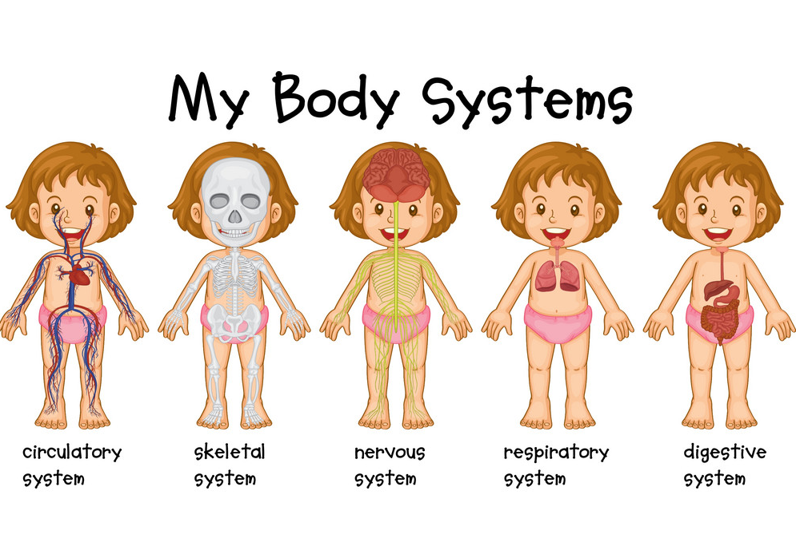Ask the group to identify and point out the various systems based on the clues given below. After the group shares, add any information that may have been missed.

**ADAPTATION FOR TOTALLY DEAFBLIND:**

* Use tactile models, textured materials, and hands-on activities to help participants explore and understand the structures of different body systems.
* Relate concepts to real-life experiences. For example, connect the digestive system to eating and the respiratory system to breathing. Place their hands on their chest or back to feel the rise and fall during inhalation and exhalation.
* Relate body system concepts to the participants' own body. Allow them to feel their own pulse, heartbeat, or breath to connect theory with personal experience. Use textures, temperatures, and vibrations to convey how nerves transmit information.
* Use the participants’ preferred mode of communication, which may include tactile sign language, Braille, or other forms of communication tailored to their needs.

**FACILITATOR WILL SHARE THIS INFORMATION IN THE SIMPLEST WAY THAT THE PARTICIPANT WOULD UNDERSTAND**

* **Which system helps us to think and act; move our hands and legs; write and speak?**

Nervous system helps us see, feel, and understand things. The brain is the most important part   
 of this system.

* **Which system helps us to breathe?**

Respiratory system helps us to breathe air in and out through the nose. Besides the nose, the throat and the lungs are important parts of this system.

* **Which system enables blood to circulate in our body?**

Circulatory system enables blood to circulate in our body through the various arteries and veins. Its most important part is the heart.

* **Which system helps us eat?**

Digestive system: Food from our mouth travels down the gullet then goes into the stomach where certain digestive juices help in the absorption of the food into the body. This is the digestive system.

* **Which system helps the other systems work well?**

Endocrine system comprises various glands located in different parts of our body. These glands secrete hormones, which help in the coordination of all other systems and enable them to perform their functions.

*For example: Glands in the mouth secrete saliva, which helps in the digestion of food. Similarly, the physical changes experienced by teenage boys and girls are caused by this system through certain hormones.*

* **Which system helps us run?**

Muscular system: Running, swimming, playing, washing clothes, drawing water from the well - all these activities involve the use of hard or semi-hard fleshy parts of our body. These parts are called muscles and make up the muscular system.

* **Which system gives us structure?**

Skeletal system is made up of many bones in our body. The bones give the body a shape, structure and size. The skeletal system also helps us to move around and protects the organs such as the heart, lungs inside our body.

* **Which system helps us get rid of waste liquid or urine from our body?**

Urinary system helps us in passing urine. This system is connected to the reproductive system.

* **Which system helps a woman bear a child?**

Reproductive system helps in the conception of a baby in the woman's body, and later (after a period of nine months) in the birth of the baby.

**Facilitator’s Sum up**

*It is the reproductive system we are going to learn more about.* Why?

*Because it is closely related to the physical and emotional changes adolescents experience, and also to childbirth, which is important for us to learn about.*

## Private Body Parts

|  |  |  |
| --- | --- | --- |
| **Session 2: Activity 3**  **Private Body Parts** | **Objective**   * To teach about private body parts to help understand the concept of privacy. * To teach the importance of consent. | **Issues/Information**   * Girls become more aware of their bodies and understand which parts are considered private. * Empowered to assert their boundaries. |
| Time: 30 mins | Material required:   * Anatomically correct Paper Dolls (Printable annex). * Once printed, you’ll need some cardboard (a cereal or biscuit box will do), scissors and a glue stick, coloured pencils for colouring in. * Outline of women’s & girls’ body for reference. * Outline of men’s and boys’ body for reference. | |

**Introductions:**

Learning about their private body parts helps young adolescents to understand more about their bodies and how to take care of them. It also allows building the skills involved in identifying private places and private behaviours, which are essential skills to keep safe and participate in the community.

**Private Parts:**

***An easy way to identify private body parts is that they are the areas covered by underwear/your bra. Private parts are always covered in Public.***

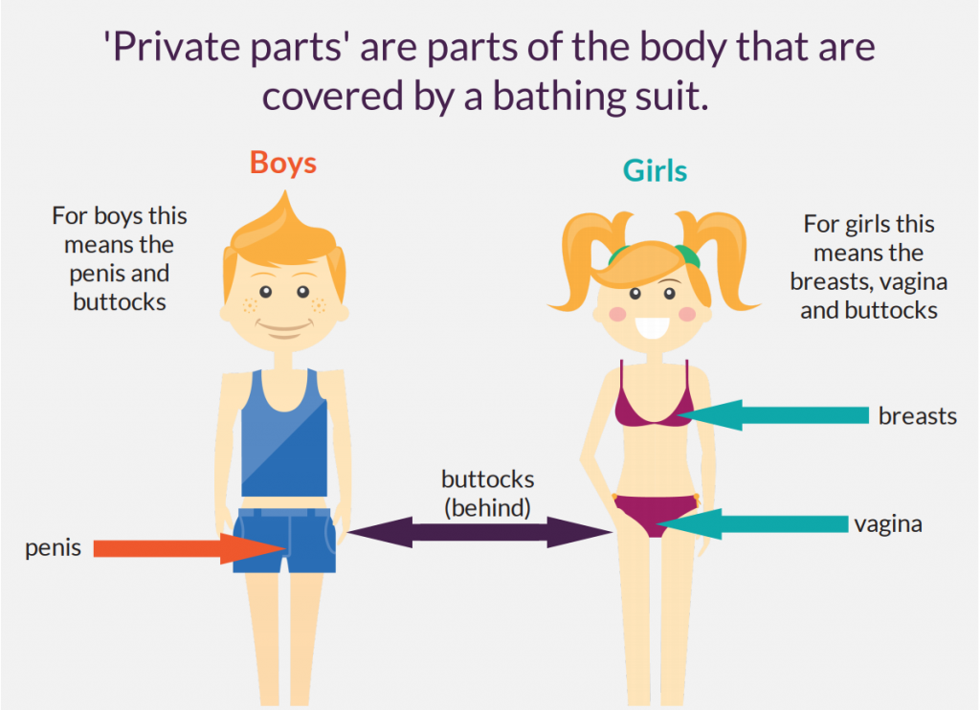

**Resource: You can use visual resources like the anatomically correct dolls to help teach private** **parts or can procure** **Vikapl’s “Kahani Her Mahine Ki” – which includes a life-size human body model for demonstration, tactile diagrams and material and texts for the sighted and Braille for the visually impaired.**

**PRIVATE PARTS OF THE BODY**

|  |  |
| --- | --- |
| **PRIVATE PARTS OF FEMALES** | **PRIVATE PARTS OF MALES** |
| * Breasts, * Vulva- outside private body part * Vagina- is on the inside of the body * Bottoms (buttocks) | * Penis, * Testicles * Bottom |

**Pubic hair**: Hair grows on different parts of a woman’s body. Hair that grows around the vulva is called pubic hair. She may also grow hair under her arms, on her legs and sometimes around her nipples.

**Breasts:** Breasts can be of different shapes and sizes. Sometimes one breast is bigger than the other. On each breast is a nipple. This is a darker colour as compared to the rest of the breast.

*A woman’s breasts, vulva, anus and buttocks are all her private body parts. Girls and women must keep their private body parts covered unless they are in a private place. It is OK for girls and women to look at their private body parts and to touch them as long as they do this in a private place. It is not OK for anyone else to touch a woman’s private body parts without her permission.*

**ACTIVITY:** **MAPPING OF PRIVATE BODY PARTS**

1. Ask the participants to draw two separate outlines of a female child and a female adult. (01 outline of girl’s body and 01 outline of woman’s body)
2. Ask them to name public and private parts in both outlines.
3. Draw underwear or colour, where private parts are.
4. Ask participants to do the same activity for male child and adult.

*The outline for reference is attached in the annexure.

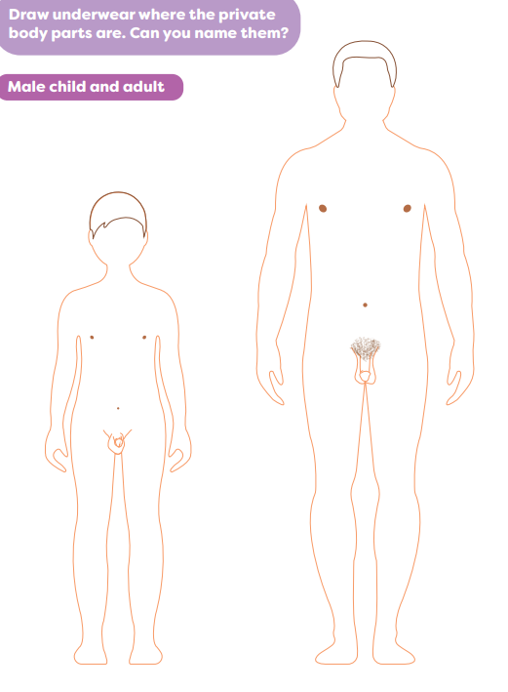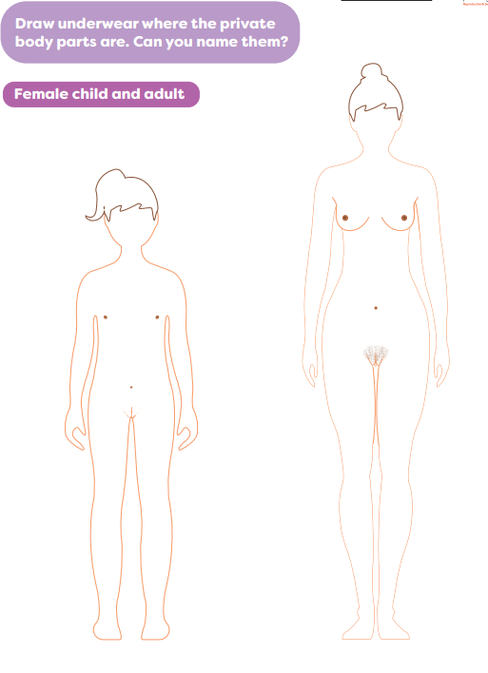

**Below are ‘Reference pictures’- attached in annexure for print out or reference**

## CONSENT: WE ARE IN CHARGE OF OUR BODIES

|  |  |  |
| --- | --- | --- |
| **Session 2: Activity 4**  **Consent** | **Objective**   * To teach the importance of consent. * To help how to respond if someone is touching them in a way that makes them feel uncomfortable. * Identify a trusted adult. | **Issues/Information**   * Understand the importance of consent. * Increased awareness and the ability to identify and report inappropriate behaviour, reducing the risk of abuse. |
| Time: 90 mins | Material required:   * Power point, flipcharts, quiz cards, and small gifts for participants. | Methods Role play, reflections and discussion, analyse the role-play and discuss its relevance to their lives. |

**The facilitator to share the below case ask participants questions and start a discussion based on that.**

**Case 1:** *Meet Mia, a 10-year-old girl, and her neighbour, Mr. Johnson, a friendly man who lives next door. Mr. Johnson often sees Mia playing in the backyard and strikes up friendly conversations over the fence. They share a neighbourly bond, and Mia feels comfortable chatting with him. One day, while Mia is playing outside, Mr. Johnson unexpectedly tries to touch her shoulder and neck. Mia feels uncomfortable and confused by this action. Unsure about what just happened, Mia decides to share her feelings with her mother. She explains the incident, expressing confusion and discomfort. Mia's mother listens attentively to Mia's concerns, reassures her that she did the right thing by speaking up, and explains that some touches are inappropriate.*

**After sharing Mia’s incident start discussions on the following:**

* Why Mia felt uncomfortable?
* What according to you is good touch & bad touch?
* Introduce the concept of "No-Go-Tell," emphasizing the importance of saying "No," recognizing when to "Go" or leave a situation, and the necessity of "Telling" a trusted adult about uncomfortable experiences.

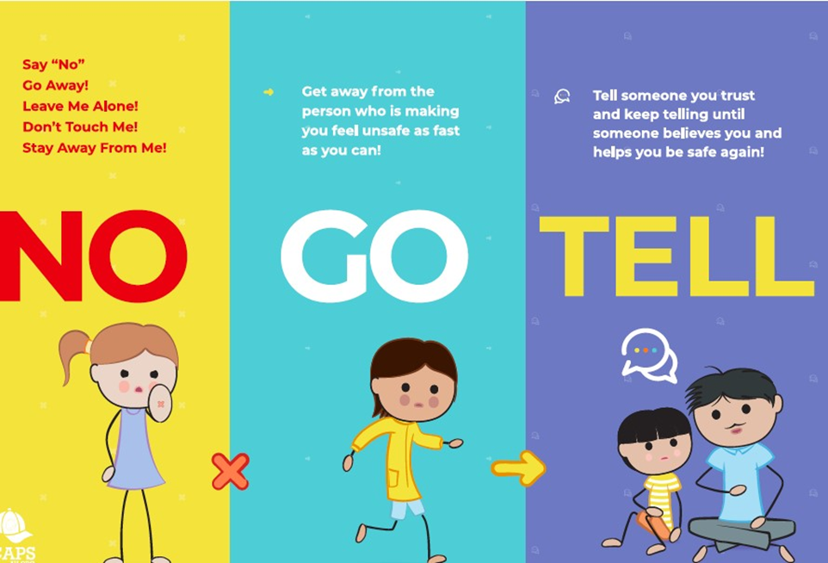

**COMFORTABLE TOUCH AND UNCOMFORTABLE TOUCH:**

**Facilitator will Say:** I want you to share with you Pinki’s story.

***Case 2*:** *Pinky is 12 years old. One day her mother sent her to her neighbour’s house to borrow some sugar, but her neighbour wasn’t there, instead, there was someone she didn’t know. This man told Pinky that he would give her some sugar and invited her in to wait. The way the man was standing close to Pinky made her feel uncomfortable. He started to get closer to her and tried to stroke her back. Pinky doesn’t know if what happened is normal and what she can do.*

Today, we will help Pinky to know if what the man did was a comfortable touch or an uncomfortable touch-

* The facilitator to ask participants if they have any questions before they start.
* Explain there are different types of touches, some are comfortable, others are uncomfortable and some can be confusing or unwanted.

**ACTIVITY:** Give some indications (like thumps up, thumps down and fist) that will represent some types of ‘touches’ These indications will represent what they think the touch means.

|  |  |
| --- | --- |
| **TYPES OF TOUCHES** | |
| Hugging | Back rubs |
| Kicking | Stroking |
| Kissing | Medical examination |
| Pat on the back | Biting |
| Punching | Holding hands |
| Pinching | Touching private parts |
| Tickling | Slapping |

**EXPLAIN:**

* Some of these touches could be comfortable touches or uncomfortable touches depending on the reason for the touch and how they make a person feel.
* A comfortable touch should make someone feel safe and happy.
* An uncomfortable touch or a confusing touch can make someone feel sad or embarrassed. It is an uncomfortable touch if:
  + Someone touches a girl on her body where she doesn’t want to be touched.
  + That touch makes her feel scared or worried.
* Sometimes, we may be touched and it might not feel good, but it doesn’t mean it is a bad touch, it means it’s an unwanted touch. Such as if someone grabs you to keep you from harm (whilst crossing a dangerous road) or an examination by a doctor or nurse because you are sick.

**Case 3:** *“Inayat was walking down the school corridor one day when she was violently pushed against a wall and forcibly kissed. The perpetrator was Ayush, an older male student who was her friend too. When asked about his behaviour, Ayush wasn’t repentant in the least. ‘What I did was normal, since I had asked her (Inayat) many times,’ he said, justifying his action.”*

**After discussing the case have a general discussion on**

* **What is Consent?**

**(First, ask the participants for their input and then add the remaining points from the list below. You may add more to the list as you deem fit.)**

* Consent is when both people say ‘yes’ to do something.
* One person will ask for permission to do something.
* The other person thinks about what they want to do.
* You can say ‘yes’ or ‘no’. It is your choice.
* You can change your mind later.

*In all healthy relationships, people make decisions about what they feel ok about doing, and other people respect this and don’t push them to do things that they don’t want to do. Asking people if they want to do things is called ‘looking for consent’. People may say ‘yes’ or ‘no’ and their choice has to be respected.*

* **When do you need to ask for consent?**

**(First, ask the participants for their input and then add the remaining points from the list below. You may add more to the list as you deem fit.)**

There are lots of different types of consent. You need consent to:

* touch another person’s body.
* touch another person’s private body parts.
* touch another person’s belongings.
* enter another person’s private place.
* enter another person’s home or car.
* do an activity with another person.
* consent of different kinds is something that you will learn more about as you grow up.
* consent about the body, who touches it and in what way, is always important.
* **Why is consent important?**

**(First, ask the participants for their input and then add the remaining points from the list below. You may add more to the list as you deem fit.)**

* Your body belongs to you.
* Nobody should touch your body unless you give consent.
* ***consent helps to:***
  + *have healthy relationships*
  + *make healthy decisions*
  + *make friends and have fun*
  + *be part of their community*
  + *be safe*

***In the end, explain the following to the participants: -***

***If anyone wants to touch you sexually or have you touch them without your consent, you should tell a trusted adult immediately. You might be asked to keep it a secret. The person might say that what’s happening is your fault or that it’s because they love you, but that’s not true. A trusted adult, such as a parent, relative, teacher, etc. will help you.***

**ACTIVITY: Ask all participants to listen to this poem**

|  |  |
| --- | --- |
| **English** | **Hindi** |
| *Your body is always with you*  *You only get one body, so always take care,*  *Respect it, protect it, and be aware:*  *One person controls the things you say and do,*  *And that one person can only be you!*  *All of your body is good; every part has a role.*  *It’s ok to be curious, but safety is the goal.*  *No matter the shape or size, your body is one of a kind*  *Who you are is special, so always keep in mind:*  *Your body is yours, so give it a listen,*  *Check in with each other, and always ask permission*  *So, trust how you feel and remember this song*  *Your body is yours to stay safe and strong!* | आपका शरीर हमेशा आपके साथ है  आपको केवल एक ही शरीर मिलता है, इसलिए हमेशा इसका ख्याल रखें,  इसका सम्मान करें, इसकी रक्षा करें और जागरूक रहें:  आप जो कहते और करते हैं उसे केवल आप ही नियंत्रित करते हैं, और वह एक व्यक्ति केवल आप ही हो सकते हैं!  आपका शरीर सबसे अच्छा है, हर अंग की अपनी भूमिका है। जिज्ञासु होना ठीक है, लेकिन सुरक्षा ही लक्ष्य है।  इससे कोई फ़र्क नहीं पड़ता कि आपका शरीर किसी प्रकार का है या नहीं  आप कौन हैं यह विशेष है, इसलिए हमेशा ध्यान रखें:  शरीर तुम्हारा है, इसलिए इसे सुनो,  एक-दूसरे से बातचीत करें और हमेशा अनुमति मांगें  इसलिए, विश्वास करें कि आप कैसा महसूस करते हैं  और इस गीत को याद रखें, सुरक्षित और स्वस्थ रहें आपका शरीर आपका है! |

## Public & Private Places and Behaviour

|  |  |  |
| --- | --- | --- |
| **Session 2: Activity 5**  **Public & Private Places and Behaviour** | **Objective**   * To teach about private and public places. * To teach public & private behaviours. | **Issues/Information**   * Girls become more aware of their surroundings (private and public). * Aware of acceptable behaviours. |
| Time: 30 mins | Material required:   * White Board/Flip Chart, Pictures/list of public and private places. * 3D model of women’s internal organ can also be purchased for the training. | |

**Facilitator starts this session by asking the participants if they know the difference between Public and Private places. Facilitator is to note the response on the flip chart/whiteboard if available. Facilitator to add information from the following list.**

**INFORMATION:**

**PUBLIC PLACES:**

* Places where there is more than one person.
* Places where you are likely to find/see other people.
* Examples: Classrooms, school grounds, public washrooms, parks, banks, cinema halls, malls, libraries, markets, hospitals, stations, swimming pools, religious places etc.

**PRIVATE PLACES**

* A place where there is only one person.
* A place in which you are usually alone.
* Examples: Bathroom, bedroom, trial room.

**ACTIVITY:**

* Ask participants to write/tell you one by one what they think is public behaviour or activity.
* If participants are not responding, tell them that you will mention an activity and they have to say if it’s a private or public activity.
* Is eating a public or private activity? (Public)
* Talking on the phone? (Public)
* Washing Dishes (Public)
* Bathing (private)
* Changing clothes (private)

**Information:**

* Public Behaviour/Activity are things we can do when people are around us. (singing, dancing etc.)
* Private activity- Some activities are done only when we are alone. (bathing, dressing, using the toilet, adjusting underwear)
* Some activities like shaving, applying ointments to private parts, and touching private parts should be done with doors closed in a private place which could either a bedroom or bathroom.

|  |  |  |
| --- | --- | --- |
| **Session 2: Activity 6**  **Helen Begins a New Journey** | **Objective**   * Understand physical and emotional changes during adolescence in boys and girls. | **Issues/Information**   * Physical, and emotional changes during growing up: why changes during adolescence happen, exploring feelings. |
| Time: 60 mins | Material required: A doll or a flipchart with a girl (character) drawn, Body Growth & Change poster for girls & boys. | Storytelling, Discussion |

**Facilitator Talking points**:

* We are going to talk about the changes we experience in our bodies as we grow up.
* These are both changes that we see and changes that we feel.
* We know that we can be shy to talk about these changes, but it is important that we talk about them, because it is a natural and special part of growing up.
* I know that I noticed many changes in my body when I was your age.
* Around the world, girls that are aged between 9 and 16 go through some changes in their body and also in the way they think about things.
* When young girls go through these changes it is called “puberty”. They are changing from a girl to an adult.

**Storytelling**

*This is a story about a 12-year-old girl named Helen. She lives with her parents in a small town. Every morning, she goes to school. After school, she goes straight to a playground to meet her friends Paro, Jaya, and Rupa. They have a lot of fun together in the playground. Helen usually helps her mother with household chores. She's a happy and funny girl, but lately, something seems different, she is spending a lot of time dressing up. For the past few weeks, she hasn't looked very happy and has become quite moody. You can tell she's a bit upset. Little things seem to bother her, and all day, she looks troubled. She can't figure out why this is happening. Helen's mother is asking her to come home early and help with more chores, which Helen finds strange. What's even more odd is that her mother doesn't want her to play with boys anymore. She wants to just spend time with her friends and is listening to them a lot. Sometimes she does things to just seek their approval. It's confusing for Helen as she tries to understand these changes in her routine.*

*Top of Form*

*The reason behind all these changes is that Helen is growing up. Sometimes, when she looks in the mirror, she feels a bit shy because she notices some changes in her body. Her breasts are growing (and sometimes they might even feel a bit painful), and her hips are getting broad. These are natural parts of growing up, but it's new and might be a bit confusing for Helen. She can see some hair growth in her armpits and around her vulva, she is sweating too. Her hands and feet are growing in size and she is also getting taller. Not only externally, but she is growing internally too, she doesn’t know that behind these changes in her body from the outside there is something important that is changing inside.*

*Exactly, Helen can see the physical changes happening on the outside, like her growing breasts and hips, but she might not fully understand what's happening inside her body. These changes are a result of hormones, which are natural substances in the body that play a big role in growing up. It's a normal part of becoming a teenager, and as Helen navigates these changes, she'll gradually learn more about this natural process of growing and developing.*

**ACTIVITY:**

* Ask the group to recap the various physical and emotional changes experienced by Helen.
* Ask the group to recap what were the various emotions and feelings experienced by Helen in the story.
* Then ask the group to individually share various emotions (embarrassed, sad, happy, attracted, in love, joyful, depressed, lonely, etc.) they have felt in the recent past.
* Ask them to share whether they discussed their feelings with anyone or they kept them hidden.

**Facilitator’s Sum up**

*These changes, the feelings, the confusion and the curiosity are all a normal part of the growing-up process. It is important to be able to recognize one's feelings and share them rather than keep them suppressed.*

**Summarize changes:**

**PHYSICAL CHANGES in Helen**

* + *Increase in height.*
  + ***Breasts*** *have grown and she has gained weight.*
  + *Hips have grown.*
  + *Pubic and underarm hair are growing.*
  + *Skin and hair are getting oily and she has got some pimples.*
  + *Perspiration increased and she sweats more, her body odour changed.*
  + *The skin has become oily.*

**EMOTIONAL CHANGES in Helen**

* *Different feelings she experienced: Getting annoyed easily. Feeling angry, sad, moody.*
* *Changes in things: like she never enjoyed dressing up or doing makeup, but now she spends a lot of time on this.*
* *Helen wants to spend more time with friends and less time with family. But this does not mean she doesn’t love her family- it means she likes being with her friends more than before as she feels they understand her more and treat her well.*
* *Worrying about her body and the way she looks (Helen is not happy with the way her hair looks or how she is fitting into her clothes).*
* *Feeling pressured by friends to act a certain way (friends ask her to do something she does not want to but she does not know how to say no because they are her friends).*

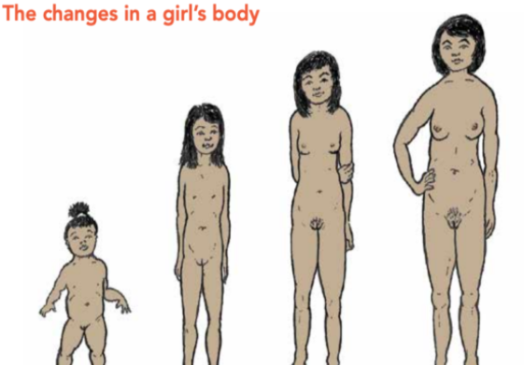

### SUMMARIZATION GROWING UP

### FACILITATOR TO USE FOR RECAP

|  |
| --- |
| **SALIENT FEATURES:**  **Key Information**:   * Adolescence is a normal phase of the life cycle when a child matures into an adult. It starts with the onset of puberty. It is a period of rapid growth and development involving many physical, psychological and social changes leading to the development of an independent, adultpersonality. * Puberty is the time when a child’s body begins changing to an adult’s body. * Puberty begins at different ages in different individuals — it starts as early as 8 years of age for some and as late as 15 years of age for others. * Girls usually reach puberty earlier than boys. * Sexual feelings begin at puberty and sexual urges may grow stronger.   **Physical Changes during Puberty**   * + At puberty, the body grows and changes very quickly. This is caused by the release of chemicals (known as ‘hormones’) in the body.   + Hormones cause the sexual and reproductive organs of the body to mature – boys begin producing sperm and girls begin to menstruate.   + The reproductive functions of the body also start to mature. After reaching puberty, a girl can become pregnant, while a boy can father a baby.   + In boys, testosterone hormone is responsible for hair growth on the pubis and face, voice deepening, growth of penis and testes, and production of semen.   + In girls, oestrogen hormone is responsible for development of breasts, pubic hair, rounding of hips and menstruation.   **Emotional and Psychological Changes**   * Boys and girls often feel worried and embarrassed about body changes such as growth of hair, pimples and growing taller. * It is common to feel awkward, shy and confused during this period. * Changes in mood may occur without reason – feeling high or low. * Sexual thoughts and feelings increases. * Many young people feel confused about their sexual feelings – they may feel attracted to members of the opposite sex, or the same sex. * Guilty feelings and confusion may occur because of sexual feelings. * Girls may become very sensitive and emotional just before menstruation. * There may be changes in personality – young people wants greater independence.   **Social Changes**   * Peer group becomes more important and young people are more easily influenced by their friends. * Young people start to seek independence from their parents and may challenge their parents’ values and beliefs. * Young people usually seek information about sexuality and body changes from their friends – however, this information is often incorrect. * Adolescents must find a balance between peer pressure and listening to the advice of parents.   **Moral and Spiritual Changes**   * The ability to tell right from wrong begins to develop. * Adolescents start to form their own values and moral beliefs. * Older adolescents are more able to take responsibility for the consequences of their actions and make independent decisions. * A sense of belonging and meaning in life becomes important during adolescence. |

# C. SEXUAL AND REPRODUCTIVE HEALTH

## Energizer Clay Game

|  |  |  |
| --- | --- | --- |
| **Session 3:**  **Energizer**  **Clay Game** | **Objective**   * Warm up- To relax and have fun before starting the new unit. | **Time- 15 minutes** |

* **STEPS**

1. Ask participants to sit in a circle, making sure that everyone can see each other clearly or they can reach out to each other’s hands easily.
2. Give the following instructions:
   * + One person begins by imagining they are holding a handful of clay, which they can make into any object they want. They mime with their hands, transforming the clay into an object, for example, a cup of tea, and they then use the object, e.g. they show drinking the tea.
     + The imaginary object is then passed on to the person beside them, who squashes it back into a clay lump and makes it into something else.
     + Stop after everyone has had a chance.

**ENERGIZER: Debrief:** You may get any situation in your hand, but it's up to you what you make out of it. It's entirely up to you to cry over a situation or to see it in a positive light and let it pass in a fun way.

## Recap

|  |  |  |
| --- | --- | --- |
| **Session 3:**  **Recap** | **Objective**   * Revisit topics and learnings from the previous day. | **Time- 30 minutes** |

**ACTIVITY 2: RECAP**

* Thank participants for the previous day for being attentive and participative. Before starting the next unit/session, tell them we will do a quick RECAP.
* Then ask participants to brainstorm what adolescence means.

**SUMMARISE:**

* Adolescence is the time in life when we move from being a child to becoming an adult.
* Adolescence is both challenging and exciting.
* Adolescence can be confusing because sometimes you feel or are treated more like an adult and sometimes you feel or are treated more like a child.

**Remind them of their discussion on the physical, emotional and social changes that take place in males and females during adolescence;**

**Preparation**

1. Write or print the following pointers in large letters, one on each piece of paper or chits. When you have finished, mix them up so that they are not in order.

|  |  |
| --- | --- |
| * Breasts develop | * Shoulders broaden & chest gets wider |
| * Sweat glands develop | * Hips, thighs & bottom widen |
| * Growth of facial hair | * Skin becomes oilier; may get pimples & acne |
| * Genitals get bigger | * Moods change quickly |
| * Menstruation begin | * Try to know & understand yourself |
| * Hair grows on body, in armpits and on   private parts | * Start feeling sexual attraction |
| * Become taller & gain weight | * Develop own values |
| * Voice changes | * Concerned about being normal & fitting in |
| * Start having romantic relationships | * Feel peer pressure |
| * Become part of peer groups | * Become more independent from parents & family |
| * Want to look & behave like your peer   group | * Feel closer to friend |

* + Take three pieces of flipchart paper and draw a figure of a boy on one, a figure of a girl on one and a half boy/half girl figure on one. Write ‘PHYSICAL’ above the body, write ‘SOCIAL’ on the left side and ‘EMOTIONAL’ on the right side, as shown:

Social Physical Emotional Social Physical Emotional Social Physical Emotional

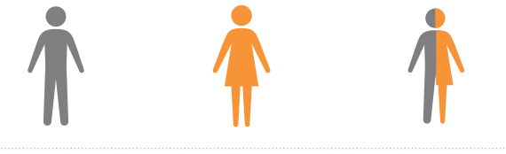

* **STEPS:**
  + Tell the participants that this activity is about the changes that take place during puberty and adolescence.
  + Post the pictures that you prepared at the front of the room.
  + Divide participants into 03 groups. Tell them that each group will get 7-8 chits that have some changes written on them.
  + In their groups, they will discuss and decide if the change is something that happens to only boys, only girls, or both boys and girls.
  + Then they will decide if the change is physical, social or emotional.
  + Give them 10 minutes to discuss in their groups.
  + Then call their attention back to the front.

Ask the first group to have one of their members come to the front with one of the changes and tell everyone where the group decided it should be posted. Ask if the others agree. If it is correct, have them post it in the correct place. For physical changes, they should post them on the body shown in the picture. You can continue with 4-5 more changes.

* *Use the Facilitator Information: Physical, emotional and social changes in boys, girls and both sexes during adolescence as a guide to the correct answers. As you go through the changes, ask them if they have any questions and discuss them as needed.*
* Ask them the following questions:
  + What do you notice about the changes that are different for boys and girls?

(Answer: They are all physical.)

* + Are the changes mostly the same for boys and girls or mostly different?

(Answer: They are mostly the same.)

* + How do these social and emotional changes make you feel?

(Possible answers: Shy, confused, worried, happy, excited, among others.)

* Tell participants that the changes are mostly the same, but that as a group, girls start changing about two years before boys.
* Individuals will start changing at different ages.
* Reassure them that this is normal.

**Facilitator to share these options as Positive ways to manage the moods and emotions they experience during adolescence.**

Some examples of coping strategies are:

* Exercising or doing some physical activity
* Eating well
* Discussing emotions with family, friends, or religious leaders
* Laughing
* Crying
* Doing something you enjoy, like a hobby
* Participating in activities
* Reading

**Summarize what they learned during the activity.**

Add any of the following points that are not mentioned.

* As a group, girls start puberty earlier than boys.
* Puberty changes do not start at the same age for everyone.
* The social and emotional changes are the same for girls and boys, but some physical changes are different for boys and girls.
* These changes can make us feel confused or worried.
* There are many ways to manage our feelings, including talking to adults, friends, or others about what we are going through.

**Linking to next unit:Facilitator's sentence:***Some of the physical changes that take place during puberty - prepare our bodies for having children. We are now going to talk about the sexual and reproductive parts of the body - those that are involved with having sex and making babies.*

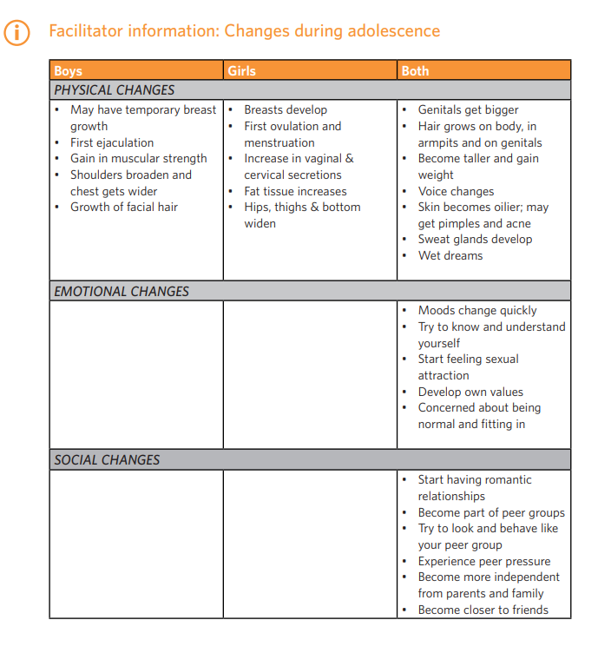 **\*Genitals can be referred to as private parts.**

**\*Wet Dreams not introduced yet facilitator can decide whether to share this information or not.**

**\*Vaginal discharge introduced in the next session.**

|  |
| --- |
| **ADAPTATION FOR DEAFBLIND**: VIKALP has developed a kit called "Kahani Her Mahine Ki". It is a Menstruation Kit - developed for the visually impaired young girls and women. The kit "Kahani Her Mahine Ki" covers the subject of menstruation and how to manage during 'periods'.  The kit has the following features:   * A life size human body model for demonstration. * Tactile diagrams and material are in the form of Information Slates, with labels of the different body parts. The Information Slates fit into a box with slats. * Each slate has text for the sighted and Braille for the visually impaired.   Available at [Vikalp Design](https://vikalpdesign.com/sadhvi_thukral) |

## The Female Sexual and Reproductive System

|  |  |  |
| --- | --- | --- |
| **Session 3: Activity 1**  **The Female Sexual and Reproductive System** | **Objective**   * To discuss and understand the parts of the female sexual and reproductive systems and their functions. | **Issues/Information**   * Name the main internal and external parts of the female sexual and reproductive systems and their functions. |
| Time: 60 mins | Material required:  Poster: Female Sexual and Reproductive System, Externa & Internal.  *Take a printout of poster & worksheet: external & internal organs given for activity. | Posters, activities & Discussion |

**Preparation:** Review the Facilitator Information so that you can add to what participants say without reading it as this will bore the participants.

* **STEPS**
  + 1. Brainstorm what the word ‘reproduce’ means. (Answer: to have children or offspring.)
    2. Tell them that the diagram is the female reproductive and sexual system.
    3. Refer to the words on the poster:

**EXTERNAL** **FEMALE SEXUAL & REPRODUCTIVE SYSTEM**

LET’S KNOW THEM MORE: Facilitator to explain the following to the participants.

**A woman’s vulva:** The vulva is the part between the tops of a woman’s legs. The vulva is made up of two large and two small lips of skin.

* **These lips are called the labia**. The labia cover two holes, or openings, called the vagina and the urethra.
* **Vagina:** When a woman has her periods, the blood comes out of her vagina opening each month for a few days. We will talk about Periods or Menstruation. A woman can have intercourse with her vagina. If a woman is having a baby, the baby will usually come out of her vagina when it is being born.
* **Urethra:** Sometimes people think the vagina is where urine comes out of a woman’s body when she goes to the toilet, but the urine comes out of a different hole called the urethra. The urethra is the small hole above the opening to the vagina.
* **Clitoris** is the small organ, shaped like a flower bud, at the top of the inner lips, above the urethral opening.
* **Anus and buttocks:** Behind a woman’s vulva is her anus and buttocks. The anus is where faeces come out when she goes to the toilet. Faeces is the correct word for ‘shit’.
* **Mons pubis** is the pad of skin and fat over the pubic bone. It protects the internal sexual and reproductive organs. It becomes covered with pubic hair in puberty.

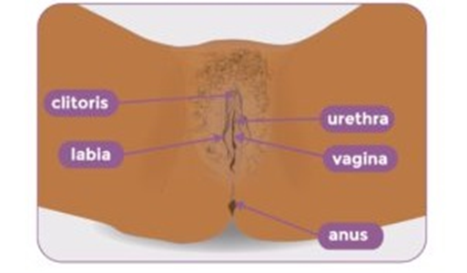

**ACTIVITY:**

* Divide participants into groups of four or five.
* Take a printout of the given picture.
* In their groups, they should discuss the words listed on the worksheet and label the parts on the picture.
* Put up the poster of the external female sexual and reproductive systems (showing the external parts).
* Go through the answers by pointing to each body part and asking the following two questions for each one:
  + What is this part called?
  + What is its purpose?

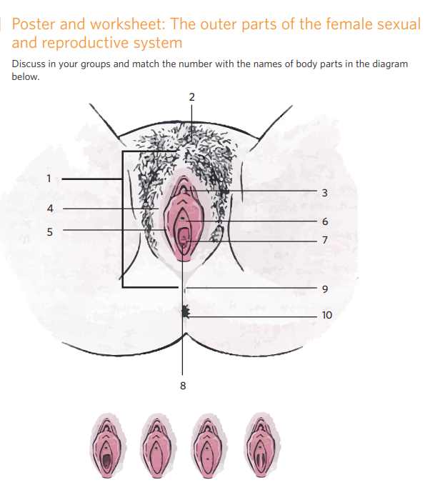

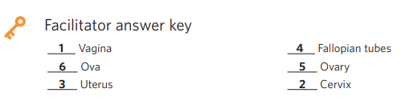

Resource: for print, the diagram worksheet is attached in annexure

### INTERNAL FEMALE SEXUAL & REPRODUCTIVE SYSTEM

**Facilitators’ opening remarks:**

We need to talk about and learn how our sexual and reproductive organs work so that we can stay healthy and protect ourselves from harmful sexual activity. These organs are the same as any other body parts and there is no need to feel shy talking about them. We can use the name for each organ that we feel happy with, so long as we all understand what we mean. We need to learn the English words so that we can talk easily with doctors if we need to. Let’s look at the internal system now.

* The woman’s sexual and reproductive organs are located inside and outside her body.
* The uterus is where a fertilized egg grows into a baby.

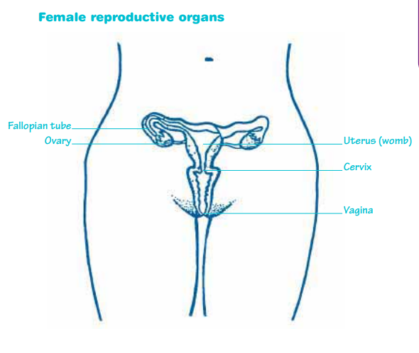

|  |  |
| --- | --- |
| **Name and what it is** | **What it does** |
| **Vagina:**  A tube inside the body that has a very small opening into the uterus and opens between the legs. | * Penis goes inside the vagina during sex and puts sperm into the vagina. * Babies come out through it at birth. * Menstrual blood leaves the body through it. * The **vagina** is separate from the **anus,** the hole through which faeces come and the **Urethra** from where urine comes out. |
| **Uterus** or womb Bag at the top end of the vagina | * Every month, the womb prepares itself for a baby by making a thick lining. If there is no baby, the womb throws away the lining when the girl has her period. * The baby grows in the womb during pregnancy. |
| **Fallopian tubes:**  Two tubes connecting the ovaries to the womb. | * One egg travels along the tube from the ovary to the womb each month. |
| **Ovaries:**  Two sacks on each side of the womb. | * Store about 300,000 eggs and take it in turns to send one each month to the womb. |
| **OVA: Eggs Tiny cells** inside the woman’s ovaries. | * After sex, an egg joins with sperm at fertilization to make a baby. |
| **Cervix:**  An organ that surrounds the opening from the vagina to the uterus. | * Cervix allows the passage of blood (menstrual flow) from uterus to the vagina. * During childbirth it dilates to allow the baby to pass through. * Cervix produces mucus that serves as a barrier to prevent infections from entering the uterus. |

**ADAPTATION FOR TOTALLY DEAFBLIND: On a cloth the reproductive organ can be embroidered.**

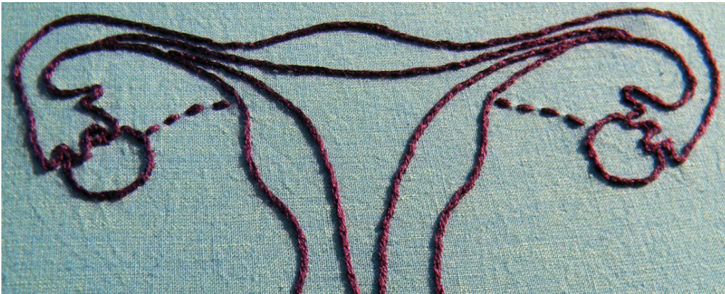

**ACTIVITY:**

* Divide participants into groups of four or five.
* Take a printout of the given picture- internal female system.
* In their groups, they should discuss the words listed on the worksheet and label the parts on the picture.
* Go through the answers by pointing to each body part and asking the following two questions for each one:
  + What is this part called?
  + What is its purpose?

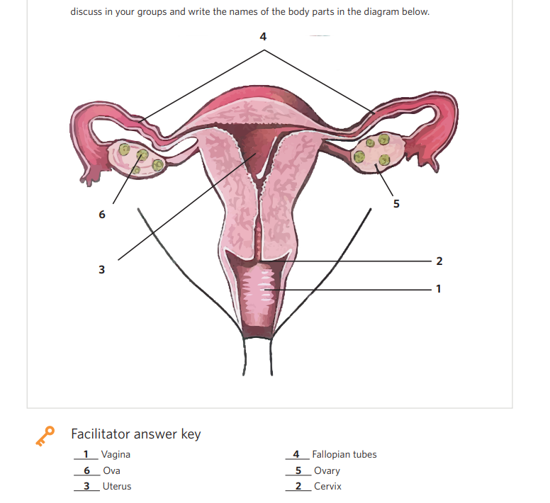

Resource: attached as an annexure to take a print for activities

**Vaginal Discharge (20 minutes)**

**Facilitator Says**: Girls will sometimes find a secretion on their underwear; this is called discharge. This is usually clear, white, or off-white in colour. This is normal and helps to keep the vagina healthy. Normal vaginal discharge is a healthy bodily function and it’s the body’s way of cleaning and protecting the vagina.

**For the Facilitator’s Information**- Discuss the different types of discharge a girl might find in case there are questions regarding this from the participants, or else just mention the different kinds of discharges.

* **White:** A bit of white discharge, especially at the beginning or end of the menstrual cycle, is normal. However, if the discharge is itchy and has a thick, cottage cheese-like consistency or appearance, it’s important to see a doctor.
* **Clear and Watery**: A clear and watery discharge is perfectly normal and can occur at any time of the month. It may be especially heavy after exercise.
* **Clear and Stretchy:** When the discharge is clear but stretchy, instead of watery, it indicates that a girl is likely ovulating. This is a normal type of discharge.
* **Brown or Bloody Discharge**: is usually normal, especially when it occurs during or right after the menstrual cycle. A late discharge at the end of your period can look brown instead of red. Girls may also experience a small amount of bloody discharge in between periods, which is called spotting.
* **Yellow or Green**: A yellow or green discharge, especially when it’s thick, chunky, or accompanied by a bad smell may be a sign of infection and advice should be taken from a doctor.

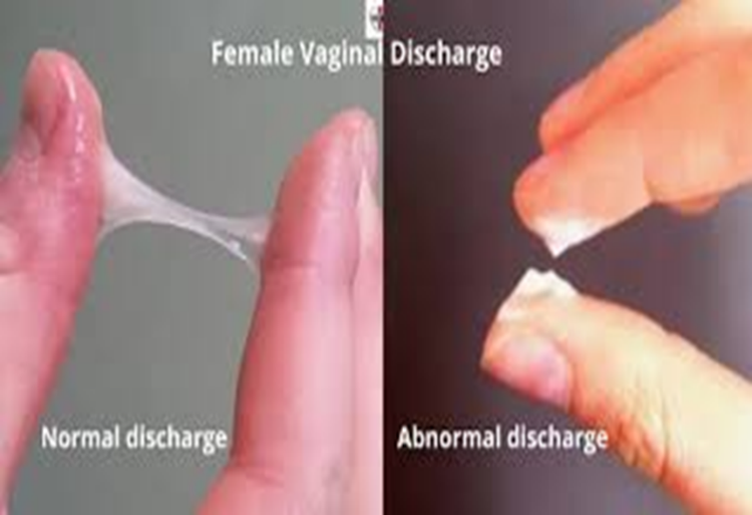

**In case any queries about this comes up as a concern, then have a quick Q&A which can be done by the facilitator.**

**ASK:** What should a girl do if she experiences a discharge that they are worried about? (Talk to someone they trust and see a doctor).

**SAY:** *Remember, reproductive health is health! And to make sure we are healthy and protected, we must take care of all parts of our health, including our physical health, our emotional health and our reproductive health.*

**DO: Ask the girls to write down any questions they have anonymously on a piece of paper and then collect the questions and address them at the beginning of the next session.**

## Understanding Menstruation

|  |  |  |
| --- | --- | --- |
| **Session 3: Activity 2**  **Understanding Menstruation** | **Objective**   * To understand what menstruation is and why it happens, to provide information about menstruation, and dispel misinformation. | **Issues/Information**   * Explain the basic process of menstruation. * Identify myths about menstruation. |
| Time: 90 mins | Material required: Poster: Female Internal Sexual and Reproductive System.  Red cards & Green cards- True/false Game. | Story, Posters, activities & Discussion |

**FACILITATOR NARRATES A SHORT STORY:**

You met Helen in the previous session; she wants to share a story with you about something she experienced recently. Let’s all sit in a circle.

**READ**: *I am Helen, and I am 11 years old. One day, when I got home from school. I noticed that I had some blood stains on my underwear. I was really worried and thought that I had hurt myself, but I didn’t feel any pain. So, I changed my underwear and continued with my day, but at the end of the day, the blood was still there! So, I decided to tell my mother because I thought I was sick and needed to see the doctor. When I told her, she explained that this was normal and meant I was growing up. She explained that this happens to all girls when they reach a certain age and that this is not something to worry about.*

**SAY:** Now that Helen has had her period, it means her body is capable of getting pregnant, so for us to understand periods, first we need to understand how babies are made.

**Facilitator’s** **Tips:**

* By now participants understand the internal reproductive system and its functions.
* Show or use the below pictures to highlight how an egg is fertilized to make a baby.
* You can ask participants what they think is happening. You can also cut these pictures and place them separately for the group to put them in order.

If the group is not clear, then the facilitator can share the below pointers first.

* Every female is born with thousands of eggs in her ovaries.
* The eggs are so small that they cannot be seen by the naked eye.
* 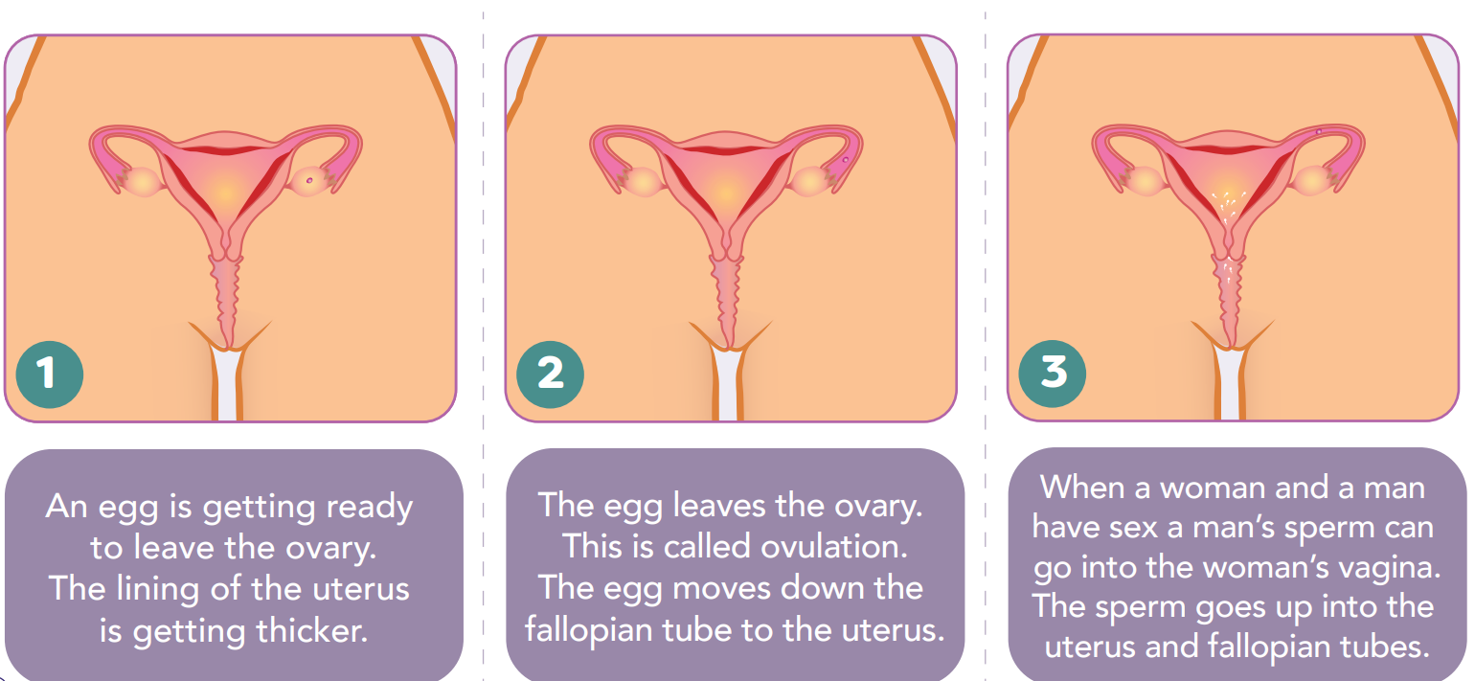Once a girl reaches puberty, a tiny egg matures in one of her ovaries and then travels down a fallopian tube on its way to the uterus.

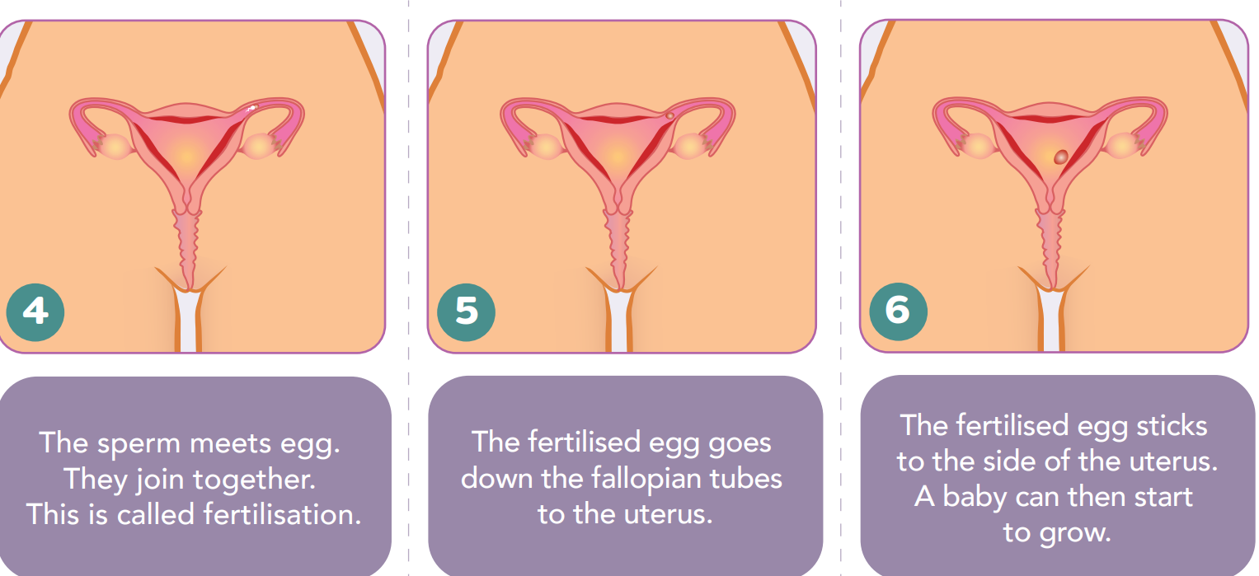

* If the girl has had sex in the last few days before or the day after ovulation, by the time the egg arrives in the fallopian tube, there might be some sperm waiting to unite with the egg.
* If the arriving egg is united with the sperm (called fertilization) the fertilized egg travels to the uterus, and attaches to the lining of the uterus (called implantation) and a pregnancy begins.

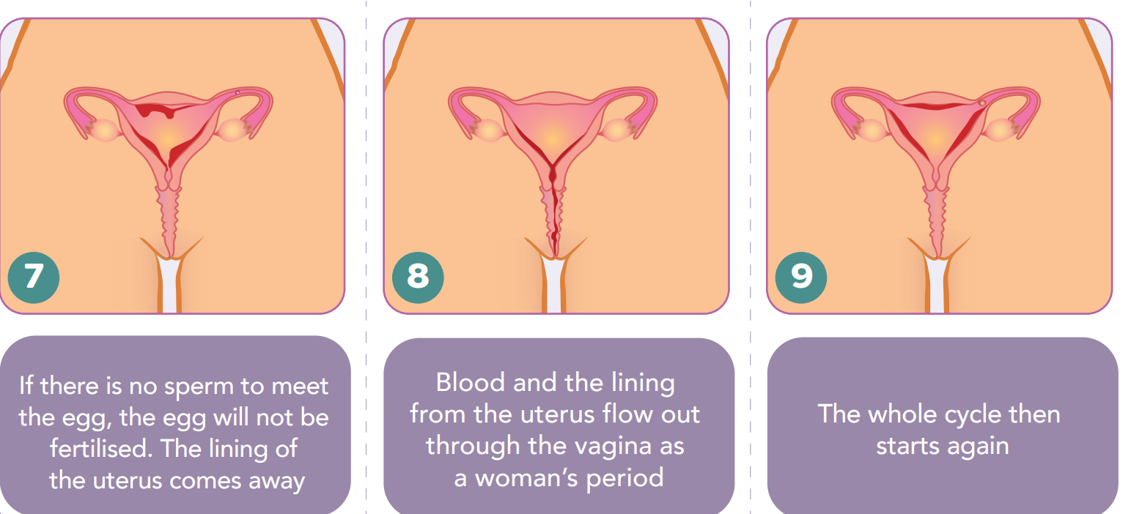

* If the egg is not fertilized, there is no pregnancy and the uterus does not need the thick lining it has made to protect the egg.
* It discards the lining, along with some blood, body fluids, and the unfertilized egg. All of this flows through the cervix and then out of the vagina.
* **This flow of blood is called the “period” or menstruation. The blood and tissue usually leave the body slowly over three to seven days.**
* The blood coming out might not always be bright red. It can start off bright red but may become brown in colour towards the end of the period.
* This whole process repeats itself roughly once a month and is called the menstrual cycle. The period is just a small part of the cycle, the part that we see.
* Your periods do not last your whole life. They stop somewhere between your mid-forties and early fifties.

Menstrual Cycle

|  |  |  |
| --- | --- | --- |
| **Session 3: Activity 3**  **Menstrual Cycle** | **Objective**   * To discuss and understand the phases of the menstrual cycle. * To understand the fertility pattern. | **Issues/Information**   * Improved knowledge about reproductive health. |
| Time: 45 mins | Material required:  Poster: Female Sexual and Reproductive System, Externa & Internal  *Take printout of poster & worksheet: external & internal organ given for activity. | Posters, activities & Discussion |

**Facilitator can explain to young adolescent girls the entire cycle and what happens inside the body.**

**DAY-WISE EXPLANATION OF THE MENSTRUAL CYCLE:**

**Day 1**

This is the first day that your period starts. Usually, there is a little more blood on the first day or two, and then there is much less on the remaining days. Most periods last about 4-6 days. The total amount of blood that comes out is about 2-3 tablespoons.

**Day 1-Day 13**

A hormone from the ovaries called estrogen tells the uterus to get ready to take care of a fertilized egg. The inside lining of the uterus becomes thick with tiny blood vessels and glands.

**Day 14**

An unfertilized egg is released from one of the ovaries. This is called ovulation. If this egg is joined by a sperm, it becomes a fertilized egg and it can grow into a baby in the uterus. If the egg does not join with a sperm, it remains an unfertilized egg. When an unfertilized egg arrives in the uterus, it disappears.

**Day 15-25**

A new hormone called progesterone is sent from the ovary that let go of the egg. It tells the tiny glands in the uterus to pour out their fluid so nutrients are waiting if a fertilized egg arrives in the uterus.

**Days 25-28**

These are the few days right before your period starts. They are called premenstrual days. You might feel some tenderness in your breasts, your pants might fit a little tighter and you might feel a little cranky. When your period starts, these signs will go away.

**CALCULATING THE CYCLE: (30 MINUTES)**

**SAY:** Now that we know about girls’ periods, let’s learn about how often we get them.

**ASK:** How often do you think girls get their periods? (wait for the participants to answer)

**SAY:** When a girl first gets her period, it may be irregular, but after a few months, girls will roughly start to get their period once a month depending on how long her menstrual cycle is. If a girl’s menstrual cycle in short, her periods will come again more quickly than if her cycle is long. The length of the cycle is the number of days counted from the first day of the last period up until the day before the next period.

**SAY:** Let’s meet Helen again!

**READ**: *It’s been a few months since I have been getting my period now. After the first time, my period didn’t come again for a long time. But over the last few months, it has been coming roughly once a month. But I am still not sure when it is going to come and sometimes, I am not prepared and it comes when I am at school or playing with my friends.*

**SAY:** Let’s help Helen and other girls calculate their cycle so that they can be prepared when their period is coming.

**SAY**: For example, if Helen’s period started on 10 January and her next period started on 7 February, then the length of her menstrual cycle is counted from 10 January- 6 February which is 28 days. This means she will get her period roughly after every 28 days. For some girls, their menstrual cycle can be as short as 21 days, while for some it can be as long as 35 days. This is normal. BUT if a girl’s period suddenly stops for more than 90 days after being regular, this could be because of certain body complications and she should visit a doctor.

**\*To keep a record of your periods, write down the day that bleeding starts in a notebook. You can then count how long your cycle is. You can also write down the day the bleeding stops to find out how long your periods usually last. There are Apps and websites that you can use to track your menstrual cycle.**

## Menstrual Management & Hygiene

|  |  |  |
| --- | --- | --- |
| **Session 3: Activity 4**  **Menstrual Management & Hygiene** | **Objective**   * To promote awareness and practices that ensure the cleanliness and well-being of participants. | **Issues/Information**   * Improved understanding of menstrual hygiene, proper use of sanitary products and adoption of hygienic disposal methods. |
| Time: 90 mins | Material required:  Poster, PPT, Stories | Posters, activities & Discussion |

**MENSTRUAL PRODUCTS:** Ask participants if they are aware of the variety of products that can be used during menstruation. List the below products.

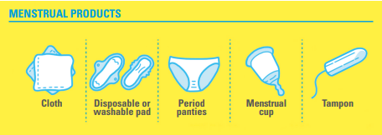

A tactile kit can be used to demonstrate how each product is utilized during menstruation. Alternatively, a simple demonstration can involve using women's underpants to illustrate the proper application of a sanitary pad.

**MENSTRUAL MANAGEMENT: A QUICK GUIDE FOR PARTICIPANTS**

**Facilitator to discuss**

1. **DON’T BE SHY TALK ABOUT IT:**
   * Carry a sanitary pad with you when you go out to school or elsewhere if you are expecting or having your period.
   * If you need a sanitary pad while you are at school, don’t feel shy to talk to your female teacher, they are used to being asked.
   * Don’t be embarrassed to talk to someone you trust about your periods like your parent/guardian, sister or school, or health professional. Every girl goes through it!
2. 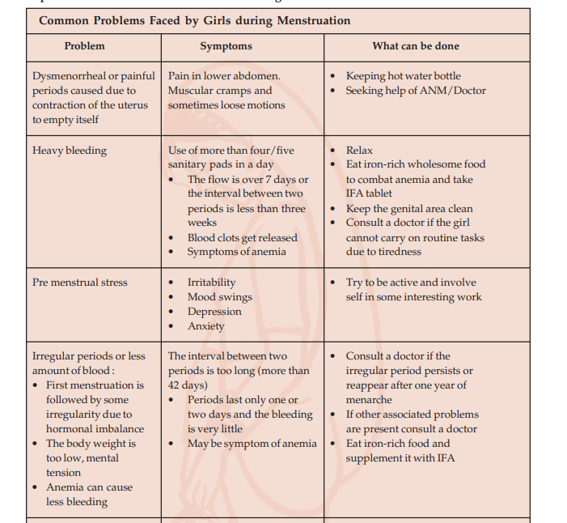**WHAT TO DO WHEN:**

**MENSTRUAL HYGIENE**

**The facilitator will initiate discussions and encourage participants to share their understanding of personal hygiene and why it is particularly crucial during menstruation. The facilitator to note down the participant’s inputs on the whiteboard/flip chart if available. After the participants are done giving their inputs, the facilitator to provide the missing points from the list below.**

* + Wash your private parts frequently (every time you go to the toilet) to reduce bad body odour and infections.
  + Bathe at least once a day so your body is clean and does not smell.
  + Pat dry private parts. Always wash or dry from front to back to avoid infections.
  + Use a deodorant or antiperspirant on your underarms to get rid of body odour.
  + Now that your body creates more oil, you may have to wash your hair more often and you will need to pay more attention to washing your face well and keeping your hands clean!
  + You may get more hair on your arms and legs and they may get thicker. You can choose to wax or shave.
  + Wear clean, washed clothes and underwear that are comfortable. Cotton underwear works well and is great for the skin.
  + Wash your hands regularly.
  + Change your sanitary pad regularly every 4 hours (or more if periods are heavy)
  + Dry your clothes in the sun to avoid fungal infections.
  + Changing pads infrequently or use of unclean pads can cause skin irritations and infections. If you get a rash or find your private parts are itchy, you should talk to a doctor or nurse.
  + Always dispose of the used pad hygienically.

**ACTIVITY:**

**Use of Menstrual Hygiene Kit Demonstrate how to use Menstrual Hygiene Kit**

1. Lay the menstrual items out on a table so the students can touch and feel them.
2. Using the Menstrual Hygiene Kit show the students some menstrual pads.
3. Let the children know that various sizes/types (large/Extra-large, with wings/without wings) are available and it is best to use the unscented ones.
4. Young girls should be taught about which is best to use.
5. Demonstrate using a small cup of water mixed with red food colour and how sanitary pads work by pouring the coloured water and watching as it absorbs the coloured water.
6. Use a sanitary pad and a pair of women’s underwear to demonstrate how to peel off the sticky strip on the back of the pad and show how it should be placed in the underwear. Also, show how to fix the side wings.
7. Demonstrate how to dispose of used/soiled materials properly. To do this, take toilet paper and a pad. Demonstrate how to fold a pad and then how to roll it in toilet paper/old newspaper/old or used envelope.
8. Then take your students into the restroom and show them (or see if they can show you) where to dispose the used pads. Discuss where they should dispose pads at home too.
9. Emphasize again that pads are never flushed in the toilet but should be thrown in the trash bin. If the students have difficulty in wrapping (or) rolling pad, use an old envelope to dispose the used/soiled pad.
10. Discuss how often to change pads (every 4-5 hours, or more often if needed) i.e., in case of over bleeding.
11. Reinforce the need to wash hands both before and after changing a pad.

**\*Touch and practical experience will help participants understand better**

**EATING HEALTHY**

* + Drinking plenty of clean water is important.
  + A good diet helps to make your periods more manageable.
  + You may experience mood changes and irritability. Learning how to relax and manage them is part of growing up.
    - Deep breathing can help us relax and feel better.
    - Daily stretching of our muscles help our bodies relax and reduces pain and bloating during periods.
    - Proper rest and sleep are essential for you to grow, be healthy and feel good.
    - If cramps are so severe that you are missing school or other activities, you could also see a doctor, who can help you manage your periods better.

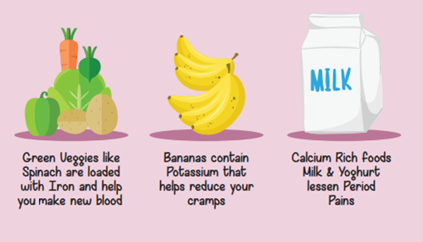

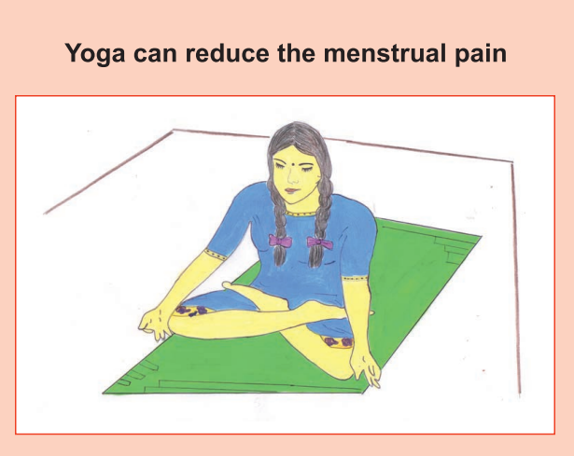

# D. UNDERSTANDING GENDER

## Gender Education

|  |  |  |
| --- | --- | --- |
| **Session 4: Activity 1**  **Gender Education** | **Objective**   * Identify gender role expectations and how they can limit life options. * Define the terms Sex and Gender. | **Issues/Information**   * Improved understanding of Gender. |
| Time: 60 mins | Material required: Flip charts | Posters, activities & Discussion |

1. **GENDER ROLES AND EXPECTATION**

STEP 1

Write the following two phrases, one per flipchart page.

|  |
| --- |
| In my culture, women must . . . .  In my culture, men must . . |

Ask the participants to return to their small groups and spend a few minutes brainstorming responses to the statements you have just written.

A note-taker in each group should note the responses on a piece of paper.

STEP 2

Ask each group to share its responses to the two statements. Capture the responses on the appropriate flipchart page. Discuss the activity using the following questions:

* What are your observations in comparing these two lists (men and women in my culture)? What do these lists show you?
* How do people view the characteristics/activities on the two lists?
* Do women and men have to be or do the things that you wrote down?
* Can women and men do things expected of the opposite sex? What are the consequences?
* How do these different roles, responsibilities, and expectations affect the life choices of women or men?

**Emphasize that both women and men are restricted in their behaviours, responsibilities, and life choices because of culturally assigned roles and stereotypes.**

STEP 3

Ask participants to spend a few minutes writing down responses to the following statement:

**As a human being, I want . . . .**

Have participants share their responses and, as they do so, create a master list on a flipchart page.

Ask the participants what they notice about this list.

Here are some possible responses:

• Freedom to pursue dreams

• Decision-making freedom

• Peace and justice

• The ability to be what I want to be

**NOTE TO THE FACILITATOR:** In the discussion, be sure to note that human beings want similar things and that these basic needs and wants are often unrelated to being male or female. Nevertheless, the social construction of gender has, in many societies, restricted women’s ability to achieve these basic human wants more than men. This is why it is often said that gender issues are human rights issues.

1. **DEFINING GENDER TERMS**

STEP 1

Ask the participants if they can define gender based on what they have learned so far. Write suggested definitions on a flipchart. Post the following definition and compare it to the participants’ definitions. Add any useful elements from the participants’ definitions that are not included.

**GENDER: *The socially constructed roles and responsibilities assigned to women and men in a given culture or location and the societal structures that support them. Gender is learned and changes over time.***

STEP 2

Explain each term to participants:

|  |  |
| --- | --- |
| SEX  Biological  Universal  Born with  Generally unchanging  Does not vary | GENDER  Socially constructed roles, responsibilities, behaviours  Cultural  Learned  Changes over time  Varies within and between cultures |

The completed Sex and Gender Chart includes examples, such as those shown below:

|  |  |
| --- | --- |
| **SEX**  **Biological** (vagina, penis, ovaries, uterus)  **Universal** (factors related to sex are the same around the world — men have penises and women have vaginas in every country)  **Born with**  **Generally unchanging** (factors related to sex are the same around the world — men have penises and women have vaginas in every country)  **Does not vary** | **GENDER**  **Socially constructed roles, responsibilities, behaviours**  **Cultural** (elements related to gender vary within and between cultures; the roles of men and women in America may be different from the roles of men and women in India)  **Learned** Behaviour  **Changes over time** (in the past, few women became lawyers or physicians; today it is very common to find women in these professions)  **Varies within and between cultures** |

**SEX AND GENDER**

The concepts of sex and gender may be defined as follows:

* Sex refers to the biological differences between men and women. These differences are generally universal and unchanging.
* Gender refers to the socially constructed roles and responsibilities of women and men in a given culture or location. These roles are influenced by perceptions and expectations arising from cultural, political, environmental, economic, social, and religious factors, as well as from custom, law, class, ethnicity, and individual or institutional biases.
* Gender attitudes and behaviours are learned and can be changed.

**Sex Role**

The only roles related to sex are those associated with reproduction; for example, women give birth and breastfeed, and men impregnate women with sperm.

**Gender Role**

Activities assigned to individuals on the basis of socially determined characteristics, such as stereotypes, ideologies, values, attitudes, beliefs, and practices. Gender roles are established through the influence of family, community, schools, religious institutions, culture/tradition/folklore/history, media, policies, peer groups, and the workplace.

**ACTIVITY: GENDER GAME**

Read the statement and ask participants to indicate if it is referring to ‘Sex’ or ‘Gender’

|  |  |  |
| --- | --- | --- |
| **Gender** | **Sex** | 1.Women give birth to babies, men don’t. |
|  |  | 2.Girls should be gentle; boys should be tough. |
|  |  | 3.Women and girls are caregivers globally. |
|  |  | 4.Women can breastfeed babies and men can bottle feed. |
|  |  | 5.Many women and girls do not make decisions, especially regarding couple relationships. |
|  |  | 6.Boys are more intelligent than girls in school. |

Answers: 1. Sex, 2. Gender, 3. Gender, 4. Sex, 5. Gender, 6. Gender

**Facilitator’s Tip:** *You can add more statements.

E. ADOLESCENT ISSUES

Adolescent Issues

|  |  |  |
| --- | --- | --- |
| **Session 4: Activity 2**  **Adolescent Issues** | **Objective**   * To identify certain issues faced during adolescents. | **Issues/Information**   * Improved understanding of emotional & physical constraints during adolescence. |
| Time: 90 mins | Material required: stationary/flipchart | Posters activities & Discussion |

* + - 1. **BODY IMAGE- I AM, I CAN & I HAVE**

STEP 1

Ask the participants to write or mention three things that they like about themselves and fill in the sentences below:

1. I like myself because or I AM_______________________

2. I’m an expert at or I CAN____________________________

3. I feel good about or I HAVE_________________________

STEP 2

Ask students, ‘What does the term “body image” mean to you?’ Answers will vary.

Put some ideas on the board. Build the class understanding of body image and factors that contribute to feelings of self-worth.

Next, ask students the following questions: ‘What does the term self-esteem mean to you?’

Self-esteem describes how you feel about yourself. It is related to self-image.

Why is self-esteem important? It has a major impact on many aspects of your life (school, making friends, managing disappointments, coping with stress, etc.)

1. Valuing ourselves and believing that others appreciate us and enjoy our company.

2. A positive attitude: accepting our strengths and our weaknesses, and avoiding three negative attitudes.

* Focus on your positive qualities, skills, and talents.
* Say positive things to yourself every day. (practicing affirmations puts this suggestion to use)
* Avoid negative or berating self-talk.
* Focus on appreciating and respecting what your body can do.
* Set positive, health-focused goals rather than weight loss-focused goals.
* Admire the beauty of others, but avoid comparing yourself to anyone else.
* Remind yourself that many media images are unrealistic and unattainable for the vast majority of people with the introduction of photoshop.

**KEY POINTS:** Remember that strengths are just like muscles. We need to keep exercising them to keep them strong. As we work together as a circle, let’s focus on recognizing our strengths and exercising them to make them stronger.

**ACTIVITY:**

**Pick the Orange** (5 minutes) Stretching Exercise

* Ask the girls to imagine a big orange tree.
* First, they will stretch with one hand all the way up to pick an orange and put it in their basket and then with the other hand.
* Each time they put the orange in their basket. Then they will reach all the way back and pick an orange from behind them. Then from the left. Then from the right.

*\*for participants with physical disability, this can be done while being seated.*

* + - 1. **PEER PRESSURE (30 mins)**

Facilitator **ASK:** What do we call it when we feel pressure from our friends or classmates to act or behave in a certain way? (Peer pressure)

**ASK:** What can some of these pressures be? (What to wear, how to behave, etc.)

**ASK:** How can girls manage or avoid peer pressure? (Saying no, find people who have similar interests to you and try not to judge others)

**ACTIVITY:**

Facilitator can decide the choice of presentation for group story telling/role play or just discussions. This role play can be on any one scenario shared in above discussions/responses.

Questions to ask/discuss

* What can a girl do in a similar situation? (What are the solutions?)
* Would the suggested solution work in real life?
* Is this a common situation in your communities?

**PROBLEM SOLVING: SUGGEST and SAY:**

Everyone has worries and problems in their lives. Some are big problems and some are smaller ones. We can learn to solve problems or conflicts as much as possible and to live positively with conflicts that we cannot solve. We learn and feel strong by looking at how we have solved problems in our lives before. We can use the same ways again for other problems. We can also imagine new ways to solve problems and put them into action. We can understand our problems better by looking at why they happen. We can then think of ways to avoid them.

**ACTIVITY:**

STEP 1

Separate participants into small groups. Ask them to brainstorm the type of problems that girls their age face. And ask them to present back to the group. Capture the themes across the groups and write down the key problems on the flip chart.

STEP 2

Ask participants how they would deal with such problems? They can answer anything.

Problem Solving Techniques:

List the tips the girls come up with on the flip chart board.

You can add:

* Identify the problem
* Focus on the problem, not the person
* Attack the problem, not the person
* Listen with an open mind
* Treat the other person’s feelings with respect
* Take responsibilities for your own actions.

**Facilitator’s Tips**: Take one example mentioned previously by the girls and give the tips above and link it to the example so that the girls are able to relate to the tips more practically.

**Tips for Dealing with Disagreements**:

* Respond, don’t react. If you keep your emotions under control you have a better chance of hearing what the other person is trying to say.
* Listen carefully without interrupting. Ask questions and wait for answers and listen to answers.
* Acknowledge the other person’s thoughts and feelings. You do not have to agree with the other person to acknowledge his or her feelings.
* Give respect to get respect. Treat people the way you would like to be treated if you were in the same situation.
* Communicate clearly and respectfully so your viewpoint can be understood.
* Look forward, not backward. Live in the present, plan the future, and do not dwell on the past.
* Stay focused on the topic at hand. Don’t expand an argument. If there are a number of issues, deal with them, one at a time.
* Conflicts don’t have to end with a winner and a loser. Try to find a solution that is acceptable to both parties.
  + - 1. **RELATIONSHIP WITH PARENTS AND CAREGIVERS**

**ACTIVITY 1:** WHAT ARE THE ISSUES: (20 minutes)

*When girls are growing up and going through many changes, this can affect the relationship they have with their parents. Facing new and difficult situations can also put pressure on these relationships.*

STEP 1

Split the girls into small groups and ask them to think about the following questions (they can put their answers down on a piece of flip chart paper).

1. What are the key issues girls face with their parents/caregivers?

2. What do you think are the key issues that parents/caregivers have with their daughters?

STEP 2

Ask the participants to present their answers back to the wider group and write down notes of the key themes that arise from the groups.

Facilitator SAYs: Sometimes the disagreements girls have with their parents/caregivers may not be their fault. Living in this specific situation, parents are under a lot of pressure and stress which may affect the way they treat their children. Let’s look at some of the things that we can do to help improve this relationship.

**ACTIVITY 2:** HOW TO TALK TO PARENTS

There are specific skills that you can use to improve the way you talk to your parents/caregivers. These are called the ‘convincing’ skills:

STEP 1

ASK participants what are some of the ways that you already use to communicate with your parents/caregivers?

Facilitator to write their ideas on the flip chart and include the following:

1. **Be prepared**: Know what you are asking for and think through the consequences of your request.
2. **Pick the right time:** When the situation at home is relaxed, check their mood and the way they feel, behaviour to see that they are ready to talk
3. **Be calm:** Present your topic calmly and with facts.
4. Listen to what your parents or guardians have to say: Consider their point of view and whether they might be right.
5. Use ‘I’ Statements:

There are a few tricks you can use to share your feelings well, both to your friends and family members. Use sentences that show how you feel or what you think, instead of using sentences that are blaming the other person. These sentences are about our own experiences and feelings. Which means you might say, “I feel sad because you told my secret to someone” instead of saying, “you are a bad friend for telling my secret”.

STEP 2

Ask if the girls have any questions about this and discuss and clarify. Use an example from the same group and go through the tips using this example. This will help girls to understand the tips in a practical way.

* + - 1. **CHOICES WE MAKE (DECISION-MAKING)**

**Smart Choices (20 minutes)**

Facilitator Says: Girls have to make many choices (decisions) every day. But sometimes it can be difficult to make some choices/decisions.

* I like to think of all of my options first.
* I sometimes ask people I trust for advice.

**ACTIVITY:**

STEP 1

Ask the girls to sit in a circle. Ask the following question and throw the ball around the circle until each girl has answered.

* What are some of the decisions that girls have to make every day? (e.g., what clothes to wear, whether to go to activities, what food to eat).

STEP 2

When the girls have finished, do the same thing with the following question:

* What are some of the decisions that parents, decision-makers, or older brothers or sisters might make for girls? How could this make girls feel?

Facilitator says that sometimes, girls might not have control over the decisions taken for them. For many important things in girls’ lives, parents, brothers, and other family members may make decisions for them.

Although girls may not always be successful, they can try to talk to their parents/family about some of these decisions that are being taken for them.

**Decision-Making Graph: (25 minutes)**

Show the girls the diagram of the Decision-Making Graph (see below).

Ask the girls to choose an example from the first activity about decisions made by parents/decision-makers.

Use this example and explain to girls how to use the Decision-Making Graph based on this example.

Use the information we learnt in ‘Talking to our Parents’ sessions to explain the graph.

**KEY POINTS:** We all make decisions, sometimes these can be the right decision for us or sometimes we can get it wrong. Although there is no way to always know if we are making the right or wrong decisions for us, we can at least think about how to make smart decisions. There are a number of steps to making a smart decision.

These include:

* List my options.
* Ask others for advice.
* Think about the “Pro’s and Con’s”

Write these steps on the flip chart.

Facilitator Explain to girls that ‘Pro means good things and ‘Con’ means bad things. You can explain Step 3 by saying: ‘Imagine what might happen if I made each decision. What bad things? What good things?’

ANNEXURE

#### ADDITIONAL RESOURCES









**MENSTRUAL MANAGEMENT: Additional Information**

**WHAT ARE THE PROBLEMS THAT A GIRL MAY ENCOUNTER DURING MENSTRUATION?**

* **Painful periods and Irregular Periods**: For the first few years of menstruation, cycles are irregular. They may be shorter (3 weeks) or longer (6 weeks). A young girl may even have only three or four periods a year. A girl’s cycles will usually become regular within two to three years of menarche (first occurrence of periods).
* **Heavy periods**: A heavy period is one which lasts longer than eight days, saturates the napkin within an hour or includes large clots of blood in the menstrual flow. This is common in adolescents because of slight imbalance in chemical hormones secreted by the body. However, if this happens regularly, it leaves the girl feeling exhausted; which means that the body is losing more blood than it is producing. The girl should then consult a doctor immediately.
* **Painful period**: Slight pain during periods is quite normal. This is due to a chemical called prostaglandins in larger quantities than normal. This leads to nausea, headaches, diarrhoea and severe cramps. Usually, this lasts only for a day or two.

**To get relief from these symptoms, a girl should try the following methods**:

* Fill a plastic bottle with hot water, wrap it in a towel and place it on the abdomen,
* Massage the abdomen
* Local remedies such as ginger tea can be taken
* **Premenstrual Syndrome (PMS):** This refers to a combination of physical and emotional symptoms experienced by all women during the menstrual cycle, usually just before bleeding begins.
  + - These symptoms include: Temporary weight gain and a feeling of heaviness due to accumulation of water in the body, headaches and cramps, painful or heavy feeling in the breasts, feelings of irritability.
    - These symptoms begin five to seven days before the period starts and disappear before the bleeding begins.
    - This can be managed with remedies for pain described above and eating a diet that is low in salt, and includes foods like leafy green vegetables and raw fruits and vegetables, which are low in sugar and high fibre.

**BREASTS**

* Girls start to grow breasts during puberty.
* Most girls start to grow breasts between the age of 9 and 16.
* Everyone is different.
* It is good to talk about growing breasts.
* This will help them to prepare for changes to their body.

**How breasts grow?**

At the start of puberty, girls will grow breast buds. These look like a small lump under the nipple. They can feel sore and hard to touch. As the breast bud grows, the nipples may stick out and the skin might feel itchy. This is OK.

It is a part of growing breasts. Breast buds can grow at different times. Girls might grow one breast bud and the second bud might grow a few months later. This is OK.

Girls might have one breast bigger than the other. This is OK too.

**When to start wearing a bra?**

People wear bras for different reasons.

* Some people start wearing a bra because their breasts move around when they run or play sports. This means that their breasts need some support.
* Wearing a bra can help to stop breasts feeling sore or uncomfortable.
* Some people choose to wear a bra when their nipples show through their clothes.

**PUTTING ON A BRA FOR BREASTS**

Use modelling.

Show your child how to put on a bra by putting it on yourself or a doll.

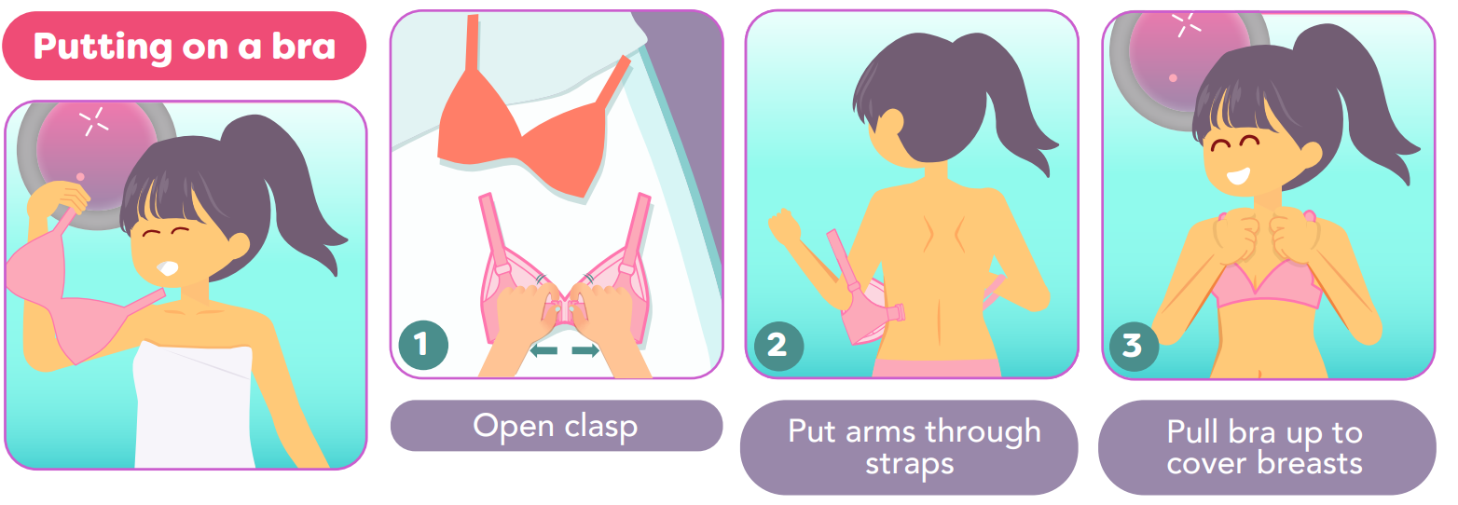

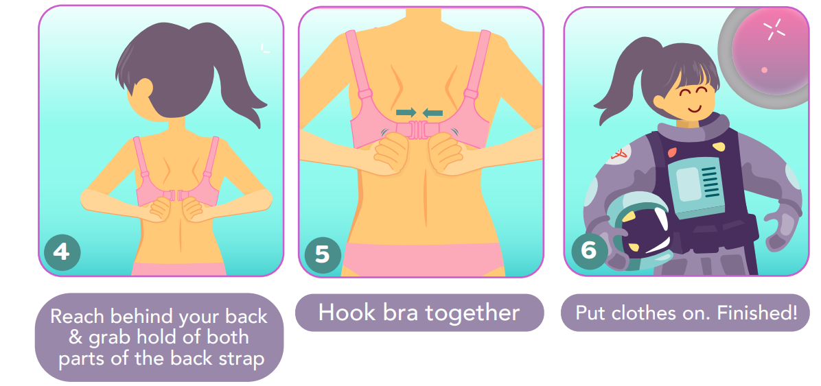

**RELATIONSHIPS**

* A relationship is when people know each other.
* People have different types of relationships with the people they live with, the people they work with, their family, their friends, their support workers and the people they do not know well.
* Usually, the closest relationship a person has is with their girlfriend or boyfriend, or husband or wife. Sometimes people call this person a partner.
* Some good things in a close relationship can be sharing, talking to each other, doing things together and helping each other. Close relationships can make people feel happy and good about themselves.

**TALKING ABOUT RELATIONSHIPS CAN BE HELPFUL**

Sometimes when a person wants to have a girlfriend or boyfriend but they do not have one, this can make them feel very sad. If a person feels sad about this, they should talk to someone they trust.

Some people do not know many other people. They may not have a girlfriend or boyfriend or a family. That is OK. Everyone is different. If a person wants to meet more people so that they can have more relationships, they should talk to someone they trust about how they could do this.

**Sometimes people in a relationship argue**

Sometimes people in a relationship do not agree with each other and they argue. It is normal for people to have arguments sometimes. Small arguments are OK when both people say sorry. Arguing can make people feel very sad, especially when they argue a lot. If this happens, they might decide that they do not like each other anymore, and then they end their relationship.

People can decide for themselves who they want to have a relationship with. It is OK for a person to end a relationship if they want to.

**Some people have more than one close relationship in their life**

People often have more than one close relationship in their life. Sometimes when two people are in a relationship, one of them decides to end the relationship. People often feel sad when a relationship ends. This is normal. Sometime later, one of the people might have another relationship with a different person. This is normal too.

Sometimes a person might want to be in a close relationship with another person who does not want to be their boyfriend or girlfriend. People can only be someone’s boyfriend or girlfriend if both people want this. A person should say ‘No’ if someone wants to be their girlfriend or boyfriend, but they do not want this.

**DIFFERENT TYPES OF RELATIONSHIPS**

**Shaking hands is OK if people do not know each other very well**

It is OK for people who work together to shake hands or wave to each other. It is OK for two people to shake hands or wave to each other if they have been introduced to each other by someone that they know.

**Close friends can hug**

It is OK for close friends to hug each other when they first meet or are saying goodbye. A person should always ask someone if it is OK before they touch or hug them and wait for them to say ‘Yes’.

**Family members can hug but they must not have sex**

It is OK for someone to hug and give a friendly kiss on the cheek to someone in their family if they both want to. It is not OK for a person to have sex or do sexy touching with someone in their family. If a family member tries to make another person in their family have sex with them, they should try to say ‘No’ and tell someone that they trust about what has happened.

**Kissing, touching and sex are OK in a close relationship**

It is OK for people in a close relationship to hold hands, hug, kiss and touch each other’s bodies if both people want to.

It is OK to have sex in a close relationship like a boyfriend, girlfriend, husband or wife if both people want to and the law says that both people are old enough (18 years and above)

What the law says about having sex.

It is against the law to have sex with someone who is under 18 years.

**Comprehensive Evaluation Tool- For Girls and Women with Deafblindness and Multiple Disabilities**

This assessment tool has been developed as per the **Kirkpatrick assessment model** and comprehensively evaluates learners' proficiency in applying, understanding, and recalling information covered during the training. This type of evaluation tool indicates a balanced approach to assessing participants' understanding and retention of the training content.

* **Recall:** This aspect of the model assesses the learners' ability to remember and recall specific information from the training. It assesses their memory retention and how well they can recall facts and details. In this questionnaire, **31%** of the questions are based on the ‘recall’ aspect of the model.
* **Understand:** This aspect focuses on assessing learners' comprehension and understanding of the material and goes beyond mere memorisation. This aspect also tests the comprehension level of the underlying principles and concepts covered in the training. It goes beyond rote memorization and assesses the depth of their knowledge. In this questionnaire, **37%** of the questions are based on the ‘understand’ aspect of the model.
* **Apply:** The "Apply" aspect of the model evaluates learners' ability to apply their knowledge and skills to real-world situations and assesses their capability to use what they have learned. This aspect talks about the ability of the participants to transfer their learning to relevant situations in their everyday lives. In this questionnaire, **32%** of the questions are based on the ‘apply’ aspect of the model.

**Overall Implications of this evaluation tool:**

The curriculum which this evaluation format assesses isn't focused only on memorizing facts, but also on understanding the main ideas and concepts. For parents, educators, and caregivers, it's not only about learning about sexuality education but also understanding why it's crucial for their child's growth and education.

The evaluation tool has been meticulously designed to measure a holistic understanding of the training material and how well the participants can apply what they learned in real-life situations. If the participants score 80% and above, especially in the "Understand & Apply" part, it means they're not just recalling information; rather, they can use it in different situations. This shows they truly grasp what the training is all about.

The emphasis is on practical skills—how they can use the knowledge gained during the program in everyday scenarios. So, success in this evaluation means they're not just absorbing the information; they can put it into action, demonstrating a comprehensive understanding of the training content.

**Note:**

* When giving this tool to participants, please provide the content without including the titles and additional details mentioned before each question.
* You're welcome to decrease the number of questions in the format. If you choose to reduce the questions, it is recommended to do so from the recall section.

**Q1- Introduction & Communication- Recall**

As a teacher or parent, why is it important to teach deafblind students and those with multiple disabilities about sex and relationships?

1. It contributes to their overall learning and well-being, helping them understand their bodies and feelings.
2. It’s not important, as it might be too much for them given their challenges.
3. We should focus on helping them adjust to society.
4. Tell them about it only if they ask; otherwise, let's avoid the topic.
5. There is no need for sex education, including for students with disabilities.

Bottom of Form

**Q2- Communication- Apply**

You are a teacher/parent of an adolescent, and your student/child approaches you with the question, "How are children born?" How would you respond?

1. Laugh and say, "we go and pick them up from the hospital."
2. Respond with discomfort, "We don't talk about those things; it's not appropriate."
3. Say “You will come to know when the time is right”.
4. Calmly explain to them the process of conception and pregnancy.
5. Ask them to just focus on their studies and not waste their time on such useless things.

**Q3- Behaviour change – Apply**

As a parent or a teacher, you are concerned that introducing the topic of sexual education to your child/student might make them sexually active. What is an appropriate course of action in this situation?

1. Avoid any discussions related to sexual education to prevent potential curiosity.
2. Educate yourself on the benefits of age-appropriate sexual education to address concerns and make informed decisions**.**
3. Assume that discussing sexual education will indeed lead to increased sexual activity and act accordingly.
4. Share your concerns with other parents and collectively decide to exclude sexual education from the curriculum.
5. Disregard the concerns and proceed with the sexual education discussions without considering potential consequences.

**Q4- Comprehensive Sexual Education - Recall**

At what age should sexual education ideally start?

1. 12 years old
2. 15 years old
3. 6 years old
4. 10 years old
5. 18 years old

**Q5- Comprehensive Sexual Education - Understand**

How is quality Reproductive and Sexual Health (RSH) education linked to the well-being of young people?

1. It leads to early sexual experiences.
2. It prevents unwanted pregnancy & sexually transmitted infections.
3. It increases vulnerability to exploitation.
4. It confuses young people about sexual health.
5. It has no impact on young people's well-being.

**Q6- Identifying body parts - Apply**

A child with multiple disabilities reacts negatively to a certain touch. As a caregiver, what should be your immediate response?

1. Ignore the reaction as it might be a sensory issue.
2. Assume the child is having a bad day and needs time alone.
3. Investigate the touch and, if inappropriate, address the issue sensitively.
4. Avoid discussing the matter, respecting the child's privacy.
5. Immediately report the incident to healthcare professionals.

**Q7- Identifying body parts - Understand**

Why is teaching the correct names of private body parts crucial for all children (irrespective of any disability)?

1. It is a cultural norm.
2. It helps in building language skills.
3. It is a legal requirement.
4. It empowers them to communicate accurately about their bodies.
5. It is essential only for older children.

**Q8- Talking about sex and sexuality - Apply**

As a teacher/parent of deafblind students/children, who have limited knowledge about periods and menstruation, you want to introduce this topic sensitively. What would be your approach?

1. Skip the topic entirely to avoid potential discomfort.
2. Use appropriate techniques & tools to explain the basic concepts of menstruation.
3. Ask a fellow student to explain it to them privately.
4. Organize a group discussion, hoping someone else will bring up the subject.
5. None of the above.

**Q9- Sex and sexuality education – Recall**

Which of the following is incorrect?

1. Sex education is all about teaching children how to have sex.
2. Sexual education develops the ability of children and young people to make satisfying, healthy and respectful choices.
3. Sex education is an ongoing and lifelong process, and it evolves with age and experience.
4. Sex education also includes information about contraception, sexually transmitted infections (STIs), and healthy relationships.
5. Sex education should include age-appropriate discussions and learning for children of different ages.

**Q10- Personal values about sexuality – Understand**

Why is it important for parents/teachers/caregivers to know their own feelings and thoughts about sex when talking to their children/students?

1. So children/students follow strict rules & restrictions about sex.
2. It allows for open and respectful discussions that respect personal beliefs.
3. To stop kids from forming their own ideas about sex.
4. It enforces a rigid approach to sexual education without flexibility.
5. It discourages discussions about sexuality, leaving children uninformed.

**Q11- Gender– Recall**

What does the term "gender" refer to?

1. Biological differences between men and women.
2. Socially constructed roles and responsibilities assigned to women and men.
3. Inherited physical traits from our parents.
4. Genetic factors influencing our physical features & behaviour.
5. Economic disparities between men & women.
6. Top of Form
7. Bottom of Form

**Q12- Gender– Understand**

Which of the following sentences is true?

1. Gender and gender biases limit both girls & boys.
2. Gender and sex are the same thing.
3. Gender roles impact only girls and women.
4. Gender differences are necessary for a harmonious society.
5. Gender stereotypes do not influence individuals and their behaviour.

**Q13- Gender– Understand**

From what you've learned from your family, culture, religion, and friends about how boys and girls should act, which statement best fits what you think?

1. Your ideas about how boys and girls should behave come mostly from your family.
2. Your beliefs about boys and girls are not influenced by your culture.
3. Religion is the main thing guiding your understanding of how boys and girls are different.
4. All of the above
5. None of the above.

**Q14- Consent – Recall**

When discussing consent with our children, it's important to emphasize that they should seek consent for various actions. Which of the following requires obtaining consent?

1. Touching another person’s body.
2. Buying vegetables from the market.
3. Taking a walk in the park.
4. All of the above.
5. None of the above.

**Q15- Consent – Apply**

Upon noticing a situation where one student is consistently touching another, despite the other student appearing uncomfortable, you decide to discuss consent with your students. What topics will you cover in your talk?

1. Discussing the importance of respecting personal boundaries and seeking consent before physical contact.
2. Exploring how cultural norms can influence our understanding of personal space and consent.
3. Providing strategies to foster open communication about boundaries and consent.
4. Addressing the potential consequences of not respecting someone's personal space and boundaries.
5. All of the above.

**Q16- Action Planning – Understand**

As a caregiver, you are advised to become a reliable support system for your child and their friends when addressing issues related to bodies, sex, romance, and relationships. What can be your suggested role in this scenario?

1. Isolate children from discussions about these topics.
2. Encourage children to rely solely on their best friends for advice.
3. Equip children with accurate and age-appropriate information, considering their understanding and needs.
4. Leave the responsibility entirely to health care professionals.
5. None of the above.

**Q17- Comprehensive Sexual Education – Understand (Extra Question)**

What is the responsibility of educators and parents concerning sexual education for children with disabilities?

1. Ignore the unique needs of children with disabilities.
2. Delegate the responsibility to healthcare professionals only.
3. Act only if requested by the child.
4. Ensure sexual education is part of every young person's journey, irrespective of any physical or intellectual disability.
5. Focus solely on the physical aspects of sexual education.

**Answer Key:**

1. A. 2. D. 3. B. 4. C. 5. B. 6. C.

7. d. 8. B. 9. A. 10. B. 11. B. 12. A.

13. e. 14. A. 15. e. 16. c. 17 d.

References/work-cited/ Bibliography:

* UNFPA. (2003). *Adolescent Reproductive Health Training Manual.* Copyright Secretariat of the Pacific Community.
* UNICEF. (2017). *Adolescent Girls Toolkit 2017* <https://www.unicef.org/media/73606/file/Adolescent-Girls-Toolkit-2017.pdf.pdf>
* Youthreach. (2009) *Planning for Life project 'Samriddhi': Adolescent Reproductive Health & Life Skills Training Manual and Curriculum*. Planning for Life: A Program of the International Youth Foundation and curriculum and aids developed by Thoughtshop Foundation, supported by USAID
* Norwegian Church Aid. (2022). *Comprehensive Sexuality Education (CSE) Toolkit*. Awiti, P., & Jura, C. (2022). *Title of the Report*. Edify Learning Forum Africa (ELFA) for Norwegian Church Aid. Retrieved from

<https://www.kirkensnodhjelp.no/globalassets/cse/comprehensive-sexuality-education-toolkit-trainers-manual.pdf>

* <https://www.unfpa.org/resources/adolescent-sexual-and-reproductive-health>
* <https://www.guttmacher.org/journals/ipsrh/2009/06/adolescent-sexual-and-reproductive-health-developing-countries-overview>
* <https://www.who.int/reproductivehealth/topics/adolescence/what-works-ASRHR/en/>
* "Tuko Pamoja: Adolescent reproductive health and life skills curriculum." Nairobi: PATH and Population Council, 2006.
* UNFPA. (2018). *Regional Comprehensive Sexuality Education Resource Package for Out-of-School Young People.*   
  [https://moldova.unfpa.org/sites/default/files/pub pdf/cse_facilitators_manual.pdf](https://moldova.unfpa.org/sites/default/files/pub%20pdf/cse_facilitators_manual.pdf)
* Y-PEER. (2020). SRHR Training Manual for Deaf and Hard of Hearing Young People- <https://ypeerap.org/wp-content/uploads/2021/09/SRHR2021.pdf>
* Ministry of Education and UNICEF.(2018). Growing Up Well for Girl <https://www.unicef.org/maldives/reports/growing-well-girls>
* Menstrual Hygiene Reading Material for ASHA NRHM. National Health Mission, Ministry of Health and Family Welfare, Government of India. <https://www.nhm.gov.in/images/pdf/programmes/mhs/Training_Materials/PDF_English/reading_material.pdf>
* National Institute for Empowerment of Persons with Intellectual Disabilities (NIEPID). (2022). Sexuality Education: A Pictorial Guide for Teaching Adolescents & Adults with Intellectual Disabilities. <https://niepid.nic.in/SE_PG.pdf>
* Plan International Kenya. (2019). Sexual Reproductive Health and Rights for Adolescents and Young People. <https://plan-international.org/uploads/sites/26/2022/07/srhr_training_manual_1st_oct_2019_plan_kenya.pdf>
* National Institute of Public Cooperation and Child Development (NIPCCD). (2011). Module on SABLA
* **Planet Puberty** is a digital resource suite by Family Planning NSW that aims to provide parents and carers of children with intellectual disability and/or autism spectrum disorder with the latest information, strategies and resources for supporting their child through puberty.
* Planet Puberty website and this is Funded by the Australian Government Department of Social Services. <https://www.planetpuberty.org.au>
* Menstrupedia videos <https://www.menstrupedia.com/>