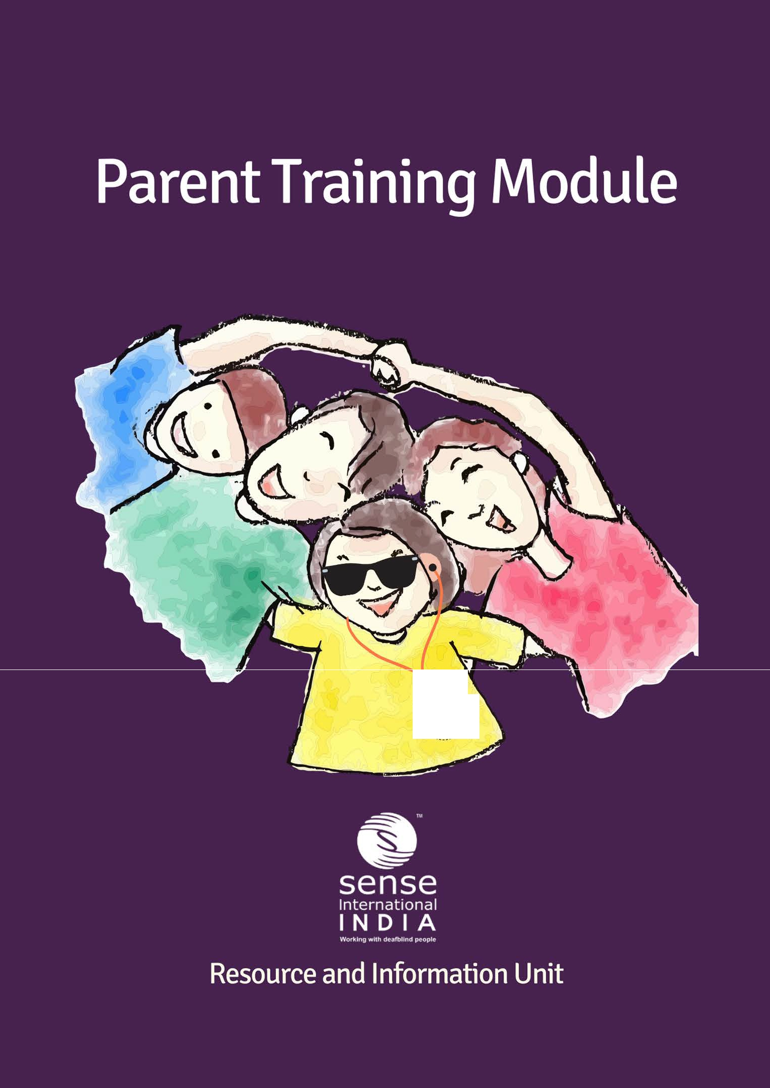

**PARENTING A CHILD WITH DEAFBLINDESS**



ISBN- 978-81-935361-2-4

Copyright© 2017

First published in India in 2017

This book is published, produced, and distributed by Sense International India. Sense International India

2nd Floor, Admin Block Andhajan Mandal Campus Vastrapur, Ahmedabad 380 015

Tele: +91 79 26301282

Website: [www.senseintindia.org](http://www.senseintindia.org/) Email: [info@senseintindia.org](mailto:info@senseintindia.org)

All Rights Reserved

No part of this book may be reproduced or used in any form or by any means (graphics, electronic, mechanical, photocopying, recording, taping, web distribution, information storage and retrieval systems or otherwise) without prior written permission of the publisher.

Printed in India

# ACKNOWLEDGEMENT

This Parent Training Module was possible with the support of professionals who have vast experience and deep knowledge in the field of deafblindness and have facilitated many trainings for parents of persons with deafblindness. We value all those individuals with deafblindness, parents, family members and educators who provided the opportunity for us to comprehend their needs and unique world. Without them we could not have this opportunity to develop this training manual. Our partner organizations in 23 states of India also graciously supported with photographs and information for this publication.

Foremost appreciation goes to the arduous efforts of Mr. Akhil Paul, Executive Director, SII, Mr. Uttam Kumar, Director Programmes and Mr. Sachin Rizal, Head- Capacity Building for developing content of the handbook and structuring the content into individual chapters. The chapters were systematically stringed into a life cycle approach of persons with deafblindness.

The bulk of credit for this module is due to the ungrudging efforts put in by the entire team of Sense International India and professionals in the field of deafblindness. Special mention goes to the contributions, creativity, and diligence of Ms. Dipti Karnad, Ms. Brahada Shanker, Mr. Deepak Krishna Sharma, Mr. Srinivasan P, Mr. Rashmikant Mishra and Dr. Atul Jaiswal. They have constantly reviewed the entire module by editing, adding, and compiling with never ending enthusiasm. We also appreciate the efforts of Mr. Kanishk Rastogi, Ms. Mousumi Mondal and Mr. Prashant Sharma for designing the art lay out of the module. We also recognize the effort of Ms. Sonia Gervasis for designing the cover page of the module.

With regards, Sense India team

Developing Literacy through functional activities. 79-82

* 1. Orientation and mobility concepts.................................................... 82-96
  2. Common teaching Strategies. 97-112

Module: 4 Importance of play in overall development. 113-124

* 1. Activities for Daily Living (ADL). 133-134
  2. Personal hygiene. 134-140
  3. Importance of balanced nutrition. 140-142
  4. Disturbed sleep patterns. 142-143
  5. Positioning. 143-149
  6. Social Skills. 149-150

**Module: 6 Needs and concerns of adolescents and**

**young adults with deafblindness........................................**

**151-167**

* 1. Understanding transition. 151-153
  2. Sex Education. 153-156
  3. Economic Independence and self-esteem. 157-165
  4. Independent living skills. 165-165
  5. Small savings. 165-167

**Module: 7 Acts and Schemes (Central and State). 168-195**

* 1. Legislation on Disabilities in India and National Awards. 168-182
  2. Disability Certificate. 182-186
  3. Schemes (Inclusive education, Girl child education, Life Insurance

Corporation of India, Government and Private sectors, Government 187-193

rules (GR), Pensions) ...........................................................................

* 1. Advocacy 193-194
  2. Networking and developing support system among parents. 194-195

## Module 1

**Understanding Children with Deafblindness**

**1.1 Area Crucial to Learning**

**1.1 (a)**

Parents want to help their child to learn the necessary skills for thinking and problem solving, regardless of how much vision or hearing is left with their children. Parents wish that their child should be able to use all the senses.

##### Vision/ Sight

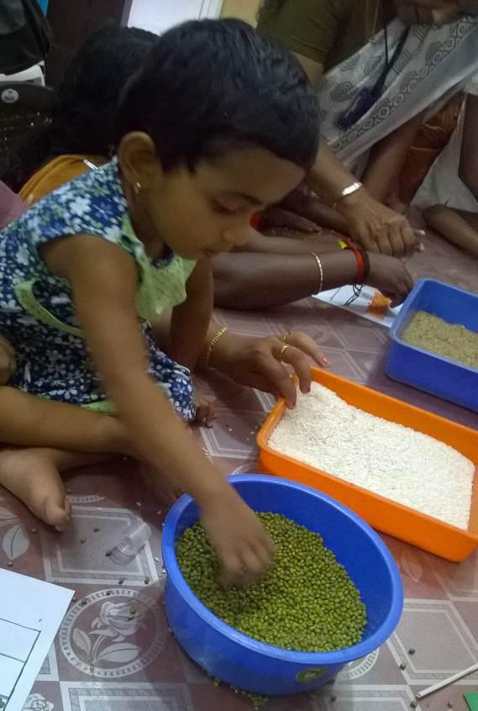The eyes are involved in ‘seeing’. They gather information from the environment, and the brain interprets and makes it ‘functional’. For example, walking straight on the give- end path or walkway, eyes collect the information, and brain interprets and guide body organs to function accordingly. Eyes of some

children may appear to be fine, but they may not be able to use it functionally, in an activity as shared in the above example. This is due to damage in particular part of the brain that controls vision or damage to the visual path- way that transmit the information from the eye to the brain. Thus, even though their ‘eyes’ as an organ are functioning well, these children may not be able to process or fully understand the information. Children who are visually impaired may have some residual/ usable vision. It is used for both gathering in- formation nearby (what can be seen and touched) and at a distance (beyond arm’s reach). (Source: Family Connect, (2017). Available online http://www.familyconnect.

org/info/multiple-disabilities/learning/us- Ing-the-senses/135)

##### Things to Remember:

If child has a visual impairment and additional disabilities, s/he needs to use all her/

his functional (remaining) senses—**hearing, touch, smell, and taste**—to get the in- formation about the world.

* Keep things in designated place; do not keep the materials or things cluttered, do not keep sharp edge furniture chairs, tables lest the child gets hurt.
* Provide safety and try to build confidence in your child in moving around in the

environment.

* Give opportunity to the child to explore his/her environment.
* Use real materials so that the child gets an opportunity to explore exact texture, smell and taste. Avoid plastic or wax materials which may appear as the real ma- trial but, it is not going to help the child who has deafblindness.

##### Hearing

When sight is absent, hearing does not replace it. However, hearing continues to pro- vide important information from the environment. Hearing Impairment can have a ma- jar impact on the development of speech and language along with overall physical development and growth.

Children also use their hearing as they listen to others talking. Through lip reading and observations they usually begin to understand and learn to use language. Therefore, it is important for parents and others to talk to the child. Parents must try to remember not to give him/her too many words.

(Source: Family Connect, (2017). Available online <http://www.familyconnect.org/info/> multiple-disabilities/learning/using-the-senses/135)

##### Things to Remember:

* Use as many visual aids as possible.
* Use speech, speak with a reasonable pace and volume.
* Always include them in common group/family conversation that helps them devel- op vocabulary and language.
* One person at a time should communicate with the child, or else the child gets confused.
* As far as possible keep the environment less noisy and echo free.

##### Touch

A girl child with deafblindness in adapted little
room
Touch is an extremely important sense for a child who has a visual impairment. Many children with deafblindness use touch as one of their primaries means for gathering information. Therefore, it is important to end-

courage the child with deafblindness to use their tactile senses and provide an opportune- Nity to enhance their tactile sense. Beginning in infancy, touching and exploring objects and feeling it would teach the child to explore the world. Parents can help their children to explore by using their own hands and guide-

Ing the child to reach out to new things in the environment.

*Figure 2: A girl child with deafblindness in adapted little*

*room*

*(Source: Family Connect, (2017). Available online* [*http://www.familyconnect.org/info/multi-*](http://www.familyconnect.org/info/multi-) *plea-disabilities/learning/using-the-senses/135)*

Some children with deafblindness may be “Tactile Defensive” which means they may be averse to other’s touch or touching objects, some of them might be “Tactile Seek- Ing” which means they may not show any discomfort on touching objects or persons. *(Source: Family Connect, (2017). Available online* [*http://www.familyconnect.org/info/multi-*](http://www.familyconnect.org/info/multi-) *plea-disabilities/learning/using-the-senses/135)*

Some children may like to touch soft things; some children may be defensive to new touch or that they may not like to touch hard objects. In such cases, there is need to observe what are they avoiding and how they are responding with defensive body language. They may show some sense of insecurity through cries, avoidance etc. For example, rather than asking the child to touch an object she/he has never touched before, begin with things that are familiar to them and introduce unfamiliar objects gradually over time. The use of the hand-under-hand technique is often effective in helping children become more comfortable with touch.

##### Things to Remember:

* Encourage the child with deafblindness to touch objects as a way of exploring the world, beginning of infancy.
* Train the child with deafblindness to overcome tactile defensiveness by beginning with things that are familiar to him/her and introduce unfamiliar objects gradually

over time, rather than asking the child to touch an object she/he has never touched before.

* The use of hand-under-hand technique i.e., you place your hand on the object and ask the child to keep his/her hand on yours. Then gradually withdraw your hand encouraging the child to touch and explore the object. This will be effective in helping the child become more comfortable with touch.
* Help the child to explore by using your own hands for guiding the child to reach out to new things in the environment.

##### Smell and Taste

Smell and taste are not often thought of as significant senses for gathering informationabouttheenvironment, buttheyareimportantforachildwithadeafblindnessand additional disabilities. Like vision, hearing, and touch, smell and taste can help the child in gathering information about the world. For example, the child may use the sense of smell when s/he is traveling to seek out clues in the environment to help him/her be more independent. S/he may know that to get to her/his favorite clothing store at the mall, s/he needs to walk straight from the entrance until s/he comes to the sweet shop, which s/he can identify by smell, and then turn right. The smell sense helps to identify the mall or shops which they want to visit.

Special educator helping a girl child with deafblindness to identify smell
 
 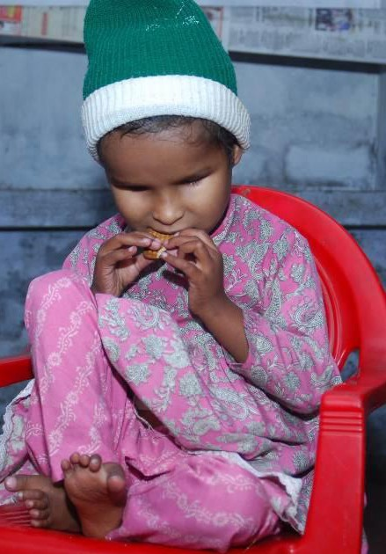

*Figure 3: Special educator helping a girl child with deafblindness to identify smell*

*Figure 4: A girl child with deafblindness sitting on chair eating biscuit using both hands*

The child can also use both smell and taste to identify foods. The parent might some- times find that the child is resistant to tasting new foods or having foods that have a certain kind of texture. Some children may like to eat semi solid food, some children may be defensive to eat solid food.

Before eating food, many a times children may use their sense of smell by putting their head down closer to the food.

*(Source: Family Connect, (2017). Available online* [*http://www.familyconnect.org/info/multi-*](http://www.familyconnect.org/info/multi-) *plea-disabilities/learning/using-the-senses/135)*

##### Things to Remember:

* Like vision, hearing, and touch, sense of smell and touch can also help the child with deafblindness in gathering information about the world.
* Child with deafblindness may use the sense of smell when he/she is traveling to seek out clues in the environment to help him/her be more independent. He/she may know that to get to his/her favorite samosas or jalebis at the sweet shop, he/ she needs to walk straight from the entrance until he/she comes to the sweet shop, which he/she can identify by smell, and then turn right.
* Expose the child to various smells to recognize places like the kitchen, bathroom, hospital etc.
* Let the child identify good smells like that of perfume, fruits, food flavors and odors like that of the hospital, toilet, fish market etc.

##### Vestibular system

The Vestibular System is responsible for our body balance and our sense of oriental- Tion in space. It provides information related to movement and head position. The vestibular sense is important for development of balance, coordination, eye control, attention, being secure with movement and some aspects of language development.

**Dysfunctions in the vestibular system can cause** -Anxiety, nausea, a need for self-stimulation, abnormalities in muscle tone etc.

##### Signs of Vestibular Dysfunction

Hypersensitivity to Movement (over-responsive):

* Avoids/dislikes playground equipment; i.e., swings, ladders, slides, or merry-go-rounds.
* Prefers to do tasks at one place which moves slowly and cautiously, avoids taking risks.
* Avoids/dislikes elevators and escalators; may prefer sit- ting.
* Prefers to take support of person or object.
* Fear of falling - even when there is no real risk of it.
* Afraid of getting down from the stairs and height.
* Fearful of feet leaving the ground.

##### Proprioceptive System

A young girl with
deafblindness sitting on swing


*Figure 5: A young girl with*

*deafblindness sitting on swing*

The proprioceptive system refers to components of muscles and joints. It gives information about the body position (posture) and joint position as well.

##### Signs of proprioceptive dysfunction:

Sensory Seeking Behaviors:

* Jumping, bumping, and crashing activities
* Stamps feet while walking
* Biting fingers
* Loves to be tightly wrapped in many or weighted blankets.
* Prefers to wear tight clothing (belts and shoelaces, heavy shoes)
* Enjoys bear hugs
* Excessive rocking movements of body

*References: Supporting and advocating for people with Sensory Processing Disorder. Re- thieved from* [*http://www.spdaustralia.com.au/the-vestibular-system*](http://www.spdaustralia.com.au/the-vestibular-system)

##### How does your child will learn to communicate?

All infants communicate to fulfil their needs, establish and sustain relationship. At the beginning, infant’s communications are unintentional and gradually it turns to intent- tonal communication hence, we have to learn to understand and respond to infant’s communication without fail. Especially when the baby is having deafblindness/MSI, we have to be more focused on bonding and trust in order to develop effective com- medication.

##### Remember each child with deafblindness/MSI is unique

* Your child is able to gather and understand information depends on the amount and type of residual vision and hearing he/she has, and how he/she learns to use in daily life. It also depends on the onset of deafblindness.
* The way of understanding and using sensory information differs from child to child.
* Children with total deafblindness depend on their tactile sense to explore and understand the world around them.
* Many children learn best through multisensory approach i.e., using a combination of vision, hearing, tactile etc.
* Children with residual sight and hearing may not always depend on either sight or hearing. It may vary according to the activity, environment, and materials used etc.
* We have to deeply observe the child in various environments and in different times to understand the way child uses its residual sight and hearing because, the child may respond well one day and may not give any responses for the same stimuli on the other day.

*(Source: Gleason (2008). Available online https://nationaldb.org/library/page/2062)*

##### Watch out for these cues (signs) if your child is communicating

* Her/his breathing may change when s/he hears familiar voices, like grandmother or grandfather’s voice, recognizing a familiar and beloved person in her/his life.
* As an indicator of like/want the child may open his/her mouth to have food as soon as the spoon touches his/her mouth.
* As an indicator of dislike/don’t want, the child may not open his/her mouth or turn head away as soon as the spoon touches his/her mouth.
* When you pause clapping hands, the child may reach out to your hands as an in- dictation of wants more/again. The same can be applied for rocking game and any other body games.
* When the child turns away or stiffens hands and body during the circle time/action songs/body games then it may indicate that the child is not interested in participate- Ing in the games. At this juncture we have to give a pause/change the game/move on to other activities.
* Establishing early “conversations” through daily routine and fun filled activities with

proper turn-taking, rhythm, pause and pace are necessary for the child.

*(Source: Gleason (2008). Available online https://nationaldb.org/library/page/2062)*

##### Communicating does not mean only speaking, it could mean the way in which a child with deafblindness expresses his/her wants and feelings known to you. You must be aware of these signals and respond quickly.

**To develop good communication, you must:**

* Develop a close and trusting relationship with your child by holding him/her close to you to make him/her feel safe and secure. Thus he/she will learn that there are caring people around him/her and that he/she is not alone.
* Use consistent daily routines in which your child is fully involved like brushing, bathing, eating, going out, sleeping, according to a routine so that he/she can ex- pact the order in which activities will take place.
* Provide your child with cues so he or she can learn to anticipate what is going to happen, like- handing over a small mug when there is a need to use the toilet, bringing a plate (thali) and bowl (Katori)/spoon for lunch, mat/pillow for bed time.
* Give your child opportunities to have some control over his or her environment. Allow him/her to explore the outside world by handling different kind of textures, having various movement experiences like going on a swing, walking in the gar- denning, visiting grandparents, going for a wedding etc.
* Allow your child to have a need to communicate. Let him/her feels hungry and then feed the food, note the signals he/she gives. Feeding at a regular time is good for the parent but your child will never have an opportunity to ask for food.
* Join your child in play and be a child when you do so.
* Play simple turn-taking games together, which, through daily repetition, a child may learn to recognize and this will encourage your child to tolerate touch and handling. This way he/ she will begin to demonstrate enjoyment during interactions.

The following suggestions may be helpful when you and your child learn to commune- cate together:

**Special Greeting** - Always greet your child with a special “hello”, e.g., Vijay is a boy with deafblindness, whenever his teacher meets him, he touches on his left side just above the chest with his two fingers making the “V” hand shape with little extra pressure. Through this unique greeting, Vijay immediately recognizes his teacher and happily extends his hands for a “hand-shake”.

**Object of reference –** All the family members, teachers who interacts with the child with deafblindness should have their own object of reference through which the child will recognize the person. It could be a ring, wrist watch, hair band, wrist band, hair clip etc., but the object should be unique from others and it should be consistent.

**Establish predictable routines with clear beginnings and ends -** Children carry out many activities in their everyday routine, we have to consider activities such as eating, dressing, bathing, and playing and plan how you can let your child anticipate what will happen, when it will start, where it will take place and when it will end.

We have to have an individualized symbol or object and materials for each and every activity so that the child may associate the activity with that special object. Ex. When- ever the morning prayer is over Arihant (boy) will be given sign for “Yoga”, he straight- away goes to the place where the mat is kept and brings to the place where the activity is performed, spreads the mat and gets ready for “Yoga”. The activity “Yoga” always comes after the morning prayer, same mat is used and it happen in the same place, Arihant leant this just because of predictable routines with clear beginnings and ends.

**Involve your child in the whole activity -** In order to have a good concept develop- mint we have to involve the child in the whole activity. It is very much important for the child to learn the sequences of any activity. The child with deafblindness should physically participate from the beginning till the end of the activity. For example, at mealtime, you and your child wash your hands together, go to the kitchen together, reach for the shelf, pick up a thali, Katori and spoon, go to the pot of rice, spoon it into the plate (thali), ladle out the pulses (deal) into the bowl (Katori) and place the vegetable (sabia) on the plate (thali). Then, go to the table or sit on a low stool in the kitchen where the whole family eats. At the beginning of a meal, your child may touch his /her bib. It will be better if you help him/ her before putting it on, and when s/he is finished eating he /she can help take off his/her bib. After the meal, bring the used dishes to the washing place /sink together and turn on the water to scrub with scrub- beer and rinse them. Throughout the activity, you must offer your child simple signs (hungry, eat, drink, finished, wash).

**Choices Making –** Children with deafblindness should be given opportunity to make their choices in all the activities that takes place in their everyday life. Kiran a child with deaf- blindness likes recreational activities very much, his teacher always gives him the choice like Ball or Swing? Priya, likes a lot to go for outing. Mother never misses to give her choices to her like - Frock or Pant, Shoes or Sandals, Park or Beach, Car or Scooter Etc.

If the child is totally deafblind then we may need to make the choices concrete and allow the child to touch and explore. In case the child has some residual vision then understand the field of vision, the distance at which the child can see the object, how much light is required in the room etc., all these small things need to be paid attention in order to help the child to explore the options and make choices.

**Remember to offer pauses –** Each child has its own pace of understanding the Infor- motion that they receive through various senses and they may take time to respond as well. It is our responsibility to give enough time to the child to receive and respond. If we do not give required time to the child then they might give up trying or avoid the activity. So, one should always learn to respect the child’s pace and follow their lead.

When a question is asked or choice is given to the child with deafblindness, it is nec- Essary that we allow the child to take its own time and pace to understand what we are trying to communicate. Facilitate the child to give responses in case the child has any physical limitations. If the child has a toy, but he/she is having difficulty in lifting it up, then facilitate the child to hold the toy and lift it with appropriate techniques/ support.

**Cues–** Cues are made using body movements, breathing, vocalization, head nodding, eye blinking etc., without using any words. The child may use various cues to communicate with us to say what they like or don’t like, want more or enough, I am happy or not happy, boring or interesting etc. It is our responsibility to understand the cues made by the child and respond accordingly to develop further communicate- Tion skills. Suppose the cues are ignored or unnoticed the child may stop doing so. Hence, we have to focus on subtle cues made by the child and nurture communication skills.

**When to introduce cues–** Cues should be given just before starting the activity, it should be simple, consistent and respectful. It should also be comprehensible applied by the child with deafblindness. To let the child know it is meal time, for example, you might touch the lip of your child with hand making the shape/ sign like eating food, guide the child to wear the bib or spread the towel/mat on the table/floor, let the child smell the food, allowing the child to touch the food on his/ her own. This way the child will learn to anticipate familiar activities. This will lead his/her world to be little bit pre- datable and interesting and he/she will develop a trusting relationship with the people who cares for him/her.

##### How to interpret cues?

* If the child turns away his/her head or body - “I don’t like or don/t want anymore”
* Leaning back, - “stop”, “Don’t force anymore”
* Stiffening, worried, crying, withdrawing, - “don’t like what you are doing”
* Engaging in self-stimulatory behavior such as head waving or eye poking, closing eyes or mouth, - “leave me alone”
* Shifting attention to another object or activity (pulling on a blanket, sucking on fin- Gers, etc.). – “want to do something else”/ “I’ve had enough and now I need a break”
* Hitting, scratching, biting self and others – “I am angry, don’t disturb me”

Reading these cues and responding appropriately is a very important part of early interactions.

**Hand under Hand –** This strategy helps a lot for a child with deafblindness to accept and explore things without fear. Child with deafblindness may feel uncomfortable and have weird feeling while touching unfamiliar things. Some children may have tactile defensiveness or fear towards certain textures and materials. At this juncture, if we use hand under hand strategy i.e., our hands should be under the palm of the child, we will be touching/exploring the materials first and the child hands will just rest over ours, still there are chances for the child to touch the materials unintentionally. Gradually, the support of our hands can be withdrawn for the child to get an opportunity to touch or explore things/ objects. This strategy will also help the child to develop understand- Ing for tactile sign language. This method also makes the child to understand that other person is also getting the same experience.

Whereas, if we use Hand over Hand strategy it is like blocking the child’s eyes and ears with our hands. For example- If Hoh technique is applied before the child’s un- Der standing of the actual concept of exploring things, then they may get frighten. To the child the object’s touch may be something new and child may not like that. To overcome that issue, Huhn is better to start with in the beginning. For a child with deaf- blindness his/her hands are the eyes and ears. Many children will have fear over this method especially at the early age and when opportunities are given to explore new materials.

**Follow the child / Coactive play –** At the early age instead of making the child to fool- low you or do what you want the child to do, you have to take the lead from the child. Whatever material the child likes and plays with it you just repeat the same action which the child does with that material. It should be done with turn-taking, it could be even the favorite action or body movement of the child. Make the child realize that you are following him/her, you are interested in the way or action done by the child, this will build trust and bonding well.

You can join him/her in play as you invent a turn-taking game: Example: first, he/she bangs on the toy drum, then you take a turn and pause and wait for him/him to repeat his/her turn. By joining your child in a movement or activity he /she likes, by following your child’s lead, and by imitating your child’s movements and/or sounds, you and your child can share many enjoyable “conversation.”

**Encourage use of all sensory information -** Help your child with deafblindness or MSI learn to use their residual vision and hearing for functional activities and to interpret the limited sights and sounds that are available. Approach your child gently to let him/her know you’re available for interaction; do not “surprise” him/her with un- expected or abrupt touches or sounds. Attend to and imitate any actions and sounds; invite him/her to take another turn; let him/her know you share his/her interests. Offer consistent touch and object cues to signal at the beginning of an activity and use movement and body contact during your interactions.

**Least Restrictive Environment –** The place where the child with deafblindness lives should be least restrictive and should encourage learning, communication, movement etc. The place should be clutter free, should have enough lighting and ventilation. Materials around should have good contrast so that will enhance the use of residual vision. The materials should keep at the level where the child can reach. The materials used and the objects around should be free from injuring the child, this will make the child to have an interaction with the surroundings. Moving or rearranging things often will confuse the child and hinder to have orientation, hence things should be kept in the same place, if you have to move the things then do it along with the child.

**Arousal Levels –** Many children with deafblindness may have different tolerance level to different stimuli in immediate environment. Some children may not tolerate more than one or two sensory stimulations at once. Khushi is two and a half years old child with deafblindness, whenever her mother takes her to the sensory therapy room she falls sleep soon. Observations made and found that when giving visual stimulation mother keep on talking with the child and also the child was placed in the mother’s lap, she gets sensory inputs through vision, hearing and tactile all at once. From next class onwards Khushi was made lie down and no hearing inputs were given while doing visual stimulation. Now, Khushi could tolerate and was awake for the whole session.

**Expose your child to develop their language skills–** Many parents stop teaching or don’t go beyond basic communication due to lack of knowledge to develop language skills for children with deafblindness. Whereas child with sight and hearing get the opportunities to make use of his/her vision and hearing and hears a lot of verbal cons- versations well before they learn to talk. Likewise, a young child with deafblindness or MSI needs to be involved in an environment that is rich in all forms of communication. This may include words, signs, gestures, touch cues, object cues, movement cues, contextual cues, visual and/or auditory cues. Find out the best and suitable form in which your child can learn language skills. It is important to expose the youngest

infant to sign language. When you use object cues, combine them with simple signs.

As you respond to your child’s communications, offer him/her simple signs.

Playing games is much more than mere play. Through play, your child can learn a great deal:

* Trust and anticipation that certain things will always occur
* How to make things happen
* Ways to ask for help, ask for more, ask to be done
* The power of making choices
* Better understanding of the world
* Communication in its many different forms

*(Source: Gleason (2008). Available online https://nationaldb.org/library/page/2062)*

#### 1.1 (b)

##### Social relationships

A social relationship refers to a relationship between two people, three people or more than one individual. Social relations are derived from individuals and form the basis of a social structure. The relationship includes relationships between the child, parents, grandparents, siblings, peers and friends. For a sighted child the mutual smile between infant and mother is the beginning of attachment, recognition, and commune- cation.

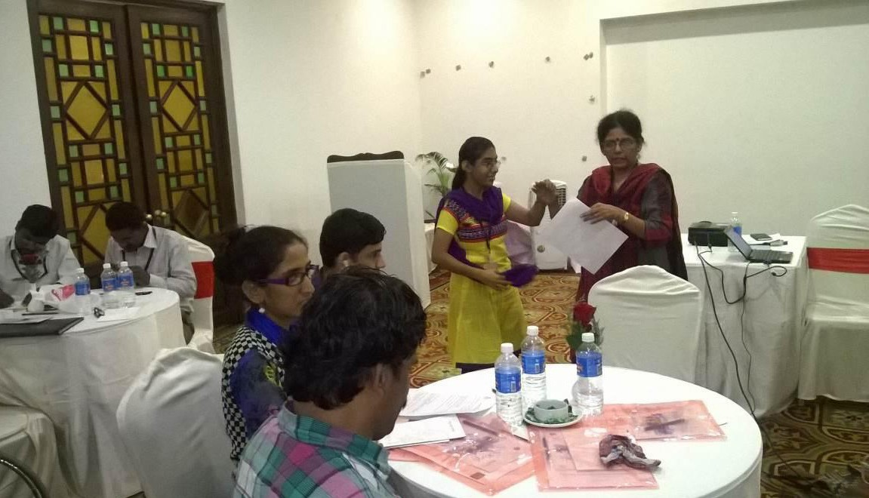

*Figure 6: A girl with deafblindness introducing herself in a meeting*

Social relationship also provides opportunities to discuss feelings, expand thought processes & knowledge, and experiment with language and social roles.

**Challenges faced by children with deafblindness in developing social relationship** 95% of what we learn about the world comes from what we see and hear around us. When both these senses are affected, it makes a deafblind child very vulnerable. It becomes very difficult for the child to make sense of the people and things around him/ her.

Due to limited vision and hearing these children face problem in communication (not able to com- muricate with the family members, siblings). Children with deafblindness are not able to hear people speaking, observe facial expressions and body language. Mobility is restricted due to loss of vision and hearing and they become isolated. Social interaction becomes limited. The parents need to involve the child in as much activities as possible in their day-to-day life.

##### How can we develop social relationship in deafblind children?

Parents should develop bonding with young child- Dren by playing body games like clapping games, tickling games etc. Personal identifiers can be used, for example the mother wearing a particular bangle always and making the child touch it each time she goes near him/ her. The child will learn to relate the mother with that bangle.

A deafblind child needs his/her parents, siblings, grandparents, uncles and aunts to love him/her and give him/her time.

A deafblind child will enjoy in learning things which other children do or learn at his/her age. However, the deafblind child may need a little bit more time or support to do it.

A boy with deafblindness learning fine
motor skills


*Figure 7: A boy with deafblindness learning fine*

*motor skills*

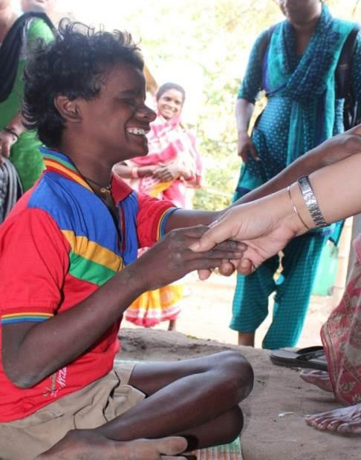

*Figure 8: A boy with deafblindness shakes hand with a person*

*Reference; Social networking service, From Wikipedia, the free encyclopedia*

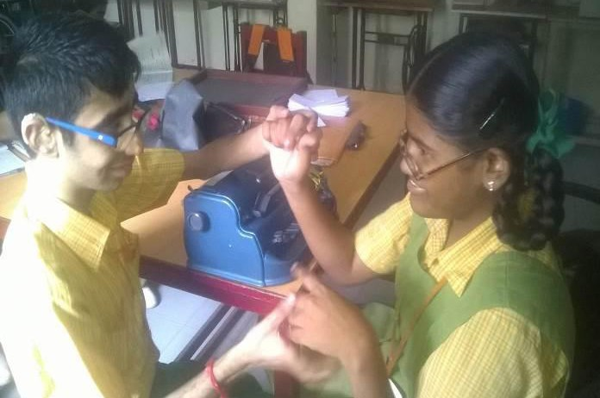 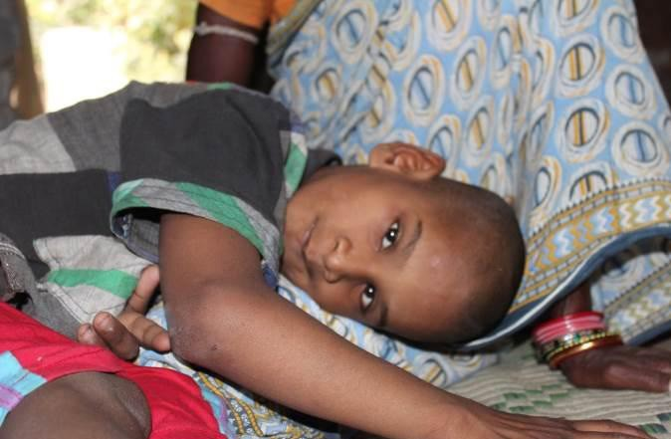

*Figure 9: Two deafblind adults interacting in tactile sign language*

*Figure 10: A boy with deafblindness sleeping in his mother’s lap*

The other family members may help the child in during the learn- Ing process. Peers can make a huge impact on the lives of children with deafblindness.

#### 1.1 (c)

##### Cognition

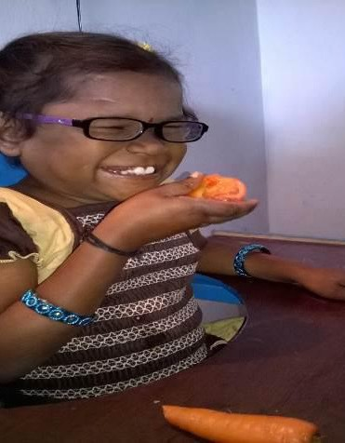The term cognition means to know, to understand things and to get the concepts, to recognize etc. For children with deafblindness, one of the most challenging areas of learning is concept development. As 95% of what we learn about the world comes from what we see and hear; with both the senses affected it makes difficult for the child to understand and conceptualize things.

##### How concept development is delayed in children with deafblindness?

Some children with deafblindness may not have cognitive delay, but may have problems in learning if the opportunity for interactive environment is not provided from the beginning of their childhood or age of onset. Some children with deafblindness may also have additional disabilities which may increase the level of difficulty in over concept development of the child. Concepts can be divided into three categories:

1. **Concrete concepts:** Concrete, which means existing, real or materials (like tables, chairs etc.).

*Figure 11: A young girl with deafblindness smelling the fruit*

1. **Semi concrete concepts:** This is more related to action which can be shown through demonstration (moving, skipping, walking etc.)
2. **Abstract concepts:** This is more related to feelings and emotions that cannot be seen but could be felt (happy, love, sad, angry etc.).

Each child with deafblindness and/or MSI develops his/her own unique concepts based on his/her personal experiences. Here are some ideas that make sense from the perspective of the persons with deafblindness who had them, but that might seem

“odd” to someone with sight and hearing:

* 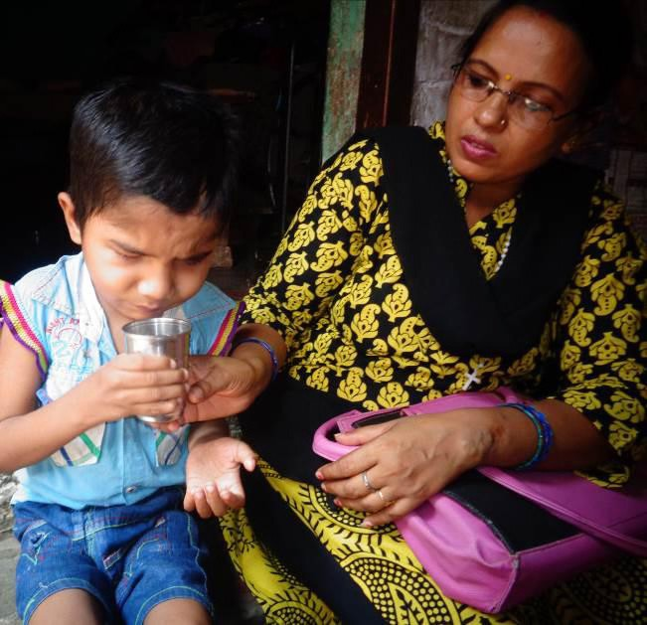Tinu thought “going to school” meant the shaking of the auto rickshaw and a long time spent in it before it stopped and he got out and whenever he went in an auto rickshaw, he thought he was going to school.
* A girl touched a wet leaf and signed “cry” (it felt like tears)
* A girl did not know that vegetables came from the market before they went into the fridge as she was never received any kind of prior information or an opportunity to ex- patience and learn about the situation.

Each of these examples teaches us how important it is to understand child’s perspective and becoming sensitive towards providing appropriate information in their day-to-day life. This may help them to change them

*Figure 12: A boy with deafblindness is learning to drink with a glass*

perception and understanding about the world around them and bring new dimensions in the concept and give shape to it. We need to continually ask, “What idea might she have or be developing about this experience, object, person, or place?” If we want to help a child develop meaningful concepts, we must be willing to enter into a relationship and seek to understand the child’s concepts. Most importantly, we must take the responsibility of providing experiences that will maximize the child’s opportunities to develop useful and meaningful concepts of the world. Children who lack sight and hearing or who have significant impairments in these senses need to be consciously given continual access to the world and the society around them.

#### (d)

##### Concept of self and body Image:

**Objects exist:** Children with deafblindness have difficulty in learning or knowing that

object exist as they are not able to see and hear.

**Object permanence:** Since there is a loss of sight and hearing the information which is there in the environment has to be explored with other remaining senses. Apart from sight and hearing, touch is another sense which helps a child with deafblindness to receive the information from the outside world. The reach of deafblind child is limited

up to their fingertips only. Therefore, it becomes very difficult for them to understand that the object is permanent (e.g. the ball which the child has thrown while playing has rolled away from his/her reach even though the ball is few centimeters away but for a deafblind child it is out of the reach or not being there).

**Objects are different from one another:** There is difference between food item and

play materials.

**Object has name:** As the deafblind children do not see and hear they do not know that the object has names.

**Cause and effect:** As the vision is required to observe what is happening around us “what happens and when” e.g. when we put on the switch the fan starts.

**Lack of visual memory and visual imagery:** Children with deafblindness who are blind by birth do not have the visual imagination hence they mostly lack the concept of colors, environs and visuals like mountains, sea, sky etc. The children who acquire visual impairment at a later stage of their lives may have visual memories of all that they might have actually seen over the years when they had vision. Hence this often forms the basis for formal reasoning. The other senses do not provide the information about the world the way vision does however, children with visual impairment do have their own ways to create their world, and develop intelligence.

#### Development of concepts in children with deafblindness

Concepts should be developed around familiar routines and activities that are mean- infula to the child.

When sight and hearing of a child are impaired, s/he gets the concept of things around him/her through touch, like doing activities by hand over hand or hand under hand techniques. Concept development can also be encouraged by assisting a child with providing necessary support / help or making the child move in his/her environment and allowing the child to explore as much as possible. It is very important for the child to feel the things around him/her to understand the concept. Therefore, the caregiver needs to encourage the child to explore through touch and locate where things are kept. The child can try to get them from the specific location when required e.g. toys may be kept in a cupboard or a specific place in a cupboard, box, table, drawer etc.

#### Myth and Facts about Deafblindness

Myths are attitudinal barriers that interface with the ability of person with deafblindness to have equality. These barriers usually result from a lack of experience and interaction of persons with disabilities. Listed below are some common myths about people with disabilities and their true facts.

**MYTH:** A deafblind person is sick, or there is something wrong with them.

**FACT:** Deafblindness is a condition and it is not the same as being sick. Mistaking a deafblind for sickness not only fails to respond to a person’s needs, it perpetuates a negative stereotype and an assumption that the person can and should be cured.

**MYTH:** People with deafblindness have a poor quality of life.

**FACT:** This is one of the most common and damaging stereotypes, because it discs our- ages social interactions and the development of mature relationship. Social handicaps individuals by building inaccessible schools, theatres, homes, buses, etc. The attitude that deafblindness is a bad thing and that deafblindness means a poor quality of life is often viewed as more disabling than the disability itself.

**MYTH:** People with deafblindness are inspirational, brave, and courageous for living successfully with their disability.

**FACT:** A person with deafblindness is simply carrying out normal activity of living when they drive to work, go shopping, pay their bill, or compete in athletic events. Access to community based, pay their bills, or such as attendance care, access to buildings, public transportation, sidewalks, etc. access to quality health care, and necessary equipment that enables them to carry on the same as non-disabled people.

**MYTH:** People with deafblindness do not have sexual needs.

**FACT:** People with deafblindness do have normal physiological and sexual needs.

**MYTH:** People with deafblindness have high sexual desires

**FACT:** People with deafblindness have similar sexual needs as their nondisabled peers.

**MYTH:** People with deafblindness always need expensive and high-tech assistive device or services.

**FACT:** Simple inexpensive device is recommended in helping people with deafblind- ness to live independently. Assistive device can be as affordable as an eating utensil or Velcro strap.

**MYTH:** People with severe deafblindness have to live in nursing home or rehabilitation hospitals or under constant supervision so that they do not hurt themselves.

**FACT:** Unfortunately, this myth has created a system of long-term care in our mind that relies on institutions such as nursing homes and other facilities. Even those with the most severe deafblindness could live in their own home given adequate community-based service, and at the very least, they should be given that choice.

**MYTH:** People with deafblindness feel more comfortable around other people with disabilities or deafblindness.

**FACT:** This myth has arisen from the many years of segregated learning and living environment. Years ago, it was common to see people with deafblindness grouped together. This is no longer the case.

**MYTH:** People who are blind and deafblind have a sixth sense.

**FACT:** Although most people with blindness and deafblindness develop their remain- Ing senses more highly than other but they do not have a sixth sense.

**MYTH:** People with deafblindness need to be protected from failing in life.

**FACT:** People with deafblindness have right to participate in the full range of human experience including success and failure.

**MYTH:** People with deafblindness do not have goals in their life.

**FACT:** People with deafblindness do have goals.

**MYTH:** People with deafblindness have problem getting around.

**FACT:** People with deafblindness know what they need to get from Point A to B and may use a sighted guide, walker, wheelchair (i.e., if persons with deafblindness are having an additional disabilities) vehicle to reach the destination. Problem only arises when architectural or attitudinal barriers get in the way.

**MYTH:** People with deafblindness are usually very sedate and unable to participate in recreational activities.

**FACT:** People with deafblindness lead diverse lives and take part in any sport or hob- by you can think of including: mountain climbing, dancing, horseback riding, racing, snow skiing etc.

##### Defying stereotypes: the way forward

Persons with deafblindness should be shown as an ordinary part of life in all forms of

representation, not as stereotypes or invisible.

* Avoid depicting persons with deafblindness as always receiving. Show them as equals, giving as well as receiving.
* Avoid presenting physical and mental characteristics as determining personality.
* Refrain from depicting persons with deafblindness as objects of curiosity. Make them ordinary. The dual sensory impairments should not be ridiculed or made the butt of jokes.
* Avoid sensationalizing, especially as victims or perpetrators of violence.
* Refrain from endowing with superhuman attributes.
* Avoid showing persons with deafblindness as non-sexual. Show them in Lov- Ing relationship and expression the same range of sexual needs and desire as sighted-hearing people.
* Show them as an ordinary part of life in all forms of representation.

#### Parental attitudes towards children with deafblindness

1. Accepting the child
2. Learning to deal with their own emotions
3. Prevent labelling
4. Preventing isolation
5. Encouraging healthy bonding and attachment
6. Encouraging a positive self-concept/self esteem
7. Creating a learning environment (motivating the Child)
8. Keeping learned helplessness away
   * Parental Motivation
   * Parents’ perception of safety
   * Learned helplessness

It has been said that the parents of children with deafblindness and other disabilities experience prolonged stress. Having a child with disabilities affects not only the par- ents, but also siblings and their relationships.

The family members have great plans for and expectations from their children; they look forward to watching their children take their first steps, speak their first word, go to school and college. When some of these expectations are not fulfilled, initially parents’ reaction is that of shock and disappointment, they often get emotionally disturbed and sometimes may also restrict themselves from the outside world.

##### Stages of coping

**Guilt:** While some parents have a sense of guilt “why did this happen to me “, others feel guilty about having reacted this way. Sometimes parents who are in this stage tend to blame self or their spouse for the birth of such a child. They may be ashamed to have a child with a disability. Many may feel guilt and will believe that their ‘Karma’ or sins of the past has led to the punishment in the form of a child with a disability.

**Denial:** This is the second common reaction of parents when they are told that their child is disabled; the extreme form of denial is not to admit that one’s child is in any way different from the other ‘normal’ sighted-hearing children. They believe that there is a ‘mistake’ in the diagnosis and deny that the child has disability. Most often, this kind of denial act as a hinderance to children over all development.

**Over protectiveness:** Some parents, usually mothers devote all of their time to the disabled child which leads to the exclusion of their siblings and their spouse. They constantly treat the child as if the child is less capable than he or she is, for example, mother may dress the child even if the child is able to do it independently.

**Acceptance:** Once the parents come to terms with the child’s disability, they are more focused on child’s abilities and potential, his strengths and limitations. The parents within their capacity attempt to provide the best possible medical, educational and recreational services available. The parents are able to provide their disabled child with as much affection and attention as is provided to their other children while at the same time not going overboard with their love for the disabled child at the cost of other children.

#### Stress Faced by Parents

**Stress:** The nature of stress includes several aspects of family life such as daily care demands, emotional distress (e.g., maternal depression), interpersonal difficulties e.g. Parental dispute, financial problems and adverse social consequences (e.g. social isolation).

Stress again experienced by the families is influenced by child specific factors viz. age, sex and severity of the problem. Few things are more frustrating than disagreements of parents with others over their children. This can be especially true when others do not accept child has a disability.

**Negative Comments:** Other people who do not understand disability and they may say negative things/ comments to parents or to the child as well.

**Punishing and not teaching:** Many times, those who do not understand a children dis- ability will punish them rather than teach. For example, a child with low vision will be forced to see and write normal fonts or may be given extra writing assignments as a punishment for incomplete work rather than better writing instruction in the first place.

**Unwillingness to Accommodate:** Teachers and family members may refuse to change the way they interact with the child or what they expect of him/her when they do not believe and understand that the child has a disability.

**Parental Concerns:** Parents who have a child with disability always have concern whether s/he is will be able to take care of her/himself or will s/he have the ability to receive education and be able to work to make an independent living.

**Family Stress:** Sometimes dealing with a child’s disability can cause the family sys- teem to collapse; on the other hand, in a relationship that is strong and relatively non- stressed, a child’s disability may develop increased closeness and strength in the parent’s marriage.

When people decide to have children there is always a great joy. That joy and hope for the future may collapsed when a baby is born with a disability.

A family who has a child with a disability may experience repeated physical and emotional crises, ruined schedules, and additional expenses which can create financial burdens on a family. It may be during these times of physical and emotional stress that parents will take out their frustrations on each other, the other children or even the child with the disability.

**Marital Strain:** To avoid dealing with marital problems, some parents will turn most of their attention to the disabled child to avoid dealing with their spouse or other children. This can make things worse by creating an unhealthy bond between the parents and may take the focus off their relationship thus placing it on the child’s disability.

**Sibling Strain:** Siblings may share the same emotions that parents feel (i.e. grief, anger, guilt and insecurity) some of these arise from fear and misunderstanding. Siblings may be afraid that they too can have the disability. Sometimes, siblings may also feel jealous and left out as the child with the disability sometimes may get too much attention to attend to everyday needs. At times, the sighted- hearing siblings

may be embarrassed about having a sibling with a disability.

**Communication:** One of the most important aspects of any human relationship is communication. Communication is giving, sharing and receiving of information between two or more people. The parents should share and communicate their feelings with one another, so that they do not have to make assumptions or guess as to what the other partner is feeling or going through.

Parents should share the child’s disability, illness, diagnosis, doctor’s report, and other important information with the family members. It is important to educate, discuss with siblings and other family members so that they may increase their understanding and acceptance of the sibling with the disability.

**Seek Professional Help:** Counselling can offer family members the opportunity to redirect their emotions into something positive for the family and the best interest of the children.

Individual and group counselling can take place with psychiatrists, psychologists, or within a support group of people who have similar experiences. Parents may need assistance deciding on what level of support they need from counselling. Support groups /families’ group can be beneficial to the husband-wife team as they meet with other husband-wife groups who have lived their current experience and can provide valuable insights or just listen to what a couple is dealing with in their life. Support groups can also be a valuable tool for the single parent or the sibling who needs someone to listen to them and give them emotional support as they deal with their family’s situations.

**Making Time a Priority:** For parents of a child with a deaf blindness, time is a rare gift. Making time for each other, as husband and wife, not just as mom and dad, should be a priority in parenting and key for keeping the marriage intact and healthy try to make time for each other. Go for outing, going to a movie, etc., and just spending time together. Parents should think about what they really need to take care of their relationship and plan ahead to make it happen.

**Develop a Support Network:** As parents of a child with a deafblindness, the most valuable resource available is the family’s support network such as family members, professionals, friends, support groups, trained, etc.

**Respite:** Respite is a short period of rest or relief from the current situation. Therefore, in case of a parent with deaf blindness, it is the time away from their child with deaf blindness and or stress of family, where individual or family members can focus on themselves or other family members. This may give the parents an opportunity to

spend some time away from their daily routine and also carry on with important work or attend some family function as well. Respite may also be needed by the child with the disability or the siblings, time away from the family. There are two types of respite care; formal and non-formal.

**Formal respite:** Formal respite is created through using organized programs such as camps, and special recreation, some organizations having a facility of respite care like keeping /attending the child if any parents have to attend some family function, have to go for outings etc. Many organizations offer organized camping programs which have specialized respite weekends where the child with a disability can go to camp or engage in recreational activities for the weekend.

**Non-formal respite:** Non-formal respite is created through utilizing the support network. This can be having a family member or friends of parents staying with the children while the parents take a vacation, shopping trip, etc.

Through recreation and leisure experiences family members have an opportunity to experience self-actualization, creatively, express themselves, build family unity, be healthier, build esteem of the individual members and of the collective family. This can also reduce stress, conquer boredom, and socialize with each other while extending their social network by making new friends outside of the family.

**Safety:** Parents of children with deaf blindness may perceive that their children are more vulnerable to accidents and injuries as a result of their disabilities they may worry. For instance, that their children with sensory impairments may fall from stairs or there may be accident while walking on the road etc.

Parents, take all-important steps by developing a close and trusting relationship with the child. One of the most important thing parents can do to develop a sense of bonding and security is to hold the child in arms. Parents can hold child’s hand encourage him/ her to walk with support rather than leaving the child alone and isolated in his/her own world, S/he will begin to learn about a larger world that includes caring people and a variety of interesting movements, things to touch, textures, smells, and perhaps some sounds and sights.

Without vision or with residual vision, a child with deaf blindness will not only have difficulty in moving around but may often be reluctant to explore the environment. Hence safety is of critical importance to the child with vision and hearing impairment. The environment should be made safe for him/her so that the child should feel safe in moving around on his/her own. Parents should create proper space for their child to play and explore; try providing toys and materials with sensory characteristics. S/ he will appreciate the sensory feedback from toy with some bright color, some toys

with sounds and some textured toys/objects should be placed where child can reach to them. It can be placed in the drover from where the child can take/ reach out the toys. The object/ toys can also be hanged on the child’s chair. In this way, s/he will not “lose” them.

#### Role of Family Members

**1.4 (a) Maintaining Schedule and Routine**

A routine means “not necessarily things that happen customarily but they are simply times of a day. For example, doing the activities of the daily living like brushing should be done with the child in morning at fixed time similarly like bathing, dressing etc.

Routines are a mix of structured and unstructured life experiences. A structured activity might be doing things on time like going to school, going for work etc. That happens regularly on a particular time. Whereas, an unstructured activity could be swimming in an inflatable pool, going to a market to buy some vegetables with mom/ dad etc. If activities occurring often enough creating a meaningful part of the child’s everyday life, then become routines.

Routines of the day vary for each child and their family. It is important that the routines are meaningful and occur often enough that they are predictable for children to anticipate their role and participation. Intervention often begins with routines that are highly preferred and motivating for the child.

***References: The Deafblind Disabled Baby – Available in the internet***

#### 1.4 (b) Understanding Goals, based on child’s needs and IEP

There are so many areas where we need to intervene and plan for the overall development of the child with deaf blindness. To make the child achieve its full potential and full participation in his/her routine there should be a specific goals and objectives. Goals and objectives are integral parts of an Individualized Educational Plan (IEP). Parents may have many dreams and most of them want their child to be self-reliant in their life. To enable the child with deaf blindness to be self-reliant parent, should have a clear idea about the goals and objectives, how to achieve those goals.

It is not possible to have goals in all the areas at once, hence parents and educators should be able to prioritize the areas first based on the current level of the child. A child needs, area of intervention, skills to be learnt by the child based on his/ her abilities will help a person understand to plan the goals appropriately. This will help the child to be self-reliant in future. However, goals should be prioritized as per the need,

current/present level and age of the child as well. To make the Parent’s dream come true they should know clearly about the IEP.

#### Individualized Education Program

The term “IEP” refers to **Individualized Education Program**, and is most often used in Conjunction with special services or for providing instructional services for a child with special needs. An IEP is developed to provide comprehensive information that provides for suitable decisions to be made about a child’s educational plan. The IEP for student with deaf blindness is a written plan describing the special education and related services designed to meet the unique educational needs.

It contains objectives and goals based on the child’s present level of educational performances, it specifies the educational placement, settings and describes the related services and support which is necessary for the child to benefit from the special education program.

#### Who is responsible for developing the IEP?

To create an effective IEP, the team should usually include the following members:

* Parents, family members, peer group or caregivers
* Special educator/ field /CBR staff in home based or community-based setting)
* Class room teacher (if child is in inclusive education)
* Specialists such as counsellor, Therapists; speech, physio and occupational
* Other medical professionals like Ophthalmologist, Psychologists, Vision Consultants, Audiologists, etc.
* Child, wherever possible. However, one should understand that child is always a silent participant and one needs to follow the child while developing an IEP.

#### What does an IEP include?

An IEP includes the details regarding the following components:

* General Information about the child
* Medical information – medical history, diagnosis, any medication, etc.
* Brief Profile of the child highlighting strengths and concerns in various areas.
* Present level of functioning of the child.
* Annual goals.
* Short term objectives.
* Evaluation.

#### 1.4 (c). Keeping in Touch with Professionals

Parents are equal partners in progress and development of their child, so they should keep trust on professionals. Parents should share child’s behavior at home, limitations and strengths with the professionals., This will help the professionals to make a suitable plan for the child. Parents should give due respect and be accepting of professionals’ objective views and opinions on their children that are often based on their skill, knowledge, and experience of having worked with several children with disabilities. However, if the parents have any kind of difference of opinion, then it should be brought down and resolved with a healthy discussion with the professionals. Transfer of skills: Parents in the interest of their children’s wellbeing should make efforts to acquire the necessary knowledge and understanding of the child’s disability with special reference to matters viz. ways to handle the child, early intervention, sex education, and transition planning etc. Parents can also read simple literature about deafblindness, disability, governmental schemes, provisions, and concessions. Parents are the best person to make a demand with the government regarding their rights, needs and other facilities available and required for children and adults with deafblindness. *References Creating Learning Opportunities, A Step-by-Step Guide to Teaching Students with Vision Impairment and Additional Disabilities, Including Deafblindness-Edited by Reena Bhandari & Jayanthi Narayan-2009-Voice & Vision India.*

#### 1.4 (d) Ensuring consistent interaction between the child and the family

It is evident that most of the parents and family members do not interact with their child with deaf blindness in a meaningful way, they approach the child only to fulfil their everyday needs, medical requirements etc. To make the child understand the interactions well, it should happen consistently and in a systematic way. Interactions doesn’t mean only talking or signing with the child.

#### 1.4 (e) Ensuring the child’s participation in the family’s routine events.

Parents should ensure that the child with deaf blindness is also an equal member of the family and needs to participate in all the family functions and events. There are times when the other members in the family are not well acquainted with the child and may show disrespect towards the disability. However, the parents should understand that the child with deaf blindness also have the right to understand and participate in all kinds of family events. This will provide an opportunity to the child to mingle

with family members. It will also allow the child to communicate, understanding of the event, create bonding with other family members helps in socialization and build confidence as well.

#### References:

*Creating Learning Opportunities, A Step-by-Step Guide to Teaching Students with Vision Impairment and Additional Disabilities, Including Deaf Blindness-Edited by Reena Bhandari & Jayanthi Narayan-2009-Voice & Vision India.*

## Module 2

#### Basics about Deafblindness/MSI

**2.1 (a) – Concept of Deafblindness and Multi- sensory Impaired**

##### Definition of Deafblindness

“Deafblindness is a condition in which a person may have a combination of hearing and visual impairments causing severe communication, developmental, and educational needs” and includes:

1. Moderate to profound hearing loss and significant visual impairments;
2. Moderate to profound hearing loss and significant visual impairments with other disabilities;
3. Central processing problems of vision and hearing;
4. Progressive sensory impairments including hearing and visual impairment; and
5. Possible loss of auditory and visual processing disorder (associated with locomotor or intellectual conditions) and severe communication delay.

##### Moderate to profound hearing loss and significant visual impairments

The term includes any person with hearing loss of 41 dB and above, based on results from clinical hearing assessment by a qualified professional. In addition, the person should also have ‘Significant visual impairments. They are those, whose clinical vision assessment report confirms visual acuity of 6/18 or poor or loss in field of vision in better eye after correction.

##### Moderate to profound hearing loss and significant visual impairments with

**other disabilities**

The condition is inclusive of term explained above, with additional disabilities, like Cerebral Palsy, Intellectual disabilities, Autism, or any other sensory processing disorder.

##### Central processing problems of vision and hearing

The term includes any person with central processing problems of vision and hearing, including cortical visual impairment, cortical deafness or any other functional limitations caused due to involvement of central nervous system.

##### Progressive sensory impairments including hearing and visual impairment

The term includes persons with significant visual impairment or hearing impairment, whose sensory abilities are set to deteriorate due to genetic or medical conditions. The person may have vision and/or hearing abilities within the normal range at the time of identification.

##### Possible loss of auditory and visual processing disorder (associated with locomotor or intellectual conditions) and severe communication delay

Auditory processing disorder - It is also known as central auditory processing disorders. It is a neurological condition and it is associated with the problems with processing of information through the auditory pathways to the brain. An auditory-processing deficit is the inability to interpret, organize, analyze, or synthesize an auditory message without having any hearing impairment. This may include auditory discrimination, auditory memory, auditory sequencing etc. The appearance of the ear may look absolutely normal.

A visual processing, or perceptual, disorder refers to a hindered ability to make sense of information taken in through the eyes. This is different from problems involving sight or sharpness of vision. Difficulties with visual processing affect how visual information is interpreted, or processed by the brain, which includes visual discrimination, visual closure, visual memory, visual sequencing etc.

You would have noticed that the definitions speak about:

* + Combination of vision and hearing impairment
  + Does not imply total vision or hearing loss
  + Communication is most severely affected
  + Highly individualized training
  + The world is much narrower
  + Affects person in totality
  + Associated medical conditions

The above-mentioned definition gives an overview about deafblindness; it’s a collective combination of varied features affecting intensely, in the life of an individual with deafblindness.

In India there are an estimated **more than 500,000** deafblind people, this figure has been derived from 0.04% of the total population based on the research for the prevalence of deafblindness in UK.

**Classification of Deafblindness:**

* + **Totally deaf and partially blind**
  + **Totally blind and partially deaf**
  + **Partially blind and partially deaf**
  + **Totally deaf and totally blind**
  + **Functional deafblindness**

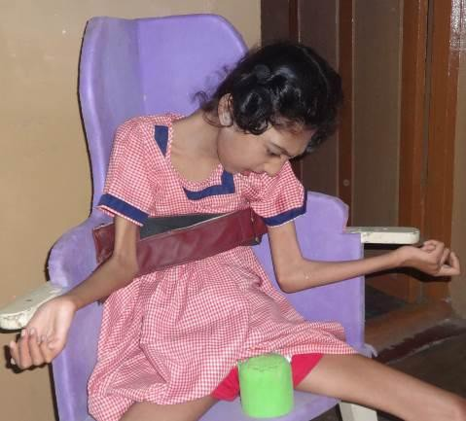

*Figure 13: A deafblind girl with cerebral palsy is sitting on an adapted chair*

To get clearer view over distinction among deafblindness, multi-sensory impairment (MSI) and multiple disabilities, as mentioned below:

##### Multi-Sensory Impairment

When children have severe developmental problems in addition to deafblindness they are known to have multi-sensory impairment. Many of these children will also have a wide range of other disabling conditions - such as learning difficulties, epilepsy, feeding problems and severe disabilities.

This term is widely used to reflect that a child with MSI has very complex educational

and developmental needs, particularly relating to the use of remaining senses.

Persons with multi-sensory impairment are likely to encounter difficulties not only with hearing and vision but also with the other senses like Tactile, Olfactory, Gustatory, Vestibular, Proprioceptive and Kinesthetic. The term MSI is a functional description rather than a medical one.

Children with multi-sensory impairment have much greater difficulties in accessing the curriculum and the environment than those with a single sensory impairment. They have difficulties in perception, communication and in the acquisition of information. Incidental learning is limited. These children need teaching approaches which make good use of their residual hearing and vision, together with their other senses. They may need alternative means of communication.

##### Multiple Disabilities

Multiple Disabilities (more than one of the above specified disabilities) including deaf blindness which means a condition in which a person may have combination of hearing and visual impairments causing severe communication, developmental, and educational problems. (Rowdy Act 2016)

#### (b) Causes of Deafblindness

The main cause can be divided as;

**PRENATAL STAGE** - the period before a child is born.

**NEONATAL STAGE** - the time around baby’s birth.

**POSTNATAL STAGE** - the period of baby’s infancy, i.e. One week from birth to three

years.

Besides this, there are many genetic syndromes.

##### Prenatal Causes:

* A mother who is under 18 years or over 35 years may be at higher risk for having

a child with special needs.

* Mother could have had German measles, tuberculosis or other infections.
* Mother could have suffered from very high fever during pregnancy.
* Mother could have got inadequate nutrition during pregnancy.
* Mother could have undergone some X-rays in the early stages of pregnancy.
* Mother could have suffered from chronic ailments like hypertension, diabetes etc.
* Rh incompatibility in mother and baby’s blood.
* Mother could have taken the wrong drugs or excessive drugs.
* Physical and/or emotional trauma during pregnancy
* Multiple attempts for abortion.
* Mother had convulsions (fits) during pregnancy.

##### Neonatal Causes: -

* If the child is born premature, i.e. before 37 weeks or 259 days or post-maturely,

i.e. after 42 weeks.

* Mother had a prolonged labor, or a very difficult time during the delivery.
* The umbilical cord could have been tightly wrapped around child’s neck.
* Child could have had bleeding in brain due to injury during birth.
* Birth cry could be delayed and child could have taken time to breathe.
* Child was deprived of oxygen during or immediately following birth.
* Skilled people were not available during delivery to take care.

##### Post–Natal Causes:

* Child could have high fever or convulsions (fits) which could have damaged child’s

brain.

* Child could have got a head injury due to fall.
* Child could have had insufficient nutrition, which could lead to malnutrition & hamper child’s development.
* Child could have had a metabolic disorder, which could make the child unable to assimilate fat, protein, or carbohydrates.
* Child could have suffered a brain fever which could have led to brain damage.
* Early childhood jaundice or jaundice at the time of birth.
* Child could have suffered or had been improperly treated for tuberculosis.
* Brain infections like Meningitis or Encephalitis.

##### Look for these signs and symptoms Does your child

* Sleep a lot, cry a little bit and not move his/her arms and legs much
* Makes little eye contact with mother or other people
* Does not make sounds, grasp objects, sit, pull himself up to standing and walk by the expected time
* Does not reach out and move towards things
* Does not react to loud noises, voices or sounds
* Rocks backwards and forwards, bangs his head or pokes his/her eyes
* Does not like being touched by people or things
* Cleft lip and palate
* Malformations of the head or neck
* Malformations of the ears
* Lack of opening at ear canal (ear canal atresia)
* Frequent ear aches or ear infections (otitis media)
* Discharge from the ears
* Have few or inconsistent responses to sounds
* Not seem to listen
* Not respond to care givers calling his/her name
* Show a preference for certain types of sounds
* Have limited vocalizations
* Have abnormalities in voice, intonation, or articulation
* Show a delay in language development
* Pulls on ears or puts hands over ears
* Breathes through mouth
* Tilts head to one side

##### S/he may have a difficulty in hearing/speaking

*(Sources: Chen, 1998, 1990; Gatty, 1996; Fewell, 1983; Joint Committee on Infant*

*Hearing, 1991)*

##### Does your child have

* A drooping eye lid which hides the pupil
* Noticeable abnormalities in the shape or structure of eyes
* Absence of a clear, black pupil
* Constant redness of conjunctiva (normally white)
* Constant watering of eyes without crying
* High sensitivity to bright light shown by squinting
* Closing eyes, or turning head away
* Jerky eye movements (nystagmus)
* Absence of eyes moving together
* Absence of sustained eye focus after 4 to 6 months of age
* The habit of tilting or turning head in certain positions when looking at an object
* To hold object close to eyes to see them
* To turn away gaze or seems to be looking besides, under, or above the object of focus
* Lack of eye contact by 3 months
* Lack of visual fixation or following by 3 months
* lack of accurate reaching for objects by 6 months

##### S/he may have a difficulty in seeing

*(Sources: Calvello, 1990; Fewell, 1983; Taplin, 1995)*

If your child has any one or other of the above combinations of hearing loss and visual

loss symptoms, it may mean that child has deafblindness.

In case hearing loss and vision loss symptoms are there with learning difficulties, epilepsy, feeding problems and severe disabilities then your child needs to have intervention as early as possible.

But remember there are organizations like Sense International India, other NGO’s and government organizations to help you to bring up your child with all that is good for him/her.

##### Some common infections that lead to Deafblindness: - Cytomegalovirus (CMV): -

**Cytomegalovirus** is a common virus that infects most people at some time during their lives but rarely causes obvious illness. It is a member of the herpes virus family. Manifestations of this disease may be minimal (e.g., rash and fever) or severe (e.g., microcephaly, mental retardation, and profound sensorineural hearing loss). In most cases, there is no treatment. An effective vaccine has not yet been developed.

##### Meningitis: -

Meningitis is a condition in which inflammation of the longing (meninges) of the brain and spinal cord occurs due to a bacterial or viral infection. Meningitis is usually bacterial or viral, but in rare cases it can be caused by fungus. In its bacterial form the condition is life threatening. The viral form is usually less severe.

The central nervous system may be affected, and some loss of sight or changes in vision may occur (e.g., strabismus, decreased acuity, cortical visual impairment, and photophobia due to changes in the sizes of the pupils.) Babies born prematurely or with low birth weight have a higher risk of all forms of neonatal meningitis. Prolonged labor after rupture of membranes also increases the risk of neonatal meningitis.

##### Toxoplasmosis:

Toxoplasmosis is caused by a parasite called toxoplasma gondii. It forms cysts, which are passed in the faces of its primary or main host, the cat. Cats alone are not the only reason for the incidence of this condition. Undercooked meat and the increasing consumption of un-pasteurized goat’s milk are two other potential causes.

##### Genetic Causes and Syndromes:

There are more than 50 syndromes which has associated condition of deafblindness. The conditions described in following syndromes may cause multiple disabilities, including deafblindness. Some of them are;

##### Congenital Rubella Syndrome:

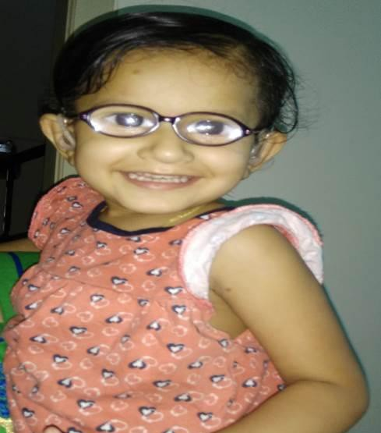Rubella, or German measles, is a mild disease caused by a virus. Usually, rubella causes a slight fever which lasts for about 24 hours, and a rash on the face and neck that lasts two or three days. Most people recover quickly and completely from rubella. However, the greatest danger from rubella is not to children or adults, but to unborn babies. If a woman gets rubella in the early months (first trimester) of her pregnancy, her chance of giving birth to a deformed baby may be as high as 80%. These babies may be born deaf or blind or deafblind. They may have damaged hearts or unusually small brains. Many children may also have

additional conditions like intellectual disabilities. Miscarriages are also common among women who get rubella while they are pregnant.

Rubella can be prevented by a rubella vaccine, which is usually given to children at 12 to 15 months as part of the scheduled Measles- Mumps-Rubella (MMR) immunization. A second dose of MMR is generally given at 4 to 6 years of age, but should be given no later than 11 to 12 years of age.

The member states of the United Nations have agreed to eliminate measles and rubella to bring about an end to the associated deaths in

newborns and children by 2030. This will aid in Figure *14: A young girl with deafblindness*

the accomplishment of the Sustainable Development Goals. Both measles and rubella are major public health concerns that account for a significant socioeconomic burden on the families and the community in general.

In 2017 the government of India started Measles-Rubella Vaccination Campaign. The aim of the campaign is to reach more children (aged 9 months to 15 years) in the next couple of years and administer a single shot of MR vaccine regardless of their earlier vaccine or disease status. The vaccine is free of cost across the states in schools, health facilities, and in outreach sites. However, for the campaign to be effective, no child should be left behind, and hence it is extremely important that all the stakeholders (viz., parents, community leaders, teachers, and health workers) should actively participate in the campaign. Eventually, the plan is to introduce the MR vaccine in the national immunization schedule and replace the existing strategy of administering two doses of measles vaccine, at 9–12 months and 16–24 months of age.

##### Charge Syndromes:

**CHARGE** Association is a multi – featured disorder characterized by a unique combination of diverse abnormalities. The name “CHARGE” is made up from the initial letters of some of the most common features seen in this condition.

**Coloboma** is cleft or failure of the eyeball to close resulting in abnormalities of the retina or optic nerve. This may result in significant loss of vision, defects in visual acuity resulting in near or farsightedness, and oversensitivity to light.

**Heart defects** the most frequent type of heart defect is TOF (Tetralogy of Fallot) reported in the CHARGE association.

**Atresia of choanae** is the blocking (atresia) of the airways (choanae) from the back of the nose to the throat that would allow breathing through the nose.

**Retardation of growth** and development is usually due to heart problems, nutritional problems, or growth hormone deficiency. The developmental delay often is associated with sensory deficits (vision and hearing loss).

**Genital abnormalities** in boys possibly undecided testes. The girls

may have small labia. Reflux of the urinary tract or kidneys is common.

**Ear abnormalities** include a common finding of unusually shaped ears (short and wide with very little or no earlobe). Hearing loss, conductive and/or nerve.

Evidence exists of other anomalies associated with this condition in addition to those above:

* Abnormal tongue size
* Cleft lip and /or palate
* Facial palsy
* Renal abnormalities
* Malformations of the larynx
* Atresia of the esophagus
* Skeletal abnormalities

Although some cases appear to be influenced by heredity. However, environmental

factors have not been ruled out.

There is no laboratory test that can diagnose CHARGE Syndrome. Usually, the diagnosis is made because of the presence of a number of these typically unrelated anomalies. At least four out of these six abnormalities should be present if a child is to be diagnosed as having CHARGE Association...

##### Acquired Deafblindness – Genetics disorders, Head Injury, Strokes, Seizures,

**High Fever, Encephalitis, Meningitis, Accidents or Trauma, Ageing. Usher Syndrome:**

Usher syndrome is a genetic disorder that is characterized by hearing impairment as well as an eye disease called Retinitis Pigmentosa (RP) in which vision degenerates (gets worse) over time. Some people with Usher syndrome also have body balance problems.

There are three different clinical types of Usher syndrome (US). They are called Usher syndrome type 1 (US1), Usher syndrome type 2 (US2), and Usher syndrome type 3 (US3). Types 1 and 2 are more common than type 3. All types of the syndrome are inherited in the same pattern—as autonomic recessive traits.

##### Usher Syndrome type 1 (US1):

* People with US1 are profoundly deaf from birth.
* Many of these individuals obtain little or no benefit from hearing aids.
* Most use sign language as their primary means of communication.
* They have severe balance problems, because of the balance problems, children with US1 are slow to sit without support and rarely learn to walk before they are 18 months old.
* These children usually begin to develop vision problems by the time they are ten.
* Visual problems most often begin with difficulty seeing at night, but tend to progress

rapidly until the individual is completely blind.

##### Usher Syndrome type 2 (US2):

* People with US2 are born with moderate to severe hearing impairment and normal balance.
* Although the severity of hearing impairment varies, most of these children perform well in regular classrooms and can benefit from hearing aids.
* These children most commonly use speech to communicate.
* Retinitis pigmentosa, which is a degeneration of the retina (the part of the eye that receives images of objects), is characterized by blind spots that begin to appear shortly after the teenage years.
* The visual problems in US2 tend to progress more slowly than the visual problems in US1. When an individual’s vision deteriorates to blindness, his or her ability to read speech from the lips is lost.

##### Usher Syndrome type 3 (US3):

* Children born with US3 have normal hearing and normal to near-normal balance.
* Hearing worsens over time.
* Children develop noticeable hearing problems by their teenage years and usually become deaf by mid to late adulthood.
* Retinitis pigmentosa in the form of night blindness usually begins sometime during puberty.
* Blind spots appear by the late teenage years to early adulthood.
* By mid-adulthood, the individual is usually blind.

##### Ageing as a cause of deafblindness

Most common cause of deafblindness is simply the age. After the age of 50 years, hearing and vision impairments become more common and prevalence of sensory impairment increases with age.

Other than these significant causes, there are some other causes that may cause

deafblindness in individuals which are as follows:

##### Nutrition

During the prenatal period, baby is completely dependent upon the mother for its nutritional needs. This is the most important time of an individual’s life as far as nutrition is concerned. This time of rapid growth and development of the baby determines whether or not the child has met the developmental potential, not only as a baby but for the rest of his or her life. Poor nutrition and unbalanced diet during pregnancy can cause low birth weight or premature birth. Infants who survive these conditions are more likely to have mental retardation, cerebral palsy, epilepsy and respiratory disease which may result in deafblindness/MSI or multiple handicaps.

##### Jaundice

Jaundice results when a chemical called bilirubin builds up in the baby’s blood. Too much bilirubin can cause hyperbilirubinemia. It also causes problems with vision and teeth and sometimes can cause mental retardation and cerebral palsy. Maternal jaundice during pregnancy can also be vital for the developing fetus. High level of bilirubin can harm the developing brain of fetus and thus hearing and vision might get affected.

**Rh Incompatibility**

Rh incompatibility is a condition which develops when there is a difference in Rh blood type between that of the pregnant mother (Rh negative) and that of the fetus (Rh positive).

During pregnancy, red blood cells from the fetus can get into the mother’s bloodstream as she nourishes her child through the placenta. If the mother is Rh-negative, her system cannot tolerate the presence of Rh-positive red blood cells. In such cases,

the mother’s immune system treats the Rh-positive fetal cells as if they were a foreign substance and makes antibodies against the fetal blood cells. These anti-Rh antibodies may cross the placenta into the fetus, where they destroy the fetus’s circulating red blood cells. Rh factor can result in severe anemia, jaundice, brain damage and heart failure in a new born. In extreme cases, it can cause the death of the fetus because too many red blood cells have been depleted.

##### Maternal fits

Epileptic attacks and convulsions cause a risk of maternal and fetal hypoxia (lack of required oxygen) as well as increasing the fetal heart rate. During labor and delivery there is also the risk of premature labor in the epileptic mother.

##### Fits

Epilepsy is a brain disorder in which clusters of nerve cells, or neurons, in the brain sometimes signal abnormally. In epilepsy, the normal pattern of neuronal activity becomes disturbed, causing strange sensations, emotions, and behavior or sometimes convulsions, muscle spasms and loss of consciousness. This abnormal signal sometimes destroys the brain cells.

##### Drugs

Addictive drugs such as cocaine, heroin used during pregnancy place the baby’s life at risk. The drugs may cause brain damage, such as when a fetus experiences a stroke due to cocaine exposure. Bleeding, stillbirths and premature delivery are only a few of the additional complications that can result from the use of narcotics during pregnancy.

#### 2.1(C) Additional Disabilities

Child may have additional disabilities like Mental Retardation, Cerebral Palsy, and Autism with Deafblindness. If the children have additional disabilities with deafblind, the impact of disability will be increased in learning and daily to day activities.

Intellectual disability, a condition characterized by significant limitation both in intellectual functioning (reasoning, learning, problem solving) and in adaptive behavior which covers a range of every day, social and practical skills, including -

1. “Specific learning disabilities” means a heterogeneous group of conditions wherein there is a deficit in processing language, spoken or written, that may manifest itself as a difficulty to comprehend, speak, read, write, spell, or to do mathematical calculations and includes such conditions as perceptual disabilities, dyslexia, dysgraphia, dyscalculia, dyspraxia and developmental aphasia;
2. “Autism spectrum disorder” means a neuro-developmental condition typically appearing in the first three years of life that significantly affects a person’s ability to communicate, understand relationships and relate to others, and is frequently associated with unusual or stereotypical rituals or behaviors. (RPWD Act, 2016)

Autism is a group of neuro developmental disorder. Mainly affects the three areas of development. Language and communication, reciprocal and social interaction, imagination, so it is also known as “Triad of impairments”.

Autism presents at birth; onset of symptoms starts before 36 months. Autism spectrum disorder (ASD) identified at the age of 18 months. Diagnosis possible at 24 months. Diagnosis is typically made at 36 months or older. Autism can be present in combination with other disabilities. It is not a mental illness or Intellectual disabilities or caused due to neglect or bad parenting. (RPWD Act, 2016)

Intellectual Functioning

*Intellectual functioning*—also called intelligence—refers to general mental capacity, such as learning, reasoning, problem solving, and so on.

One way to measure intellectual functioning is an IQ test. Generally, an IQ test score of around 70 or as high as 75 indicates a limitation in intellectual functioning.

Adaptive Behavior

*Adaptive behavior* is the collection of conceptual, social, and practical skills that are learned and performed by people in their everyday lives.

Conceptual skills—language and literacy; money, time, and number concepts; and self-direction.

Social skills—interpersonal skills, social responsibility, self-esteem, gullibility, naivete (i.e., wariness), social problem solving, and the ability to follow rules/obey laws and to avoid being victimized.

Practical skills—activities of daily living (personal care), occupational skills, healthcare, travel/transportation, schedules/routines, safety, use of money, use of the telephone. Standardized tests can also determine limitations in adaptive behavior.

American Association on Intellectual and Development Disabilities (AAIDD)

##### Cerebral Palsy

“Cerebral Palsy” means a group of non-progressive conditions of a person characterized by abnormal motor control and posture resulting from brain insult or injuries occurring in the pre-natal, peri-natal or infant period of development.

Cerebral palsy is a persistent but not unchanging disorder of movement and posture

due to a defect or lesion of a developing brain. It occurs in about 2 in 1000 live births.

The main problem of children with cerebral palsy is they have a physical problem but with the physical problem some children may also have associated problems.

* 1. **(e) Medical Concerns Prevention of Disabilities: - Pre Natal-Stage: -**
     + Eat a well-balanced and nourishing diet supplemented with leafy vegetables, proteins and vitamins.
     + Have regular medical checkups during pregnancy.
     + Take medications only if prescribed by a doctor. Even the normally safe and recommended drugs and medicines may under certain conditions cause serious defects in an unborn child.
     + Avoid pregnancies before the age of 18 years and after the age of 35 years consult

a doctor before planning pregnancy.

* + - Provide vaccination against rubella for all women before reaching child bearing age.
    - Avoid exposure to illness like measles, mumps etc. especially during the first three

months of pregnancy.

* + - Avoid X-rays and exposure to any kind of radiation.
    - Avoid smoking, chewing tobacco, consuming alcohol and narcotics.
    - Avoid hard physical work such as carrying heavy loads especially in fields, and

other accident-prone activities such as walking on slippery ground or climbing stools and chairs.

* + - Pregnant women should not be subjected to undue emotional stress and strain.
    - There should be a minimum gap of 3 years between consecutive pregnancies.
    - Avoid induced or illegal abortions.
    - Delivery must be conducted by trained persons preferably in a hospital where facilities are available.
    - Breast feeding by mother immediately after birth will protect the baby from infections.
    - Can go for genetic counselling or for genetic test.

##### High Risk Pregnancies: -

* + - If there is incidence of birth defects in the family
    - If there has been difficulty in conceiving or there has been a series of miscarriages
    - If the mother has “Rh -vet” blood type
    - If previously mother had multiple pregnancies

##### High Risk Infants: -

* + - Premature baby (before 28 weeks), low birth weight babies (less than 2.5 kg), babies born after difficult labor, babies with congenital disease.
    - If the baby does not cry immediately after birth (birth cry is considered “absent”

after 3 minutes) restitution should be undertaken at once.

* + - If the baby’s head appears to be abnormally small or large, have it measure and consult a doctor. The approximate head size for a male child at birth is 35 CMS. and female child is 34.5 CMS.

##### Post Natal Period: -

Take the baby to a doctor immediately if:

1. Jaundice persists even after three days of birth (baby appear yellow)
2. Baby is blue or even if the tips of the fingers and toes appear blue
3. The child has persistent diarrhea
4. The baby has difficulty in breathing or appears to be choking
5. Do not allow your child’s temperature to remain above 1010F at any time
6. If your child gets fits take him to a doctor immediately. Your child should be immunized against infectious disease like Polio, Measles, Tetanus, Tuberculosis etc.
7. Do not allow your child to have too much contact with paint, newsprint ink, lead etc.
8. Take precautions against head injury, and other accidents
9. Ensure that your child gets a well-balanced diet and clean drinking water.

##### Your worries and concerns

* + You may be worried that your child has vision and hearing problems.
  + You may find it difficult to relax and get to know your baby.
  + Since your child may have medical complications, you may need a lot of visits to the hospital.
  + You may have to listen to different kinds of advice from elders or opinions from

professionals.

* + Your child may associate being touched with unpleasant medical procedures. S/he may fuss or stiffen whenever anyone touches him.
  + Your child may appear unresponsive. S/he may not smile or make eye contact. It may be difficult to understand what your child enjoys or what will make him/her happy.
  + Interactions may be frustrating and may take a lot of effort. Your child may act

passive.

* + Your child may need constant help from you since he or she can’t “explore” or

“Listen to” environmental cues.

* + It may be difficult to understand what your child is trying to communicate.

Remember you need not go through this journey alone. There are many professionals who will help you and offer services. The professionals will help, but in the long run, it’s the parents and the family, who will have the most influence on the child. Your child’s life will be shaped by the caring and trusting relationship and the kinds of interactions he or she has with you. Your relationship with your child will form the foundation for him/ her to explore the world and learn from it.

*(Source: Gleason (2008). Available online https://nationaldb.org/library/page/2062*

#### – Impact of Deafblindness

* 1. **(a) On areas crucial to learning**

##### Impact on Communication

Communication is the area which is affected the most in deafblind individuals.

Deafblindness greatly reduces the interaction level of an individual with his/her environment. We rely on the information that we get through our visual channels and from what we gather through hearing. Loss of any one distant sense i.e. vision/hearing will directly affect the communication skills.

You would observe following points in an individual with deafblindness:

* + - Difficulty in communicating or inability to communicate in a meaningful way. Due to limited pathways to explore self in an environment, natural inputs that would help an individual to express him/herself completely are missing in a deafblind individual. Learning from natural surrounding and learning the right way to communicate gives meaning to our communication. Also, for a person with deafblindness sensory input from all the senses plays a major role.
    - Often, communication attempts are missed or misunderstood because the right method to communicate is unknown due to lack of observation and exposure on the part of deafblind individuals. The misunderstandings often occur from the immediate contact or caregivers as they don’t have the understanding of communication skills that deafblind individuals have adapted and also because of not having a common language among each other. This leads to development of inappropriate communication skills and maladaptive communicative behavior of deafblind individual.
    - Difficulty in approaching a right communication partner who would understand and

relate to the need.

* + - Restricted modes to communicate as they are unable to speak, read and write.
    - They find it challenging to develop social relationships often resulting being in

isolation.

* + - Due to lack of visual and auditory information there is reduced motivation to communicate.

##### Impact on Vision & Hearing Vision

Sense of sight is the primary source of learning for most of the individuals. Vision guides the developing child’s motor milestones and also often takes a lead role in every developmental domain.

There are certain challenges which are associated with the loss of vision

* + - Vision brings together information gathered through other senses
    - Vision tells us about the world that is at a distance
    - Vision helps us anticipate what is about to happen
    - Vision gives us a sense of the “whole” object or event
    - Vision enables alertness and attention even without a structured period

##### Hearing

Out of the five senses that human beings are normally born with, nature has endowed the sense of hearing with significant social and biological functions, ranging from the reflex alerting to the sounds around us to the relatively effortless development of speech and language skills. The sense of hearing, the perception of sound and its biological purposes, is not therefore a trivial consideration that can be lightly dismissed. On the contrary, it is a human birth right that must be respected and utilized to the fullest extent possible.

##### Impact on Social Relationships

We develop our social relationships by interacting with one another, through different modes of communication. Imagine a world with big void of communication, no one to interact with, and no one to talk to, with restricted pathways towards reaching others. Socialization is altogether an outcome of communication. An individual with deafblindness has very poor scope of reaching out to others to share his/her needs, events, and entertainment.

Following pointers will enable you to know more characteristic features related to Socialization:

* + - Children with deafblindness face difficulties in building /maintaining relationship and it is severely affected.
    - Opportunities to interact is very limited.
    - Ability to move around is restricted.
    - Need help in simple day-to-day activities

**Isolation:** Individual’s with deafblindness may detach from others and avoid social interaction. Due to their unique way of communication, deafblind children hesitate in initiating conversation which results into detachment from society. Most of the time, they also learn to avoid social interaction.

##### Impact of Deafblindness on Cognition & Incidental Learning

Learning through doing, forms the basis of a strong learning environment for child with deafblindness. It is evident that the child faces a major obstacle in learning because of the lack of opportunity to access visual and auditory cues from the environment, less able to anticipate events in his/her immediate environment and limited scope to make choices. To reduce this loss, it is important to develop routines in the life of a child with deafblindness.

**(V) Impact on Motor Development and Mobility**

Children learn about their environment as they move through it. They learn about people, objects, sizes, shapes and distances. For sighted- hearing children the senses of sight and hearing provide the greatest motivation for exploration. Children use their vision and hearing to gather information about their surroundings while growing, to understand their own bodies and their own capabilities of movement. The sight of toys or people and the sounds of voices or objects encourage them to move and discover. As they do so, they gather, recognize, and interpret an amazing array of sensory information. Children with deafblindness get constrained information through sensory system.

* + - Severe medical problems and/or other handicapping conditions, leads to serious developmental delays affecting motor and mobility problems that affects life expectancy of a child with deafblindness.
    - Difficulty in independent exploration and hence difficulty in getting a control over

the environment.

* + - Due to the limited interaction with the environment, children with deafblindness do not get to explore themselves and in the immediate and surrounding environment.
    - Conceptual development and experience of space and direction differ significantly

from other children.

##### (VI) Mental Imaginary

Mental imaginary means seeing with your mind’s eyes. There is special link between imagery and emotion showed that compared to verbal processing, visualizing emotional scenarios elicits stronger positive as well as negative affective reactions. Mental imaginary plays a vital role in our daily life, we may think of mother or father and immediately get their image in our mind. Mental imaginary helps us to remember and recall quickly about a certain thing or person or an action.

(Source: [https://www.ncbi.nlm.nih.gov/pmc/articles/PMC4493655/)](http://www.ncbi.nlm.nih.gov/pmc/articles/PMC4493655/))

We depend majorly on our sight and hearing to learn about something. For children with congenital deafblindness their mental imagination is very badly affected as they do not get any experience through their sight and hearing. They are completely dependent on experience gained through tactile and other senses.

Children who have partial vision and hearing may develop a distorted mental image; this depends on each child’s visual and auditory conditions. It is also important to teach children with deafblindness in a natural settings using real materials to build their mental imagination.

#### Assistive Technologies for Persons with Deafblindness

**Assistive technology** or **adaptive technology (AT)** is an umbrella term that includes assistive, adaptive, and rehabilitative devices for people with disabilities and also in- clues the process used in selecting, locating, and using them. AT promotes greater independence by enabling people to perform tasks that they were formerly unable to accomplish, or had great difficulty accomplishing by providing enhancements or changing methods of interaction and the technology needed to accomplish such tasks.

Examples of assistive technology include the curb cut in architecture, standing frames, text telephones, accessible keyboards, large print, Braille, and speech recognition software. Assistive technology or interventions are sometimes controversial or reject- ed, for example in the controversy over cochlear implants for children.

##### Access to Computer

**JAWS** - JAWS (**J**ob **A**ccess **with** **S**peech) converts your computer into a talking com- putter. It reads out all the matter that is on the computer’s screen through your com- putter’s sound card, thus providing access to a wide range of informative, educational, and job-related applications thus making it possible for the blind to independently use the computer – be it at school, college, university or their workplace.

*Socure:https://*[*www.google.co.in/search?hl=en&authuser=0&biw=1093&bih=508&tb-*](http://www.google.co.in/search?hl=en&authuser=0&biw=1093&bih=508&tb-) *m=isch&sa=1&ei=wq4gW6LJIsSCvQTugJiwBQ&q=Job+Access+wth+Speech&oq=Job+- Access+wth+Speech&gs_l=img.3...3199.8749.0.9018.25.20.1.2.2.0.182.1469.9j5.14.0. 0..*

*. 1c.1.64.img.8.15.1142. 0..0j0i67k1j0i5i30k1j0i8i30k1j0i24k1.0.8o6HHUCMEfk#imgrc=ob8n- phWCc2Ph-M:*

**Nonvisual Desktop Access (NVDA)** is a free, open-source, portable screen reader for Microsoft Windows. The project was started by Michael Curran in 2006. NVDA allows blind, vision impaired people and persons with deafblindness to access and interact with the Windows operating system and many third-party applications.

**Talking Typing Teachers -** Talking Typing Teacher is a revolutionary new typing pro- gram specially designed for the blind and visually impaired that’s ideal for home or classroom use. An ideal program that helps to train the visually challenged and per- sons with deafblindness to master the computer keyboard like a touch typist using all ten fingers.

**Packmate*-*** PAC Mate is an acronym for Personal All-Purpose Computer. The PAC Mate converts objects and text to speech so users who are blind can hear documents, images and Web content. Portable computers/ note takers enhance the independence of the blind and deafblind people. They play a key role in empowering and increasing the productivity of persons with visually impairment in their jobs/ professions enabling them to work even when they are on the move.

**Packmate Portable Braille Display -** This first-of-its-kind, truly portable display not only makes PAC Mate™ more accessible, but it also can be used with desktops and laptops. Featuring a low-cost, simple platform this refreshable Braille unit adds funk- tonality to any computer with a USB port. A new seamless design between Braille cells makes the display feel like paper. With a pair of three-way Whiz Wheels for rapid navigation and dual-purpose cursor routing buttons, users can quickly and accurately obtain the information they need. The built-in Vari Braille and programmable hot keys make the PAC Mate 20 Portable Braille Display a convenient extension to any Win- dowse or Windows CE operating environment.

*Source:*[*https://www.google.co.in/search?hl=en&authuser=0&biw=1093&bih=508&tbm=is-*](http://www.google.co.in/search?hl=en&authuser=0&biw=1093&bih=508&tbm=is-) *ch&sa=1&ei=LqwgW_mRBsv5vAS8mZx4&q=PAC+Mate+20+Portable+Braille+Display+&o- q=PAC+Mate+20+Portable+Braille+Display+&gs_l=img.3...490206.492597.0.493943.39*

*.14.0.0.0.0.105.1072.11j2.13.0....0...1c.1.64.img.37.0.0.0. 0.4xi-ibJVCmo#imgrc=OIdU-*

*1V3yxH303M:*

**Connect Outload web access software -** Connect Outload is an easy-to-use tool offering Braille and speech output to the web and gives the user the ability to send and receive e-mail. Designed for beginners or experienced computer users, Connect Out- loud offers speech and Braille output (*with a Braille display*) of the Internet, email and basic Windows Operating System applications. Connect Outload’s interactive talking

install makes it easy to get started without sighted assistance.

**Focus Braille Display -** Portable and affordable Focus 14, Focus 40 and Focus 80 Braille Displays with the latest in braille display technology. Based on features rated most desirable by braille display users, Focus Braille Displays are packed with ad- vaned features and options that can be easily configured through JAWS® and NVDA software.

**Mobile Speak Software -** Mobile Speak is a screen reading software for mobile phones that allows access to most of the functionalities of the mobile phone and will make it possible for persons with visual impairment for the first time to navigate through the internet using a mobile phone.

**Braille Watches for Ladies & Gents -** Braille watch allows persons with visual im- payment and persons with deafblindness to check the time on their own.

*Source:https://*[*www.google.co.in/search?hl=en&tbm=isch&sa=1&ei=qa8gW-SiBsT-*](http://www.google.co.in/search?hl=en&tbm=isch&sa=1&ei=qa8gW-SiBsT-) *1vgTrhLfABA&q=Braille+Watches+for+Ladies+%26+Gents&oq=Braille+Watches+- for+Ladies+%26+Gents&gs_l=img.3...25382.26795.0.28377.13.7.0.0.0.0.170.641. 5j2.7.0....0...1c.1.64.img.10.0.0. 0.MrJrDSjx2YU#imgrc=xFhU4912XP0QMM:*

**Magic Screen - Magic Magnifies the computer screen.** Magic is a software which allows to magnify the computer screen from 1 to 36 times its normal size. One can choose from several adjustable views to see both magnified and unmagnified areas of the screen.

*Source:* [*https://www.freedomscientific.com/Products/LowVision/MAGic*](http://www.freedomscientific.com/Products/LowVision/MAGic)

**Large Print Keyboard -** Large print keyboards have been designed specifically for those with conditions that cause visual impairment, low vision and deafblindness. These user-friendly large print keyboards are also perfect for those who simply have a hard time seeing the existing commands on their keyboards. With a bigger and bolder typeface, the keys are easier to see.

**Prisma Magnifier -** The Prisma is a full color reading device that offers the user flex- bile way to read, write and look at photographs and other things that need to be mag- unified. It offers variable magnification and a full color; magnified image is displayed on a standard television.

*Source:* [*https://www.google.co.in/search?hl=en&tbm=isch&sa=1&ei=xq8gW56JEMTYvgTvo-*](http://www.google.co.in/search?hl=en&tbm=isch&sa=1&ei=xq8gW56JEMTYvgTvo-)

*qRI&q=Prisma+Magnifier&oq=Prisma+Magnifier&gs_l=img.3...287249.297957.0.298278.58*

*.27.0.0.0.0.0. 0..0.0....0...1c.1.64.img.58.0.0.0. 0.D1xlcwDfrXE#imgrc=bIEwuEZyvSumYM:*

**Alva USB 640 -** Optelec is setting the standard in Braille communication. With the introduction of the ALVA Braille Controller 6-series, Optelec presents the first series of Braille access solutions that merges classic Braille display access with modern note taking functionality.

*Source:*[*https://www.google.co.in/search?hl=en&authuser=0&tbm=isch&source=hp&bi-*](http://www.google.co.in/search?hl=en&authuser=0&tbm=isch&source=hp&bi-) *w=1093&bih=508&ei=h6kgW6jQK4zvvAS5iLngDg&q=alva+usb+640&oq=Alv&gs_ l=img.3.0.35i39k1j0l9.3663.4494.0.6074.4.4.0.0.0.0.79.224.3.3.0....0...1ac.1.64.*

*img..1.3.222.0. 0.3dyKvjnY1iQ#imgrc=moi-rwYuqAWLDM:*

**ALVA Satellite 544 Traveler -** The ALVA Satellite was designed to completely control the PC from a Braille display. From e-mailing to word-processing, the ALVA Satel- lite does it all while eliminating the need to repeatedly switch your hands from the keyboard to the Braille display. This ensures an ergonomically sensible posture. The Braille Voyager connects easily to a PC or laptop through a USB port

**EasyLink 12 -** Easy Link is the first series of wireless Braille Assistants that combine the benefits of a Braille display and Notetaker in an ultraportable, versatile and stylish design.

**Duxbury Braille** Translator for Windows (DBT 10.7 SR1) - DBT provides translation and formatting facilities to automate the process of conversion from regular print to Braille (and vice versa), and also provides word-processing facilities for working di- rectly in the Braille as well as the print. **‘Fonts’** are used for displaying the Braille.

Duxbury Braille Translator (DBT) allows to create highly accurate Braille for school books and teaching materials, office memos, bus schedules, personal letters etc. DBT software is designed for two types: those who don’t know Braille and those who do.

**Optelec PowerTV Glasses -** Optelec Power TV Glasses is lightweight and adjust- able. It provides 2.1X magnification for distance viewing. These comfortable glasses are perfect for watching television, movies, sporting events or other outdoor activities. Using a binocular telescope system, the Optelec Power TV glasses help to maximize the size of the television screen and other objects.

*Source: https://us.optelec.com/products/optelec-2.1x-powertv-binocular-glasses.html With adjustable lenses, the glasses can easily adjust and the hands free frame allows for complete enjoyment of multiple activities*

**Electronic and Smart Cane -** White canes are very much important for a person with blindness/deafblindness to be independent in mobility. It gives them the confi- dent to move around and get oriented to the place where they live.

**Smart Cane -** Smart Cane device is an electronic travel aid which fits on the top fold of the white cane. It serves as an enhancement to the white cane and overcomes its limitations by detecting knee-above and hanging obstacles. When any obstacles ap- pear within 2 meters of range the cane will vibrate. There latest smart canes which can be paired with the smart phones and integrated with voice assistant and google maps.

*Source:*[*https://www.google.co.in/search?hl=en&authuser=0&tbm=isch&source=hp&bi-*](http://www.google.co.in/search?hl=en&authuser=0&tbm=isch&source=hp&bi-) *w=1093&bih=508&ei=_bIgW4NYiNu- BLCBnoAG&q=electronic+cane&oq=electronic+- cane&gs_l=img.3..0l2j0i30k1.1273.5622.0.5864.16.13.0.3.3.0.96.882.12.12.0....0...1ac.1.64.*

*img..1.15.891.0..35i39k1j0i10k1.0.UAW_j17nZIE#imgrc=jLVZSaszNQ9KwM:*

**Electronic canes** with sensors (i.e., ultrasonic, laser, or infrared sensors) obtain information about the area surrounding the user, which enable detection above chest and in an extended rang. Electronic canes detect obstacles even above knee-level and distances over two meters, although detection capabilities depend upon sensor quality. Ultrasonic sensors can work effectively outside and usually detect obstacles over a wider range. Many electronic canes use ultrasonic sensor which are effective for obstacle detection.

*Source: https://link.springer.com/chapter/10.1007/978-94-007-5086-9_10*

**Smart Gloves -** Roy Allela, a Kenyan man has invented **smart gloves** that can convert hand gestures of sign language into audio speech. This innovation could change the lives of hearing-impaired people across the world. The **gloves** have sen- sores stitched to each finger, the sensors interpret the word being signed from the bend of the fingers. The glove can be paired with the smart phones, when the person with hearing impairment wears the glove and sign the hearing person can hear it as voice from their smart phone which is paired with the glove. People speak at different speeds and it’s the same with people who sign – some are really fast, others are slow, when the smart glove is paired with the phone it’s comfortable for anyone to use it.

**Samsung Good Vibes App -** Samsung Good Vibes is a two-way communication app that allows the deafblind to send and receive messages with friends, family or anybody else through their smartphones. It translates Morse Code input into text or voice and vice versa. This is an **app that has two interfaces for person with deaf- blindness.** A deafblind person can send a message from the app by tapping on the screen using Morse Code—where all letters of the English alphabet are combine- tons of dots and dashes. The letters can be input as short tap for a dot and long press for a dash. Likewise, incoming messages can be understood as vibrations by the deafblind, where small vibration means a dot and long vibration means a dash.

**For people with normal sight and hearing -** Anyone can send a message, by typing or speaking. It has a standard chat/voice interface that delivers the message to the deafblind person as Morse Code vibrations.

**OrCam Miye 2 Spectacles -** A smart camera is attached to a pair of spectacles. The device uses the power of Artificial Vision to assist people who are living with vision loss. It is a tool for blind people to become more aware of their surroundings. By audio description provided by the device, users can become more independent in their day-to-day life.

The OrCam device has two parts. There is the lightweight camera that clips onto the wearer’s glasses and is connected by a thin cable to the second part of the device which is a tiny wearable device the size of a finger. The device uses audio feedback to relay visual information (through speech) to the user. More than a pair of glasses for the blind, it is a tool to receive information that users can’t receive on their own. It can read texts, recognize faces, identify products, barcodes, colors, signs, labels, menus, text on a smart phone or a computer, etc.

OrCam devices use advanced technology to provide more information to the user. Information about their surroundings to the level that no other device for the blind or visually impaired is currently capable of. Users also have the ability to personalize the OrCam device by teaching it to recognize particular products and identify faces of friends and family. Previously stored faces are both identified and announced after entering the camera’s view.

##### Reference

1. *Deafblind Disabled baby – Internet*
2. *Barbara Miles and Barbara McLetchie -* ***Developing concepts with children who are Deafblind- Db Link Feb 2008***
3. *Calve loll, G. (1990) Identifying visual impairments in infants. D. Chen, C.T. Fried- man, & G. Calve loll (Eds.), Parents and visually impaired infants. Louisville, KY: Amer- icon Printing House for the Blind.*
4. *Chen, D. (1990) Functional hearing screening. Duchene, C.T. Friedman, & G. Calve loll. Parents and visually impaired infants. (pp.1-8). Louisville: American Printing House for the Blind.*
5. *Chen, D. (1997). Identifying infants who are deaf-blind. In D. Chen (Ed.), Effective practices in early intervention: Infants whose multiple disabilities include both vision and hearing loss. (pp. 33-49). Northridge: California State University.*
6. *Fewell, R.R. (1983). Working with sensorily impaired children. In S.G. Garwood (Ed.). Education, gypsum handicapped children. A developmental approach (2nd. ed., pp. 235-280). Rockville: Aspen Publishers*
7. *Gatty, C.G. (1996). Early intervention and management of hearing in infants and toddlers. Infants and Young Children (1), 1-13.*
8. *Joint Committee on Infant Hearing. (1991). 1990 Position statement. ASHA, 33, 3-6*
9. *Taplin, S.W. (1995). Visual impairment in infants and young children. Infants and Young Children, 8(1), 18-51.*
10. *Sense International India, 2014 Handbook on Deafblindness*
11. *Karishma Enterprises -* [*http://www.karishmaenterprises.com/*](http://www.karishmaenterprises.com/)
12. *Barrier Break Technologies -* [*http://barrierbreak.com/*](http://barrierbreak.com/)
13. *SSA DB Module*
14. [*http://niepid.nic.in/THE%20NATIONAL%20trust.pdf*](http://niepid.nic.in/THE%20NATIONAL%20trust.pdf) *National Trust*

## Module 3

#### Living and Working with Children with Deafblindness

**Contents of the module:**

#### Development of communication in children with deafblindness

##### (a) Understanding to the development of communication What do we mean by communication?

Communication means is exchange of ideas between two or more persons. It is to in- tract and express feelings with the people around. Communication may be verbal or non-verbal. The person may use gestures, eye contact or body language to express his/ her feelings and emotions. All children learn to communicate in some form or the other even before they learn words or signs.

##### Communication development - What is it?

Communication process starts at birth and various kinds of sensory and other Informa- tonal inputs are the most vital factors in ensuring its appropriate development. The ca- paucity to communicate is an inborn skill which a child starts at a very early stage of life. The child starts interacting with the mother or other care givers right at birth. The mother attends to the child’s cry, makes him/him comfortable, smiles at him/her, talks to him/her in baby language and the child gets attached to the mother. Child starts responding to her in his/her own little ways and an interaction starts, the process also helps in developing bonding between mother and child.

##### Development of Communication as per the growth of child Birth to 3 Months

* + - Some kind of reactions to loud sounds
    - Calms down or smiles when spoken in a soothing voice
    - Recognizes mother’s voice and calms down if crying or in distress
    - When feeding, starts or stops sucking in response to sound
    - Coos and makes pleasure sounds
    - Has a special way of crying for different needs
    - Smiles at the familiar faces

##### 4 to 6 Months

* + - Follows sounds with his or her eyes
    - Responds to changes in the tone of your voice
    - Notices toys that make sounds
    - Pays attention to music
    - Babbles in a speech-like way and uses many different sounds, including sounds that

begin with p, b, and m

* + - Laughs
    - Babbles when excited or unhappy
    - Makes gurgling sounds when alone or playing with you
    - Imitate simple vowel (a, e, I, o, u) and consonant (p, b, m, k, l etc.) sounds
    - Understands different facial expressions also try to imitate the same
    - Watch/listen other people speaking

##### 7 Months to 1 Year

* + - Enjoys playing peek-a-boo
    - Turns and looks in the direction of sounds
    - Listens when spoken to
    - Understands words for common items such as “cup,” “shoe,” or “juice”
    - Responds to requests (“Come here”, “please give”)
    - Babbles using long and short groups of sounds (“tata, up up, bibiji”)
    - Babbles for attention seeking
    - Communicates using gestures or nonverbal signals such as waving or holding up arms
    - Imitates different speech sounds
    - Has one or two words (“Hi,” “dog,” “Dada,” or “Mama”) by first birthday

##### 1 to 2 Years

* + - Points few body parts when asked
    - Follows simple commands (“Come here”, “throw the ball”) and understands simple questions (“Where’s your doll?”)
    - Enjoys simple stories, songs, and rhymes
    - Points to pictures, when named, in books
    - Acquires more new words on a regular basis
    - Uses some one- or two-word questions (“Where kitty?” or “Go bye-bye?”)
    - Puts two words together (“More chips”)
    - Uses many different consonant sounds at the beginning of words

##### 2 to 3 Years

* + - Has a word for almost everything
    - Uses two- or three-word phrases to talk about and ask for things
    - Uses k, g, f, t, d, and n sounds
    - Speaks in a way that is understood by family members and friends
    - Names objects to ask for them or to direct attention to them

##### 3 to 4 Years

* + - Hears when called from another room
    - Hears the television or radio at the same sound level as other family members
    - Answers simple “Who”, “What”, “Where” and “Why” questions
    - Talks about activities at day care, preschool, or friends’ homes
    - Uses sentences with four or more words
    - Speaks easily without having to repeat syllables or words

##### 4 to 5 Years

* + - Pays attention to a short story and answers simple questions about it
    - Hears and understands most of what is said at home and in school
    - Uses sentences that give many details
    - Tells stories that stay on topic
    - Communicates easily with other children and adults
    - Says most sounds correctly except for a few (l, s, r, v, z, Ch, she, and the)
    - Uses rhyming words
    - Names some letters and numbers
    - Uses adult grammar

**This checklist is based upon How Does Your Child Hear and Talk? courtesy of the American Speech–Language–Hearing Association.** [***https://www.nidcd.nih.gov/health/speech-and-language***](http://www.nidcd.nih.gov/health/speech-and-language)

Early communication in children happens the moment child is born. Children use them for expressing their needs. Early communication is also the key for relation development

with parents and caregivers. Early communication helps the child and the parents Mutu- ally to connect with each other.

The communication development is slow in a child with deafblindness and becomes much more difficult because of the loss of hearing and vision. This means that the activity of the child will be different from that of a sighted/hearing child. For e.g., if there is an in- retesting toy or object, children with deafblindness may not demonstrate curiosity like a sighted-hearing child. They may not watch and learn to handle and explore objects by imitating other people, unless shown how to explore it through touch. They may lack the basic knowledge that they live in interesting surroundings which they themselves could explore and influence. Children who have some limited or residual vision and / or hearing may respond to visual and/or auditory cues. However, they may be unable to understand them, and either become wary of them and tend to withdraw, or repeatedly want to exam- Ine things or people close up. Thus, the true nature of a child’s curiosity can be distorted by the effects of deafblindness.

For children with deafblindness the most important senses are the sense of touch– while some of them may still have residual vision and/or hearing. This means that the parents of children with deafblindness have to start to respond to the needs of their children expressed in one or more modes of communication like gestures, signs, crying, smile etc. Hence, the parents need to adapt themselves to these specific/preferred) communication needs of their children, based on residual vision and hearing. This is the most important factor for developing communication in children with deafblindness.

Parents and caregivers of children with deafblindness must share the same (preferred) mode of communication like they share with their other sighted-hearing child. They need to introduce both conventional and other non-conventional modes of communication that their deafblind children understand and use it appropriately. They should know their child well in terms of how he/she communicates, understand what is interesting for the child and may want to communicate about. They can enhance communication using uniform patterns of communication while undertaking activities that encourage turn taking, choice making, imitation, exploring together, manipulating, socialization, and pretending games etc.

##### What is different about the communication of children with deafblindness /MSI?

Deafblind children do not have the security and motivation to move around and interact with people and objects in their environment. The information they receive about their environment is also distorted and interferes with their interaction with others. Thus, they often remain isolated and face the challenge of having very little opportunity to acquire communication skills incidentally. There should be some reason to communicate. Early communication should be based on emotional bonding and the needs of the child to have a control on his/her environment. We should avoid anticipating the needs of the child as this will reduce the opportunities s/he gets to communicate and for problem solving. As a parent, educator or professional one must ensure that the child has problems to solve and choices to make and that S/he must communicate his/her decisions to you.

##### Hence some of these implications of deafblindness /MSI on communication abilities

**are listed below:**

* + - Eye contact that helps maintain communication with others is missing.
    - Body language that helps person to take information about the speaker and sometimes also conveys meaning of speaker’s information is not interpreted due to visual loss.
    - Inability to anticipate what is going to happen next and understanding prompts hinders
    - Development of reciprocal interaction and turn taking.
    - Inability to understand the meaning of communication expressed through verbal communication.

##### Why is Communication Intervention important for a child with deafblindness and MSI?

As we all know, communication is the basis for building social relationships, understanding new concepts and thus for growing and learning. Sighted and hearing children develop through specific stages in both expressive and receptive language developments. For the child with sensory impairments however, the environmental stimulation is diminished and the child loses opportunities to develop language in the natural manner, through exposure to a communication rich environment, children with deafblindness can develop a similar sequence as sighted and hearing children. The development of appropriate communication skills in individuals with sensory impairments assumes importance because of the following factors:

* + - Learning alternate ways to communicate wants and needs enables them to communicate their satisfaction and dissatisfaction in ways that are understood by the people in their life.
    - They are able to have more independence and confidence in their daily lives to

generate more positive reciprocal social relationships

* + - It gives them a clear sense of control over their environment as they realize that their actions produce favorable reactions from their environment
    - It enables them to make choices to get more involved with the activities they participate
    - They develop communicative skills and strategies, which help them interact in their home environment effectively, which makes them positive and contributing members in the family.
    - It builds up their self-esteem in the child with deafblindness and MSI
    - It replaces unwanted behavior such as head banging, screaming, hitting and eye gouging with more appropriate communicative approach
    - It expands his or her selection of communication intents or functions
    - Communication intervention helps the student make his/her symbolic message

more specific and interactive

* + - It enhances the quality and happiness of their lives by allowing them to initiate and engage in interactions with a variety of individuals in the society

##### What does a child with deafblindness and MSI need to learn? Hershel needs to learn the following:

* + - The concept of communication and the possibility that people can share ideas with him/ her and S/he can share their ideas and information with the other person
    - The intention to communicate which has to be built up by the parents, caregivers, siblings and teachers
    - The value of communication, its benefits for him/her, the power it gives him/her and the ability to control others or an effect on what other people can do to him/her
    - The existence of an object even if he/she is not touching it (object permanence). The deafblind child cannot easily hold the image of an object in his/her mind when the object is not present. The ability to do this is closely related to the ability to name and categorize objects, and thus tied to language and conceptual development.
    - How to move around, explore the world, develop curiosity and learn how people and objects is connected with each other. Visual and sound objects are lures for the child

and help to draw him/her out to crawl round his/her world. As a child learns these skills, he/she learns to ask questions, to protest and to request for things.

Although not every child with deafblindness/MSI can learn the following. However, the higher functioning child must learn the following as well

* + - The ability to symbolize that an object, a picture and a gesture mean something
    - The vocabulary and signs as a mode of communication.
    - Put the words together in proper syntax.

In the presence of additional disabilities in the child, no single communication method will be helpful. For such children we have to learn about the avenues through which they can receive information, how they can process information and express their thoughts. This understanding will lead us to develop meaningful ways to communicate with them.

##### Developing Communication in Children with Deafblindness /MSI

1. **Understanding how to develop communication**

Parents/Teachers can use a number of methods to enhance the use of communication and the development of interactions at school and in the community by children with deaf- blindness/MSI.

Some of the useful methods are listed below:

* + - Family must be given priority; child’s interaction with his/her environment is dependent

upon the family’s activities and different sources of interaction

* + - Always give an opportunity to communicate and celebrate every attempt of communication made by the child
    - Recognize and react to the child’s communication
    - Communication options should not be limited. Based on the skills, the child will be learning the communication pattern involved in the surrounding environment. Different communication options should be involved while communicating with the child with deafblindness.
    - Communication should occur with many different people (including peers)
    - Communication should not be one-sided/directive. Whoever is interacting with the

child should interact as a partner and not give orders. For example, “do what I am asking, without questioning”.

* + - Communication between the partners should be as direct as possible. Interpreter may be involved to facilitate social interaction at all times. If interaction is frequent, all must learn appropriate ways of communicating, including the use of augmentative aids.
    - Communication exchanges should occur frequently.
    - Communication is a dynamic process, hence all our programmed planning must enhance
    - Child’s interactions at every level (environmental, partners, skill areas) communication should be part of all areas in the educational program of the students (IEP)
    - During interaction systematic procedures should be used to expand the child’s communication system.

**Rules for interactions with children with deafblindness/MSI**

# DO’S DON’T

* + - * Deal with each child in a sensitive way
      * Be aware of the child’s messages
      * Encourage the child to commune- cate
      * Consider the child’s residual Sens- es. Things can be too LOUD or too BRIGHT
      * Make sure each person who interacts with the child uses the same cues
      * Do allow time for the child to un- verstand your message
      * Do plan activities that means something to the child through his or her daily activities
      * Don’t act on the child without letting him or her knowing what is about to happen
      * Don’t ignore the child’s attempt to communicate
      * Don’t decide for the child what he or she wants to or needs.
      * Don’t overload the child’s ability to see, hear, and move
      * Don’t set the child up to fail
      * Don’t rush the child
      * Don’t waste valuable time doing things with the child that will not help him or her in life
      * Don’t start all the communication; let the child begin some interact- tons
        + Do involve other people in the in- traction
        + Do remember having fun is a part of all our lives
        + Don’t make every activity just work.

*Source: (from– a resource manual for understanding and interacting with infants, toddlers, and preschool age children with deafblindness- ski-hi institute, Linda Alsop- editor)*

##### Good ways to promote communication

1. Model good communication. Comment about the environment all the time.
2. Provide opportunities to communicate and allow turn taking in-group games or passing materials in art or cooking classes.
3. Face the student and speak slowly to allow them to process and comprehend what is being said.
4. Allow time for the student to respond.
5. Exaggerate gestures, facial expressions and body movements.
6. Exaggerate key words and intonation.
7. Use all appropriate modes of input – auditory, tactile, and visual.
8. Clarify or expand the sentence on the student responds. For example, student signs “more”. Teacher can sign by saying/ say “more” and then followed by signing “You want more juice?”.
9. If the student has hearing loss or is easily over stimulated, communicate in a quiet and non-distracting environment.
10. Increase demands and expectations. Ask open ended questions.

##### What to avoid while communicating

1. Avoid-using communication boards as the primary responding mode. This means that priority must be given to the child’s natural gestures and cues.
2. Avoid limited range of communication intents. Expect intents like requests, questions, rejection, approval, denial and agreement.
3. Avoid expecting no responses but ask in a way that the child can answer in the best way
4. Avoid overlooking initiations because every eye blink, grimace or smile may be a com- medication initiator
5. Avoid the predominance of adult- child communication and encourage communication among peers both disabled and non-disabled.

##### Fostering Communication

**Preparation: Communication Initiation**

Use of different gestures, touch cues, including signs allow the child with deafblindness to anticipate what is happening around, anticipate the activities, express a reaction to its occurrence and become ready to participate in it. A child may dislike an activity even if s/ he is unaware that the activity will be presented to him/her. For example, if a child is taken from one room to other without intimating and have been asked to put objects from one box to other. S/he will become confused and resistant and will struggle with the boxes. Whenever the activity is scheduled, even if the child likes the tasks s/he may not like to indulge in the task because of compulsive indulgence. However, if the child was taken to the calendar box, where s/he finds a sorting of objects in one section, the child will be prepared for the activity and would enjoy the whole activity. These five components of communication should be kept in view.

##### Choice of the Activity

As we all keep changing our choice of activities with time, similarly children with deaf- blindness/MSI go through the same depending upon the mood, physical well-being, or other factors. We could structure our settings in such a way that it provides maximum opportunities to the child for making choice. Help him/her to communicate his/her Pref- ernes and enable to have control over the environment. Successful control over the environment motivates the child to communicate more.

##### Environment

Children having dual sensory loss of varied degree, environmental conditions, such as the amount of lighting, noise, can have impact on the enjoyment of the activity or interact- Tion and the amount of communication they understand and express.

##### Safety

Child needs to be comforted and should be given a secure environment. Insecurity can push off even a most anticipated activity. Safety factors like travel conditions, Orientation and Mobility (O&M) should be consulted with the O&M specialist and understand the skills and familiarity with the instructor.

##### Familiarity

We all, including children with deafblindness/MSI seek an environment that is familiar for learning a new skill. For example, a child with deafblindness /MSI is learning names of fruits. So, the child can be taken to the fruit / vegetable shop for introducing the fruits through some buying activity. Since s/he has limited vision and hearing, child’s first trip would be confusing because of different lights, smells and vibrations. The child may not remember and would seek teacher’s involvement in locating the item. After a week’s trip to the shop, the child would be able to identify varied cues to relate self to the store and would be more comfortable to the new environment as well as the activity.

##### Turn taking

Turn taking is very important social skills to develop relationships and understanding with friends, families and other acquaintances. Simple activities like mother and the child clapping alternately on each other’s palms, a simple taping on the table alternately in the same rhythm/pattern, throwing the ball alternately at each other, games like pushing cars back and forth, or blowing bubbles are all great activities for implementing turn-taking. It is easy to manipulate those activities for “my turn,” “your turn,” as well as adding a sound to each part of the activity. When you add a sound or word like, “in” while putting a shape in the shape sorter, you may try giving the child a little extra time to imitate before taking another turn.

##### Choice making

Choice making offers opportunity to the child for active participation. It offers a sense of control. It is essential to provide several opportunities throughout the day to make the child learn about choice making in routine activities. For e.g. choices can be given be- tween food items like, an apple or a banana, choice between flavored biscuits or a play item like a small ball or a big ball), clothes; full pant or short pant etc.

##### Imitation

This involves doing some activity and let the child imitate you, like you clap and let the

child also clap, you show them brushing in upward and downward direction let the child also do it.

##### Exploring Together

Exploring enables the child to feel secure about the world around him/ her. It helps to make new discoveries and learn about the world. For e.g. parents can explore toys or objects together.

##### Manipulating

Games/Play enhances the child’s ability to coordinate his/ her hands and eyes, which enables the child to have control over toys/objects. By manipulation, s/he learns all about the objects and how to use them, which enhances her/his self-respect and independence in future. For e.g. Playing with spoons, drawing etc.

##### Socialization

It is the interaction between two or more people. It involves give and take. It offers the child opportunity to observe people, peers imitate them, communicate with them and also experience turn taking and interacting with people for e.g. playing with peers, siblings etc.

##### Pretending Games

A child pretends to be a doctor/police/parent is known as pretend play. Pretend play is essential for development of thoughts and language and enhances the child’s experience to be creative.

##### Building Trust and Close Relationships

It is important for the parent to show affection towards their child by use of touch. For example, for a child with deafblindness and additional disabilities may exhibit their feelings in a different way which may not be accurate or easy to understand. However, parents or caregivers must try their level best to understand their expressions and provide a responsive and nurturing environment. This will develop into building a close relation- ship and trust between the child and the parent. It is important that parents interact with the child undertake body games and provide massage through some effective activities. While holding, cuddling and stroking children with deafblindness/MSI encourage bonding between the child and the parents/caregivers which is crucial for his/her overall develop- mint including the development of communication.

Children with deafblindness will need many opportunities to communicate than a non-dis- abled child. Parents need to understand the factors influencing their children communicate- Tion at any given time. Parents could think of these critical questions that are specific to communication:

* What opportunities the child gets to communicate?
* What responses s/he gets?
* Whether the most appropriate communication modes are being used consistently and skillfully?
* Thus, Communication does not happen in the conventional way for a child who is deafblind. The way and speed in which the child’s communication develops, depends on the onset of vision/hearing loss and upon the severity of loss. The impact of both the hearing and vision loss on the child’s communication can be tremendous. In addition, if the child has motor or cognitive disabilities, the child may need more time and intense support for communicating effectively.

##### Expressive and Receptive communication

Expressive and Receptive communication are the integral part of effectively communicate- Tion cycle.

If both expressive and receptive communication of the child with deafblindness is at the same level then a normal development of language and social relationship could be ex- pelted. But, most of the children and adults with deafblindness may have different level of expressive and receptive communication.

##### Expressive Communication

Expressive communication means conveying one’s thoughts, feelings, desires etc., to

another person to influence them to make them understand what we want them to do.

Children who have good hearing and cognitive skills may develop perfectly normal sop- ken language skills, Children who are hearing impaired and have limited cognitive skills may never learn to communicate through speech. Thus, expressive communication is a process of sending a message to another person.

##### Receptive Communication

Receptive communication means understanding other person’s verbal nor non-verbal communication. Even before understanding the meaning of a word, a baby can understand the facial expressions, tone of the voice etc. Thus, receptive communication is the process of receiving and understanding a message from another person.

##### Some Receptive Communication Modes are:

* Object cues
* Pictures & tactile drawings
* Photos
* Gestures
* Concrete materials
* Sign language
* Written words
* Speech/Vocalization
* Tadoma
* Haptic signals

##### Some Expressive Communication Modes are:

* Body movements
* Touching objects and/ or persons
* Through behaviors (Crying, Laughing, Hitting, Biting, Head movement etc.)
* Gestures
* Vocalizations
* Eye pointing
* Concrete
* symbols/pictures/photographs
* Speech
* Written word
* Sign language
* Augmentative modes- aid or technique that supplement speech
* Alternative communication used by a person without any vocal ability

##### What is involved in Communication?

Communication has three aspects:

* How people communicate.
* Why people communicate.
* What people communicate.

This means that when a person sends a message or receives a message, there are three parts involved

* Some message or matter to communicate.
* A way for sending or receiving the message.
* A reason for sending or receiving the message.

##### How do people communicate?

Communication can occur in any of the sensory domains commonly involving speech (vocalizing), singing, listening, looking, moving and experiencing through touch as well as through body language and gestures. For example, when buying vegetables or groceries, the clerk is given money; then a hand held out by the buyer, this gesture indicates “I want my change/bill”.

People usually receive messages by hearing the message sent and often a gesture helps in receiving it. For example, when we leave the room, we wave our hand to indicate, “Goodbye, I’m leaving”. The message is received without exchanging any spoken words.

A person communicates by

* Verbalizations
* Vocalizations
* Eye gazing
* Hugging
* Object manipulation
* Reaching
* Touching
* Smiling
* Laughing
* Grumbling
* Crying
* Changes in muscle tone
* Head movement
* Gestures (for example. pushing away)
* Hitting
* Biting

##### Why do people communicate?

The given below examples will be helpful in understanding the meaning of communicating.

* To request attention “Look at me.”
* To request affection

“I need a hug.”

* To request assistance “Help me please.”
* To request for objects or food “Give me some milk”
* To protest

“Don’t touch me!’

* “I don’t like what you are doing.” “Stop tickling me!”
* To refuse something “I don’t want”.
* To express continuation

“I want some more biscuits.” “I want some more swinging.” “I need some more work.”

* To express frustration

“I feel so sad”, “I feel angry”

* To express pleasure “I like this.”
* To greet someone and make social comments “Namaste.”

“Thank You.”

“Bye.”

* To express boredom or fatigue “I am fed up.”
* To make a choice

“I want some more chips.” (not more idle) “I need to play.” (no more work)

* To make offers

“Would you like some?” “Here, have some of mine”.

* To provide comments “You look pretty.” “This is good.”

“My frock is dirty.”

* To reply to a previous statement “Okay.”

“Later.”

* To get more information “What are we going to do?” To share an idea.

“Do you know….?”

##### What do people communicate about?

The given below points will be helpful in understanding what people communicate about

many different things like

* People
* Objects
* Actions
* Events
* Feelings
* Needs
* Likes and dislikes
* Doubts/questions

#### Modes of Communication

Before we decide on what mode of communication will be suitable for the child, it is important as a parent to know the range of possible modes of communication.

The way in which a person communicates is considered as the mode of communication. These can be basic forms like; crying, smiling etc. to more advanced forms such as speech and sign language. We can categories forms of communication into Intentional and Non-Intentional Communication and as Non-symbolic and Symbolic communication.

##### Pre- Intentional communication

If a baby makes noise, it does not mean that s/he intended to communicate something. A child will understand that his or her actions (crying, touching smiling etc.) may have an impact on other people. For example, a child may unintentionally touch his/her mother’s hand while moving her arm and in response, the mother will pick up the child. This will help the child to understand that, touching someone will give a response.

##### A deafblind girl with cerebral palsy is sitting on an adapted chairIntentional communication

It happens when the child expects to use a certain form of communication that will bring a response. For e.g. after drinking the milk the child may throw the bottle out of its crib; to indicate he/ she has finished and needs attention, or will throw a toy with the intention of getting attention.

##### Unconventional Communication

Or otherwise called as Non-Verbal commune- cation, involves basic forms of communication, which do not rely on symbols to represent the communication intent. Children in this stage of communication rely on various body move- mints, eye gaze, touching, objects, pointing, vow- callusing and gesturing to convey their message,

*Figure 14: A deafblind girl with cerebral palsy is sitting on an adapted chair*

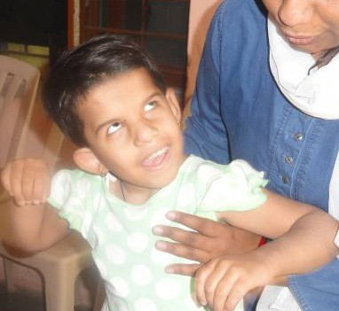

*Figure 15: A girl with deafblindness is using eye pointing to respond*

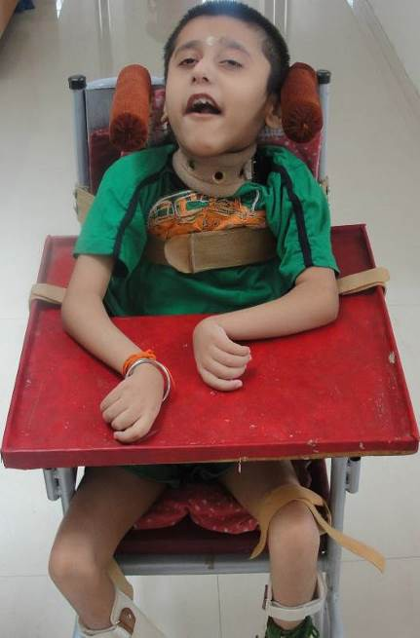

*Figure 16: A deafblind boy sitting on a CP chair*

usually with in an immediate context. Some examples of these non-verbal communication forms, expressed by the child are:

**Body Movements -** Tensing muscles or making a face to indicate discomfort or displeasure, reaching towards something, touching to indicate tactile interest. Relaxing and conforming to being held to indicate comfort and pleasure.

**Natural Gestures** will include Pointing, shaking the head for “no” or nodding for “yes’, “naming” an object or activity

by imitating the associated movement (e.g., producing a bouncing or throwing action with hands to convey idea of ball), pointing to the tap or cup to indicate need to drink.

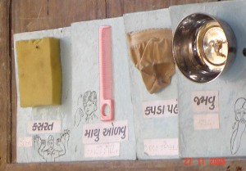**Vocalization** involves the use of voice, without words or formal language for communication. Some vocalizations are unintentional like cries, laughs, screams, but they still communicate reactions. The same vocalizations can also be intentionally directed towards a person to express these reactions. For e.g. A consistent whining sound that indicates distress and is a way of seeking relief and help. A calling sound used when the child is alone and wants some attention, babbling play that is specifically intended to get the mother or family member to join in.

**Use of objects for communication** - The use of objects is natural part of interaction of most children. A child for example will recognize that it is time for her/him to bath when s/he sees the mother getting a towel or when the mother brings a cup of milk recognizes and gets ready to drink. A child who is deafblind may also make natural use of

*Figure 17: A communication board with object symbols*

objects for communication. For e.g. the child will hand a toy to a parent to help activate it.

A deafblind child is likely to do this if s/he is in the familiar environment to make them in to mutual topics of conversation. On the other hand, as a parent, the toy could be turned into a mutual topic of interest with the deafblind child, like playing with the toy, or discovering the toy along with child, and also using it a natural cue for something upcoming. It is also

important for parents to know that objects should always be used in conjunction with other forms of communication, such as gestures, signs, and speech while conversing with the child. Often this is the first form of symbolic communication used expressively by a child with deafblindness.

**Symbolic Communication** involves a more complex system of communication. It uses one thing (a word, sign, symbol, picture, text) to represent another (an object, person, activity, idea. It enables the child to communicate about things or events that may be present or elsewhere, happening currently of remembered from the past or anticipated in the future. The use of such symbols is the key aspects of language.

**Oral language** -This is the expression of communication through speech and the understanding of it through hearing or lip reading.

**Sign language** - This involves the use of specific hand shapes, body movements and facial expressions to represent ideas and concepts. Sign language can be received visually or tactually. Tactual reception of sign language requires the receiver’s hands (or hand to rest lightly upon the hands of the signer, who signs normally. Sign languages vary from country to country. In India, itself it varies a lot from State to State.

**Printed language** - Reading can be through regular size or large print using various types of magnifico- Tion.

**Printing on Palm** - This is a system of forming blackletters on the palm of the receiver using the index fingers as “pen”. It is often used by people with

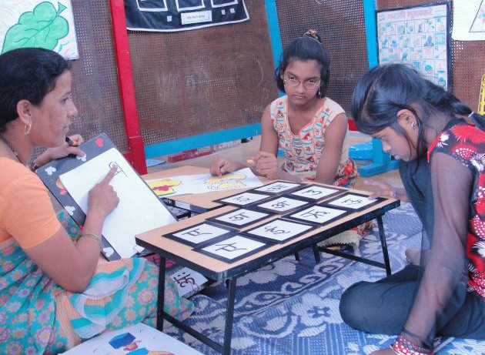

*Figure 18: The teacher is using oral common- citation with students*

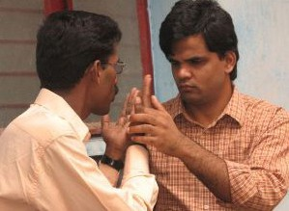

*Figure 19: Adults with deafblindness comma- nictating in tactile sign language*

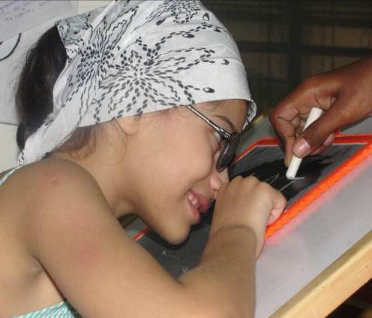

*Figure 20: A girl with deafblindness reading alphabets on slate*

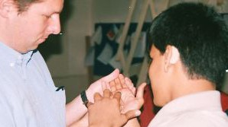

*Figure 21: A deafblind person using print on palm with a person*

deafblindness who are literate and whose major mode of communication is signing when they are communicating with non-signing people.

**Braille** - is a series of raised dots that can be used for reading and writing by the person with blind or deafblindness or whose eyesight is not sufficient for reading printed material.

Braille is not a language, rather, it is a code by which languages may be written and read.

**Augmentative & Alternative Communication Systems** These involves us of variety of system which is individualized and useful in environments (such as public place, or work situations). It includes objects, pictures, electronic communication systems etc.

##### Helping your child to communicate

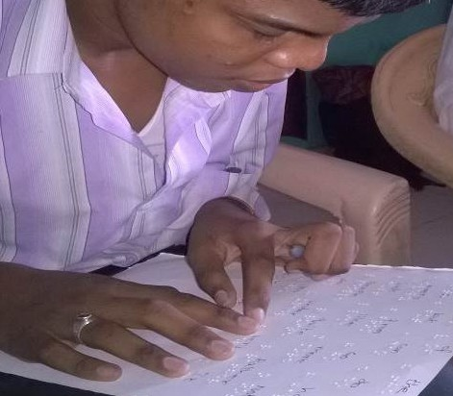

*Figure 22: A deafblind boy reading braille*

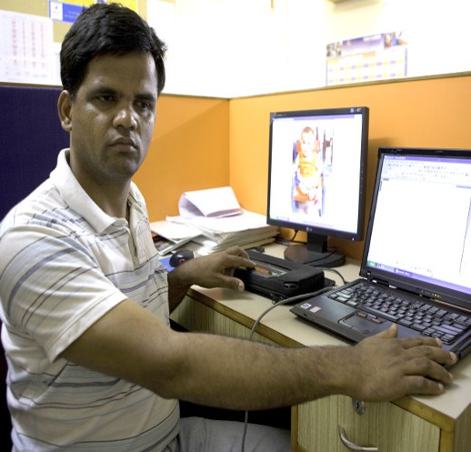

*Figure 23: A deafblind adult using a refreshable braille device*

As we now understand that child with deafblindness relies largely on his/her sense of touch to receive information and express himself or herself. It is hence essential for the parents to use touch cues when communicating with the child. Communication is an integral part of day-to-day life for a child with deafblindness. The parents must also make conscious effort to create more and more opportunities for the child to communicate.

##### Including Communication in activities of day-to-day life

At times we also use objects as cues. e.g. Ram needs to know that it is time to go for a bath. You might show him the towel, which he uses to wipe himself after the bath. Once he touches the towel before going for a bath, it gives him an indication that it is time for a bath.

A movement cue could also be used. e.g. you could also do the action/movement of rub- Bing the soap on the body before the bathing activity, so that the child understands it is time for a bath.

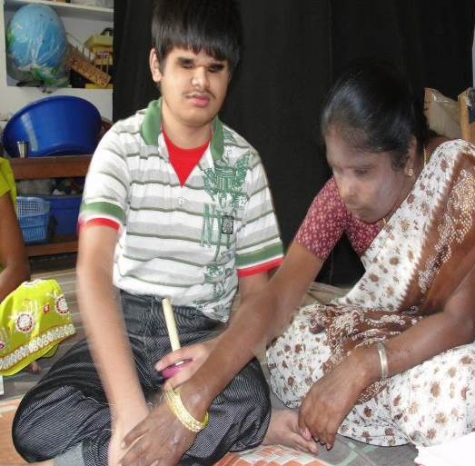You could also combine a touch cue with an ob.- jet cue. e.g. for the activity of wearing pants, you could show the pants to the child which he will be wearing, that is an object cue. At the same time, you could tap his waist, that is a touch cue.

*Figure 24: Teacher is teaching a boy with deafblindness through touch*

There are many environmental cues, which could be used as well, such as smell of the food when the child comes near the kitchen. As you consistently combine verbal commune- cation with cues, the child gradually learns to understand it.

For a child to initiate and understand communication it is important that the people who communicate frequently with the child such as his/her parents or teachers, use commune- cation forms, such as cues, speech, etc. which s/he is capable of understanding, respond- Ing and later on using it.

As mentioned earlier, it is also important that the child has topics, experiences and needs or wants to communicate about. This comes through giving the child opportunities for communication in his/her day-to-day life. Thus, the key is in finding out opportunities for communication in different activities which are done on a daily basis, such as bathing, eating food, dressing, etc.

In the life of a child with deafblindness/MSI, these four components occupy a high priority.

**Anticipation:** The child must have enough information through touch cues, environment- tall cues, object cues, picture cues, signing, print, or speech to anticipate coming events.

**Motivation:** The persons surrounding the deafblind child must always motivate him/her to be enthusiastic to learn new skills and practice old ones.

**Communication:** S/he must receive information in a way that is understandable to him/ her and learn to express in a way that others understand.

**Confirmation and response:** The child with deafblindness must get information and immediate feedback so that s/he knows what effect his/her actions are having on the world around him/her. S/he needs someone to say, “Yes, I understand what you said, go ahead!” It could be a nod of the head, a squeeze of the hand or a sign or a hug to give feedback. Then a response to what is communicated.

Each child with deafblindness/MSI is a unique individual personality who communicates in unique ways. It cannot be over emphasized that it is essential to follow the lead of a particular child in helping him or her to develop communication skills. No single method works for all children. Although methods must be tailored to the individual’s strengths and style of learning, the way we think about these children must embrace what they have in common.

###### “Once I knew only darkness and stillness… My life was without past or future. But a little word from the fingers of another fell into my hand that clutched at emptiness and my heart leaped to the rapture of living.” - Helen Keller

These moving lines of Helen Keller explains the importance of communication in her life and we realize that it would be the same in the lives of all children and adults with deaf- blindness. Without the ability to communicate, development of meaningful human real- townships is impossible. Life is timeless, formless, and isolated. There can be no service greater to a person with deafblindness/MSI than to provide the ability to interact with the environment and communicate with others.

##### References:

1. *NIMH, 2003, Education of Children with Deafblindness and Additional Disabilities, Source book for Master trainers. Published by NIMH in collaboration with Voice and Vision task Force, HKIDB, Mumbai.*
2. *Miles B and Riggio M, Editors, 1999, Remarkable Conversations, Watertown, Massachusetts, Perkins School for the Blind*
3. *Miles B, 1995, Overview of Deafblindness, Internet, DB Link, Available from* [*http://www.*](http://www/)

*nationaldb.org/, accessed April 2014*

1. *National Consortium of Deaf-Blindness (previously DB-LINK), 2005, Receptive Communication: How children understand your messages to them (revised), Internet, National Consortium of Deaf-Blindness (previously DB-LINK), Available at* [*http://www.*](http://www/) *nationaldb.org, accessed April 2014*
2. *Awareness cum training Packages in Disability-Hearing Impairment-fostering Language development.*
3. *Training Module on Deafblindness- Sarva Shiksha Abhiyan*
4. *Healthy Lifestyle Infant and Toddler Health Language Development –Speech*

*Milestones for babies-By Mayo Clinic Staff-Internet*

1. *Communication Manual by Dipti Karnad submitted participant in Educational Leadership Program-Perkins School for the Blind-February 2000*

### Developing literacy through functional activities

##### What is Literacy?

**Literacy:** It generally refers to the ability to read and write. However, it is also known as the ability of performing the skills in day to day lives. Literacy develops from birth and the development of literacy depends upon variety of experiences. Almost 90% of all our early learning is dependent on vision.

We need to consider the child’s age, learning method (visual, auditory, tactile), degree of sensory loss, cognition, functional/formal literacy approach & communication mode for teaching literacy.

##### Facet Literacy:

* 1. **Emergent Literacy:** It is the process of developing literacy that begins at birth and ends when children begin to engage in conventional or functional reading and writ- Ing. *(Soulsby & Teale, 1991)*
  2. **Academic Literacy:** The basic reading and writing skills taught in a conventional literacy medium during elementary and middle school years is known as academic literacy. *(Koenig & Holbrook, 2000)*
  3. **Functional Literacy:** The application of literacy skills and the use of a variety of literacy tools to accomplish daily tasks in the home, school, community and work

setting is called functional literacy. *(Koenig, 1992)*

1. **Importance of literacy:** Literacy helps us to make sense of the world. The time we wake up and time till we sleep consistently making meaning of the world around us. There are living and non-living creatures around us and we attach, acquire and communicate meaning to lead our day today activities smoothly. As much as important it is for everyone to be good in literacy so is for a person with deafblindness and additional disabilities, literacy is the ability to perform in jobs, run household, act as citizen, to be independent in life.
2. **Methods and strategies to develop literacy**: A person who has unique visual and hearing difficulties, unique language developing challenges, physical limitations or cognitive challenges, none of their challenges should be a barrier to the development of literacy. By proving the required and different strategies as per their needs and abilities, they are discussed as below:

**Create opportunities for literacy:** It is important to provide an opportunity for a child with deafblindness and additional disabilities. Create a variety of books, magazines and writing materials for the child to explore. Allow the child to explore in whatever way(s) work best (initially may involve tasting, smelling or acting on the materials in a destructive way), establish a consistent location for materials so child can access independently, allow children to explore writing using adapted and non-conventional materials if/when child is ready, provide opportunities for child to scribble, stamp, finger paint etc.

**Model reading and writing behaviors:** Let the child know that you are reading and writing to him/her, enhance the communication skills through signing, using a cue or an objects and pictures. Let the child knows what you are doing by explaining and allowing her to touch and feel, e.g. mommy writing a grocery list, daddy is paying the bills, brother is doing homework, teacher is taking attendance etc.

**Embed literacy learning activities into routine:** Providing all the possible means of concepts and add a meaning to his/her routines. Here’s how you can access and develop child’s literacy through materials:

**Objects:** To label all the materials and objects in the environment e.g. labeling the names of materials like Television, fridge, door etc., or putting a tactile symbol or labeling them

in braille, this would allow the child to learn about things and names unknowingly without much effort. Also, one should note that symbols or an object used to represent any activity or cue has to be familiar object to the child so that it helps the child to be aware and connect easily.

**Adapt the language level concepts:** Adapting the level concepts in the textbook for the child to learn to suits the learning and understanding of the child, highlighting and presenting only the key words for the child to learn is necessary. So that he/she would be able to learn rather than learning everything. For example, I finished having my breakfast, the key word would be **breakfast done.**

**Embossed prints:** Embossed prints is the method of pressing an image into a paper or a sheet where it gives tactile input through raised surface.

**Adapted story book:** Adapted books are books that are modified to make reading accessible to an individual, it is being prepared in such a way that learners can easily access as per his/her requirements. Using low-cost materials like cardboards, plastics, and different kinds of readymade materials. One can prepare a story which are meaning for the child, experience story book, festivals book, summer vacation book etc.

**Adapted reading and writing materials:** Supply reading and writing materials to the child like black markers, large crayons, special grips (tape wrapped around the marker to hold it and make it easily graspable, in case of physical limitations), adapted computer keyboards by tactile labels in each key), providing large prints, pictures and color contrast etc., these are some examples for such child who has difficulties in different areas which may be aided in doing so.

**Sign Language:** Involves using of specific hand shapes and body movements to express themselves. It may be of Visual and tactual/tactile sign language. Visual signing means communicating using sign in front of a sighted or a person having residual vision at the eye level. Tactual or tactile sign language is the mode of communication used for a per- son who have very little vision or who is totally blind. The sign is felt through touch by placing or signing together with the learners and the sighted person or no vision at all. The hand of the learner may be placed under or above the signer hand to encourage and ex- press the child or adult to communicate. There are also a fixed number of finger positions which can be used to convey numbers, when teaching and provided sign language, this will allow real access to the language being represented by Braille or print, when com-

medicating of the child’s interest using sign, this will allow the child to learn and improve language when signing and then transcribing it in braille or print.

**Braille:** Braille is a system of touch and reading for visually impaired and persons with deafblindness using raised dots and each dots represents the letters of the alphabets, numbers, punctuations, musical keys etc. Braille is critically important as it allows one to read and write and it opens the door to literacy, allows equal opportunities and intellectual freedom.

#### Orientation and Mobility concepts

1. Developing Pre-mobility
2. Improvement in body awareness through identification of body parts in different

activities of daily living

1. Development of indoor and outdoor mobility
2. Importance of community experience
3. Mobility techniques
   1. Sighted guide
   2. Use of protective techniques
   3. Trailing technique

##### Orientation and Mobility for Persons with Deafblindness

Orientation and mobility training provides a person with deafblindness with a set of found- dation skills to use residual visual, auditory and other sensory information to understand his/ her environment and provide the child to build movement security and encourage exploration. It helps them to move around, travel safely and independently in a familiar or unfamiliar environment. Orientation and mobility training involves the use of sighted persons, canes, walkers, or wheelchairs.

**Orientation:** Orientation is the ability to know where we are in an environment, it depends on the things in the surroundings. To get orient our self we rely on our remaining senses to get to know our position in the environment.

*https://atmapping.wordpress.com/2018/05/17/orientation-and-mobility-om/*

**Mobility:** Mobility is defined as “movement” not just a particular technique or device. It in-

clues obtaining freedom of movement, safety in travelling as well as minimizing the level of stress placed. A well-developed mobility facilitates independent movement. Mobility refers to total bodily movement which involves a change in spatial location accomplished in an upright position under one’s own power. It describes all situations ranging from mov- Ing around within a single room, in a house or travelling from one town to another or even between countries. To be mobile, person with deafblindness should be able to gather and use sufficient information from the environment to avoid hazards and to reach his/ her destination safely. Thus, mobility is the ability to move in the environment in relation to oneself from one place to another.

##### Importance of Orientation and Mobility:

* It is an important pre-requisite for the integration of a person with deafblindness into the community and working life.
* Being able to travel freely.
* Safety of the individual.
* It enables him/her to learn to become more independent in indoor as well as outdoor mobility.
* It allows a person more freedom and makes him/her less dependent on family and friends.
* It also educates the public for changing attitude.
* It is essential for correcting gait and postures.

##### Using other senses for orientation:

Persons with deafblindness attains independence in travel if trained in effective and ap- propriate use of remaining senses. Sensory stimuli termed as ‘Clues’ generally enable him to determine his position or direction in respect of the environment. Sensory training should be provided in the following areas:

**Touch:** A person with deafblindness can orient by the sense of touch. It is essential for concept clarity and determination of exactness of the object. S/He can use hands or feet to explore the environment in the following ways:

##### Hands can be used to:

* + Understand spatial quality, surface texture, temperature, movement and weight
  + Establish the position and identifying the objects
  + Avail information about the layout of the environment through object symbols, landmarks, tactile maps, models, embossed diagrams and relief maps
  + Understand the variety of objects available

##### Feet can be used to:

* + Understand position of various landmarks on the pathways etc.
  + Understand the relative position of buildings and the direction and lengths of connecting roads
  + Feel changes in surface texture, slope etc.
  + Understand differences in geographical conditions

The touch has its limitation as large objects and the environment in general is invariably beyond tactile exploration.

1. **Smell** is useful for orientation both in house and outside in the following ways:
   * Particular shops, factories or establishments can be identified by odor
   * Smell from kitchen, store, prayer room or dining room can be useful as a cue for direction
   * Through smell, one can establish presence of particular animals in the proximity
   * Typical odor from the sewerage or open drains in the rural areas can be used as landmarks
   * Senses of smell is useful for understanding one’s relative position in an agricultural or a dairy farm or a garden
   * To relate or associate different items from their smell
2. **Temperature:** Changes of temperature on the face or body can be used to provide orientation information. For example, it is possible to recognize position of the sun by part of the face which feels hot. The relative position can be understood by a change from shade to sun.

The response of the body to external stimuli, termed as kinesthetic sense enables a person to avail environmental information like heat, cold, rain, breeze, sharp turn etc.

1. **Vestibular Proprioceptive & Kinesthetic Sense:** A person gets the body balance and keep themselves upright because vestibular sense. The proprioceptive sense helps the person to understand the type of ground or surface where they are standing or walking. The receptors in the joints and muscles are giving information to the brain about the physical/body movement of the individual, with this information, a person with deafblindness comes to know how much they need to raise/move their limbs or body while moving from one place to another, this is termed as kinesthetic sense.
2. **Sense of Taste:** It has less utility for sensory training in orientation and mobility as it does not provide any information about the relative environment. This sense needs to be provoked for its utility. It helps a person with deafblindness to associate names of the particular substances with their particular taste:
   * Sweets with sugar, candy
   * Sour with citrus fruits, juices
   * Bitter with medicines, herbs, plants
   * Hot with tea, coffee, milk
   * Cold with ice-cream, ice, cold water etc.

The sense of taste is particularly useful for identifying the ingredients of food items, dietary substances and like items.

##### Adaptation of techniques to suit Indian conditions:

Many persons with Disabilities in India reside in the rural areas. The road conditions in India, particularly in the rural areas are unsafe. The approach/ roads to most of the villages and streets in the rural areas are not well planned and are unmetalled. At the same time, education as well as training opportunities for people with disabilities, particularly those who acquire visual impairment and hearing impairment at later age are grossly inadequate. The mobility aids are not easily available. Whatsoever aids are available, these have to be suitably adapted to suit the local conditions.

While adapting the mobility techniques for people with deafblindness living in the rural areas, following factors should be kept in mind:

* + Easy to perform with the least possible physical strain
  + Cost within the reach of everyone
  + Maximum safety in local conditions
  + Appearance in consonance with the surroundings
  + Easy to repair and maintain
  + Easy availability

##### Developing Pre-Mobility Skills in Children with Deafblindness

Although orientation and mobility involve an understanding of one’s location in a given environment and the ability to move through the environment safely and independently, it is also equally important to recognize the underpinning significance of movement in the development and maintenance of both as a pre-mobility skill.

One of the most important tasks for the parent of a child with deafblindness is to get the child moving. Movement brings the child into contact with objects and people in the world. Contact with the world stimulates many aspects of the child’s development—language, curiosity, problem solving, concept development, social interaction.

Early and conscious intervention to encourage and maximize movement development is vital for children with deafblindness. Touch plays a significant role in movement develop- mint i.e. what can be felt by the body through accidental, directed or purposeful touch or because of movement.

Children with vision, develop some of their movement skills by copying those that they observe around them. Children with Deafblindness require their movements to be guided through coactive physical contact for the same development to take place. Inevitably, this is not the case with the development of movement for a child with deafblindness as there is no sensory feedback. This leads to a sense of fear and instability in the child with deafblindness.

Mothers in the northeast states of India tie their babies with their chest or back with a cloth and carry on their regular household and other works. Babies get constant information of body movement of their mother and get used to various body movements like bending, pace of movements, breathing patterns etc. Thus, it helps the child with deafblindness to have a basic idea about movement and when they are let down, they don’t have much hesitations to move around independently.

**b) Improvement in body awareness through identification of body parts in different**

**activities of daily living**

**Concept Development Directions and Body Awareness**

Children with Deafblindness requires specific intervention to learn to identify their body parts, understand movement and learn what the bodies of other people are like. Activities to support this development of this awareness should begin from early infancy. Playing games together also enhances learning of communication and awareness of body image together. Closely associated with body awareness is the range of concepts related to position, movement and directionality of body like, up-down, top-bottom, straight- bent, front- back, right- left etc. By understanding these concepts, children with deafblindness define their relationship with the word. Using a wide variety of activities and playing games assist children with deafblindness to identify their body parts and build a realistic body image. For e.g. by placing the child’s hand on your head and then observing if the child is able to touch his/her head and identify it. While playing parents can indicate the different functions of the body parts, explain, and demonstrate what each part does in a way the child will understand. Other important skills related to body awareness for effective move- mint and walking include how far body parts can reach and bend and knowing where the body fits as movement takes place. For example, the child can move in and out of a big empty carton or box.

**Environmental Sounds:** Besides light and directions, sound play a very important role in orientation. Teach your child to listen to the sound produced by moving objects like vein- clues going by on the street, to the refrigerator humming in the kitchen, or to the sound of the television in the living room. Point out that far away sounds are quiet or muffled and pick out important sounds in your house or neighborhood (each room in your house may have a particular sound like a clock ticking or a sink dripping).

**Listening Play:** One of Sunnys favorite games is to throw his blocks and listen to what they hit. He throws blocks in different directions then waits to hear what he had hit. This helps him learn to listen and to identify objects in different locations around him. The skill is defined as localization of sound.

**Introducing cane through play way method:** This play is a great idea to familiarize your child with deafblindness with the object that will be so important to their independence when they get older. You can begin teaching them by giving orientation to various sounds produced by the cane when it touches different objects. Make them feel the difference felt in their hands when they touch different objects, make them feel the vibrations when it hits the mud ground and solid concrete or tar roads. Make your child sit in your lap and hold on to the cane with him/ her while you tap carpet, tile, wood, plastic, and other surfaces.

Cane can be used as a hockey stick as well, give the cane and a medium weighed big size ball to the child and guide to hit ball slowly with the cane, move forward find the ball and keep hitting with the cane. The activity will be helpful for all children with deafblindness, gradually they learn to hold, lift and move the cane well. Also, they learn to balance themselves using the cane.

**Texture Play:** Helping children with deafblindness to touch different textures with his/her hands are also very helpful in understanding what’s around them. Children can be taken for a walk down the street and guide them to touch everything while you describe it. Some children with deafblindness will react negatively to certain textures, such as sticky

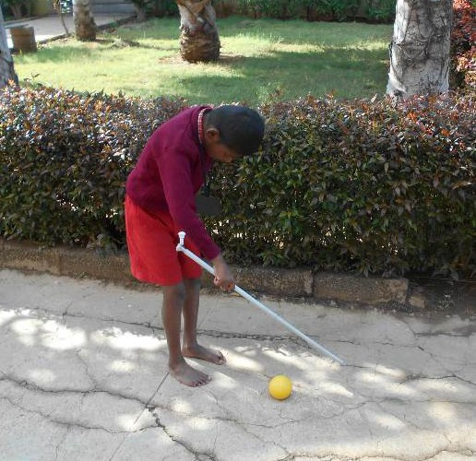

*Figure 25: A boy with deafblindness using cane during play*

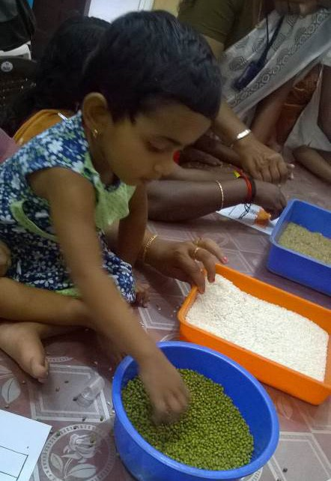

*Figure 26: A young girl playing with grains*

things. If parents of children with deafblindness encounter this problem, they should not force the children to touch such things. They may consider using HUH strategy first to make the child feel comfortable to explore new textures. Child’s hands are kept over the mothers’ hands and mother should touch the textures or things and explore and gradually make sure that the child’s hands get the opportunity to touch the texture or things. Try following some activity which may desensitize the problem. For example, put together a

“Sticky box” where you fill a box with all sorts of sticky things which your child just hates to touch. Guide the child to play with the box few times a week. Feeling doesn’t stop at the hands! Be sure to get their feet in that box, too!

##### Development of Indoor and Outdoor mobility

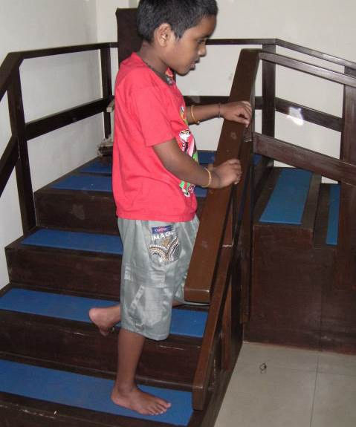Indoor mobility may include activities like stair climbing, negotiating articles and things and varying floor surfaces of different rooms, going to the toilet etc. The child can be helped to climb stairs by holding on to the handrail, with one hand while facing straight up the stairs. She can also be oriented with layout of things and articles. Remember that this will take time and practice.

##### Outdoor mobility Sighted Guided Travel

Moving from one place to another by holding just above the elbow of a sighted person is known as sighted guide travel. The sighted person can pass cues to a person with deafblindness by moving their hands up and down or folding the hand behind them. This technique gives the person with deafblindness a constant grip and feels secured as the sighted person go a step ahead. This technique also makes the active participation of the person with deafblindness, whenever they want to rest or slow down the pace of walking, they can manipulate the sighted guide.

The sighted guide can make a person with deafblind- ness to understand the environment by giving cues through their arm and body movement. They can just lift their arm a bit up as an indicator to climb the stairs, bend the arm to their back as an indicator of a narrow space and the person with deafblindness should come directly behind the sighted guide. A common adapt- Tion for smaller students to the “basic” guided travel technique is to have the student grasp the guide’s ex-

*Figure 27: A boy with deafblindness climb- Ing stairs using railing*

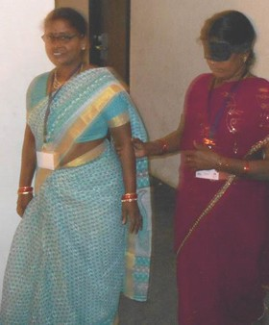

*Figure 28: A teacher with blind folds learns- Ing sighted guide technique*

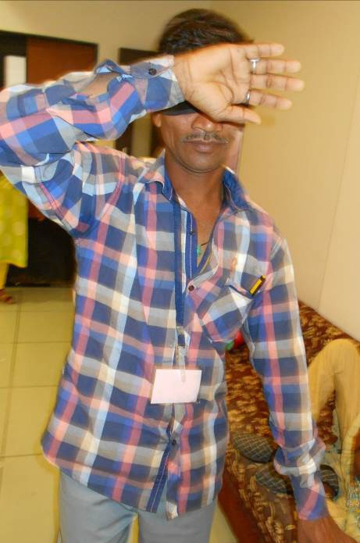tended fingers, wrist, or forearm rather than maintaining a grip above the elbow. Effective sighted guided travel involves a partnership between guide and child with both portici- pants actively involved.

##### Protective Techniques

Protective techniques are used during independent mobility to reach a place safely, usually this technique is used in the familiar places. Also, this technique is useful to locate the objects without getting hurt. Upper hand and forearm protection technique in which the arm is bent and held across the body at shoulder height, parallel to the floor, with the palm facing outward and the fingertips extending beyond the opposite shoulder, will provide protection from objects the student may contact at head and chest level. Lower hand and forearm protective technique with the arm extended down and held diagonally across the body, provides protection from obstacles

*Figure 28: A teacher with blind folds learning sighted guide technique*

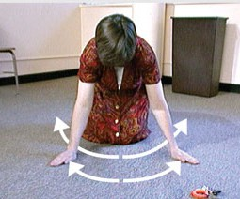at waist to upper leg level. The technique involves holding the arm out in front the area to be protected such as the waist, groin or upper thigh. This technique can be used to locate the back of a chair, a low table, etc. These two techniques are sometimes used together, but they can be fatiguing. Typically, neither technique is used continually, but rather is applied as needed or required. For example, an individual may use trailing skills while walking down a familiar hallway and use the forearm protection technique only near the end of the hall because he knows that there is a door that is often left open and s/he wants to locate it without injury.

*Source: https://nationaldb.org/library/page/1936*

##### Safely locating a dropped object

It is often very difficult for a person with deafblindness to find objects after they have fallen on the floor. Persons with deafblindness has to perform this task a little differently than a sighted person. In the case with children with hearing-sight, they may bend down

*Figure 29: A teacher with blind folds learning searching techniques*

on their knees and would locate it with sight and hearing. The same procedure may not be applicable with a child with deafblindness, if the child simply bends forward to pick up an object, s/he will not know if there is an object in the way (e.g., a low table) and could hit her/his head on it while bending. The child should use the upper hand and forearm technique when actually bending forward to the floor.

The actual searching for the dropped toy may be side-to-side sweeping motion of one or

both hands. The child should have as much of her/his arm on the floor as possible.

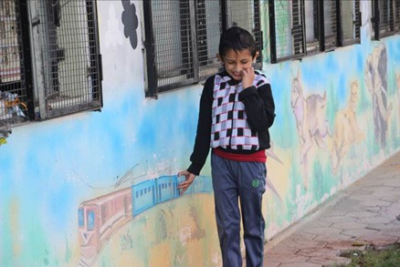By taking these few extra steps, the child will remain safe, even when attempting to locate a dropped toy. If the child does not take the extra precaution of using the protective technique when bending forward, s/he may

frequently bump her/his head.

**Trailing:** It is essential to impart training to persons with deafblindness. Trailing helps them to walk straight and provides them with tactual information. It enables them to detect landmarks or find doorways. While trailing, a student will extend the arm at about 45 degrees, holding the arm to the side and

*Figure 30: A boy with deafblindness using trailing tech- Nique for mobility*

slightly in front of the body while maintaining contact with the surface, such as a wall. This technique can provide with a method of maintaining alignment. It also provides some protection during travel, as well as some information about the environment. This skill can be used in a variety of situations. Examples include traveling down hallways while looking for a specific object such as a door, or when a person wants to achieve a straighter line of travel to maintain orientation, or while traveling along the outside of a building while locating a way in. Trailing is also sometimes used along with a mobility device, or in conjunction with upper hand and forearm protection.

1. Side or back of the hand should be used to follow a wall, edge of a table, or other similar objects
2. Stand next to the object s/he wants to follow.
3. Extend the arm that is closer to the object and back of her/his fingers should

touch the object

1. Walk by trailing fingers along the surface towards her/his destination.

##### Some Cautions to be followed under trailing:

1. Only the side or back of the hand should touch the surface to be trailed because the

inside of the fingers are too delicate and may get hurt while trailing a rough object.

1. While trailing, the arm and hands should not drop too close to the body as the person

may not find time to stop when there is an obstruction.

1. The other arm should be used for protection of the head.

##### A young girl using walker to learn walkingCane technique

There are many mobility devices that can support a person with deafblindness for independent mobility. The devices should be provided to a child with deafblindness with the means for independent, safe and efficient travel. The most commonly recognized mobility device for persons with deafblindness is the long red & white cane. Many other mobility devices are also available but the red & white cane is suited to Indian conditions. Mobility devices serve as an extension of the user’s arm(s), hand(s), and fingers, and provide protection from obstacles allowing access to information in the environment.

**Pre-cane Devices:** These devices were originally devel- opted by Dr. Everett Hill at Vanderbilt University. They are useful for preschool children with deafblindness These resemble the mobility devices used by seeing toddlers when they start walking with the help of a support. These devices are suitable for children with deafblindness to use as soon as they start walking with confidence.

This is mostly used in rural areas of India.

*Figure 31: A young girl using walker to learn walking*

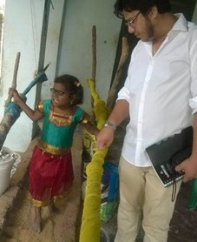

*Figure 32: An expert observing a girl with deafblindness on an adapted parallel bar at home*

These devices may be made from materials like:

* Bamboo
* Wood
* PVC pipe
* Plastic molded pipe
* Aluminum rod

The size of device will depend upon age and height of the child. Beginning may be made with a simple rectangle shape pipe structure with a provision for a hand grip. As the child gains confidence, device may be modified to

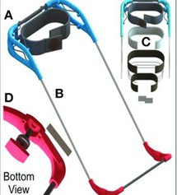

*Figure 33: A percale device for children for mobility*

the shape of an “inverted T”. Subsequently, castor wheels may also be added to enable

the child to roll it on the ground.

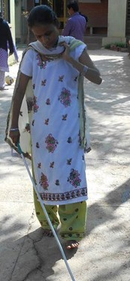This device would:

* Enable the child with deafblindness to gain confit- dance in movement
* Provide safety from the obstructions on the floor
* Be a fun to experience independent movement

Lay the foundation for the use of mobility cane when the child grows. The red & white cane is used primarily as an extension of the fore finger to help in locating obstacles along the route and provide information about the environment. White cane is accepted as a symbol of visually impairment and red & white cane of people with deaf blindness. It has been regarded as the proven mobility aid which is inexpensive, handy and has adjustable length. It plays a vital role in the education, social integration and comprehensive rehabilitation of people with deafblindness.

*Figure 34: A woman with deafblindness using cane for mobility*

##### Adaptation of the Cane Technique

The cane technique can be modified according to:

* traffic conditions
* surface
* Rural or urban conditions, etc.

##### The following modifications are advisable:

* In an urban area, it is advisable to walk in the middle of the pavement to avoid the hazards found at the pavement boundaries.
* In a busy and congested area, it is advisable to reduce effective length by holding the

grip lower down to reduce contact with other persons.

* In rural areas where the pavements are not properly laid, the effective length as well as sweep may be increased to cover a wider area. In muddy conditions, the effective length as well as sweep may be reduced.

Thus, the red & white cane system has given a new lease of life and a new dimension of independence to a large number of persons with deafblindness.

##### Practical Strategies for Families and Team Members

* Provide opportunities for your child or student to explore all areas of his or her environment, particularly the home. Help the child to locate stationary landmarks that provide reference points. For example, a child may know that S/he is in the bedroom after locating his/her bed with the “special” mosquito net. Be sure to allow him/her to find mosquito net so he/she will know when he/she is in the bedroom.
* Let your child or student experience a variety of surfaces such as carpet, tiled floors, vinyl flooring, grass, pavements, sand, uneven road, etc.
* Allow your child or student to participate fully in activities. For example, if he/she wants to play with toys, help him/her go to the place where the toys are located and select the toy that interests him/her. Travel back to the play area together. This process allows him/her to understand his/her environment more completely, as compared to having the toys simply brought to him/her.
* Make full use of “reference points,” those clues that help us know about our position. We have all experienced being lost in an unfamiliar city, only to become “reoriented”

once we locate a familiar landmark. Similarly, children with deafblindness need to learn to use reference points to help them stay oriented in their environment. Reference points can be auditory, tactile, olfactory, or visual.

* Encourage your child or student to travel as independently as possible. If s/he can walk independently, allow him/her to do so. If s/he is learning to walk with a guide, don’t hold his/her hand and pull him/her along with you. If s/he is capable of reaching out to locate a desired toy, don’t allow it to “magically appear” by bringing it to him/her.
* Be sure lighting is adequate for children who have residual vision. The use of high contrasts can also assist some students. For example, using a light rug on a dark carpet may help the child recognize a transition to a different room
* Make use of physical boundaries so the child can better understand his/her surroundings. It is much easier to comprehend a play area bounded by wall dividers or bookshelves than an arbitrary space in the middle of a large room.
* Provide opportunities for the child or student to solve problems on his or her own. Avoid helping before s/he can even think of how to solve the problem for example if the ball rolls away, do not pick it up instead wait for the child to find a way to retrieve it.
* Help a child or student associate familiar toys and objects with the environments in which they may be used. For example, show him/her the towel before walking to the bathroom for a bath, or the ball before going to the garden to play.

Thus, Orientation and Mobility (O&M) is a vital programmed for children and persons with deafblindness/MSI and its importance can never be over emphasized. O&M is important because instruction covers the following areas:

* Sensory development or maximizing all of your senses to help you know where you are and where you want to go - Sensory development, which includes visual, auditory, vestibular, kinesthetic, tactile, olfactory, and proprioceptive senses, and the inter- relationships of these systems
* Concept development which includes body image, spatial, temporal, positional, directional, and environmental concepts
* Motor development, including motor skills needed for balance, posture, and gait, as well as the use of adaptive devices and techniques to assist those with multiple disabilities
* Residual vision stimulation and training
* Human guide technique
* Upper and lower protective techniques
* Locating dropped objects
* Trailing
* Squaring-off
* Using a cane and other devices to walk safely and efficiently
* Soliciting and/or declining assistance
* Following directions
* Utilizing landmarks
* Search patterns
* Compass directions
* Route planning
* Locating destinations using various techniques and tools
* Analysis and identification of intersections and traffic patterns
* The use of traffic control devices
* Techniques for crossing streets
* Techniques for travel in indoor environments, outdoors, travel in rural areas
* Techniques for crossing streets, such as analyzing and identifying intersections and

traffic patterns

* Problem-solving skills to determine what to do if you are disoriented or lost or need to change your route
* Using public transportation and transit systems
* Evaluation with sun filters for the reduction of glare
* Instructional use of low vision devices

Independent movement is critical for all children with deafblindness/MSI. Orientation and Mobility specialists are trained to provide instruction which will enable children with deafblindness /MSI to reach their highest level of independence. The services provided by an O & M may not always need to be delivered directly to be effective, but even infants or children with multiple disabilities need the special support of a trained Orientation & Mobility Specialist but these activities can be replicated at home too.

###### References:

*Hand in hand: essentials of communication and orientation and ..., Volume 1 By Kathleen Mary Heubner Orientation and Mobility for persons with deafblindness, Sense international India Visual Impairment handbook – Blind People’s Association*

### Common Teaching Strategies

##### Guidelines for working successfully with children with deafblindness Teaching Strategies for children with deafblindness

Walking, running, bending, sitting, writing, dressing – many of these everyday activities is very easy to do for a child with sight and hearing. While, for a child with deafblindness, it is not always easy. It requires a lot of patience to teach a child with deafblindness all daily living activities and developing their skills. There are several strategies used for teaching a child with deafblindness. It may not be possible to use all the strategies at once, or even on a daily basis, but each will help to work with them in a natural manner.

##### Teach Functional skills

Children with deafblindness need to receive constant accurate information about the environment. They need to be taught that people communicate, and they need a communication system that will enable them to interact with others. They need to learn to anticipate events in life, and they need to be given the opportunity to make choices. Teaching strategies which should be kept in priority are as follows-

* + - Always let the child know you are there, and who you are
    - Focus on developing a trusting relationship with the child
    - Create opportunities for ‘more’ responses, such

as rhythm games, finger plays and songs

* + - Create opportunities for turn – taking (e.g. Mother will clap first; she will wait and give the opportunity and time to the child also to clap)
    - The hands become the eyes and ears. HUH technique allows the child to observe with his/her hands
    - Use routines to teach practical skills in natural settings. This helps the child anticipate events and actions (teaching brushing should be done

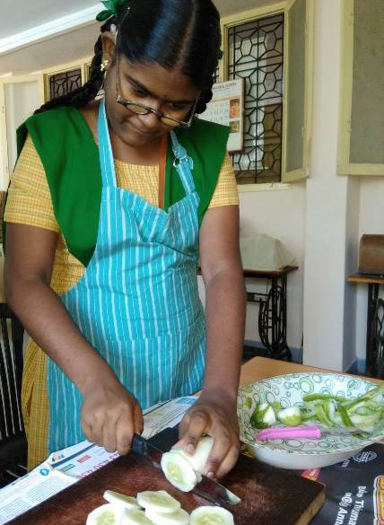

*Figure 35: A girl with deafblindness doing cooking activity*

in the morning and at a fixed place)

* + - Emphasize the beginning, middle and end of activities and routines to provide structure
    - Prepare schedules to organize time, develop anticipation, and understand that one thing must be completed before going on to the next thing

##### Develop bonding:

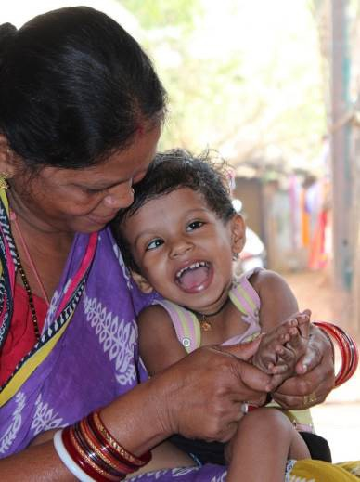First thing the parents and family members need to do is to develop bonding. Bonding means to develop good relation and trust. For e.g. mother holding a child in her lap and singing the song as well as doing the actions co-actively.

It is not so easy for the child with deafblindness to bond with everyone, also the child may take time to bond with a particular person. Just by working with the child regularly we can’t develop bonding, the child needs to feel comfortable and safe with the person then gradually bonding will take place. Bonding will take place when their favorite activity is used following the child’s lead.

*Figure 36: A mother is playing with a young child with deafblindness*

Mala is a four year’s old little girl with deafblindness. Her favorite activity is to stay by herself and spin around. Her new caretaker Meena is trying to establish a bond with her. Meena realizes that she has to take the lead from Mala and she picks her up and spins her around gently. Initially Mala resists and wants to be let off, but when Meena stops and sets her down, she stretches her arm to look for her teacher, as if asking for her to spin her again. This starts the process of bonding. When Meena takes the lead from Mala in various situations, the latter realizes that she can trust the adult. When this bonding is established, a schedule can be developed.

In case of a child with deafblindness or MSI, things often magically appear and dismal- pear before her/him. Cause and effect are elusive. People do things to her/him but not necessarily with her/him. There is hardly any explanation of events before they occur. Instruction that are always directive requires no response from the child. For this reason, it is important to make use of turn taking activities so that the interactions are balanced making the child (my turn, your turn) to encourage equal participation.

##### Creating a successful environment for learning: -

1. **Using routines to create stability:**

Everyone depends on routines. Children with deafblindness depend on routine to allow them to understand what is happening, and what will happen next. Routine can give them information they cannot access through their senses. As they learn to use a routine, they understand more about the world, and it seems a less frightening place. Routine allows a child to the maximum possible chance of recognizing an event, and thus of feeling secure, of making responses, and of learning.

The child with sensory impairments will learn to use a variety of cues to help her/him understand her/his place in the routine.

Cues that may help children with sensory impairments to orient themselves in routines include:

##### Musical prompts

The child may actively and eagerly participate in a familiar song and movement game (such as “Row, Row, Row Your Boat,” for five minutes or so; then you may feel her/his participation fade. S/he may turn her/his head to the side. If you persist in continuing the interaction, s/he may actively resist moving her/his hands with yours, stiffening her/his whole body and turning away.

##### Touch to specific parts of the body

The child may open her/his mouth eagerly when her/his spoon touches her/his lips, clear- lee indicating s/he wants more food. S/he may keep her/his lips closed as the spoon ap- preaches, and if feeding attempts continue, may turn her/his head away, lean back into his/her chair, stiffen, or become agitated, indicating s/he does not want to eat what is being offered.

##### Movement

The child may crawl to the door and sit, or bang the door, as an indication that s/he wants

to go out. Later, s/he may even come take your hand and take you to the door as a re- quest to go outside

##### Object ‘prompts’

Towel and soap are given to the child to make her/him anticipate time for bathing. Using spoon is an object cue for indicating it is time for taking food

##### Teaching in natural settings

* + - **Specific places for activities**

The child is made to sit at the dining table and s/he gets the cue that it is time for taking food. Some of these cues may be deliberately introduced, and others will occur naturally during the routine.

At first, a child may only understand short and simple routines. These may involve play such as ‘peek-a-boo’ games, where the child starts to anticipate the cloth coming off, or singing ‘round and round the garden’, as the child starts to laugh before the tickle. Simple home routine before a bath or taking food, may also begin to have meaning. As a child masters simple routines, more elements can gradually be included in the routine.

To allow the child to recognize and learn the routine, elements or task needs to be pre- scented in the same way and in the same order each time.

The routine of beginning, action and finishing which underlines many activities can be

emphasized by:

* + - Beginning: taking correct objects out of a box
    - Action: placing object on table or tray and using it
    - Finishing: returning it to the box

The child him/herself may learn to use the routine and later on they will be able to inform parents/ educators whether he/she wants to start, continue or finish particular an active- ties. Initially parents can focus on routines like: Brushing, Bathing, Meal Time, Play Time

etc. with the children. Routines are an essential tool in giving the child confidence in a world that need not be alarming. They allow the child to experiment with more confidence in a predictable situation.

##### Helping children to feel secure with people:

Like other people, children with deafblindness and sensory impairments prefer to work with people they know. Initially, it may be advisable to limit the number of people who works with each child. One member of the family preferably the mother, father or grand- parent, may carry out key tasks with a child. In time, the child will learn to trust the familiar person and will gradually be drawn out of an inner private world into the world outside.

When the child feels confident, another person may take on a specific task, such as helping the child with meal, or working in music therapy. Gradually more people will be added. This helps the child to feel secure in that kind of space of familiar people.

Each person should introduce themselves whenever they come to the child. This will help the child to understand that people are different from each other. Cues which may help a child to recognize people include:

* + - Each having a particular touch ‘game’, such as ruffling the child’s hair, or holding his/

her shoulders

* + - Each having particular personal identifications which the child can feel such as pair of

glasses or a ring, which is always worn;

* + - Each announcing his or her name in a different sing-song voice or rhythm.
    - General teaching strategies include the following

##### Provide assistance as needed Small Steps:

Children with deafblindness and sensory impairments need to be taught by small steps. They may be involved in complex routines, such as getting dressed for an outing, but the whole routines will be too long. Parents/ caregivers will need to find small, achievable goals within the whole routine.

Breaking tasks down into smaller steps is sometimes called ‘task analysis’. e.g. teaching

a child to wear the pant you can divide into steps: first make child sit on the stool or small chair ---with hand over hand (Hoh) assistance and with verbal prompt. Support the child to put the legs in pant – encourage the child with Hoh assistance pull the pant up to knee and from knee to waist etc. The Hoh prompt can be faded seeing the ability of the child.

Some component parts of tasks need detailed instruction in a secure, low distraction end- virement. Although the child may be involved in complex routines such as getting ready for a bath, mother/caregiver will need to find small achievable goals in the whole routine.

Sumita is a 4-year-old girl whose teacher is working on her bath time activity. Mother goes with Sumita to the bathroom, helps her to locate her soap and towel and guides her to the tap in the bathroom. Once in the bathroom, Sumita is learning to get ready for her bath. Mother has broken the task into small achievable steps as follows:

* + - Reaching for bucket.
    - Placing it under the tap.
    - Turning on the water.
    - Undressing.
    - Locating the soap.
    - Picking up the mug.
    - Dipping mug in the bucket of water.
    - Scooping up water.
    - Pouring the water on self.
    - Taking out soap from the soap dish.
    - Wetting the soap with water.
    - Rubbing the soap between the palms.
    - Putting the soap back in the dish.
    - Applying lather on self.
    - Scrubbing self
    - Dipping mug in the bucket of water.
    - Scooping up the water.
    - Pouring the water on self.
    - Wiping self with the towel.

This is what we do when we have a bath but we do not imagine that there are so many steps. However, this activity has to be broken into small steps for a child with deafblind- ness and MSI to learn.

##### Maintain the right pace:

Children with deafblindness and sensory impairments may need longer time than other children to use their senses to investigate an activity, and to absorb as much information about it as possible. They may need time to understand an object or an event using even one sense, and then again with another. This too will take longer than using all their Sens- es together. Parents will need to be sensitive to the child’s lead, and give the child the necessary time to explore. Children with deafblindness may learn and act more slowly than other children. Parents should give sufficient time to the child to learn the skill.

##### Repetitions & Prompts:

Children with deafblindness may need more repetitions of an activity than other children. Initially, children may need to do the same activity repeated often such as playing ‘row and boat’ or splashing their legs in the ball pool. Repetition gives time to perceive, and recognize, and respond to all the relevant parts of the activity.

**Repetitions:** It is the action of repeating a task or an activity that has already been done earlier. For e.g. to improve fine motor skills the different activities can be taken like sorting, tearing chapatti, tearing paper and the same activity can be repeated again in the next day.

Here the task is to improve fine motor skills by repetitions by doing different activities. The child may initially need a high level of prompting, which can later be reduced. At first a child may be shown what to do, the child copying their parents.

Many children will need the support of an adult while they are learning a task. Adults may help children to start and to complete tasks by using prompts.

Prompts may be:

* + - Visual (pointing, or showing the child what to do next)
    - Auditory (making a sound, or telling the child what to do next)
    - Tactile (putting a child’s hand on an object, helping them to move their hand)
    - Or structural (pauses, starting the next part of an activity)

##### Working Hand over Hand (Hoh) and Hand under hand (Huhn):

Some approaches may be useful to children who are not able to learn well from their distance senses. An adult may manipulate their hands slowly and gently to show them how to do something.

Hand over Hand assistance can be given to the child with deafblindness while performing activities like: Play, activities of daily living (bathing, brushing, feeding, etc.)

Initially if you want to show something to a child, encourage him/her to place the hands over your hands (Hand under Hand) as you move toward the object. This way you can explore together. Then you may gently remove your hand so s/he can play on her/his own.

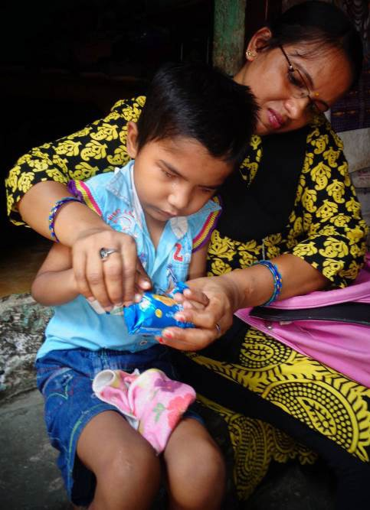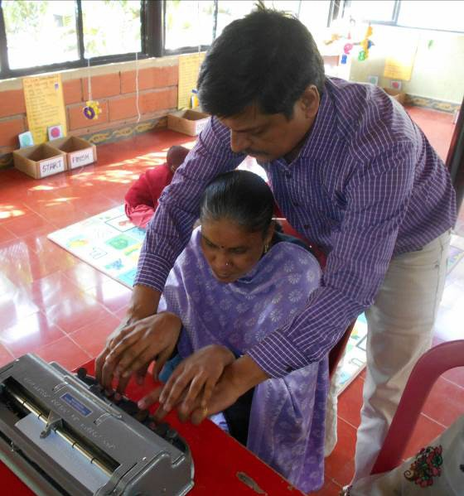

*Hand under Hand (Huhn) Hand over Hand (Hoh)*

##### Modeling:

Children with deafblindness and sensory impairments are likely to have limited grasp of con- cents which are easily grasped by other children. In many instances, they may learn best when shown what to do. They may not know, for example, that toy cars travel along roads, not under- neath them, or milk comes in a packet before they drink it from a glass. Modeling also eliminates

the need for children to understand language to follow instructions. For example, when you are doing brushing show it to the child how you do it and encourage the child also to do it.

##### Presentation:

The parents need to design and deliver the task to make the most use of the child’s sensory abilities. Materials may need to be enhanced to be more easily seen, heard, or interpreted tactilely. Some children will need tasks which they can complete using vision, others will need tasks they can complete using their hearing, and still others using pry- Marily their tactile senses. The parents should consider lighting, noise, colors, people distractions and other relevant factors as you decide how, when and where you will be teaching the child.

The parents should also consider the times of day, or of the week, when the child is most responsive, and use these for the key learning skills. You may also decide that a child will respond better with one particular adult, or with a particular, familiar piece of equipment.

##### A mother helping the child play with a hang- ing toyMotivation:

Motivation or reward is a very important part of learning. In designing a task, the parents must ensure that there is appropriate motivation for the child. The most successful motivation is to complete the task itself. This is why many children are successful at learning to feed themselves.

*Figure 37: A mother helping the child play with a hang- Ing toy*

Other tasks may be designed with specific motivating factors in the task. They become part of the task, but they are not intrinsic. A child learning to walk downstairs, may learn to do this on the way to the garden. Sometimes a task may need additional motivation. A child getting dressed may be rewarded with a tickle each time an item is put on.

The best rewards are the child’s own pleasure at success, and the parents. The parents will always show pleasure, and the child will gradually learn to recognize this and find it rewarding on its own.

##### Be consistent

Children with deafblindness receive little information from the world around them. Events need to happen very consistently, if they are to make sense. Personal identifiers, must be used every time the child and adult meet.

Use routines - carry out dressing, getting ready for dinner, saying goodbye, in exactly the same way each time, in the same place, with the same person if possible, using the same objects. Introduce change only when you are sure that the child recognizes and understands the routine.

Keep furniture in the same places and don’t leave bags or other clutter lying around. If children trip or bump into things when they try to explore, they will learn not to explore or move independently.

##### Help understanding

Tell children with deafblindness what is happening, and going to happen in advance, in a way that they can understand. Cues, such as an armband for swimming or a particular song, can be used to mark the beginnings and ends of events and to identify activities. Some children will use speech or signing or other communication modes - but all need help to anticipate what will happen next.

Give access to activities by letting children touch, smell, taste, hold their hands over or under yours, whilst you make a drink, mix the paint, put the toothpaste on the toothbrush. It takes much longer but gives the child a chance to understand the activity.

##### Give time to respond

Using limited residual vision or hearing is tiring and very slow. Using touch for information is incredibly slow compared to sight. Children with deafblindness will take much longer time to receive, process and respond to information -

##### Follow the child

Give control to the child wherever possible - many children with deafblindness learn that

they cannot understand the effect of what is happening to them, and so they give up trying, and hence the process of learning becomes very slow. They may respond to sig- nails that sighted-hearing adults do not even notice the draught from an open door. Try to understand children’s behavior and to show them the significance of the information they receive. Respond to their signals, they communicate with lot of signals during any activities/ task for e.g. the child may give a signal to you when they want to finish an ac- trinity, or to continue or change it. Give choices to them wherever possible.

##### Be supportive

Working with children with deafblindness can be stressful having a child with deafblindness is far more stressful. Multi-sensory impairment frequently causes isolation, confusion and fear to the child. Withdrawal or apparent aggression may be reasonable responses to a crowded environment, someone approaching too suddenly or too many changes. Using limited sight and hearing, or operating without sight or hearing, is tiring and often frustrating. Children will need frequent breaks.

Help your child who is having deafblindness or MSI. Help them learn to use their residual vision and hearing for functional activities and to interpret the limited sights and sounds that are available. Approach your child gently to let her/him know you’re available for in- traction; do not “surprise” her/him with unexpected or abrupt touches or sounds. Attend to and imitate any actions and sounds; invite her/him to take another turn; let her/him know you share his/her interests. Offer consistent touch and object cues to signal the beginning of an activity and use movement and body contact during your interactions.

##### Using age-appropriate activities

The age-appropriate activities selected to be taught are similar to the skills acquired, per- formed or valued by non-disabled children of approximately the same age. Activities need to be meaningful and of interest to the child.

For example, do not give a 4-year-old child activity like wiping utensils or do not give the 18-year-old adult activity of playing with the toys. The advantage of choosing activities that you know are of interest to a child is that you will already have his/her attention when you begin. A child’s interest in lights, for example, can be used to further concept development about how things work. Explore the parts of a flashlight with him/her, alternating in taking

it apart and putting it back together again, over and over. If s/he likes rough textures, find a variety of toys with these textures for her/him to play. Share her/his enjoyment by touch- Ing and playing with the toys together (Miles & Reggio, 1999).

##### Use activities that are meaningful and interesting for the child

A child with deafblindness
learning fine motor skills
It is very difficult for a child with deafblindness to understand the meaning of a particular activity especially when it is not meaningful for the child or when it is not a functional activity for the child.

For example, just asking the child to do a puzzle is meaningless especially, when the child doesn’t understand why am I doing this? When it will be over?

Also, the activity must be interesting for the child. The activity should encourage the full involvement and participation of the child.

*Figure 38: A child with deafblindness*

*learning fine motor skills*

##### Use real Objects

Object cues are real objects, associated objects, or miniature objects. These objects are intentionally given to a child to hold in order to provide information or “input” to the child. A spoon may mean that the child will eat soon, plastic tumbler to indicate time for milk.

It is important that wherever possible parents should use real objects to teach concepts. Real objects provide the necessary information with which the child with deafblindness can identify and discriminate objects, and thus build concepts of the nature and function of objects.

##### Use interesting and locally available materials

Children and adults with deafblindness require tailor made TLMs, recreational and other materials for best learning. There are very few readymade materials available for them in the market. Most of the children with deafblindness are living in the rural and they don’t get the opportunity to access readymade materials due to its high cost and availability in

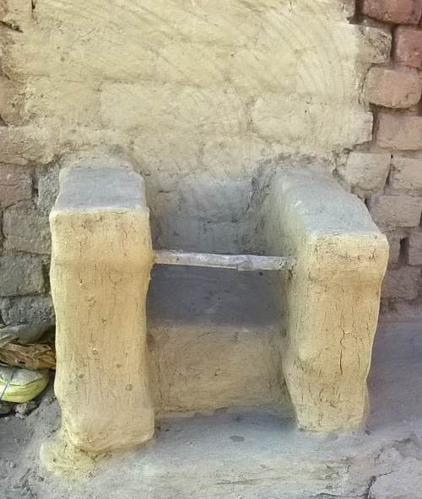the local market. It is the responsibility of the parents and the special educators to create materials as per the need of the individuals. The aids and TLMs can be made using the locally available materials.

In the remote village of Jharkhand special educators made CP chairs with the materials available in the village which is also of a very low cost. After making such an indigenous CP chair where the child got the opportunity to take part in the family conversation comfortably and was feeling happy.

Arihant is a very smart young person with deafblindness. He showed a lot of interest in learning new skills and also engaging in recreational activities. He could play “Snakes and Ladders” game without any ones help because of the material made as per

*Figure 39: An adapted CP chair made with clay*

the need of Arihant. All the checks of the board, snakes, ladders, player’s coins and

the dice were made tactile. Also, the checks were given numbers in Braille, this kind of creative material helped Arihant to have socialization with his peers and spend his leisure time meaningfully.

##### Creating environment that promotes optimal functioning

Deafblind adults playing adapted game
 


*Figure 40: Deafblind adults playing adapted game*

The arrangement of the physical environment is especially important to the child with deafblindness and sensory impairments. Children with deafblindness may finds it difficult to learn in noisy or less illuminate- ed spaces. The space or the room where the child is supposed to sit for the activity should have proper light- Ing (not very bright or dull and not too much of sounds which may be the cause of distraction during the activity. The environment must allow

the maximum use of remaining vision and hearing. The child with deafblindness requires

considerable modifications to teaching content and appropriate

teaching strategies. The learning style of a child with deafblindness is totally different form the learning style of a child with hearing impairment. Nor s/he can learn from listening like the child with visually impairment does. S/He learns only by what s/he does. This means that no learning is taking place for her/him while waiting for others to take their turn. For this reason, small group or individual instruction becomes more critical. However, large group instruction is only valuable if s/he can be consistently active (e.g. playground activities).

##### Conclusion

The term “deafblind” can be confusing. We know that very few children are totally deaf and totally blind, and when the term is used, it refers to a child who has a combination of vision loss and hearing loss. Most young children who are having deafblindness have some residual vision and/or some residual hearing.

The parents and family members have the greatest influence on the child’s development. One should always try seeking out help from others but be assured that your loving re- sponges to your child, coupled with ideas gleaned from professionals and those who have “been there,” will make the biggest difference. Just as other parents do, you will discover your child’s unique personality and celebrate your child’s achievements.

##### Understanding behavior

* 1. **All behaviors communicate**

All children with deafblindness do communicate with the external world. But the way they communicate may be different from sighted- hearing or children with single impairment. They try to convey their feelings, desires, and thoughts through some kind of behaviors. It is our responsibility to understand their behavior and respond accordingly. Even the subtle response from the child should be noted and acted accordingly. If one continues to ignore a specific communication given by the child, then they may stop communicating after some time.

A parent must be aware to differentiate between various behaviors shown by the child

during various periods of the day. All such behaviors should be gradually taught with proper signs for building meaningful language development.

##### Encourage age-appropriate behavior

It is the duty of the parents and the educators to teach age-appropriate behaviors to children and adults with deafblindness. Modelling is very much necessary for age apron- pirate development; children with sighted-hearing learns many age-appropriate manners just by watching others. Children and adults with deafblindness lack this important skill of learning from others. Intervention plans should also be based on the age of persons with deafblindness. Once they cross school age their intervention plan should focus more on vocational activities and independent living.

When there is no appropriate time table planned and if they are not engaged appropriately in activities then so-called behavioral issues will start in his/her life. Transition from one phase to another should take place regularly as they cross different stages of developments.

##### Reward desired behavior

As we studied earlier children with deafblindness may show various behaviors. All the behaviors must be noticed and interacted properly. When there are some unwanted behaviors in the child which should be discouraged by not attending it. However, the child should always be rewarded for a desired behavior. When you say NO/STOP to a particular behavior, the child may not know what the correct way of behaving. Hence, we should reward the desired behavior regularly, gradually the child learns the correct way of behaving. It is very much important that reward should be given immediately after the desired behavior.

##### Be clear and consistent

Children and adults with deafblindness need a clear and direct feedback and also it should be consistent. Always follow a clear beginning and end for the activities, the materials used to teach a particular activity should be continued every day. Same signs and same way of communication should be followed on a regular basis. Consistent and systematic approach will help the child to build concepts and learn meaningfully.

###### Reference:

* + 1. *Teaching children who are deafblind – Contact communication and learning edited by Stuart Aitken, Marianna Burthens, Catherine Clark, Jane Eyre and Laura Pease*
    2. *Understanding Deafblindness – Issues, Perspectives, and Strategies written by Linda Alsop*
    3. *Developing Concepts with Children Who are Deaf-Blind, Barbara McClatchie, Ph.D.*
    4. *Early Interactions with Children Who Are Deaf-Blind, By Deborah Gleason January 2008*
    5. *Teaching strategies and management of deafblind children- Sense International (India)*

## Module 4

#### Importance of Play in Overall Development of Children with Deafblindness and Multiple Disabilities

##### Play

Play is a universal phenomenon and a right of childhood. It is an integral part of child’s life. Through play children learn about their environment. Infant mainly in the age group of 0-2 years may like to get involve in play but it may not be intentional. Most of the children in the age group 2 – 10 years and even till the age of 16 -18 years spend majority of their time in play. Children indulge in different kinds of play every day in a small or a big group. Play is behavior that is freely chosen, self-directed for which a child is self-motivated. It comes naturally to children. Play is enjoyable, voluntary, flexible, and non-literal. It provides active involvement of the child in the environment. Every child even a child with special needs has an intrinsic motivation/urge to play. Through play child interacts and develop their other skills like motor, memory, language, creativity, imagination level, problem solving technique. It is through play that a child starts understanding turn takings, making choices, tolerance, cooperation in peer group, imitation etc.

#### Developing play in children with deafblindness (Including the use of music and dance in activities)

##### Movement

Play activities allow us to move together with the child and share the experience thus providing a good way to establish a bond with the child and provide enjoyment whether it is with a parent, sibling or another child. As parents or care-taker, it is important to observe what movements the child likes. While sitting close to the child, those movements can be performed together, for example, rocking, swinging etc. It will develop communication in the following way - you stop swinging, the child may indicate to you to continue and in this way, it will be a two-way exchange of communication. You could also combine two movements and see which one the child likes thus encouraging the child to make a choice and indicate it. Movements could include running, swinging together on a swing, jumping on a trampoline etc. Closeness also helps in developing bonding and rapport.

*Photo: Booklet on Activities for Children Deaf blindness/MSI, SII Regional Learning Centre (North), NAB Delhi.*

##### Music

Music means a great deal in the lives of most people. Music can bring people together, making music together, listening to music, moving to it, dancing, all these create harmony.

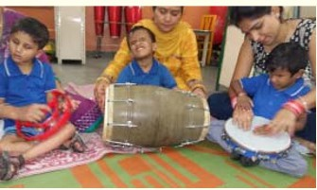Music - In very simple language it is the art of arranging sounds through rhythm, melody, harmony. Children with deaf blindness /

MSI can experience music without having to see & hear. Remember, children with deafblind mainly depend on tactile stimuli and learn through touch.

*Photo: Booklet on Activities for Children with Deaf blindness/MSI, SII Regional Learning*

*Centre (North), NAB Delhi.*

*Figure 41: A group of deafblind children playing musical game*

Initial stage of communication of children is through imitating. When mother looks at

the baby and smiles and in return baby imitate the mother and smiles.

Music thus enables children with visual impairment and additional disabilities including deaf blindness to detect sound to aid better understanding, better speaking, better language acquisition, to experience rhythm, to express themselves in dance and movement, to develop an appreciation, improve social behavior, deepen their emotional experience and creativity, and promote spatial experience.

##### Experience of Music

* Play with toys that make rhythmic sound and make children aware of the source of sound.
* Play with sounds that body can make like clapping, stamping feet, banging on tins, using a whistle.
* Allow child to feel music with hands and whole body by learning on or sitting on the source of sound.
* Use the resonance board while listening he music.

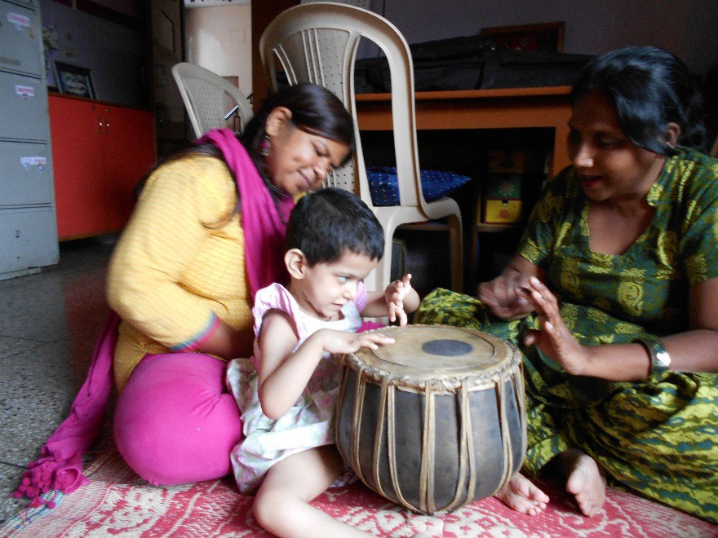

*Figure 42: A girl with deafblindness exploring tambala*

* Move in different directions when listening to music being played.
* Sing close to their eyes or in the ears (if they have residual vision or hearing).
* Associate different musical instruments with different physical activities like marching,

swinging, bouncing on ball or on mother’s knee, clapping.

**Sand Play** Playing with sand develops fine Motor Skills, improves tolerance of tactile defensiveness, encourages bilateral hand use and improves hand-eye coordination. Hand-eye coordination is very important and it is used very much in the day today activities. Writing/Scribbling in the sand with bare hands helps for teaching pre-writing skills.

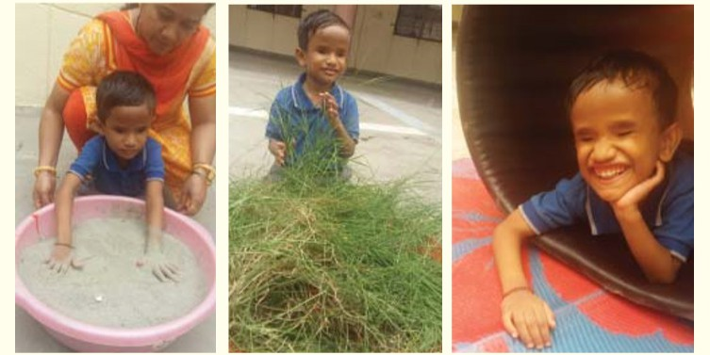

*Figure 43: A child with deafblindness getting various sensory exposures*

*Photo: Booklet on Activities for Children with Deaf blindness/MSI, SII Regional Learning Centre (North), NAB Delhi*

##### Water Play

Water play is the most favorite game for almost all children including children with deaf blindness. Through water play we can teach so many concepts, develop motor skills, improve health etc. While performing water play for children with deaf blindness use shampoo/soap in the water, this encourages the use of olfactory and tactile sense. Sponge/foams, floating squeaky toys, and toys which drown in the water can be used for developing concepts of wet, dry, heavy, light etc. Funnel, different shaped and sized containers can be used to teach the concept of full, empty, less, more etc. Cold water could be used during the summer season and warm water could be used during the winter season.

##### Group play

By the age of three, children are ready for preschool activities. They are toilet trained, able to communicate and socialize with each other. They like to share ideas and build stories around toys. Through interactive play they begin to learn social skills such as sharing and taking turns. They also develop the ability to collaborate on the theme of the play activity. Children also like to play with adults. It is important that parents spend

time playing with their children.

##### Importance of play

Life skills are learnt by playing in a surrounding with language and having access to environments that are safe and interesting to play. The senses of vision and hearing help the child to organize the information from the environment, it is very important to consider that the child who has deaf blindness or multisensory impairment do have access to the opportunities for spontaneous play and associated learning as does his/ her non-disabled peer.

A child with deaf blindness and multisensory impairment often gets fragmented or distorted information from their contact with people and the environment. Their world does not extend beyond the reach of their fingertips. They do not learn to play on their own like other children with toys unless they are taught to explore objects and feel them. E.g., manipulating a shiny piece of paper may be play for a child with deaf blindness. It is through play, children learn to explore the world around them, develop and practice skills they will use throughout their lives.

Many children who are having deaf blindness need encouragement to play, especially to use dolls, dollhouses, cars, and other symbolic toys. Good conversational interaction is playful. When a child is comfortable with genuine turn-taking interactions and mutual attention, large dolls can be included in conversations for a playful method.

##### Why should we encourage a child with deaf blindness and multisensory impairment to play?

* We all know that the world of a child with deaf blindness and multisensory impairment does not exist beyond his/her fingertips. Some children may be able to hear /see but we cannot estimate how much they can.
* Most of the time what they hear and see may be confusing or frightening to them.
* Since the child’s body is the only thing that he/she can control, we see most of the children with deaf blindness and multisensory impairment engaging in self- stimulatory behaviors.
* Sighted- hearing children watch others and learn to play but for children with deaf blindness, we need to organize and structure the play time and play environment. Sometimes, we might find them engaging in repetitive or monotonous play using the same objects.
* Play give an opportunity to communicate, explore, experiment, create and pretend,

all of which helps in cognitive development.

#### How, What and Where to play

##### To initiate play with a child with deaf blindness

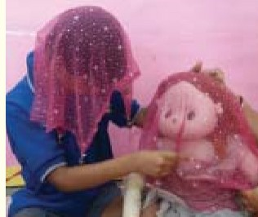Child with deaf blindness find it difficult to interact with other children so as it is necessary to introduce group play again and again until the child starts enjoying it. Group play is very necessary to develop social skills. Always keep in mind that a group play should be started with familiar toys/objects & persons (on whom a child could easily trust). Group should be small and they should be allotted with an appropriate time to mix up with other children. Let the child explore play material and wait patiently for their responses.

**Play activities for children with deaf blindness** Peek a boo is a game similar to hide and seek, but played with babies. One (child, teenager or adult) covers their face with hands or cloth and suddenly show the face into the baby’s view and say “JHA”.

*Figure 44: A child with deafblindness playing with a doll*

*Photo: Booklet on Activities for Children with Deaf blindness/MSI, SII Regional Learning Centre (North), NAB Delhi*

##### Other suggested play activities are:

* Swinging
* Play with stuffed multisensory toys
* Play with different type of puppet
* Play with squeaky toys/ rattle/Juhn jhana
* Visual and auditory stimulation play through musical and sound toys
* Olfactory awareness play (by using different fragrance like perfume, flowers)
* Water play
* Sand play
* Body games, tickling games
* Different types of movements and swing activity
* Texture plays with messy things (through wheat, pulses, rice, cotton etc.)
* Role play
* Pretend play
* Play with different sound toys and musical instruments
* Play on resonance board
* Little room
* Play with toys having different size, light, color and sound
* Play with gift paper and different textured papers
* Play with household items e.g., Cup, plate, bowls, spoons, glasses etc.
* Play with peers (slide games, rengarenga roses, dressing up a doll together, and simple clapping games with music)

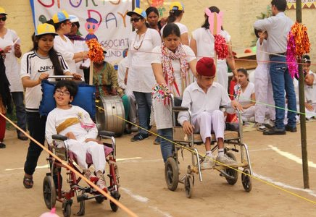

*Figure 45: Students with deafblindness with additional disabilities participating in games*

##### Play Environment for Children with Deafblind and MSI

* It should be a very friendly environment, preferably where they live.
* Environment of play should be very safe to promote free movement of the child.
* It should be comfortable.
* Child play group should be reactive and responding.
* If a child has partial vision, then color, size of the toy, and place where s/he is going to sit should be according to his/her need.
* While selecting play, child preference and comfort level should be kept in mind.
* Play environment should be interactive.

Play Environment dependents on where they reside, their family back ground, socio

economic structure, and the influence of peer group.

##### Purpose of play environment/activities:

* To enhance the residual vision and hearing of the child
* To increase awareness of environment
* To enhance the residual senses of the child (e.g. Touch)
* To enhance social development
* To engage in a meaningful way

#### Play Materials

##### Age-Appropriate activities

The best guide for choosing toys for children is to see what they enjoy best to play.

##### Activities for (0-6 months)

* + - The child plays with rattles, picking up & shaking a rattle to make sounds.
    - Using various lighted or noisy toys for developing extension of body in prone

position with the precautions of SIDS (sudden infant death syndrome).

* + - Sticky Games.
    - Keep various textured toys in a bath tub during bathing.

##### Activities for (6 Months-1 years)

* + - Spin the child in the air
    - Peek-a-boo with objects/toys
    - Let the child grasp/touch to various small objects (Marbles)
    - Mirror plays
    - Unwrapping activity
    - Up & Down activities parents’ body
    - Let the child play in sand

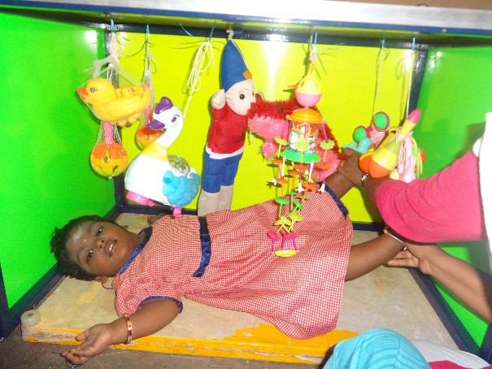*Figure 46: A child is playing in little room*

* + - Child manipulates dolls, teddy bears in his /her own way

##### Activities for (1-2 years)

* + - Let them help in various house-hold activities (e.g.- Sweeping, Washing)
    - Pulling wagons
    - Arranging the cubes according to size & shape.
    - Hold a pen or markers & try to write
    - Horse rocking on wooden horse toy
    - Dressing up a doll

##### Activities for (2-3 years)

* + - Brushing of self, puppets
    - Animal walks
    - Jumping on various objects
    - Riding a tricycle with support
    - Playing with puppets & trying to imitate someone

##### Activities for (3-4 years)

* + - Drawing various shapes, pictures
    - Using colors in a drawing
    - Playing Cricket
    - Finger printing/hand printing

##### Activities for (4-5 years)

* + - Picture and tactile story books
    - Small animals and dolls
    - Doll house
    - Making toys from clay, flour etc.
    - Puzzles
    - Simple computer games
    - Bicycle with trainer wheels and helmets
    - Simple board games

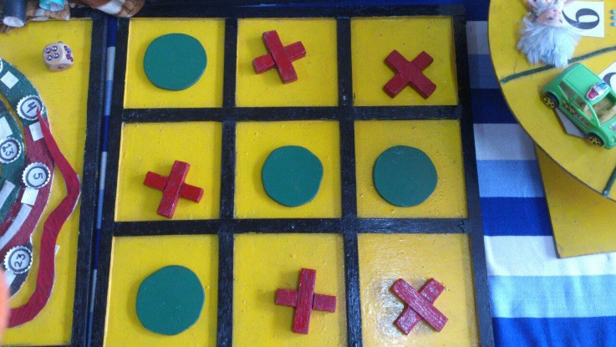

*Figure 45: An adapted tic-tac-toe*

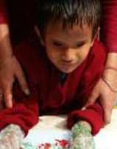

*Figure 46: A child with deaf- blinds doing texture play*

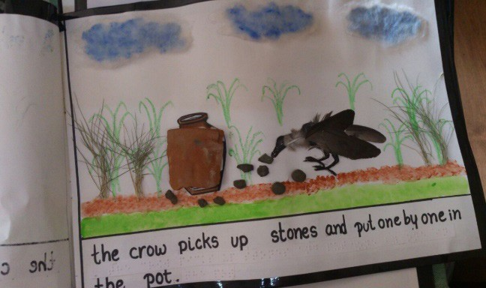*Figure 47: An adapted tactile story book*

##### Information regarding play & toys for children with deaf blindness and multisensory impairment

Creating a playful atmosphere always encourages communication and socialization in children with deaf blindness. Some important considerations to promote play in children with deaf blindness are mentioned below:

* + - Let the child know it is playing time by using a particular blanket or mat during that time/ activity.
    - Choose toys of bright colors, good contrasts and which make sounds. Put colorful tape or stickers on toys or non-toxic paints on some of the child objects to make them easily visible on a white towel.
    - Demonstrate the child how a particular toy works. It is necessary to demonstrate it for number of times.
    - After demonstration put the toy close to child in a way that touches the child’s body. Encourage the child to reach out and play with it.
    - Provide sufficient time to the child to discover and explore toys. The child may put the toys in the mouth, touch and explore it in different ways. Provide feedback to the child when they explore the toy by telling what the child is doing with the toy.
    - Adapt toys as per the need of the children. Attach masking tape, suction cups,

Velcro to keep them stationary. Use different textures, borders and boundaries.

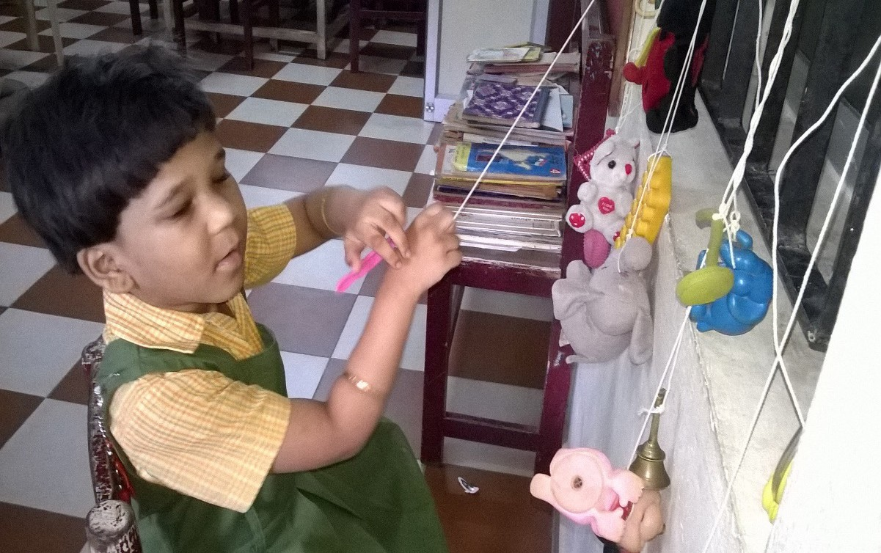

*Figure 48: A young girl playing with toys*

* + - Place the toy on the towel or cloth so that the child reach and pull it over to get the toy.

*Photo: The Clarke School for the Deaf, Chennai.*

* + - When introducing a new toy use a favorite toy along with a new toy. Place the

new toy beside the favorite toy so the children must first interact with the new toy.

* + - To create curiosity, make changes in the same toy and note whether the child is

aware of the difference or not. Attach ribbons, bells or different texture to the toy.

* + - If the child enjoys a certain characteristic of a toy, provide them toys that have similar characteristics.
    - Keep the toy box of the child which is easily located in specific cupboard space.
    - The play activities should focus on materials that can be found easily in the home.

##### Examples

The child may like a ball because it rolls. Allow the child to practice rolling object like rubber balls, round and cylinder-shaped wooden toys or real objects and things like oranges, apples etc. We can use adaptive gloves with Velcro if a child is not able to hold things.

##### Materials easily available at home for play:

* + - Pebbles and legumes etc., can be put in empty canes or boxes to make sound

toys.

* + - Plates, bowls, spoon, glass and cup etc. can also be used for play.
    - Homemade puppets or doll made of rugs can be used for play.
    - Floor dough can be used and it can substitute for an expensive clay.
    - Metal bangles tied in wool can be used for sound play.
    - Kites can be made at home using waste materials like newspaper etc.
    - Swings can be made by old sarees or old dupatta.
    - Different textures can be put in socks for sensory stimulation.

#### Yoga and Massage

##### Yoga for people with deafblindness

Yoga is a scientific system of physical and mental practices that originated in India

more than three thousand years ago.

##### Yoga and child with deafblindness

Just as sighted- hearing children can benefit from yoga asanas, children with deaf blindness too can derive many benefits from learning to do yoga. However, teaching yoga to the disabled especially to person who are having deaf blindness is an extra special task which when achieved pays rich dividends.

##### Yoga helps over all development, it enhances:

* Improves motor planning skills
* Improves balance & coordination
* Increases sensory integration
* Reduces stress
* Promotes creativity
* Helps child to relief their aggressiveness
* It builds and sets a routine for persons with deaf blindness
* Persons with deaf blindness learns sequencing and comprehension of vocabulary

like Start, End, Finish, First, Next, Last etc. through Yoga.

* Sequencing helps child to learn and understand the time and practicing asanas in order.
* It also helps to improve memory of number sequence.
* Yoga helps to develop spatial and body awareness. It builds confidence and

concentration in persons with deaf blindness.

* Through yoga children with total deaf blindness learns that there is world beyond

their fingertips as well.

Some important strategies to be kept in mind while teaching yoga to the children with deaf blindness are:

* Fix realistic goals
* Reach the target
* Stick with the time
* Use appropriate reinforcement
* Demonstrate to the student
* Provide immediate feedback
* Think positively
* Communicate with the student appropriately
* Practice yoga asanas planned for the student by yourself
* Never lose your patience.

##### Massage

Massage is a therapy which helps to induce relaxation, reduce the effects of stress on

the body and restore a healing balance to mind and soul.

Infant massage is an appropriate intervention. Infant massage provides another way for the caregiver and child to interact, establish contact and communication, and develop a deep bond.

##### Benefits of Massage to Children with Deaf blindness/MSI

* Relaxes and releases stress & anxiety
* Strengthens respiratory, circulatory, and gastrointestinal function
* Relives discomfort due to teething, congestion, colic, gas
* Helps children with deaf blindness to develop sleep pattern & sleep well
* Nourishes the child emotionally
* Enhances the bonding process
* Improves sensory awareness- develops normal sense of Touch, Smell, Taste, etc.
* It encourages the child to communicate
* It encourages the child to use their remaining senses
* It is very benefiting for premature babies to gain weight
* Improves anticipation
* Learns the sequences
* Helps in developing the time concept
* Helps in improving cooperation
* Helps in improving the muscle tone

##### Tips

**Be gentle-** There are differences between adult and child’s bodies. Massage should be done with light pressure. Development of the bone of a child is also not as solid as adults.

**References:**

1. *Co-curricular Activities for Children with VIAD/ Creating learning opportunities / A step by step guide to teaching Students with VIAD including deaf blindness – Voice & Vision India/ Hilton Perkins program*
2. *Creating play environment for children with Sensory impairments and additional disabilities – Jayanthi Narayan & Marianne Riggio – Hilton Perkins program*
3. *Play with children with deaf blindness – RLC North/National Association for the blind*
4. *Article by Dipti Karnad – The Clarke School for the Deaf, Chennai*

## Module: 5

#### Practical Management of Sleep Patterns, and Daily Living Skills

* 1. **Issues related to feeding**

For a child with deafblindness feeding may be a problem. During the infancy they may have a weak or absent sucking reflex. Others may be tactile defensive when touched on the mouth. Whatever special needs the child may have, there are some basic skills to remember when feeding.

Parents should always remember to let the child know what is going to happen before starting to feed the child. For example, touch the child’s lips and say ‘It is time to eat. “Help the infant to touch the bottle (or breast), or gently touch the nipple to his/ her lips to let him/her know it is there. Give him/her a chance to smell the milk to get more information about what is happening. Continue to communicate with him/her throughout feeding time using voice and cues and let him/her know when feeding is over.

A consistent routine for feeding is very important for a child with deafblindness. Feed her/him at approximately the same time each day and in the same position, so that the child can learn to anticipate the experience. Assist the child in the same way at each meal by using the same physical assists, verbal cues, and/or rewards. If adapted utensils are necessary, use them at every meal. Always place the plate, glass, and utensils in the same place. Be consistent and use the same communication cues including touch, smell, voice, and position, so the child can relax and understand feeding time better.

##### Some basic strategies to remember while feeding:

* + - Instead of handing the child to hold/ lift the glass or utensil, have the child pick it up

from the table may be with Hand over Hand (Hoh) support and or verbal prompt.

* + - It is important that the child’s nutritional requirements be met and the calorie intake as advised by the dieticians is used as effectively as possible to meet the needs.
    - Make sure that the child gets plenty of liquid. Dehydration can have very serious effects
    - As the child develops eating skills, it is important that every bit of progress, no

matter how small is being rewarded. Tactile and Sensory stimulation may be more rewarding to a child with deafblindness. Reinforce the child with a lot of verbal praise and encouragement.

* + - Signal to the child while s/he is eating. This will let him/her know what is going on and will strengthen your relationship towards him/her. Be consistent with communication, so the child may begin to associate words or cues with the objects and events s/he experience.
    - The child with deafblindness should be allowed to touch and handle the food, so that the child knows what is there and will be able to locate food on her /his plate. Touching is the child’s main source of sensory input.
    - Be prepared for a mess as the child begins to learn eating skills. Spreading

newspapers on the floor, under the chair and tying a large bib are some good ideas.

* + - Remember that each child is an individual and has his /her own needs. What works with one child will not always work with another. Find the method of feeding that works the best and is most comfortable for the child.

**Positioning during feeding**

Good positioning during feeding is very important in developing normal feeding patterns.

**Feeding Positions: Source- Management of Children with CP, Sense International India**

* + - The child should be as upright as possible (inclined at least forty-five degrees), with the head in midline and slightly forward to facilitate swallowing. The child’s torso

should be straight, shoulders forward, and the arms turned in towards the torso. Pillows may be used to prop her/him up.

* + - If the child is being fed on someone’s lap, remember not to lay her/him horizontally. Be sure to provide necessary support, and encourage flexion of the joints. The child needs to have some type of support under the knees to lower her/his knees, to lower the buttocks and increase flexion in the hips and knees.
    - As soon as the child develops some head and torso control, feed the child while s/he is sitting in a chair. Follow the guidelines for sitting include in the section on positioning and handling.

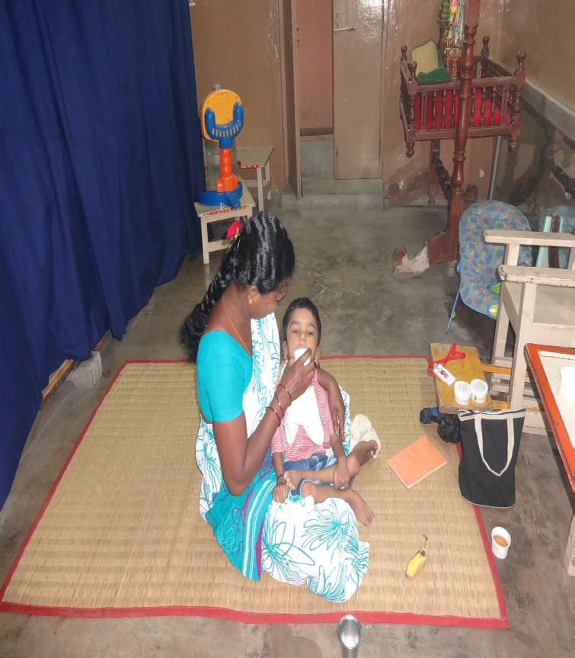

*Fig 49: The child is being fed with a glass of water on the mother’s lap.*

*Photo: RLC-South, SPASTN*

* + - Always be sure that the child has the necessary head support and feels secure. Let the child support herself/ himself as much as s/he is able to do so, regardless of whether s/he is on someone’s lap or sitting in a chair.

##### Sucking

Some infants have a weak or absent sucking reflex. Such a child may be able to drink and eat soft food that are placed on the back of the tongue by thrusting the tongue. However, the child will develop other difficulties if s/he does not learn to suck. The facial muscles that control drooling will not develop sufficiently, and the child will lack the motor development necessary for successful chewing and talking. It is important for him to develop the sucking reflex.

Some suggestions for helping the child develop this reflex are as follows-

When giving liquids, use a large, soft nipple with an enlarged hole. Make sure that the hole is not very large. Sucking may be elicited by placing soft food on a pacifier or in the middle of the child’s tongue, or by dabbing a small amount of soft food on the corner of the child’s mouth or lips.

The sucking reflex may be encouraged by massaging the area around the child’s

nose, chin, lips, gums, and palate before giving him/her food.

**Getting and holding food in the mouth**

* + - To make the child to open his/her mouth, touch the lips lightly with a spoon filled with some food. If this does not work, apply firm but gentle pressure just below the lower lip.
    - 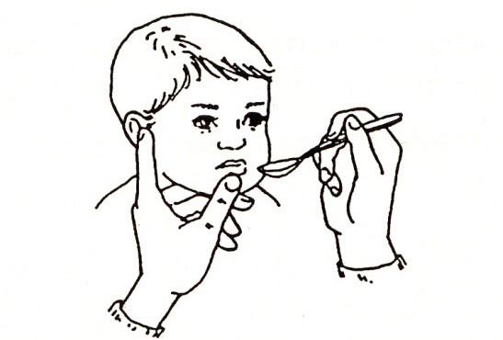The child may have trouble keeping food in the mouth long enough to before swallowing it. Putting the spoon on the tongue using some downward pressure will eliminate the child’s tendency to push food out of the mouth. Placing the food midway back on the tongue may also help,

but this should be done gently to avoid making the child gag.

* + - The child should remove the food from the spoon with the lips. Do not scrape it off on the teeth. Holding the spoon down against the tongue a few seconds will encourage the child’s lips to close around the spoon. Putting pressure on the lips will also prompt lip closure.
    - There are different methods of jaw control. When sitting next to the child, encourage the child to close the mouth by placing the index finger just below the lower lip, the middle finger under the jaw, and the thumb on the prominent bone in front of the ear. Use gentle upward pressure.
    - When sitting in front of the child, place the middle finger under the jaw bone in front, the index at the jaw joint and the thumb under the lower lip. Use gentle upward pressure.
    - When sitting behind the child, cup the chin in the hand, and use the little finger to hold the jaw shut and the first two fingers to hold the lips shut.

##### Chewing and Swallowing

Although teaching a child to chew may be time consuming and frustrating, it is very important to help the child obtain adequate amounts of nutrients needed for development. Good chewing also facilitates the development of good speech.

* + - To begin teaching the child to chew, put the child’s hand on someone’s face while

they chew, so s/he can feel the desired movement.

* + - If the child has cerebral palsy, do not move his/her jaw up and down, because this

may stimulate abnormal patterns

* + - Up and down tongue movement is a prerequisite for good chewing. The tongue should lift the food and put it upon the teeth’s surface to be chewed each time the teeth come together. To stimulate tongue movement, place the food on alternate sides of the tongue, while pressing the spoon against it.
    - Once the food is inside the child’s mouth, his/her lips should remain closed. It may be necessary to hold the child’s lips together while gently messaging his/her jaws, to help him/her with the chewing motion. The methods of jaw control described under “Getting and Holding Food in the Mouth” may also be used.
    - Do not give the child a bite until he/she has swallowed the previous one.
    - Swallowing can be stimulated by lightly stroking the child’s throat from the chin to

the chest.

* + - Helping the child hold his/her head downward and placing the food near the back of his/her mouth will facilitate swallowing.
    - Be careful not to feed the child too much or too quickly, or it will make them choke.

##### Finger- Feeding

Before a child can begin to finger-feed, s/he should be able to hold up his/her head,

hold food in his/her mouth, chew, and swallow.

Finger-feeding is an important step toward independent eating. By having direct contact with the food, the child becomes familiar with the feeding situation and learns how food gets to the mouth. The child learns about food by touching and smelling it, and s/he develops fine motor skills and hand-to-mouth coordination. When the child begins to finger feed, place a little bit of food in her/his hand, and helps him/her to hold it while gently bringing it to her/his mouth. Make sure the child moves her/his hand to her/his mouth instead of moving her/his head to his/her mouth. If the child drops the food, show her/him how to hunt for and pick it up. It takes time for the child to learn how to hang onto objects. Remember to communicate with him/her about the name of the food and about what is happening.

Finger-foods with strong smells and flavors (dal, butter or the child’s favorite food) can alert the child through her/his sense of smell that food is on the table, thereby encouraging him/her to finger-feed. Gradually withdraw assistance as the child learns

to bring food to her/his mouth by own. Encourage each small success, and allow the child to do the entire activity independently.

Because finger-feeding can be messy, be prepared with old clothes and a warm washcloth. Do not worry too much about neatness and manners. However, be careful that the focus of “learning about foods “does not turn into “playing with foods.”

##### A teacher is teaching eating skills to a deafblind childSpoon-Feeding

Spoon-feeding is a continuation of the movement used in finger-feeding. When the child is ready to eat from a spoon, be sure to let her/him know when the spoon is approaching her/his mouth. For example, sign and say “Here comes rice. Very tasty! if appropriate. Then gently touch her/his lips with the spoon.

Begin with foods that stick to the spoon such as kichadi, chapatti soaked in milk, oatmeal, yogurt, and mashed potatoes. If the child resists the spoon, try putting a portion of food on other spoon-like objects such a soft trainer toothbrush.

*Fig 50: A teacher is teaching eating skills to a deafblind child*

When the child is first learning to feed by self with a spoon or hand, certain dishes and utensils work better than other. For example, spoons with built up fatter handles are easier to grasp. Using a lightweight spoon might make it easier to recognize when there is food on it. Trying attaching a small penlight to the spoon to help the child know when the spoon is coming towards him/her. The use of a deep bowl may make scooping easier.

Spoon-feed the child while s/he is in an upright position. If s/he tends to drop gently lift her/his chin when bringing the spoon to her/his mouth and say “open,” or prompt the child to open the mouth by touching the mouth. In a short time, the child will learn to open for the next bite as soon as s/he has swallowed the previous one. The child will also learn to hold the head up when s/he smells the food coming.

##### Coactive Feeding Positions Drinking from cup

When it is time to help the child give up the bottle or breast milk (weaning), do so gradually. Try reducing the amount of liquid s/he gets from the bottle/breast feeding. At first it may be helpful to alternate sucking, the bottle/breast with sips from a cup. Then, slowly cut back on the bottle/breast, and increase time on the cup.

It is important for the child to become familiar with cups. Let her/him explore cups during bath time by filling them with water and emptying them. Let her/him feel someone else drinking from a cup.

A firm plastic cup is best for teaching the child to drink. Paper cups will crumple, and glasses can break. At first, do not use a cup with handles.

Start with a small amount of liquid to control the flow and avoid large spills. However, there should be enough liquid in the cup, so the child does not have to tilt her/his head way back to get some. First try introducing familiar, but thickened liquids in the cup (e.g. apple juice, milkshake, thinned yogurt, juice thickened with cereal). Put just a small amount in the cup.

Stand behind the child, guide her/him through Hand over Hand (Hoh) method, as s/he picks up the cup drinks from it and sets it back down. Gradually withdraw the amount of assistance as the child learns to go through these motions by her/himself, without spilling. Then, gradually increase the amount of liquid in the cup. The child should take small sips, swallowing after each one. Do not pour the liquid down her/his throat, because it may cause her/him to gulp rapidly or choke. You may need to facilitate lip closure and swallowing using the methods discussed in the feeding sections.

Sit to the side of the child, put one arm around her/him to help control the jaws and lips, and hold the cup with the other hand. Later when the child begins to hold the cup by self, try a cup with handle and a lid. Much later, try a soft plastic cup that is narrow enough for the child to get both the hands around the cup.

It is important to help the child learn to find the cup on the tray or table surface, pick it up, hold it, bring it to her/his mouth, support them to take a drink, and put it back down on the surface. This sequence is very important for the child to learn. Remember to

communicate what the actions are and to immediately reinforce the child for her/his accomplishments. When the cup is empty, help her/him to feel inside the cup in order to learn what “empty” or “all gone” means. This should be done when the child is first learning about cup drinking and will not need to be repeated every time.

It may be several years before the child completely gives up the bottle or breast feeding, depending on family’s philosophy and the child’s preference. Some child may find the bottle or breast feeding comforting when they are sick, unhappy, or ready for bed.

#### Foods

##### Introducing New Foods

Introducing new foods (semi-solids and then solids) can be especially difficult for the child with deafblindness. Solid foods should be gradually introduced as near to the normal accustomed time as possible, unless there is a physical reason which prevents it (consult a physician).

When introducing solid foods, let the child explore the spoon and the food. Touch her/ his lips and say and sign that it is time to eat. Name the food, and allow the child to smell it. Let the child taste a little of the food from her/his finger, or put a small amount in her/his mouth after touching her/his lips. If s/he reacts negatively, do not give up. Try a little of the food again the next day and so on, until the child will accept more than one spoonful without fussing. Remember to be patient, and try to keep mealtimes an enjoyable experience for everyone involved.

Never force the child to eat. Once the child is used to solid foods, introduce a variety of food with different flavors and textures. Mealtimes are wonderful times for learning about the texture, size, and shape of different food. If the child likes oranges, let her/ him feel the whole orange and then help to peel it, slice it, put it in a bowl, and eat it. Even though it can become messy, the child should be allowed to touch, smell, pick up, drop, squish, lick or explore food. Whenever possible, help the child to understand where the food comes from and how it is prepared.

It is also important to take the child to the grocery store and allow her/him to be involved in selecting foods. This is a good opportunity for sensory stimulation if the child touches different textures of fruits and vegetables, variety of odors, colors, and sound.

#### Activities for Daily Living (ADL)

##### Self-care Skills

Children have a drive to be independent and do things on their own. This is a healthy part of normal child development. As children grow, they learn to do more and more tasks. Self-care tasks are some of the most important tasks learned by children as they mature. When children practice self-help skills, such as feeding and dressing themselves, they practice their gross and fine motor skills, gain confidence in their ability to try new things and build their self-esteem and pride in their independence.

##### Dressing and Undressing

For a child with deafblindness, dressing is an excellent time to build body awareness. Prepare the child for dressing by touching and signing the name of the body part that will be dressed (e.g., “foot”,” arm”,” tummy”). The child will soon learn to help by lifting that body part and cooperating in the process. Play games such as e.g. **“Puar Dhatri goal goal, niche Dhatri goal”** and **“Johnny Johnny yes pappa, eating sugar pappa”.**

Let the child feel the article of clothing. Use signals and /or signs to communicate what is going to happen) before it happens), what is happening (while it is happening), and what has happened (after it has happened). Ask for help from the child such as “We are putting your shoes on, so push.” Let the child feel textures and shapes that will help him/her recognize clothing items. If the child has some vision, call her/his attention to color differences that will give her/him further recognition clues.

Follow a consistent pattern of dressing, so the child can learn to anticipate the next step and help with the movements (for example, diaper first, then, pants, shirt, socks and shoes).

When dressing and undressing the child, do so at consistent times of the day, in certain areas, and in the same way. For example, getting the child dressed in the morning (rather than leaving the child in pajamas all day) will help her/him learn to know that it is daytime. Likewise, getting into pajamas in the evening will help her/ him learn that it is nighttime-time to sleep. Dressing the child in her/his room, helps her/him learn where her/his clothes are kept. As the child gets a little older, show her/ him where and her/his clean clothes are kept in the drawer and the closet, while dirty clothes go in a different place.

As the child gains better head control and sitting balance, let her/him sit in the caregiver’s lap and experience the hand-over-hand movements of dressing and undressing.

Most children first learn to take clothes off (e.g., socks, and shoes). As hand skills and

sitting balance improves, the child will be more ready to learn to put clothes on.

As the child gets older (and if appropriate to the development of the child), encourage her/him to help more with the dressing movements. Signal the child to let her/him know what you want her/him to do. Pause at times to see if s/he will continue the movements on her/his own. If the child does nothing, cue her/him to help. Be sure to choose clothes that are easy for her/him to manage. Zippers, elastic waistbands, Velcro closings are easier to handle than buttons and snaps.

Fun experiences with clothes can be taken place during the laundry time. Let the child put clothes into the bucket, use clothes that he/she might recognize. Use signs such as dirty, clean, wet, dry, cold, hot, or smells good. Let her/him help turn the machines on, and communicate about how to wash the cloths. The child may enjoy playing with the soap and water. Let the child feel it and play with it. When clothes are washed and dried let the child smell and feel the freshness of the clothes. Let her/him feel the different textures, such as soft pajamas, rough jeans, and silky shirts. Show the child her/his little socks and daddy’s big socks. Different concepts can be taught from this kind of simple fun filled experiential learning activities.

#### Personal hygiene

Teaching the basics of proper personal hygiene is important for keeping children deafblindness healthy and clean. It’s especially important for little child with deafblindness to practice good hygiene like particularly hand washing as they spend so much of their time in close contact with the nature and exploring things around them in their environment. Therefore, the germs may contact them and attack their immune system, resulting in increased production of oils in skin and hair and stinky body odor. And sometimes could lead to another sickness. Some good personal hygiene practices to teach your child are:

##### Teach proper hand washing

The most important health and hygiene habit to teach your child with deafblindness is to wash her/his hands, especially before /after completing the meal, after playing in the outside environment or an activity which involves the use of hands, or after completing

the toileting activity. Hand washing is without a doubt, one of the best ways to prevent the spread of germs and illnesses. With children with deafblindness, you may need to remind them from time to time.

* + - While washing the hand, position the child in a sitting or standing position in front of the sink or tap
    - Cue: Run the water and let the child touch the flow of it, check their reaction to the

temperature and adjust it, if necessary. Assist the child in smelling the soap. Say and sign key words such as “wash,” “bubbles,” “clean,” etc.

.

* + - Pour some of the soap liquid in the water and run more water to create bubbles.
    - Assist the child in touching the bubbles and water, gently guiding the hands, assist

the child in clapping her/his hands to make the bubbles fly

* + - Throughout the activity, communicate to the child about what s/he is doing.
    - Give a cue when the activity is finished
    - For variation, add some food coloring to the water

##### Toilet Training

Toilet training is a long-term process for the child with deafblindness. There is much for the child to learn without the aid of vision or hearing, it is reasonable to expect that s/ he may not meet the same time schedules as the child who are sighted- hearing. Good toilet habits are often among the last self-help skills to be firmly established.

Toilet training is likely to take longer for children who are having deafblindness and for some children with additional disabilities, bowel and bladder control may not occur. Most children can, however, learn to co-operate in these routines. This becomes increasingly important for the carer as the child become older and heavier.

Many children are interested in their own bodily fluids and feces. For children with deafblindness, this interest may last much longer and present a problem. Therefore, it is always recommended that the child should be monitored, kept hygienic and the process of toileting should be done under the observation of parents or teachers, until the child is well trained or is able to carry out the task individually and independently. Toilet training involves more than just using the toilet. To be developed mentally ready, the child must be able to recognize the feeling of a full bladder and to get to the bathroom or indicate the need to go to the bathroom. S/he also should have learned the basic dressing and undressing skills. S/he should remain seated on the toilet for at least five minutes.

A child cannot attempt bowel or bladder control unless certain muscles and parts of the nervous system are at a point where they can be consciously controlled. Look for the following signs:

* + - First, the child’s diapers should remain dry for longer periods during the day (1 ½ to 2 hours), and s/he should have regular elimination patterns. If the child cannot do this, s/he will not know the feeling of a full bladder.
    - Second, the child should dislike feeling wet or soiled, and complain of a wet diaper after urinating. This indicates that s/he is making an association between a wet diaper and the act of urinating.
    - Finally, the child must want to cooperate in the bathroom procedures. Signs of cooperation usually show up sometime after a child is one year old. There is no set schedule for toilet training.

Throughout the toilet training process, the toddler with deafblindness will need many more chances to feel what is involved. The child needs to feel the potty chair, place her/his hands on the adult’s hands while pulling down the pants, use the adult’s hands as a guide while wiping, and finally, with help, wash and dry their hands. The time may come when the child begins to investigate the bowel movement or urine with her/his fingers. This is natural, since touch is the child’s major vehicle for learning. A matter-of-fact response by the parent or caregiver is essential. Allowing her/him to look/feel for a short time, and then communicating to her/him that these are things the body does not need, will help her/him begin to understand. Allow the child to do this to satisfy her/his curiosity, but do not permit it to become part of the toileting routine.

##### Two major factors should be kept in mind while teaching toileting skills.

**First,** caregivers and educators are involved in the process should use consistent language techniques, and procedures. Consistently use preselected signs and words for “dry” and “wet.” The same holds true for bowel movements. The objective is for the child to understand “wetness,” which aids her/him in anticipating that s/he is about to urinate. Unless the child becomes aware of internal signals, s/he is no learning.

**Second,** a routine schedule, which has been developed from the child’s personal needs and routines, should be followed. There may be situations in the family that make it a poor time or begin toilet training, or something may happen that causes a setback in the child’s progress. In these cases, it is best to wait before continuing.

##### TOILETING

If the child does not have any toilet control and wets pants

* + - Collect a baseline data

For 5 days note the time in which child passes urine

|  |  |  |  |  |  |
| --- | --- | --- | --- | --- | --- |
| **Sun** | **Mon** | **Tue** | **Wed** | **Thru** | **Fri** |
| 6:00 | 7:20 |  |  |  |  |
| 6:30 | 7:50 |  |  |  |  |
| 7:15 | 8:15 |  |  |  |  |
| 7:45 | 8:45 |  |  |  |  |
| 8:30 | 9:15 |  |  |  |  |
| 9:00 | 10:00 |  |  |  |  |

Calculate the time interval. Then choose the shortest, most frequent time interval. In the above example it will be 30 minutes

Make a schedule with half an hour interval from the time child wakes up. Mark the schedule as follows

* : passes urine in the toilet

- : does not pass urine

x: accident, i.e. wets pants

|  |  |  |  |  |  |  |
| --- | --- | --- | --- | --- | --- | --- |
| Date | 17 | 18 | 19 | 20 | 21 | 22 |
| 7:00 | ✓ | X | ✓ | ✓ | ✓ | ✓ |
| 7:30 | - | ✓ | ✓ | ✓ | ✓ | ✓ |
| 8:00 | X | X | X | - | X | ✓ |
| 8:30 | X | ✓ | ✓ | X | ✓ | - |
| 9:00 | X | - | ✓ | ✓ | ✓ | ✓ |
| 9:30 | - | X | X | - | ✓ | ✓ |

If the child does not pass urine, when taken to the toilet, try the following

* + - Leave the tap open
    - Massage lower abdomen
    - Pour water over lower abdomen and legs

If the child still does not pass urine, take him/her to the toilet after 5 minutes.

If, the child has an accident, always take him/her to the toilet before changing

her/ his clothes. This will help them to associate toilet with passing urine and changing.

Once the child is accident free, slowly increase the time by 10 minutes.

If the child is accident free for a 2-hour schedule, rt with indicating

* + - By gestures
    - Sounds
    - Remember to reward the child for both indicating and passing urine separately

Cleaning after voiding

* + - Child pours water while mother cleans
    - Child cleans while mother pours water
    - Child pours water and cleans simultaneously

##### Brushing

Encourage good dental care to children with deafblindness, as this is also an important area where hygiene should be maintained.

When the child’s teeth begin to come in, talk to a doctor about good care for her/his gums and teeth. Slowly accustom the child to have her/his gums and teeth cleaned. Let her/him chew on a toothbrush. Run it across her/his gums and teeth. Help the child hold onto the toothbrush while bringing it to her/his mouth.

Stimulation to teeth and gums can be done with several different textures (e.g.’ washcloth, clean soft facial sponge, gauze). The child might even enjoy the sensation of a toothbrush on her/his gums and teeth.

#### Bath time

##### Bathing Positions

For the child with deafblindness, bathing can be a wonderful learning time. During

a bath, s/he can learn about her/his body; experience new smells (e.g., warm, cool,

slippery, rough). Bath time can also be used for play activities using cups, sponges,

and floating toys.

At first, it might be easier and safer to bathe the baby in a tub, with towel or sponge on the bottom of the tub to prevent slipping and sliding. Always communicate to the child about what is happening, using smell and touch cues (e.g., touch her/his back, and then let her/him feel the soapy rag before washing her/his back).

If the child is fearful about being put in the bathtub, lay or make him/her sit on a towel or sponge in a dry tub, and give her/him a sponge bath. Gradually introduce water. Alternatively, try sitting the child on someone’s lap while the child plays in just a little bit of water. Always remember to bathe the baby with water poured little by little, and remember never to leave her/him alone in the water.

##### Bathing Sequence

Bathing the child at night can be one way of helping her/him anticipate the sequence of events that led to bedtime. Be consistent. One possible bathing sequence might include:

* + - Signal or sign to the child, “It is time for your bath. Let’s take your clothes off.”
    - Run the water, and help the child feel it. Adjust the temperature according to her/his preference. This is a good time to communicate about hot, cold, and warm.
    - Slowly put the child into the water.
    - Sign the names of her/his body parts as you wash them as well as of other bath time objects.
    - Let the child explore and become comfortable. Show her/him how to pat the water

and later splash.

* + - Help the child hold the soap, get some on her/his hands, and then rub a body part.
    - Try using soap on a rope, so the child can find it. Begin to show the child how to

wash their body parts on their own with a washcloth, bath mitt, or bath sponge.

* + - Help the child play with toys and objects that give practice in squeezing, pouring,

and pushing. Keep a bucket or container of toys close to the tub.

* + - Occasionally provide special experiences for the child such as bubble bath, different smelling soaps, or baby oils. Putting a little drop of food coloring in the water will change the color of the bubbles but will not stain.
    - Match actions with descriptive words and signs (e.g., splash, pour the water out, wash your hair, scrub).
    - Take turns. Pour some water from a plastic cup, and then let the child pour the

water. Rub her/his stomach, and then let her/him rub her/his stomach. Gently splash some water, and then let her/him splash.

* + - If the child makes a sound like “be,” expand it into a word for something in the tub

such as “bubble,” “bath,” or “ball.”

* + - Watch for the child to signal that s/he has had enough, and respond appropriately.
    - When the bath is coming to an end, let the child know that it is almost time to get out. This is especially important if s/he does not want the bathing activity to be over. Involve her/him in routine of gathering up the toys and putting them in a container, pulling the plug, and feeling the water as it disappears. Let the child feel the towel before drying.
    - When the child is able, let her/him help rub the towel on a part of her/his body that is easy to reach.
    - Let the child feel the clean clothes or pajamas that s/he will be dressed in. Communicate with her/him about dressing.
    - For the child who dislikes leaving the tub, always follow bath time with another activity they like (e.g., singing and finger plays, a bedtime snack, special time with dad). Let the child know this activity will happen after her/his bath. S/he may not understand at first, but in time s/he will come to anticipate it.

##### Personal Grooming

When brushing/combing the child’s hair, communicate with her/him about what is happening. Let her/him feel and play with the brush/comb. When s/he is a little older, coactively show her/him how to brush her/his own hair. Let him her/him feel someone else brush their hair, and let her/him try to brush that person’s hair. This activity can become a fun, turn-taking game.

When washing the child’s hands and face, communicate about what is happening. Do not surprise her/him. Let the child feel the warm washcloths first. Then signal or sign to her/him, “I am going to wash your face.” The child might like to hold and play with the washcloth. Show her/him how to bring it to and wash her/his face.

#### Importance of balanced nutrition

Nutrition is a science of food, nutrients and other substances found in them. Human nutrition is concerned with the body’s needs for food for growth, maintenance and proper function, and with the effects of inappropriate types or amounts of foodstuffs. Nutritional science attempts to provide information on the amounts and types of foods,

which combine to form the best possible diet. It is difficult to learn or understand nutrition, although the practical application of what is known about good diet is to avoid malnutrition and it requires no scientific background at all. There are no “good” or “bad” food, bad diets certainly exist. These may reflect poverty, tradition, fashion, poor agricultural or food-handling practices, inappropriate cooking, and changes in the natural environment or combinations of all these factors.

##### What are Nutrients?

Nutrients are chemical substances, which are constituents of food. They must be supplied in suitable amounts. The body needs a wide range of these substances.

##### Nutrients Include

* + - Proteins
    - Carbohydrates
    - Fats
    - Vitamins
    - Minerals

##### What does a balance diet comprise?

Balance diets should include foods from different food groups in the right proportions. Ensure that all nutrients are provided in adequate amounts and that the diet contains sufficient amounts of water and fibers. It is also important that the diet must be acceptable in terms of quality for a child/adult of a specific gender and age group.

##### Nutrient requirements of children

Children are constantly growing and developing. Therefore, they need more nutritious food, in proportion to their size than adults do. Children are also at risk for malnutrition unless their nutrition is properly managed.

Energy needs of children are determined by rate of growth and level of activity. Energy must be sufficient to provide for all activities and sparing the protein for its primary function for growth. However, excess energy intake may let to obesity.

Malnutrition implies that food intake is either too great or too small, in whole or in

part, resulting in interferences with growth, maintenance or functions. In addition to

causing various specific conditions, malnutrition increases the risk of poor growth and function of most, if not all, the systems of the body. Nutrition influences growth before and after birth, and can affect both physical and mental function. Nutrition is thus of major importance for us all, throughout our lives, and nutritional needs vary at different stages of life.

Children/adults with deafblindness and those caring for them has a special need for accurate nutritional information. Deafblindness can make it more difficult to consume an ideal diet, thus increasing the risk of malnutrition, which in turn can significantly interfere with the growth, fitness and function of those with all these conditions. Malnutrition is an underlying cause of many disabilities. However, on the other hand improving nutrition offers one of the most realistic ways of reducing the numbers of new cases of these conditions. Improving nutrition also offers ways of improving the function, both physically and mentally, of children who are already having deafblindness.

Poor nutritional status of a child may be attributed to interrelated, complex and multidimensional factors which may start in the fetal stage. Compromised nutrition and health in adolescence and pregnancy predisposes an infant to dangers of nutrition insufficiency even before birth. The low-birth-weight infant may grow into a malnourished child with a higher probability of infectious morbidities and mortality.

Several social and economic factors such as poverty, lack of education, and ill- informed cultural behaviors are considered as the underlying causes of malnutrition. This problem is however, further exacerbated by faulty infant and young child feeding practices, poor access to and utilization of health services, inadequate water and sanitation facilities and intra household food insecurity.

#### Disturbed sleep patterns

A good sound sleep is important for all and it becomes more important for children with deafblindness as well. Children with deafblindness have significantly more sleep problems than the sighted- hearing child.

Infants and young children with deafblindness may have difficulty distinguishing day from night; as a result, bedtime can be difficult. It is very important to have a predictable routine for getting up in the morning and for going to bed at night. In ability to fall asleep at a desired time at night, frequent night time awaking, excessive daytime sleepiness, and multiple sleeps are common sleep patterns in children with deafblindness. It is also very commonly seen among children with deafblindness, spending all night giggling/

vocalizing to themselves and then wanting to sleep most of the day.

Definite difference in day and night should be created. A dim light can be used when assisting and putting the child to bed at night, and a very bright light when getting her/ him up. Have the child sleep in her/his bed/crib at night, with blanket or cloth wrapped firmly around her/him, and have her/him sleep somewhere else during naptime, with a different blanket lightly placed over her/him.

The routine at night should include calm and relaxing, activities. The child can be given a warm bath, dressed in her/his pajamas, read to, sing to, and perhaps, can be even rocked for a short time. The child may have a favorite toy or blanket that s/he takes to bed with her/him, or s/he may want to suck a pacifier. At bedtime, the child’s physical needs should be met, and s/he should be given an extra measure of love and reassurance.

If the child wakes up in the night, if possible, s/he should be comforted while remaining in her/his bed/crib. The child’s back can be patted and or s/he can be given a pacifier to help her/him back to sleep.

A young baby will wake up frequently during the night when s/he is hungry, wet upset, or ill. Use a dim night light at these times, and keep interactions quiet and soothing. A young baby can communicate her/his needs as soon as possible. Over the period of time, it will help she/he learn how to settle back to sleep after the need has been taken care of. Try soothing the child in a bed/crib by patting her/his back and gently talking to her/him as s/he falls back to sleep. Perhaps the child can soothe her/himself with the help of a pacifier. As the baby gets older, s/he should be able to sleep for longer periods through the night. If the older baby is not able to sleep well through the night or get back to sleep to sleep once s/he wakes up, talk it over with her/his doctor.

When the child wakes up in the morning, communicate to her/him that it is time to get up. Turn on a bright light, and open the shades to let the sunlight in. Feed her/ him breakfast or her/his desired food and dress her/him. Keep the morning routine consistent and different from the night routine.

#### Positioning

There are many different reasons why a baby or a child may have trouble learning to move. However, if a child is repeatedly helped to experience normal movement and feels her/his body positioned properly, and if the child is not allowed to conform to

abnormal positions, reflexes, and movement patterns, s/he may begin to reproduce normal movement on their own. Proper positioning and handling allow freedom of movement of the head and extremities which encourages reaching, looking, and grasping and helps the child to learn required movements. Handling and correctly positioning the child who has motor delays and impairments is the best therapy that parents and other caregivers can give.

A physio therapist or occupational therapist who is experienced in working with children with deafblindness having Cerebral Palsy will be able to evaluate and determine the positioning and handling techniques that would best for the child.

##### Positioning refers to the use of appropriate body positions

Positioning reduces the likelihood of interfering reflexes and helps to bring muscle tone close to normal in order to minimize deformities and facilitate movement. For example, to lay a tight child flat on her/his back causes the muscles to become even tighter and to extend. Placing a pillow under the child’s head and one under her/ his knees help to relax their muscles and makes it easier for her/him to look and reach. This is because bending her/him at key points, such as the neck and under the knees, breaks up the extensor tone. Also laying the child on her/his side makes it easier for her/him to bring her/his hands together to play.

Appropriate positions should be used in all routines throughout the child’s day (e.g., resting, playing, sleeping, feeding, dressing, bathing). This allows the child to experience what normal symmetrical positions feel like, thereby helping the child’s brain learn to reproduce them. Special equipment’s such as corner chairs, wedges, rolls, sideliners, and standing frames are often helpful in achieving appropriate positions.

|  |  |
| --- | --- |
| **Pelvic Stability** | |
|  |  |
| **Trunk Control** | |
|  |  |
| **Head Control** | |
|  |  |
| **Jaw Stability** | |

**Positioning:** The first thing to consider while feeding a child with Cerebral Palsy is positioning the child. The child should be seated on a firm surface with stable pelvis while breast/bottle feeding so that the head is slightly forward.

**Tongue Control**

**Lip Mobility**

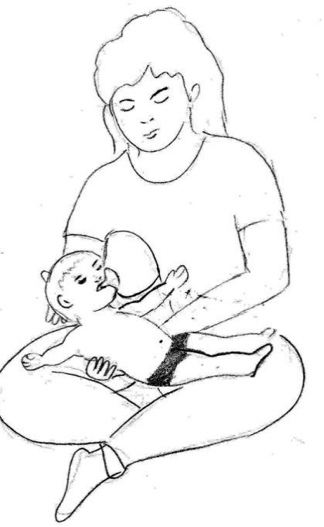 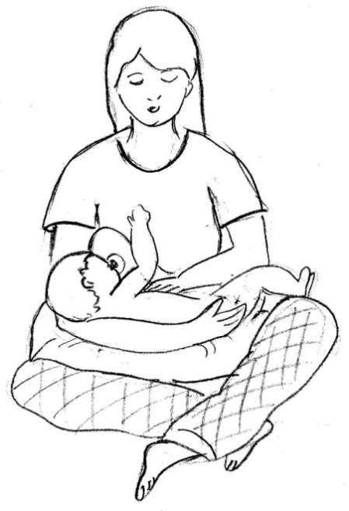

*Positioning the baby with head slightly forward*

*Avoid feeding the baby in this position*

Keep the spoon/ bottle in front and not from above or sideways. Giving food from above causes the head to press back and the body to stiffen. This makes swallowing difficult. Touch cues can be used for children with deafblindness.

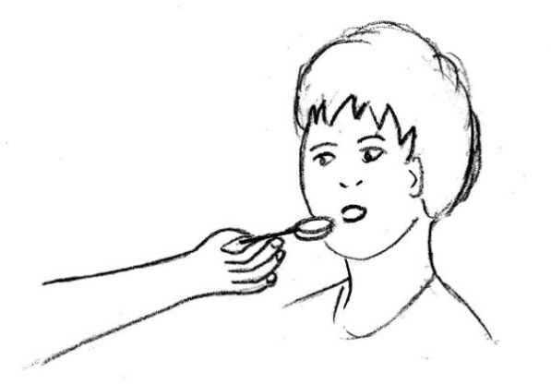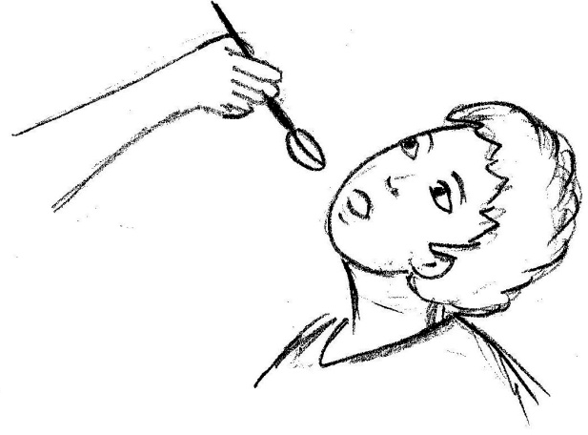

*Keeping spoon in front Do not give food from above*

##### Points to remember while carrying and positioning the child

* In any position the child should look balanced – no leaning or twisting.
* Positions should help the child relax and should keep pressure off the bony areas of the child’s body.
* Positions should be changed frequently throughout the day.
* Try to position the child so s/he can see what is going on around him/her.
* Try not to move the child suddenly or jerkily. The muscles may need time to respond to changes in position.
* Sometimes the child’s muscle gets tensed (spasm). Let muscles tense and relax on their own time – don’t force movements.
* Fear can make muscle spasms worse, so give the child as much support as s/he need when you are handling him/her, being careful not to give more support than s/he needs.
* As a general rule, while positioning in sitting, feet should be flat on the floor, knees bending at right angles, with hips firmly against the back of the seat.
* Correct positioning should increase purposeful movement in normal positions and postures. For e.g.: by freeing the child’s head for turning and looking and letting the arms for reaching.
* Get down to the child’s level when talking or playing with the child (e.g. squatting

to be face to face with the child).

* Firmer surfaces may be needed for the child with low muscle tone

Many children with deafblindness have additional disabilities like cerebral palsy which may result in difficulties in sitting independently, eating and drinking which can sometimes cause a lot of difficulty for the parents and caregivers. However, with appropriate adaptations, children can participate in these activities with less assistance from the parents/caregivers.

It is important for the parents/caregivers to remember that the earlier they start intervention by making the necessary adaptations, the better are the chances for reducing the problems.

###### photo-hetal2Position 1:

One of the best positions for the very young child is mother sitting cross legged; holding the child in her lap, this will give support to the child. In this position you can encourage the child to learn activities also.

###### KIDPosition 2:

Sitting position on the floor

If child has not learnt to sit by himself/herself without support then make the child sit against the wall using a thin pillow or cushion and place a small table or stool as per the height of the child.

###### Position 3:

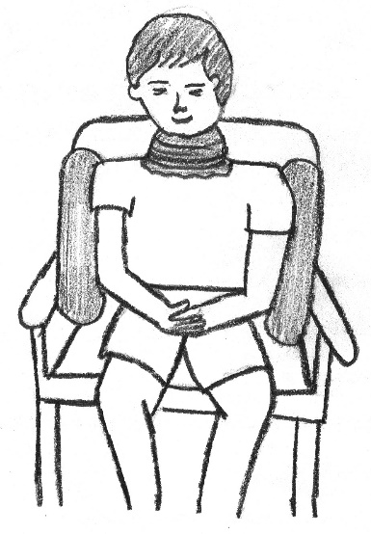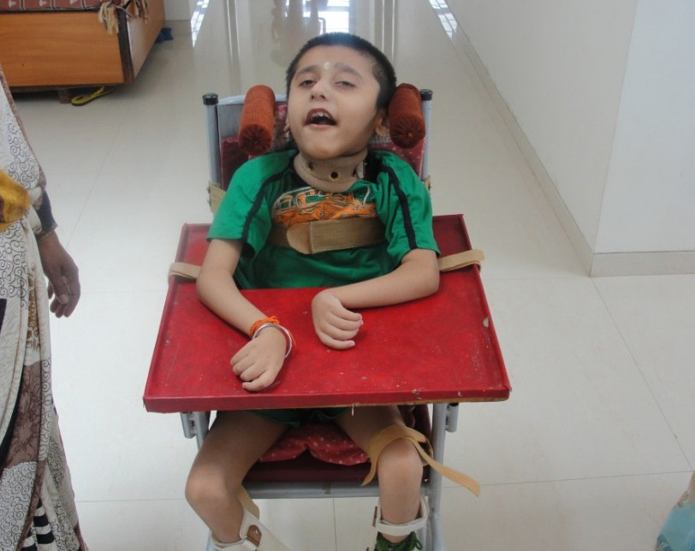

*Fig 51: Sitting position for a child with CP*

If the child is not able to control his/her neck or has poor neck control, a customized (As per size and measurement) collar can be used. This should be done in consultation with the doctor or therapist. In case it is difficult for the parent to procure a collar, a soft towel can instead be used. This is done by wrapping the towel gently around the child’s neck, making sure that it is not too tight or uncomfortable. While wrapping the towel leave enough space so that it can accommodate parents/caregiver’s finger between the neck and the towel is ideal.

It is advisable to use such a collar for not more than an hour during the time of child’s

meal or drink. However, remove it if it is uncomfortable to the child

###### photo-hetal - CopyPosition 4:

If your child is able to hold up his/her head, place him/her in a corner seat. If s/he tends to slip forward, fix a cylindrical block of wood in the seat between his/her legs, this will help the child to sit without slipping forward.

###### Position 5:

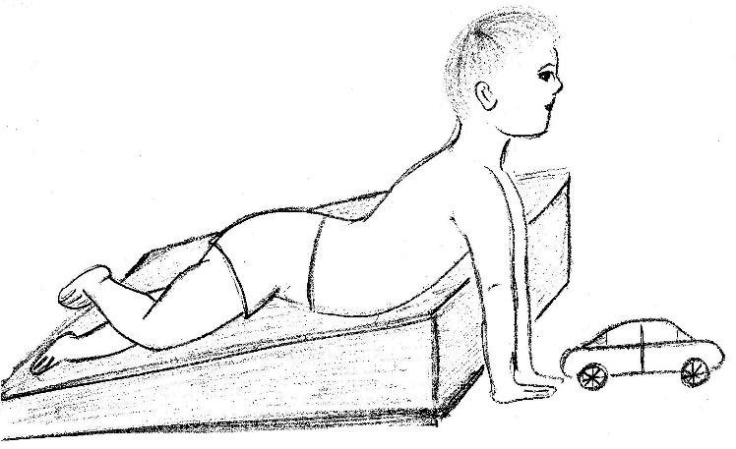Wedges are triangular shaped wooden material used for those children who cannot sit and are always in a lying position. It can be used to make the child lie on the prone position (lying on the stomach) and the child can be encouraged to use his/her hands to do activity or for lifting the head. Provide support to both the sides so that the child does not fall. Before making the child lie in this position make sure that child does not get epileptic fits.

###### Position 6:

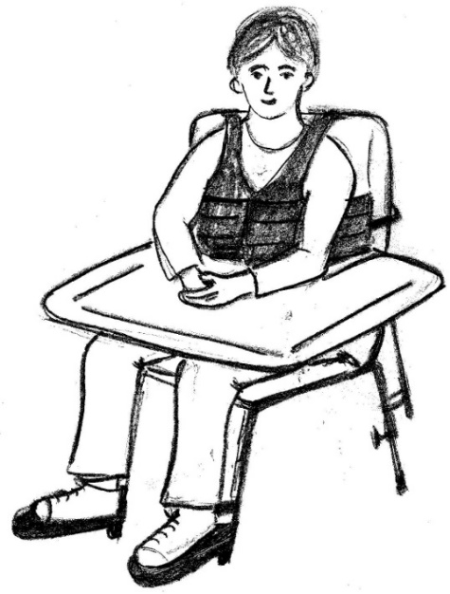Sitting position on chair:

1. If you are using the CP chair, make sure that the chair is comfortable for the child to sit (size of the chair should be as per the age and body shape of the child, there should not be very sharp edges as the child should not get hurt)
2. When the child is made to sit on the CP chair make sure that the child’s hands are not in suspended position (not in the air). A wooden support also should be made so that child can comfortably rest or keep his/her hands on that. (When the child sits on the CP chair make sure

his/her legs are not in suspended position, proper leg rest/support should be there.

1. When the child uses the chair for reading and writing or doing any activity make sure that child should not bend his/her neck too much. You can give the support to the child by putting a wooden desk.

#### Social Skills

Sometimes the world can appear to be a cruel place to a person who has deafblindness. Because of their lack of social skills, individual with deafblindness may frequently not be able to cooperate at the social activity. They also face challenges because of their limited field of vision and hearing. Sometimes they may also become very scared in the social gatherings because of the limited perception and understanding of the relationship. Thus, the curriculum of social skills training should focus on teaching students on how to act appropriately and how to function in society. Skills that can be included in this curriculum could be understanding the child with deafblindness and reacting in an appropriate manner. How to make friendships and connecting with people around, it should also cover teaching the child with deafblindness all the social cues by giving them an opportunity to interact with all their fellow friends.

All individuals need relationships in their lives that provide encouragement, support, and companionship. Friendships in the lives of children and youth with deafblindness add richness and meaning and teach them important skills for getting along with others. According to Borba and Borba (1990) “, by exploring relationships, children learn more about themselves and their own growth, as well as learning more about other children and how they handle their success and failures. Each new relationship enlarges a child’s world picture. In order to develop these relationships, children and youth must be connected to their community. Families and professionals can facilitate the building of friendships and relationships by using community members, discovering what is available in the local community for each individual with deafblindness, and assessing what relationship already exist in the individual’s life.

##### Friendship and Social Interactions

Developing friendship is not easy. It requires time, energy, and acceptance of change. “***It is the friendships and relationships in a person’s life which make her/him true members of communities (Stroll and Stroll, 1996).”*** Making connections is a lifelong challenge, especially for an individual with deafblindness. Consequently, support will be required at some level to assist or facilitate the development of relationship.

Points that need to be considered in developing friendships are:

* + - Individuals need to be in a variety of ordinary places for relationships to develop.
    - Parents, family members, educators, social workers, and students need to work on developing and supporting relationships.
    - In order to develop relationships, the gifts, talents, and contributions of each

individual with deafblindness must be valued.

* + - Friendships are not simple solutions to life’s problems. Friends will come and go, will change, will be unpredictable and will be difficult to understand.
    - Friendships are two ways: both parties must give and take in the relationship.
    - Friendships are freely given. They are not paid, and they are not given as extra

credit.

* + - Friendships come in a variety of different packages. A youth with deafblindness may want to “hang-out” with another youth with deafblindness or a sighted-hearing friend
    - Friendships are at the heart of the community, including the school community.

There are many strategies for helping a child with deafblindness to build friendship. By working with the child’s teacher and support staff, possible school friendships may be developed. Parents can assist the child in becoming part of an extracurricular activity or by becoming aware of the choices and by helping to arrange transportation. Parents can network with other parents in activities at school and in the community. It is important that the individual with deafblindness be encouraged to wear age-appropriate clothing, hairstyles, and accessories to assist her/him in being accepted by peers.

#### Seeking support from the existing community members

Friendships cannot be forced, but their development can be nurtured and encouraged in both educational and community environments. It is critical that individual with deafblindness should be there physically present in the community. It is much easier to develop friendships with same-age peers in the schools, clubs and neighborhoods of the individual’s community. It is critically important to behave and assume that friendships and relationships will happen for the child with deafblindness. Some families make sure that their son and daughter does everything that the entire family do. It may be up to the families to see how this will work and to make sure the necessary supports are provided. Being part of the community begins first with the attitude that the child is a part of the community, regardless of any disability.

## Module 6

#### Needs and Concerns of Adolescents and Young Adults with Deafblindness

#### Understanding Transition

Transition means moving from one environment or period in our lives to the next. One of the most exciting periods of change in our life is when we finish our schooling. We look closely into our future and then after few planning, we decide to join specific college, and then after that moving out of the safety of home to new adventures in employment etc. ‘Transition’ in relation to the journey of human-kind means a coordinated set of activities that will help them to move from school to postsecondary education, service specially meant for adults with deafblindness, community participation, independent living and employment. Transition services and planning are as important and vital to young persons with deafblindness as they are to other youths in the society.

* + - Similar to other adolescents of their age group, individuals with deafblindness need opportunities to: Practice self-determination
    - Develop and clarify their interests and abilities
    - Develop independent living skills to the greatest extent possible
    - Learn methods to increase the depth and breadth of social relationships and
    - Experience a wide variety of employment settings and activities

##### Need for Transition Planning

For children with deafblindness, simple transitions such as shifting from one activity to another or sometimes from one environment to another is a challenge, which many of us have to deal with in our day-to-day life, hence there is a need for a systematic plan for a smooth transition.

In this context there have been efforts by service providers towards systematic evaluation of a person’s ability and matching this with a work situation in the community. Parents must constantly communicate with the professionals working with their child and young adolescents and participate in their transition planning.

##### The Transition Team: Roles and responsibilities

The success of the transition plan depends on the people involved in working on this programmed and the manner in which each member works independently, and yet blends the work into the team effort.

The transition team therefore involves the following members:

* The **person** with deafblindness himself/ herself, also known as the focus person – the students contribute information about their preferences and dreams and participates in the decision-making process, as far as possible.
* The **family members** contribute information about the focus person’s history and take an active part in creating and implementing the dream. They are recognized as those who would know the most about their child. They get familiar with the local organizations providing support, benefits available to them and the reality of pursuing a dream that is appropriate for their child.
* The **educators or the school staff members** – They are involved in the skill\ training of the student at home, at work, in school and at leisure activities outside school. The educators work in close contact between the family and the child and helps both realize their goal in a planned manner. They help in referring families to other information sources, building awareness about the child’s potentials and limitations. They also provide placement related information regarding the readiness of the skills and special requirements at work, strengths and weaknesses of the child.
* The **Vocational Trainer or the Coordinator or a Placement Officer (in few organizations)** is generally the link between the school or the training agency and the community that has the potential of offering jobs. The placement officer gathers information from adolescent/adult’s with deafblindness and their dreams, their adaptability to different situations, their range of skills etc. and matches this with available opportunities. They also work on parent’s expectations from their child.
* The **employers and the co-workers** are also involved in the transition team in a

significant way at a later stage as and when an adult with deafblindness gets an

opportunity.

##### Personal Futures Planning (PFP)

The Personal Futures Planning (here after PFP) is an ongoing process that focuses on the strengths and capabilities of an individual with disabilities called Focus person. PFP is a person-centered planning approach seeking to identify and mobilize formal and informal support on the needs of an individual with severe disabilities including deafblindness. The process is characterized by planning that describes the capacities and opportunities in people and environment. It does this by providing an ongoing means to creatively solve the problems/ challenges encountered along the way. This is accomplished by a small group of people involved in the transition planning, also known as the ‘Circle of support’.

#### Sex Education

##### Sex Education

The word sexuality has a broad meaning to it. It is certainly not just sex, or sexual behavior, or sexual acts, or sexual intercourse, or just sexual feelings, or an expression of our sexual selves. In fact, sexuality is the combination of all this and more i.e., a fine combination of the physical, emotional, intellectual and social aspects of an individual’s personality which expresses masculinity or femininity. Sexuality is seen and expressed in all our daily activities- through the gender stereotypes reflected in our work, expression of affection, parenthood, child-rearing, watching the television and many other activities of daily living.

Another meaning of sexuality is sharing intimacies with another person. It is important that people express their sexual selves. This would apply to people with deafblindness and multiple disabilities as well, because they also are sexual beings and have feelings and sexual desires like any other person.

Adolescents and young adults with deafblindness have the same rights regardless of their learning style, age, or level of functioning. The role of parents is to develop a positive self- concept and create an environment promoting free expression in a desirable and socially acceptable manner. Some syndromes and conditions may affect sexual development and functioning.

##### Where and when does Sexuality begin?

For any child, it begins when they are born. The physical contact with the mother during

cuddling, feeding and rubbing of their body during bathing, all arouse pleasurable feelings. Their interest in own body – dressing, toilet training, going to school, learning to relate to other children, boy-girl friendships, interaction with teachers, learning with teachers, learning respect for their body and privacy of others, learning how to act towards strangers- all involve sexuality. In relation to sexuality, issues like masturbation, sexual desire, contraception, sex abuse and marriage also come into consideration.

##### What does Sexuality/Sex Education mean?

Sexuality and sex education have different focus for children with deafblindness. Initially the focus is the development and self-expression related to gender identity, modesty, and appropriate interaction. After the child establishes some of these basic concepts, specific information on menstruation, personal hygiene, physical health and development, and prevention of sexual abuse must also be included. It is important to keep in mind the Indian culture and practice while planning on sexuality education.

##### When to start Sexuality/Sex Education?

For children with deafblindness, sex education should be a part of their instruction. Fundamental fact is that although there may be many unknowns in relation to the child’s future, one can be certain that the child is always a male or a female. They will have some aspects of sexuality that can be shaped with intervention. This instruction is often the key to successful inclusion in society. It is never too early to start sex education with a child with deafblindness. Sex education may be undertaken for developing concepts related to one’s own body and behavior.

### Issues regarding Sex Education

##### Public and private behavior

Sighted and hearing young adolescents and adults have awareness that people can see and hear them. They learn quickly about the difference between public and private behaviors. Whereas, most deafblind adolescents and young adults with significant developmental delays do not have this awareness, sometimes they may not even be able to see if other people are nearby, they may not know or do not have the concept that a door or curtain needs to be close.

Adolescent and adult with deafblindness must be carefully taught about public and private

behaviors and strategies for ensuring privacy. Hence, concepts of privacy and sexuality education from the beginning, when the child is being taught things, such as dressing, undressing in private and closing the door or curtain when using the toilet.

Adolescents and young adults with deafblindness frequently miss out on feedback from others. When they are given feedback, it is often confusing. A person may tolerate a child’s hand as it moves across a face or an arm, but if it touches the private area, the person is likely to move away or push away the child’s hands. How does the child know that we consider these areas of the body to be private? To child with deafblindness these areas of the body may be just as other body parts. It is important to remember that touch is one of the primary teaching and learning channels for most adolescents and young adults with deafblindness.

##### Sexuality and adult responses

Parents often feel confused about sexuality and disability. They may think that their child’s sexual development will be delayed or may not develop sexually because they have a disability. The reality is that most conditions or syndromes that cause deafblindness do not have any impact on sexual development. Some sexual behavior from the child is not acknowledged as being sexual. Instead, parents view them as “behaviors related to deafblindness.”

Parents often might also unintentionally oversee the need for regular medical check- ups for children with deafblindness. e.g. gynecological examination may not seem necessary, considering the common belief that their girl child with deafblindness may never be sexually active. However, many of the syndromes that cause deafblindness have secondary conditions that may go undetected. Even if it is not certain that a child will live independently or holds a job in the future, it is certain that they have a gender and will be a sexual being. For this reason, sex education must be a priority for instruction. Frequently educators may believe that sex education is the responsibility of the family and not the school. Sometimes teachers’ personal comfort-levels, beliefs, and values may hinder them in their ability to address issues related to sexuality. Even when they do try to provide instruction, their approaches may not always be well adapted to meet the needs of a person with deafblindness. Efforts often tend to focus on stopping behaviors rather than on supporting to appropriately express his or her sexuality. Therefore, it is very necessary for an educator to go through training on providing sex education to a deafblind child.

##### DO’s and Don’ts for Sexuality Education in deafblind individuals

Children and adults with deafblindness follow the same pattern of sexual development

as any other child and adults, they need to receive the same information about sexuality.

|  |  |  |
| --- | --- | --- |
| **Sr. No.** | **MYTHS** | **FACTS** |
| 1. | Adolescents and young adults with deafblindness do not have sexual needs. | Adolescents and young adults with deafblindness have normal physiological and sexual needs. |
| 2. | Adolescents and young adults with deafblindness adults are overtly sexual | Adolescents and young adults with deafblindness have similar sexual needs as their normal peers. |
| 3. | Adolescents and young with deafblindness adults will have to control their needs. | Adolescents and young adults with deafblindness will have to meet their needs |
| 4. | Adolescents and young adults with deafblindness will learn to take care of it themselves. | Adolescents and young adults with deafblindness need help……Big time help! |
| 5. | Adolescents and young adults with deafblindness are showing that they are naughty and deviant. | Adolescents and young adults with deafblindness are screaming out for some attention and love. |
| 6. | Adolescents and young adults with deafblindness do not feel emotions and cannot maintain relationships | Adolescents and young adults with deafblindness need to feel important and belonged by you. |
| 7. | Sexual behavior is not the teachers or school’s problem | Family and teacher needs to stand together on sex education as well |
| 8. | Only adolescents and adults with deafblindness can have sexual needs. | Younger adolescents and young adults with deafblindness can also show ‘sexual’ behaviors. |
| 9. | Marriage will solve everything. | The person needs to be prepared for marriage. |

#### Economic independence and self esteem

It is important to discover the job preference of each individual, need to support the job choices that are made and work with the school to access a variety of job opportunities. Looking at the skills and mapping the technique of a person with deafblindness, some possible jobs may be identified for an individual. Families and professionals can share information on what chores and tasks are done at home and in the community. Many skills are learned at an early age and can be guided and enhanced for later years in same work environment. There are some important things to remember in discovering job preferences for the individuals with deafblindness are:

* + - Each individual has her/his own special skills and talents to contribute to job and

community

* + - Many of the skills learned in school and in the community can lead to a lifelong career
    - The desires, wants and preferences of individuals with deafblindness should be at the center of job planning
    - The residents in the individual’s neighborhood and community should be known
    - Friends, peers and other family members can be asked what the individual enjoys

doing in their daily lives

* + - Some hobbies and leisure activities can become careers or jobs

Economic independence refers to a financial state of a person wherein s/he is able to satisfy or meet his/her basic financial needs and that of his/her dependents, by being gainfully occupied in a vocation, business, employment etc. Every person aspires to be educated, trained and choose a vocation of his/her choice and be financially independent. People with deafblindness to have similar aspirations in their lives. With due consideration to their aspiration, abilities and skills, persons with deafblindness can benefit from a variety of work skills training for them to be placed in the various suitable employment settings like:

**Open employment:** A person with deafblindness/MSI goes out to work in other establishments, offices, factory etc. This model of employment requires a person with deafblindness to be independent in the areas of self-care, orientation and mobility, communication, money concept etc. S/He follows all the applicable workplace like timings attendance etc.

Ms. Shruti Lata Singh is a person with deafblindness. She works as Advocacy Officer with Sense International India and she is also India’s first trained physiotherapist being a person with deafblindness. She lives in a paying guest and is accompanied by sighted-hearing friends. She travels to the office independently, works and communicates with other non-disabled colleagues. She is independent in mobility, self-care, math, financial concepts etc. She has been able to make the best use of technology for better comma- nictation. She uses computer with adaptive devices, including internet and email. She is also able to make the best use of the mobile phone in terms of communicating with the outside world. She manages and handles money matters well at home, and is planning adequately for her future as well.

**Sheltered Employment:** A sheltered employment model is more suitable to a person with deafblindness who needs support in doing the task/activities including support in daily living.

A sheltered workplace provides an adaptive, supportive, and flexible work environment. The work/activities undertaken may range from a complete production or a part of production process. The focus in this kind of a setup is primarily on the strengths and interest of a person with deafblind. Hence, persons with deafblindness may be involved in one or more stages in production/manufacturing of various products.

Sheltered workshops may be involved in production, packaging, marketing of product like handicrafts, jewellery, seasonal products, spices (turmeric powder, masala), Incense stick (aggravate,) candles and a variety of products. Such a unit may be run by the organizations working for disability, parents’ groups (both registered and unregistered) etc. A monthly stipend is also paid to person with deafblindness per their skills and contribution at work. Apart from the work they are also involved in recreational activities *viz.* shopping, outings, games and sports etc.

Sita is born as a person with deafblindness, she is independent in her day-to-day activities and is also independent in her mobility (Sita is independent in her work environment). She uses sign language to communicate with her peers and teachers. She works in sheltered employment where she does activities like making candles and packing of seasonal products, making jeweler etc. Ever month she gets stipend for her work; she has her own bank account where she deposits her money. She loves going for shopping, she loves to buy new clothes, bangles and footwear for herself. She goes with her teacher to

bank and withdraws money for shopping. She does her shopping by using or showing the communication card to a shopkeeper.

In India there are not many people with deafblindness who are involved with open employment or supported self-employment, for a variety of reasons and challenges. It may be because of the poor sensitization and awareness about the abilities of people with deafblindness among the family members themselves and the people in the society. Therefore, most of the children even after having the skills and abilities to perform their skills end up in sheltered workshops. However, others who really have the need and support of the sheltered workshops are getting benefits from it.

Children with deafblindness or any other children with disability can get involved and work in the sheltered workshop staring with prevocational and then transition into vocational training. A sheltered workshop can not only support children with deafblindness/disability, but it also endorses the work of persons with deafblindness and NGOs through their products. Person with disability earns while learning the job. Once they get trained, they stand a better chance to get employment opportunity as well. When the organizations get bulk orders sometimes parents and educators are also involved in getting the work done to deliver the products on time.

**Supported Self-Employment:** When a person with deafblindness gets involved in a self-employment venture at home or outside (i.e., a shop, workshop, outlet etc.,) with the support of his/her family is known as supported self-employment. Person with deafblind- ness could be supporting or helping family members in the business e.g. sweets shop, grocery shop; cloth shop etc. Persons with deafblindness depending on his or her Capa- Bility may be involved in money transaction or weighing the material, or giving the material to the customers etc.

Rajesh is a person with deafblindness who runs a sweets shop with his family’s support. He is able to make a variety of sweet and snack preparations. He also has the money concept, concept of weighing etc.

Mahesh is a young adult with deafblindness who lives in a village in the state of Jharkhand. He could not get appropriate and timely intervention until recently. He would walk around the village aimlessly and the family was helpless. With the intervention of an organization, Mahesh has shown remarkable improvement. He is now actively involved in running his

family grocery shop. He helps in the shop by weighing material sold to the costumers.

However, the entire process of transition of a child with deafblindness, to an adolescent, to an adult is a systematic and gradual process. Inputs by way of pre-vocational and vocational trainings and other life skill trainings will definitely help him/her at the time of employment.

##### What is Vocational Training?

Vocational training consists of basic and advance training both technical and non-technical, skills updating or retraining. This training enables persons with deafblindness to enhance their knowledge, skills, and competency for a suitable job. General studies and instruction leading up to actual vocational training are also part of the rehabilitation process.

##### Vocational Rehabilitation

Vocational rehabilitation for an individual with deafblindness includes support in adapting to new life situations. A person with deafblindness usually needs special skills to improve his/her capacity to work or study. These special skills are mobility, communication and use of technical aids. Usually changes in working environment are necessary and these changes are also part of vocational rehabilitation.

For example, suitable lighting for visual situation (special light fittings and spots) and hearing aids. Vocational rehabilitation is carried out in rehabilitation centers, training centers, educational establishments and at workplaces and in the community.

Vocational rehabilitation work includes analysis of the job and creating a plan for an individual, which includes job selection and job analysis according to individual capacity of a person with deafblindness. To find a suitable job, detailed survey of the community is very important as it will give the brief idea of the person’s ability. Individual preferences of a person with deafblindness should be respected for vocational training. Vocational rehabilitation aims at enhancing work capacity, so that the person may deliver the best with his/her capabilities and gets adapted within the environment and finds a comfortable place in work situation. Vocational rehabilitation can also be an assessment of rehabilitation need, trial work & training, necessary vocational training (basic training, skills updating and retraining), receiving financial assistance to help with self-employment and receiving technical aids for work and study.

#### Job Analysis: Why is it required?

Job analysis is the procedure used by trainers to train for the job skills according to the standards and manner of the job. Job analysis is a process to identify and determine the job duties and requirements. An important concept of Job analysis is that the analysis is conducted of the job, not the person. It addresses the relationship between each task steps. It can also be used as performance checklist for the trainee.

Job analysis can be used in training/needs assessment to identify or develop:

* Training content
* Assessment tests to measure effectiveness of training
* Equipment to be used in delivering the training
* Methods of training

#### Job analysis: What it consists of?

##### Core work Areas

Core work areas are those tasks which are likely to be the most frequently performed during the work. This forms the bulk of a job that makes the job distinct and appropriate for the trainee. A major part of vocational training includes tasks identified as “Core work areas”. For example, if the job identified is making gold jewel and the core work area includes making wax model before the final stage, or later during construction, dipping the gold into water/chemical each time while molding it to make a jewel. These are the core tasks required for the trainee for the task of making a jewel. Such tasks can be taught to a person with deafblindness who meets the criteria of doing that particular job for e.g., a person with deafblindness having low vision will be able to perform the task easily.

**Work related behavior**

Work related behaviors are necessary for being successful in the job. These behaviors are also necessary to create a good working environment to continue in employment and being an inseparable member of the team with the additional quality of good working skills. Some of the work-related behaviors are punctuality, relationship with employer and co-workers, reaction to stress on different tasks, accuracy and speed of task to be performed, following instructions of supervisor(s), ability to communicate and withstanding work-related fatigue.

**Work related skills:**

Work related skills are not directly required by the employee but are vital for successful performance on the job. These skills include self-help, mobility and functional academics in addition to skills that relate to becoming a responsible worker.

##### Future support

Providing job is not the end point of rehabilitation of persons with deafblindness. Professional and family support is equally vital for them. Persons with deafblindness do have difficulty in communication, orientation and mobility and access to information. To make the environment comfortable and accessible for persons with deafblindness, professional support will be needed from time to time.

An individual with deafblindness may also acquire non adaptive behavioral issues that may not be socially acceptable or may hinder in the work environment, which may result into losing a job. As a part of ongoing vocational rehabilitation program, professional support may help an individual to maintain socially acceptable behavior by applying it in different work environment settings and unlearn behavior that may disrupt the job profile. A structured behavior management plan of an individual with deafblindness inclusive in the program would look in to such needs too.

##### Vocational Training and Employment Schemes

* Training at National Career Service Centre for Differently Abled (NCSCDA), Indian Technical Institutes (ITI’s) and Polytech’s – can be availed by the people with disabilities after completing 10the or 12the standard.
* There is 3% reservation for persons with disabled in all Govt. UGC run vocational

training courses.

* The National Handicapped Finance and Development Corporation (NHFDC) provide

support training and funds to persons with disability.

##### National Career Service Centre for Differently Abled (NCSCDA)

Under Directorate General of Employment and Training, The Ministry of Labor and Employment has established NCSCDA formerly known as Vocational Rehabilitation Centre for Handicapped (VRC’s). This was initiated mainly to provide relief and help in rehabilitating persons with all types of disabilities, including deafblindness so that they stand on their own feet economically and have a place in the society. The main purpose of NCSCDA is to enable persons with disabilities to secure suitable employment after

the training and live a life of dignity with affordable amount they get from their service. The ultimate aim of NCSCDA is to integrate or reintegrate people with disabilities in the mainstream society.

##### Listed below are the services rendered to all PWs by the NCSCDA

* Interviewing adults with disabilities for knowing their personal, social, family, educational, economic and vocational background causing adjustment problem.
* Admission of the PWs to examine them medically, to assess their physical efficiencies, measure their psychological strengths and weaknesses in respect of their intelligence, aptitude, areas of interest, psychomotor dexterity, personality traits and areas of adjustment.
* Assessing the residual capacities, attributes, and functional skills of different categories

of handicapped.

* Examination of the PWs by a panel of medical specialists to identify the degree of disability and functional capacities and suggest remedial measures.
* Testing of the PWs on the job capabilities in different trades sanctioned under National Skill Council programmed such as Electronics, Electrical, General Mechanic, Radio & TV repair, Commercial Practice, Air-conditioning and refrigeration, Automobile, Cutting and Tailoring, Computer Applications, Wood Work and Chair Caning, Arts & Crafts, Screen Printing, Photography, Metal Trades, Secretarial Practice, Painting, etc.
* Imparting workshop training to develop vocational adjustment in respect of their work habits, on the job sustainability, to ensure their job adjustment best suited to their strengths and weaknesses.
* Evaluating the PWs at the Centre to assist them in preparing their vocational plan for enhancing their levels of knowledge & skills suited to local job market needs and also assisting, guiding and motivating them for diverting to self-employment.
* Imparting in-plant training under the scheme of Ministry of Social Justice and Empowerment during which clients are given stipend to sustain their interest and motivation in the training.
* Sponsoring and assisting the handicapped persons to utilize the facilities of reservations against the seats in various educational/training institutions.
* Referring the handicapped persons to the employers against vacancies notified to the NCSCDA and taking follow up action including sponsoring them for training for the vacancy.
* Recommending the PWs for grant of loans by the concerned financial institutions under differential rate of interest or setting up of different ventures under various self- employment schemes.

**T**he National Handicapped Finance and Development Corporation (NHFDC) have been set up by the Ministry of Social Justice & Empowerment, Government of India on 24the January 1997.

NHFDC functions as an apex institution for channelizing the funds to persons with dis- abilities through the State Channelizing Agencies (SCA’s) nominated by the State Gov- ornament(s) or through Non-Governmental Organizations (under Micro Credit Scheme).

#### The Schemes provided are as listed below:

1. **Wide range of income generating activities to persons with disabilities.**

The corporation provides financial assistance for:

* + Setting up small business in Service/Trading sector:
  + Purchase of vehicle for commercial activity
  + Setting up small industrial unit
  + Agricultural activities
  + Self-employment amongst persons with intellectual disabilities, cerebral palsy and au- tams

#### Loan for Education/Training to Persons with Disabilities

##### Purpose:

The purpose of the Loan for Education/training to persons with disabilities is to meet tuition and other fees/maintenance, cost of books and equipment etc. for pursuing professional courses in a recognized educational institution in India and abroad.

##### Eligibility:

* + Any Indian citizen with 40% or more disability.
  + Parents/guardian should have regular source of income.
  + Annual income of parents/guardian should be below Rs.5, 00,000/- (Rupees Five

Lakh only).

* + Should have passed previous examination with minimum 2nd division (50% agger-

gate marks) or equivalent grade.

##### Supporting Job/career choices

The most important factor in helping individuals with deafblindness find and keep jobs is the involvement of family. Family members play crucial roles, not only in career preparation, but in job search efforts as well.

#### Independent living skills

Independent living skills derives from being independent in the society by becoming self- sustained. Moreover, this comes only if s/he is able to do the work/activities individually without support and perform the learned skills, knowledge, socialize, create a sense of accomplishment, and build self-esteem. This is true for all individuals, regardless of disability. This includes activities in the home such as cooking, dusting, washing utensils, sweeping, mopping, ironing the clothes, changing bed linen & table covers along with the activities outside the home such as shopping and paying bills. The development of independent living skills is important. If the young adult with deafblindness lives with his/ her family members, they value her/his contribution even if it is partial. And if S/He lives away from home, these skills become important and necessary. Most important thing is developing sense of responsibility and understanding of looking after oneself and the surroundings s/he lives in.

##### Adaptations and modifications will need to be considered during the planning

**process. Some general consideration includes the following:**

* + - There should be a clear physical layout for ease in O&M instruction and for safety.
    - Mats and rugs should be avoided unless they are permanently secured to the floor
    - There should be appropriate lighting in the stairs and way
    - Lamps that help in illuminating contrasts should be used with wall colors
    - Contrast should be used whenever appropriate
    - Furniture should be placed against the walls and out of mobility plans
    - When appropriate, arrangement of a large print clocks, Braille numbers on appliances, vibrating kitchen timers, and other needed aids and devices should be provided

#### Small savings

Savings refers to money set aside for the purpose of future use. Parents start financial

planning for their children at an early stage. This is generally for their education, higher

education, marriage etc. It is imperative for the parents of children with deafblindness to

plan for their child’s financial security as well.

There are various ways in which parents need to plan their finances. Opening a saving bank account

* + - Fixed Deposits and
    - Life Insurance Policies

**Opening a saving account in the bank** - This is the easiest and most reliable type of saving which anyone can do in any of the government recognized banks. But it has its own advantages and disadvantages. The account gives the client liberty to withdraw the deposited money anytime.

**Fixed deposit** - There is another type of saving which is called the fixed deposit. In the fixed deposit the larger amount is deposited in the bank for a long term and the rate of interest is higher. The amount after its maturity can be invested or saved in the same way for the future of a child with deafblindness.

**Investments and Policies -** These investments are in form of policies for guardians of persons with disabilities. The Life Insurance Corporation of India (LIC) has come out with two policies for guardians of persons with disabilities that aim to provide them (person with disability) financial security in the event of their guardians’ death.

**Jeevan Vishwas policy** covers the life risk of the proposer, parent or guardian of a physic- Cally, or person with intellectual disability and provides a regular income to the dependent. The policy pays the basic sum assured along with the accrued guaranteed additions and loyalty additions if the proposer survives the maturity date of the policy or on his/her death when the policy is in force.

##### LIC Jeevan Aadhar

Jeevan Aadhar Policy is a Limited Payment Whole Life Plan specifically designed to make provision for the maintenance of persons with disability’s dependents. The plan has been specially designed to assure a person with disability’s dependent to have a secured life.

But there are certain criteria to avail the benefits which are as follows-

* + - Benefits can be availed of only in the event of death of life assured
    - In the event of the death of the life assured, the benefits are payable partly in lump sum and partly in the form of an annuity to person with disability through a nominee or a trustee
    - The policy is a whole life plan with limited premiums
    - Premium paying terms are 10, 15, 20, 25, 30 and 35 years
    - ​

For further information and eligibility criteria you can contact the LIC agent /office or login

to [http://www.licindia.in/phone_helpline.htm#](http://www.licindia.in/phone_helpline.htm) to locate the nearest office in your area.

**References:**

* + - *Alsop, L. (2002). Understanding Deafblindness - Issues, Perspectives and Strategies*

*- Volume - I and Volume II.*

* + - *Chakravarthy, D. A. (n.d.). Nutrition and the Neurodevelopmental disorders. New Delhi: The National Trust.*
    - *Sense International India. (2013). Management of Children with Deafblindness- Cerebral Palsy. Ahmedabad: Sense International India.*
    - *Sense International India. (2014). Handbook on Deafblindness. Ahmedabad: Sense International India.*
    - *Voice & Vision India. (2009). Creating Learning Opportunities. USA: Perkins School for the Blind*

## Module: 7

#### Acts and Schemes (Central and State)

##### Legislation on Disabilities in India

The **UN Declaration on Human Rights** states that all human beings including people with deafblindness have the right to a life of freedom, with the same possibility for participation in society.

Deafblindness is a unique disability and by now you would have also understood that deafblindness is associated with complete isolation from the surroundings. This points at state’s duty to provide technical aids, interpreter/guide, enhance communication facilities by implementing Universal Sign language, accessible environment and facilitate the transport services etc., which are needed in individuals with deafblindness everyday life, to help them have access to education, work and leisure in much easier manner.

In India after the ratification of United Nation Convention on the Rights of Persons with Disabilities (UNCRPD), and after struggle and attempts of so many years, deafblindness is included under the Rights of Persons with Disability (RPWD) Act 2016 with the legal identity with many support systems in different domains of life. This chapter throws light on the laws related to deafblindness and other conditions in India.

Around 12% of the country’s population is living with varied range of disabilities. This population requires proper guidance and training. They are entitled in all respects to the freedom which are recognized under the directive principles of Articles 14, 45, 46 and 47 of the constitution, to promotion with special care of the educational and economic interest and protection from social injustice and all forms of exploitation. There are a few major laws on disabilities in India which would benefit all the persons with disabilities including deafblindness.

##### The Rights of Persons with Disabilities (RPWD) Act 2016

The Rights of Persons with Disabilities Act 2016 gives effect to UNCRPD and makes way for the principles for the empowerment of persons with disabilities including deafblindness. It ensures full and active participation in the society and provides support and rights to people with disabilities to enable them to have equal opportunities in participating as productive and contributing citizens:

1. Respect for inherent dignity, individual autonomy including the freedom to make

one’s own choices, and independence of persons;

1. Non-discrimination;
2. Full and effective participation and inclusion in society;
3. Respect for difference and acceptance of persons with disabilities as part of human

diversity and humanity;

1. Quality of opportunity;
2. Accessibility;
3. Equality between men and women;
4. Respect for the evolving capacities of children with disabilities and respect for the

right of children with disabilities to preserve their identities;

The RPWD 2016 Act includes measures for the prevention and early detection of disability, education including inclusive education & adult education, health, rehabilitation, recreation, special provisions for persons with high support needs social security skill development & employment. It also (focuses on Vocational training & self-employment, nondiscrimination in employment, policy on equal opportunity, maintenance of records, appointment of grievance redressal officer), research and manpower development. The RPWD 2016 Act also specially focuses on Rights & entitlements (Focus on equality and nondiscrimination, women and children with disabilities, community life, protection from cruelty, inhumane treatment, abuse, violence, & exploitation). It also focusses home and family, protection and safety, reproductive rights, access to voting and justice, ensure legal capacity, guardianship, designation of authorities to support.

The RPWD Act 2016 covers 21 disabilities which are listed below; 1 - Physical Disabilities (11 disabilities)

A - Locomotor disabilities, which includes leprosy cured, cerebral palsy, dwarfism,

muscular dystrophy, acid attack victims.

B - Visual Impairment includes – blindness and low vision

C - Hearing Impairment includes – deaf and hard of hearing

D - Speech and Language disability

1. – Intellectual disability (2) includes specified learning disabilities, and autism
2. – Mental behavior (1) includes mental illness
3. – Disability caused due to-

A - Chronic neurological conditions includes multiple sclerosis and Parkinson’s

B – Blood disorder includes – hemophilia, thalassemia, and sickle cell disease

1. - Multiple Disabilities (more than one of the above specified disabilities) including deafblindness which means a condition in which a person may have combination of hearing and visual impairments causing severe communication, developmental, and educational problems.
2. - Any other category as may be notified by the Central Government

Government shall appoint in every Government establishment, not less than four per cent. of the total number of vacancies in the cadre strength in each group of posts meant to be filled with persons with benchmark disabilities of which, one per cent. each shall be reserved for persons with benchmark disabilities under clauses (*a*), (*b*) and (*c*) and one per cent. for persons with benchmark disabilities under clauses (*d*) and (*e*), namely: —

* 1. Blindness and low vision;
  2. Deaf and hard of hearing;
  3. Locomotor disability including cerebral palsy, leprosy cured, dwarfism, acid

attack victims and muscular dystrophy;

* 1. Autism, intellectual disability, specific learning disability and mental illness;
  2. Multiple disabilities from amongst persons under clauses (*a*) to (*d*) including deaf-blindness in the posts identified for each disability

The RPWD 2016 Act also defines duties and responsibilities of appropriate government; act clearly defines duties which includes – awareness campaigns, accessibility, access to transport, access to information and communication technology, consumer goods which will be universally designed, mandatory observance of accessibility norms, time limit for making existing infrastructure and premises accessible and action for that purpose, time limit for accessibility by service providers, human resource development, social audit. Registration of institution for persons with disabilities and grant to such institutions defines competent authority will be appointed for the purpose, registration, limit for making existing infrastructure and premises accessible and action for that purpose, time limit for accessibility by service providers, human resource development, social audit. Registration of institution for persons with disabilities and grant to such institutions defines competent authority will be appointed for the purpose, registration, application and grant of registration, revocation of registration, and appeal. Certification of specified disabilities- formulate guidelines for assessment of specified disabilities,

procedures of certification, appeal against a decision of certifying authority.

Central & State Advisory board on disability and district level committee – members can be nominated by central and state authority, PWDs, meeting in every 6-month, state govt. deputes district level committee.

Chief Commissioner and State Commissioner, Special Courts, National and State Fund for Persons with disabilities, Offences and Provision of penalty, Miscellaneous includes; application of other laws not barred, protection of action taken in good faith, power to remove difficulties, power to amend schedule, power to Central govt. to make rules, power of state govt. to make rules within 6 months (commencement date), repeal and saving of PWD act 1995

*For more details on RPWD Act – 2016 please follow the link*

[*http://disabilityaffairs.gov.in/content/*](http://disabilityaffairs.gov.in/content/)

##### The National Trust for the Welfare of Persons with Autism, Cerebral Palsy, Intellectual Disability and Multiple Disabilities was enacted by Parliament into law in December 1999.

The Act supports the needs of persons with multiple disabilities and their family members by promoting and facilitating awareness workshops in rural and urban communities; collating and disseminating information on multiple disabilities; and helping local organizations set up day care and respite care services for children and adults with multiple disabilities. The National Trust has been a boon for parents of children with multiple disabilities and one of the major strengths of the Trust is its vision for the parents of these children. It believes that parents are the key persons in decisions involving the present and future of their children and this principle is being promoted through its various Local Level Committees and activities.

The objectives of the National Trust are:

1. To enable and empower persons with disabilities (covered by the National Trust) to live as independently and as fully as possible within and as close to the community to which they belong;
2. To strengthen facilities to provide support to persons with disabilities to live within their own families;
3. To extend support to registered organizations to provide need-based services

during the period of crisis in the family of persons with disabilities;

1. To deal with problems of persons with disabilities who do not have family support;
2. To promote measures for the care and protection of persons with disability in the

event of death of their parents or guardian;

1. To evolve procedures for the appointment of guardians and trustees for persons

with disabilities requiring such protection;

1. To facilitate the realization of equal opportunities, protection of rights and full

participation of persons with disabilities; and

1. To do any other act, which is incidental to the aforesaid objects

The National Trust has also launched various Schemes for its beneficiaries and there are some schemes which would benefit the deafblind/MSI children of our country.

It seeks to answer the question asked by parents of persons with disabilities – specifically Autism, Cerebral Palsy, Intellectual Disability and Multiple Disabilities – “What happens to my child when I’m no more?”

The objects of the National Trust are to enable Independence and Inclusion of persons with disability, and Community Participation in support and recognition of the Rights of persons with disability.

*Among recent initiatives of the National Trust, they are extending support through 10 schemes such as-*

**Gyan Prabha -** scheme aims to encourage people with Autism, Cerebral Palsy, Intellectual Disability and Multiple Disabilities for pursuing educational courses like graduation courses, professional courses and vocational training leading to employment or self-employment. This scheme aims at motivating a Person with Disability (PWD) covered under the National Trust Act to pursue higher education or skill development courses.

**Garand -**The objective of Garand scheme is to provide an assured home and minimum quality of care services throughout the life of the person with autism, cerebral palsy, intellectual disability and multiple disabilities and ensure the following for them:

* Facilitate establishment of requisite infrastructure for the assured care system

throughout the country

* Encourage assisted living with independence and dignity
* Provide care services on a sustainable basis

This scheme aims at setting up Garand Centers for life long shelter and care of Persons with Disability (PWD) covered under the National Trust Act.

**Disha -**This is an **early intervention and school readiness scheme** for children in the age group of 0-10 years with the four disabilities covered under the National Trust Act that aims at providing training (specifically school readiness) and counselling to both children and parents. This scheme aims at setting up Disha Centers for early intervention for Person with Disability (PWD) in 0-10 years of age covered under the National Trust Act, through therapies, trainings and providing support to family members.

**Vikaas-** This is a Day care scheme, primarily to expand the range of opportunities available to a person with disability attaining the age of 10 years for enhancing interpersonal and vocational skills as they are on a transition to higher age groups. The center will also offer care giving support to Person with Disability (PWD) during the time the PWD is in the Vikaas center. In addition, it also helps in supporting family members of the PWDs with disabilities covered under the National Trust Act to get some time during the day to fulfil other responsibilities. This scheme aims at setting up Vikaas Centers for welfare of PWDs.

**Sambhav -** This is a scheme to setup additional resource centers, one each in each city of the country (apart from Delhi where there is currently a Sambhav center) with population greater than 5 million (As per 2011 census), to collate and collect the Aids, software and other form of assistive devices developed with a provision of display and demonstration of the devices. The scheme also includes maintaining information, pertaining to aids and assistive devices present at Sambhav center, on the National Trust website. This scheme aims at setting up of one Sambhav Centre in each city of India with population greater than 5 million (As per 2011 census).

#### Aids and Assistive Devices

Aids and assistive devices are the supporting devices used by persons with disabilities in improving their quality of life in terms of mobility, communication and for performing their daily activities. There is a wide range of assistive devices available to meet the needs of person with disabilities. By use of these aids & assistive devices, people with disabilities becomes independent and their participation in the society increases.

Following are some examples of aids & assistive devices given below:

**Aids for Daily Living:** Which covers self-help aids for use in activities such as eating, bathing, cooking, dressing, toileting, home maintenance, etc. These include modified eating utensils, adapted books, pencil holders, page turners, dressing aids, adapted personal hygiene aids.

**Mobility Aids:** Devices that help people move within their environment, electric or manual wheelchairs, modifications of vehicles for travel, scooters, crutches, canes and walkers.

**Home/Workplace Modifications:** Structural adaptations that remove or reduce physical barriers such as ramps, lifts, modification in the bathroom to make it accessible, automatic door openers and expanded doorways etc.

**Seating and Positioning:** Adapted seating, cushions, standing tables, positioning belts, braces and wedges to maintain posture, and devices that provide body support to help people perform a range of daily tasks.

**Alternative and Augmentative Communication devices (AAC):** These devices help people with speech impairments or person having low vocal volume to communicate such as speech generating devices, voice amplification aids and communication software. For visually impaired person, devices as magnifier**,** Braille or speech output devices, large print screens, closed circuit television for magnifying documents, etc.

**Prosthetics and Orthotics:** Replacement or augmentation of body parts with artificial limbs or other orthotic aids such as splints or braces. There are also prosthetics to assist with cognitive limitations or deficits, including audio tapes or pagers (that function as s or reminders).

**Vehicle Modifications:** Adaptive driving aids, hand controls, wheelchair and other lifts, modified vans, or other motor vehicles used for personal transportation.

**Sensory Aids for Vision/Hearing Impaired:** such as magnifiers, large print screens, hearing aids, visual systems, Braille and speech/telecommunication output devices;

**Computer Access Aids:** Headsticks, light pointers, modified or alternate keyboards, switches activated by pressure, sound or voice, touch screens, special software, voice to text software that enable persons with disabilities to use a computer. This category also includes speech recognition software.

**Recreational aids to enable participation in social/cultural events and sports:** Devices to enable participation in sports, social, cultural events which includes audio description, captioning for movies, adaptive controls for video games etc.

**Environmental Controls:** Electronic systems that help people control various appliances, switches for telephone, TV, or other appliances which are activated by pressure, eyebrows or breath.

The National Trust has already established a National Resource Centre for display of available assistive devices called ‘Sambhav’ at AADI (a registered organization of the National Trust), New Delhi to demonstrate the possibility of independent or assisted living for persons with developmental disabilities through the use of aids & assistive devices and technologies.

**Samarth -** The objective of Samarth scheme is to provide respite home for orphans or abandoned PWDs, families in crisis and also for Persons with Disabilities (PWD) from BPL & LIG families including destitute with at least one of the four disabilities covered under the National Trust Act. It also aims at creating opportunities for family members to get respite time in order to fulfil other responsibilities.

It would be the responsibility of the registered organization (RO) to bring in PhDs who are either non-lower income group (LIGs) or who are not covered in the above-mentioned category, to ensure sustainability. This scheme aims at setting up Samarth Centers for providing respite and residential care of the specified categories of Persons with Disability (PWD).

**Shogi -** To provide caregiver training and create a skilled workforce to support high need persons with Autism, Cerebral Palsy, Intellectual Disability and Multiple Disabilities, their families and institutions (hospitals, schools, NGOs etc.). This scheme aims at setting up Caregiver Cells (CGCs) to provide training and create a skilled workforce of caregivers to provide adequate and nurturing care for Person with Disabilities (PWD) and their families who require it. It also seeks to provide parents an opportunity to get trained in care giving if they so desire. This scheme will provide a choice of training through two levels of courses to allow it to create caregivers suited to work both with families of Persons with Disabilities (PWDs) and other institutions catering to the needs of the PWDs (NGOs, work centers etc.).

**Prerna** - Prerna is the **marketing scheme** of the National Trust with an objective to

create viable and widespread channels for sale of products and services produced

by Person with Disability (PWD) covered under the National Trust Act. This scheme aims at providing funds to participate in events such as exhibitions, melas, fairs, etc. to sell the products made by PWDs. The scheme also provides an incentive to the Registered Organization (RO) based on the sales turnover of the products made by PWDs.

**Niramaya -** This scheme pays special homage to the real problems of the poor disabled people and this is shown in the policy where even transport arrangements are made to ensure that the patients reach the hospitals. The scheme has a wide spectrum of various well needed medical and para-medical services. Nonetheless, it also covers outpatient department (OPD) services. The premium of the insurance scheme is paid by the National Trust for the Below Poverty Line persons, which is made under the constitution of India and gets financial assistance from each general budget. A special and necessary provision is made under a clause of the scheme in which the above poverty line persons can also avail this facility by paying the suitable premium.

The scheme envisages delivering comprehensive cover which will

* Have a single premium across age band
* Provide same coverage irrespective of the type of disability covered under the National Trust Act
* Insurance cover up to Rs. 1.0 lakh
* All persons with disabilities will be eligible and included and there will be no

‘selection’

The scheme further envisages that there shall be

* No exclusion of Pre-existing condition
* Same cover as that for other persons
* Services ranging from regular Medical Checkups to Hospitalization, Therapy to Corrective Surgery, Transportation
* Conditions requiring repetitive medical intervention as an in-patient
* Pre & Post hospitalization expenses, subject to limits
* No pre-insurance medical tests
* Cashless hospitalization in empaneled hospitals, reimbursement of claims in case of OPD services and treatment through non-empaneled hospitals

**Badhe Kadam** – Badhe Kadam aims at community awareness, sensitization, social integration and mainstreaming of Persons with Disabilities. It has below mentioned objectives:

1. Raise awareness in the public, regarding Person with Disability (PWD) covered under the National Trust Act and encourage their inclusion in the society, social integration and participation of Persons with Disabilities in all aspects of life.
2. Disseminate information on preventive strategies for persons with disabilities falling

under the National Trust Act, 1999.

1. Sensitize community stakeholders.
2. Publicize and maximize benefits of the National Trust schemes for Registered Organization (RO), PWDs and for families of PWDs.
3. Increase representation in remote areas and in areas where the National Trust is

under represented.

1. Spread awareness about myths and misconceptions about disability, disability etiquette etc.

##### Rehabilitation Council of India Act (RCI), 1992

The Rehabilitation Council of India was set up as a registered society in 1986. However, it was soon found that a society could not ensure proper standardization and acceptance of the standards by other organizations. The Parliament enacted Rehabilitation Council of India Act in 1992 and it became Statutory Body on 22NdJune 1993.

The RCI Act was amended by the Parliament in 2000 to make it broader based. The Act casts time-consuming responsibility on the Council and prescribes that any one delivering services to people with disabilities, who do not possess qualifications recognized by RCI, could be prosecuted. Thus, the Council has the twin responsibility of standardizing and regulating the training of personnel and professionals in the field of rehabilitation and special education.

##### Objectives

* + To regulate the training policies and programmed in the field of rehabilitation of

persons with disabilities.

* + To bring about standardization of training courses for professionals dealing with persons with disabilities.
  + To prescribe minimum standards of education and training of various categories of professionals/ personnel dealing with people with disabilities.
  + To regulate these standards in all training institutions uniformly throughout the country.
  + To recognize institutions/ organizations/ universities running master’s degree/ bachelor’s degree/ Postgraduate Diploma/ Diploma/ Certificate courses in the field of rehabilitation of persons with disabilities.
  + To recognize degree/diploma/certificate awarded by foreign universities/ institutions

on reciprocal basis.

* + To promote research in Rehabilitation and special education.
  + To maintain central rehabilitation, register for registration of professionals/ personnel.
  + To collect information on a regular basis on education and training in the field of

rehabilitation of people with disabilities from institutions in India and abroad.

* + To encourage continuing education in the field of rehabilitation and special education by way of collaboration with organizations working in the field of disabilities.
  + To recognize National Career Service Center for Differently Abled (NCSCDA) as

manpower development centers.

* + To register vocational instructors and other personnel working in the NCSCDA.
  + To recognize the national institutes and apex institutions on disability as manpower development centers and,
  + To register personnel working in national institutes and apex institutions on disability

under the Ministry of Social Justice and Empowerment.

##### Right to Education Act – 2009

The Constitution (Eighty-sixth Amendment) Act, 2002 inserted Article 21-A in the Constitution of India to provide free and compulsory education of all children in the age group of six to fourteen years as a Fundamental Right in such a manner as the State may, by law, determine. The Right of Children to Free and Compulsory Education (RTE) Act, 2009, which represents the consequential legislation envisaged under Article 21-A, means that every child has a right to full time elementary education of satisfactory and equitable quality in a formal school which satisfies certain essential norms and standards.

Article 21-A and the RTE Act came into effect on 1 April 2010. The title of the RTE Act incorporates the words ‘free and compulsory’. ‘Free education’ means that no child, other than a child who has been admitted by his or her parents to a school which is not supported by the appropriate government, shall be liable to pay any kind of fee or charges or expenses which may prevent him or her from pursuing and completing elementary education. ‘Compulsory education’ casts an obligation on the appropriate government and local authorities to provide and ensure admission, attendance and completion of elementary education by all children in the 6-14 age group. With this,

India has moved forward to a rights-based framework that casts a legal obligation on the Central and State Governments to implement this fundamental child right as enshrined in the Article 21A of the Constitution, in accordance with the provisions of the RTE Act.

The RTE Act provides for the:

* + Right of children to free and compulsory education till completion of elementary

education in a neighborhood school.

* + It clarifies that ‘compulsory education’ means obligation of the appropriate government to provide free elementary education and ensure compulsory admission, attendance and completion of elementary education to every child in the six to fourteen age group. ‘Free’ means that no child shall be liable to pay any kind of fee or charges or expenses which may prevent him or her from pursuing and completing elementary education.
  + It makes provisions for a non-admitted child to be admitted to an age appropriate

class.

* + It specifies the duties and responsibilities of appropriate governments, local authority and parents in providing free and compulsory education, and sharing of financial and other responsibilities between the Central and State governments.
  + It lays down the norms and standards relating inter alia to Pupil Teacher Ratios (PTRs), buildings, infrastructure, school-working days, teacher-working hours.
  + It provides for rational deployment of teachers by ensuring that the specified pupil teacher ratio is maintained for each school, rather than just as an average for the State or District or Block, thus ensuring that there is no urban-rural imbalance in teacher postings. It also provides for prohibition of deployment of teachers for non- educational work, other than decennial census, elections to local authority, state legislatures and parliament, and disaster relief.
  + It provides for appointment of appropriately trained teachers, i.e. teachers with the

requisite entry and academic qualifications.

* + It prohibits (a) physical punishment and mental harassment; (b) screening procedures for admission of children; (c) capitation fee; (d) private tuition by teachers and (e) running of schools without recognition,
  + It provides for development of curriculum in consonance with the values enshrined in the Constitution, and which would ensure the all-round development of the child, building on the child’s knowledge, potentiality and talent and making the child free of fear, trauma and anxiety through a system of child friendly and child centered learning.

##### Samara Shiksha

Samara Shiksha (SS), earlier known as Sarva Shiksha (SS) is Government of India’s flagship programmed for achievement of Universalization of Elementary Education (UEE) in a time bound manner, as mandated by 86theamendment to the Constitution of India making free and compulsory education to the children of 6-18 years age group as a fundamental right. SS is being implemented in partnership with State governments to cover the entire country and address the educational needs of all children. SS seeks to provide quality elementary education including life skills with a special focus on girl’s education and children with special needs. It also seeks to provide computer education to bridge the digital divide.

SS has been operational since 2000-2001 to provide for a variety of interventions for universal access and retention, bridging of gender and social category gaps in elementary education and improving the quality of learning. SS interventions include inter alia, opening of new schools and alternate schooling facilities, construction of schools and additional classrooms, toilets and drinking water, provisioning for teachers, regular teacher in service training and academic resource support, free textbooks and uniforms and support for improving learning achievement levels / outcome. With the passage of the RTE Act, changes have been incorporated into the SS approach, strategies and norms. The changes encompass the vision and approach to elementary education, guided by the following principles:

* + Holistic view of education, as interpreted in the National Curriculum Framework 2005, with implications for a systemic revamp of the entire content and process of education with significant implications for curriculum, teacher education, educational planning and management.
  + Equity, to mean not only equal opportunity, but also creation of conditions in which the disadvantaged sections of the society – children of SC, ST, Muslim minority, landless agricultural workers and children with special needs, etc. can avail of the opportunity.
  + Access, not to be confined to ensuring that a school becomes accessible to all children within specified distance but implies an understanding of the educational needs and predicament of the traditionally excluded categories – the SC, ST and others sections of the most disadvantaged groups, the Muslim minority, girls in general, and children with special needs.
  + Gender concern, implying not only an effort to enable girls to keep pace with boys but to view education in the perspective spelt out in the National Policy on Education 1986 /92; i.e. a decisive intervention to bring about a basic change in the status of women.
  + Centrality of teacher, to motivate them to innovate and create a culture in the

classroom, and beyond the classroom, that might produce an inclusive environment for children, especially for girls from oppressed and marginalized backgrounds.

* + Moral compulsion is imposed through the RTE Act on parents, teachers, educational administrators and other stakeholders, rather than shifting emphasis on punitive processes.
  + Convergent and integrated system of educational management is pre-requisite for implementation of the RTE law. All states must move in that direction as speedily as feasible.

#### National Awards & National Trust Annual Awards

##### INTRODUCTION

In 1969, the Government of India approved a Scheme for giving National Awards to the outstanding employers of persons with disabilities as well as the most outstanding employees. The scope of the scheme has been amended whenever required keeping in view the changing scenario.

##### SCOPE

* 1. In order to recognize the effort of dedicated persons and institutions and encourage others to strive to achieve excellence in the field of disability, separate awards has been kept to felicitate the best employees/self-employed with disabilities, best employers, best placement agency/officer, outstanding individuals, outstanding institutions, role models, outstanding creative individuals with disability and for best applied research/innovation/product development aimed at improving the life of persons with disabilities. The Awards are also given to Government Sector, Public Sector Undertakings and Private Enterprises for creating barrier free environment and providing accessible website for the persons with disabilities.
  2. Awards are also presented to outstanding employees with disabilities and outstanding persons with disabilities regardless of whether they are in public sector/ government or private sector. Preference is given to the placement of women with disabilities, particularly, from the rural areas and self-employed women disabled persons. Women with disabilities may be encouraged to send their nomination for National Awards.

##### National Trust Annual Awards

Disability issues and movement in the country have fast evolved from the traditional/ religious model to charity & social models and now to a human rights model where it is no longer an issue of pity or charity but an issue of human dignity and independence. It is no longer an act of social benevolence but a matter of right that environmental and attitudinal barriers are removed. It is neither a matter of chance nor sympathy rather the persons with disability have the right to be included in schools, job establishments etc., and the right to access to public buildings, public transports and information.

It is in the light of this paradigm shift and the consequent need to recognize excellence, to encourage voluntarism and to promote best practices in the disability sector that the National Trust Annual Awards are instituted.

##### CATEGORY OF AWARDS

There are different categories for the Annual Awards (as detailed at Annexure A) which range from individual categories to institutional categories with suitable amendments from time to time in order to align with the changing needs and to focus on priority areas.

##### ELIGIBILTY

1. Disability for the purpose of Awards shall be limited to disabilities under the National Trust Act.
2. All individuals/ organizations who work for the welfare of persons with disabilities shall be eligible, but in case of organizations registered with the National Trust, such registration should have been on or before the last date of the preceding financial year.
3. There shall be no age bar.

#### Disability Certificate

##### Multiple Disabilities

**Definition:** Multiple Disabilities means a combination of two or more disabilities mentioned as below: -

1. Blindness
2. Low-vision
3. Leprosy cured persons
4. Hearing impairment (deaf and hard of hearing)
5. Locomotor disability
6. Dwarfism
7. Intellectual disability
8. Mental illness
9. Autism spectrum disorder
10. Cerebral palsy
11. Muscular dystrophy
12. Chronic neurological conditions
13. Specific learning disabilities
14. Multiple sclerosis
15. Speech and language disability
16. Thalassemia
17. Hemophilia
18. Sickle cell disease
19. Acid Attack victims
20. Parkinson’s disease

##### The guidelines issued by the Government for simplification of the procedures for issue of disability certificates are: -

* 1. Particular day(s) in a week/month for issue of certificates may be fixed.
  2. Camps may be held for issuing disability certificate at the taluka/block level.
  3. Camps with other programmed such as rural development and poverty alleviation

may be linked up.

* 1. Specific time frame may be prescribed for issue of disability certificate may be

given.

* 1. Difficulties are being faced in issue of disability certificate for persons with mental retardation due to non-availability of psychiatrist / clinical psychologist / pediatrician in the Medical Board. Private practitioners of repute may be co-opted in the Medical Board.
  2. No fee should be charged from the persons with disabilities for issue of disability certificate.

##### For issue of disability certificate to students with disabilities, the guidelines are:

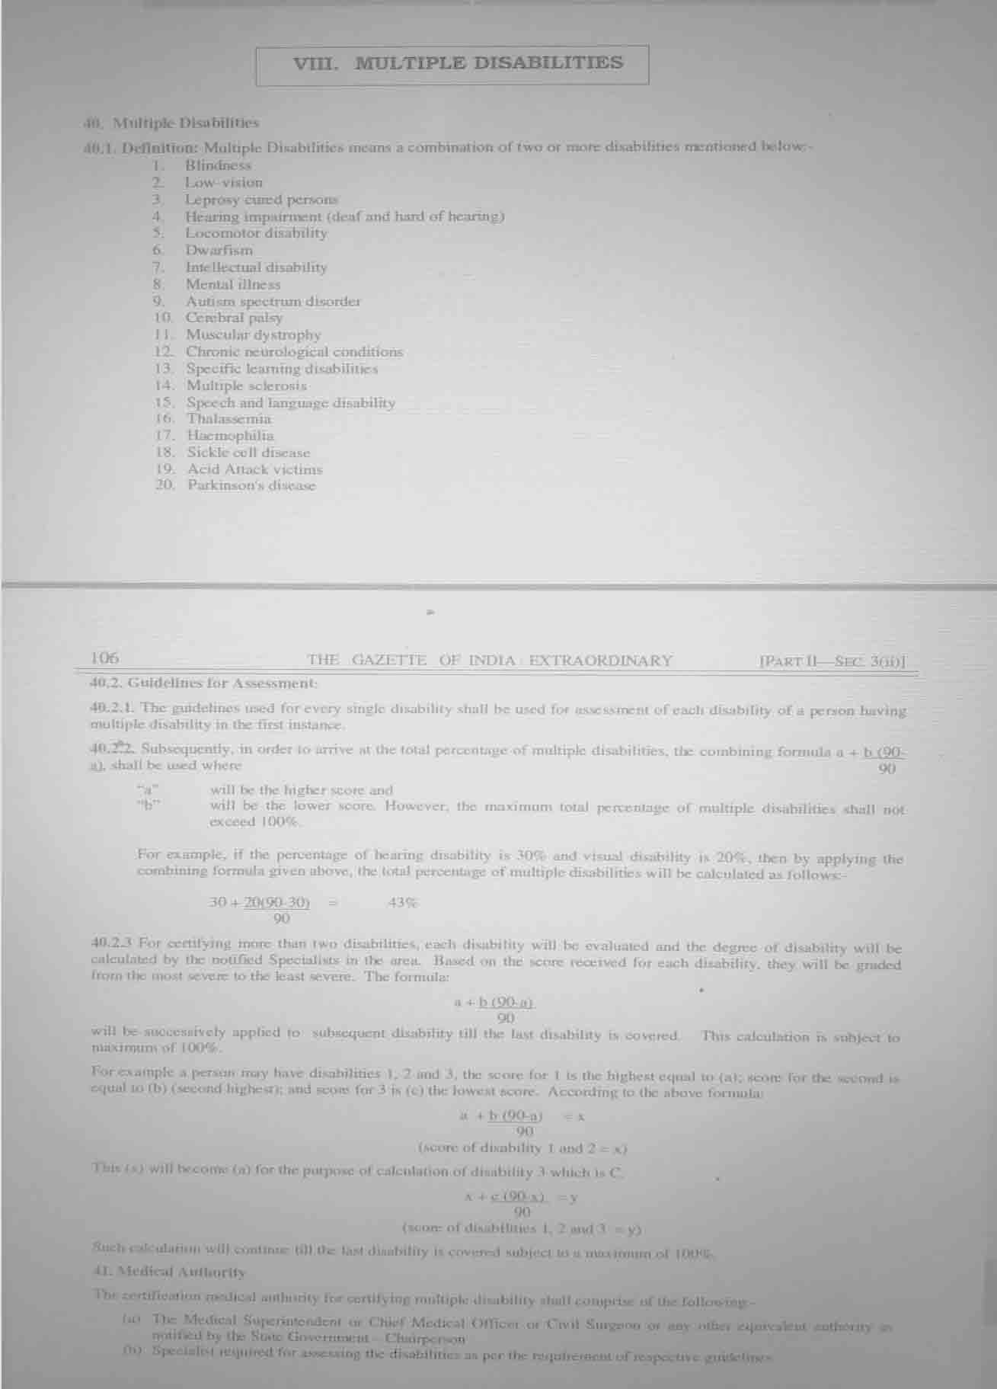

1. The responsibility for arranging the issue of the certificate has to be of the principals/

headmasters of the schools.

1. On the written request of school authorities, the District Medical Board should visit the school for evaluation of the disability of the student and issue certificate as per the notified guidelines and format of certificate.
2. In case the Medical Board is of the view that the evaluation of disability of a particular student can be done only after carrying out certain tests with the equipment available in the district hospital and therefore, the student should be brought to the hospital, where the school authority shall make arrangement for the visit. The expenditure will be borne by the Education Department of the State Government / UT Administration.
3. No fee shall be charged from the disabled students for issue of disability certificate.
4. The certificate may be issued before completion of the schooling of the disabled student along with their School Leaving Certificate or as and when required.

##### Medical Authority

The certification medical authority for certifying multiple disability shall comprise of the following: -

* 1. The Medical Superintendent or Chief Medical Officer or Civil Surgeon or any other equivalent authority as notified by the State Government – Chairperson
  2. Specialist required for assessing the disabilities as per the requirement of respective

guidelines.

Guidelines can be referred at - [http://disabilityaffairs.gov.in/content/page/guidelines.](http://disabilityaffairs.gov.in/content/page/guidelines)

pup

#### Grant-in-Aid schemes of the Ministry of Social Justice and Empowerment

The different Grant-in-Aid schemes offered are following:

##### Assistance to Voluntary organizations for disabled

The scheme was started with a view to provide assistance to voluntary organizations working in the field of disability including deafblindness. It is a comprehensive scheme to cover different areas of rehabilitation - physical, psychological, social and economic. Financial support is given up to the extent of 90 per cent of the total project cost (up to 95 per cent for the rural areas) for recurring items like staff salary, maintenance

charges, contingencies and non-recurring items like construction of the building. Rs. 5 lakhs of financial assistance are given for projects such as vocational training centers, special schools, counselling centers, hostels, training centers for personnel, placement services, etc.

##### Assistance to Disabled persons for Purchase/Fitting of Aids/Appliances

The main objective of the scheme is to assist needy physically handicapped persons in procuring durable, sophisticated and scientifically manufactured aids and appliances that promote their physical, social and psychological rehabilitation. The scheme is implemented through centers run by the companies registered under Companies Act, registered societies, trusts or any other institutions recognized by the Ministry of Social Justice and Empowerment. A large number of governmental and non-governmental agencies are engaged for the implementation of the scheme. Aids and appliances such as wheelchairs, crutches, calipers, hearing aids, Braille slates, etc. are given to different categories of disabled persons. Indian citizens possessing a certificate from a registered medical practitioner can benefit under the scheme. Disabled persons in need of aids and appliances are given travel allowance subject to a limit of Rs. 150/- for visit to implementing agencies’ center. The boarding and lodging expenses at the rate of Rs. 10/- per day subject to a limit of Rs. 150/- per beneficiary are also admissible in cases where the income of such persons is up to Rs. 1200/- per month. According to the scheme, aids and appliances up to the value of Rs. 3600/- are distributed to the disabled persons free of cost if the monthly income of the disabled is up to Rs. 1200/- and at 50 per cent of the cost if it is between Rs. 1201/- and Rs. 2500/-.

##### Assistance to Organizations for Persons with Cerebral Palsy and Mental Retardation

Under the scheme, assistance is given to NGOs up to the extent of 100 per cent for running training courses for teachers in the area of cerebral palsy and mental retardation. Both recurring and non-recurring items are considered for sanction.

Concessions and Subsidies for disabled persons including deafblind and their parents

in India.

#### Schemes

**Educational Schemes for the Disabled persons**

##### Children Education Allowance

Under Children Education Allowance scheme, reimbursement for tuition fee, admission fee, laboratory fee, special fee charged for agriculture, electronics, music or any other subject, Fee charged for practical work under the programmed of work experience, fee paid for the use of any aid or appliance by the child, library fee, games/sports fee and fee for extra-curricular activities can be claimed. This also includes reimbursement for purchase of one set of text books and notebooks, two sets of uniforms and one set of school shoes which can be claimed for a child, in a year.

Under the Scheme of Children Education Allowance reimbursement can be availed by government servants up to to a maximum of 2 children. The annual ceiling fixed for reimbursement of Children Education Allowance is Rs.12000. In case both the spouses are government servants, only one of them can avail reimbursement under Children Education Allowance. Under this scheme, reimbursement can be claimed once every quarter. The amount that can be claimed in a quarter could be more than Rs 3000 and in another quarter less than Rs.3000, subject to the annual ceiling of Rs 12000 per child being maintained.

The **Scheme for Integrated Education of Disabled Children (SIEDC)** provides educational opportunities for disabled children in the general school system so as to facilitate their protection and significant integration in the system.

##### Education of Disadvantaged Group through National Institute of Open School.

To cater to the special needs of people who are physically/ mentally challenged, socially and geographically isolated, marginalized and are from disadvantaged sections such as street children, working children, rural women; the NIOS has special accredited institutions called **Special Accredited Institutions for Education of the Disadvantaged (SAIED).**

For admission for differently-able persons**,** as a supporting document, a medical certificate from a government hospital and not from a private nursing home, is required which clearly indicates the nature and extent of disability.

##### The Central Board of Secondary Education (CBSE)

The CBSE allows provision of the facility of amanuensis (a writer or scribe) for blind and physically disabled children when they sit for the tenth standard and twelfth standard board examinations. It also opened a cell for parents to lodge the grievances of parents regarding placement of disabled children.

##### CBSE Relaxation for Disabled Children

The facilities extended by the Board to the disabled candidates (Dyslexic, Blind, Spastic and Candidates with Visual Impairment) and also could be entertained by the deafblind are as under:

1. The persons with disabilities (Dyslexic, Blind, Spastic and Candidate with Visual Impairment) have the option of studying one compulsory language as against two. The language opted by them should be in consonance with the overall spirit of the Three Language Formula prescribed by the Board. Besides one language they can offer any four of the following subjects: Mathematics, Science and Technology, Social Science, Any other Language, Music, Painting, Home Science and Introductory Information Technology.
2. From the 2002 Examination, alternate questions in lieu of questions requiring special skills based on visual inputs have been provided in Mathematics and Science for Sec. School Examination (Class X).
3. Blind, Physically Handicapped and Dyslexic Students are permitted to use an amanuensis/writer. The amanuensis/writer must be a student of a class lower than the one for which the candidate is taking the examination.
4. The visually handicapped students appearing from Delhi were provided Questions

Papers with enlarged print for 2003 Examination.

1. Disabled candidates are allowed additional one hour (60 minutes) for each paper

of external examination.

##### Scheme of National Scholarship for Persons with Disabilities

This scheme is to provide financial assistance to disabled students for pursuing higher and technical education. They will also be supported for acquiring special aids and appliances for studies.

Eligibility for the scheme is based on following criteria:

1. Financial assistance will be available to disabled Indian students.
2. They will need disabilities certificate as per definition under PWD Act 1995 to avail financial assistance under the scheme.
3. Financial assistance will be given for the study of recognized post matric/post

secondary courses in recognized institutions.

1. Scholarship will be awarded for one course to one student.
2. Financial assistance will also be given for purchase of a computer with editing software for blind & deaf graduate and postgraduate students pursuing professional courses and purchase of support access software for cerebral palsied students.
3. Students with disabilities, who have passed matriculation/secondary or any higher examination from a recognized board/University, will be eligible for the assistance.
4. Continuation/ renewal of the award for next year will depend on successfully completing the course in the preceding year with minimum 50 percent marks.
5. Assistance will not be available for courses having duration of less than one year.
6. A scholarship holder under this scheme will not hold any other scholarship/stipend. If awarded any other scholarship/stipend, the student can exercise his/her option for choosing the scholarship and inform awarding authority about the same.
7. For availing financial assistance under this scheme monthly family income of the beneficiary should not be more than Rs. 15,000/- from all sources. Family income will include income of the parent and in their absence income of the guardian.

##### 3% reservation in all UGC colleges for all courses

There is 3% reservation for person with disabilities in all UGC colleges for all courses.

##### UGC guidelines for support to students with disabilities

The UGC had started the scheme of assistance to universities/colleges to facilitate Teacher Preparation in Special Education (TEPSE) and Higher Education for Persons with Special Needs (HEPSN) during the Ninth Five-Year Plan, keeping in view the need to provide special education programmed as well as infrastructure to differently- abled persons. The infrastructure needs to be designed in a manner to enable them to easily access classrooms, laboratories, toilets, etc.

The objectives of the scheme are as follows:

1. To encourage universities/colleges of education in the country to promote teacher

preparation programmed in the field of special education.

1. To provide equal educational opportunities to disabled persons in higher education

institutions.

1. To create awareness among the functionaries of higher education about the specific

educational needs of persons with disabilities.

1. To equip higher education institutions with the facilities to provide access to disabled persons.
2. To provide appropriate financial assistance to disabled individuals to increase them

sustainability in higher education.

1. To explore suitable placement opportunities for educated disabled graduates in public as well as private sector enterprises.
2. To monitor the implementation of all existing and future legislation and policies pertain to higher education of persons with disabilities.

##### This scheme is aimed particularly at:

1. Providing assistance to universities/colleges of education to start teacher preparation courses in special education at the B.Ed./ M.Ed. level and
2. Creating appropriate facilities for persons with special needs in higher education.

##### Policies for guardians of handicapped persons

The Life Insurance Corporation of India (LIC) has come out with two policies for guardians of handicapped persons that aim to provide them (handicapped person) financial security in the event of their (guardians’) death.

***Jeevan Vishwas*** policy covers the life risk of the proposer, parent or guardian of a physically, or mentally-handicapped person and provides a regular income to the dependent. The policy pays the basic sum assured along with the accrued guaranteed additions and loyalty additions if the proposer survives the maturity date of the policy or on his death when the policy is in force.

***Jeevan Aadhar*** policy covers the life risk to the proposer and pays an annuity to the

handicapped dependent or to any person or a trust for the benefit of the dependent.

##### Employees Provident Fund

The Central Government has made amendments in the Employees’ Pension Scheme, 1995 called Employees’ Pension (Amendment) scheme, 1999. According to this scheme “If a member dies leaving behind a family having son or daughter who is

permanently and totally disabled, such son or daughter shall be entitled to payment of monthly children pension or orphan pension, as the case may be, irrespective of age and number of children in the family in addition to the pension provided under clause

(d) of sub para 3, Section 6a.

##### Tax Deduction

The Government of India has given various income-tax deductions from the total income tax of people with disabilities. The limit under Section 80-DD and 80-U of Income tax Act deducts tax up to INR 40,000/- of person with disabilities. Persons dependent on Handicapped enjoy tax deductions against expenditure on medical treatment, training, and rehabilitation of challenged dependents or amount deposited in an approved scheme of Life Insurance Cooperation (LIC) and United Trust of India (UTI).

##### Railways Concessions

Railways allow disabled persons to travel at concession fares up to 75% in the first and second classes. Escorts accompanying blind, orthopedically and mentally handicapped persons are also eligible to 75% concession in the basic fare.

##### Air Travel Concessions

Indian Airlines allow 50% concession fares to blind persons on single journey.

##### Postage

Payment of postage, both inland and foreign, for transmission by post of ‘Blind Literature’ packets is exempted if sent by surface route.

##### Customs/Excise

Braille paper has been exempted from excise and customs duty provided the paper is supplied direct to a school for the blind or to a Braille press against an indent placed by the National Institute for the Visually Handicapped, Dehradun. All audio cassettes recorded with material from books, newspapers and magazines for the blind are exempt from custom duty. Several other items have also been exempted from customs duty if imported for the use of a disabled person.

##### Hotel discounts

India Tourism Development Corporation (ITDC) has decided that in all its hotels across the country, it will offer the following two discounts to people with disabilities:

1. 50% on room rent, accompanying person / attendant shall not be charged extra i.e. ITDC shall charge 50% on single room tariff for double room.
2. 30% discount on food on the a-la-carte menu.

##### Indira Gandhi National Disability Pension Scheme (IGNDPS)

Government of India has introduced scheme i.e. Indira Gandhi National Disability Pension Scheme (IGNDPS) under National Social Assistance Programmed (NSAP). These schemes have to be introduced in the state with the contribution of 50% of the fund required for implementation of scheme. The objectives of the schemes & eligibility criteria & other details are given below.

##### Eligibility criteria and requirement of documents:

To get the benefit of the scheme, following criteria need to be fulfilled by an applicant

are:

* 1. She/He must not be less than 18 years of age and not above 64 years.
  2. She/He should be from a family which is below the poverty line.
  3. She/He shall be with severe disability (i.e. more than 80% disability) or multiple disabilities (having more than one disability and at least 40% incapacitation in each kind of disability, totaling disabilities 80% or more).
  4. She/He shall get the pension until she/he attains the age of 65 years.
  5. In case of any dispute related to determination of age, birth certificate /certificate of the Headmaster of the Primary / Madhyamik School in which she/he studied last

/ Horoscope will be accepted. If the applicant did not study in a school, certificate of the Pradhan / concerned member of the Gram Panchayat will be accepted.

* 1. She/He shall have to produce certificate issued by Social Welfare Department of the

District regarding her/his disability in support of her/his claim.

* 1. Monthly pension will be disbursed through the Bank Accounts / Post Office Accounts

of the pensioners.

* 1. The applicant has to produce photocopy of her Bank/Post Office A/c. at the time of

submission of her application.

* 1. No pension will be disbursed until the names of the newly identified pensioners are uploaded to the Website of the Ministry of Rural Development, Government of India.

#### Advocacy

##### Advocacy

Advocacy is a process through which policy and practice can be influenced and changed to bring about positive change in the lives of (deafblind) people. It is a process whereby deafblind people and their families are empowered to take control of their lives, have choices, and are able to secure access to basic services and representation, as full and active members of society. Advocacy must form an integral part of trainings courses for advocating the rights of deafblind people. Advocacy plays a bigger role to make strategies for influencing others to make a bigger impact.

##### This broadly means:

* + - Influencing others to recognize and address the needs and rights of deafblind

people in their policies and programmed

* + - Engaging with professionals in diverse fields, from education and health to livelihoods, employment and micro-credit
    - Providing a link between the government and technical / service-providing institutions, facilitating dialogue and ensuring resources are allocated to deafblind people.
    - Supporting deafblind people and their families in self-advocacy initiatives by raising awareness, providing training and counselling, supporting development of representative associations with leadership structures, and facilitating access to key decision makers
    - Ensuring Peer advocacy by other disabled people and Joint advocacy between

partners

* + - Once other organizations recognize the need to include deafblind people in their programmed, and once governments recognize their responsibility to this marginalized group and act upon it, deafblind people and their families will be empowered to take a full and active role in their communities and society.

##### Target Groups for Advocacy

* + - Local and national governments
    - Local and national NGOs
    - Local, national or regional networks
    - Opinion-makers (media etc.,)
    - The general public
    - Decision-makers (e.g. Ministers, local and national level civil servants)
    - Donors (e.g. Trusts, foundations, government departments).

##### Approaches for Advocacy

* + - Working directly with the target group (meetings, dialogue etc.,)
    - Working through others (umbrella organizations etc.,)
    - Working in alliance with others through networks
    - Written submissions to policy discourse
    - Sharing documentation of our own practice (conferences, seminars etc.,)
    - Membership of committees and networks
    - Awareness raising and training/sensitization programmed

#### Networking and developing support system among parents

A network is any group of individuals or organizations, who on a voluntary basis exchange information or undertake joint activities and organize themselves in such a way that their individual autonomy remains intact.

##### Objective of Network

The prime objective of establishing a network is to improve information exchange among members. Some networks are established to allow collaboration, research, education, and training, exchange materials, operate as pressure groups, raise public awareness etc. Very rarely does a network operate on a single objective.

##### Networks for Persons with Deafblindness, their Families and Educators in India

There are three National networks associated with deafblindness/ Multi-Sensory Impaired, which are as follows-

* + - Udaan Network - It is a network of Adult Deafblind people in the country.
    - Prayaag Network - It is a network of Parents having deafblind/Multi-Sensory Impaired (MSI) children.
    - Abhi-Prerna Network - It is a network of Educators working with deafblind/MSI

children.

To avail more information on the three National Networks, and other 21 locally registered family networks for deafblind/MSI children in different states you can contacts Sense International (India) Office, at Ahmedabad or Delhi.

##### Support from Government

There are many steps taken by the Government at various stages for the child and your family’s development. Link to some of the major schemes are listed below for your reference and action.

##### References

[*http://socialjustice.nic.in/schemespro3.php#a3*](http://socialjustice.nic.in/schemespro3.php#a3)[*http://socialjustice.nic.in/policiesacts3.php#a2*](http://socialjustice.nic.in/policiesacts3.php#a2)[*http://socialjustice.nic.in/pdf/adipsch.pdf*](http://socialjustice.nic.in/pdf/adipsch.pdf)[*http://www.thenationaltrust.co.in/nt/index.php?option=com_*](http://www.thenationaltrust.co.in/nt/index.php?option=com_) *content task=view&id=219&Itemid=283* [*http://socialjustice.nic.in/pdf/adipsch.pdf*](http://socialjustice.nic.in/pdf/adipsch.pdf)[*http://socialjustice.nic.in/pdf/naward2011.pdf*](http://socialjustice.nic.in/pdf/naward2011.pdf)[*http://nsap.nic.in*](http://nsap.nic.in/)[*http://disabilityaffairs.gov.in/content/page/guidelines.php*](http://disabilityaffairs.gov.in/content/page/guidelines.php)