**In-school Screening, Identification and Assessment of Children with Disabilities**



*Lessons from the TO51 Project in Tanzania*

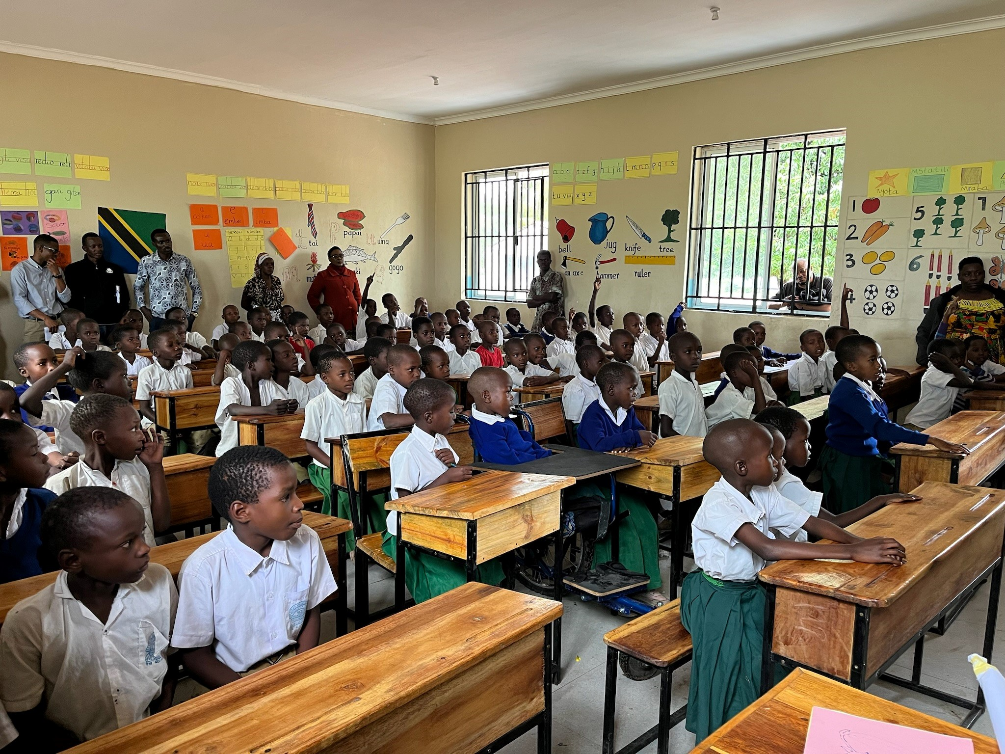

Supported by:

Contents

List of Abbreviations 2

Context 3

Document Review 4

Rationale 4

Methodology 5

Screening, Identification and Assessment of earners in Tanzania 6

Screening, Identification and Assessment: TO51’s approach 8

Lessons Learned from the In-school Screening, Identification and Assessment Approach 13

Recommendations for Future Programming on In-school Screening, Identification and Assessment 17

References 20

## 

## List of Abbreviations

|  |  |  |  |
| --- | --- | --- | --- |
| ESRACs - Educational Support, Resources and Assessment Centres | | | |
| CWD - Child with a disability |  |  |  |
| DC - District Council |  |  |  |
| DID - Disability Inclusive Development | | |  |
| ESDP - Education Sector Development Plan | | |  |
| LGA - Local Government Authority | |  |  |
| MC – Municipal Council |  |  |  |
| MoEST - Ministry of Education, Science and Technology | | | |
| NSIE - National Strategy of Inclusive Education | | | |
| OPD – Organization of Persons with Disabilities | | | |
| PO-RALG - President’s Office-Regional Administration and Local Government | | | |
| SNEO – Special Needs Education Officer | | | |
| TO51 - Task Order 51 |  |  |  |
| UNICEF – the United Nations Children's Fund | | |  |
| URT – The United Republic of Tanzania | | |  |
| WGQ - Washington Group Questions | | |  |

## 

## Context

Towards achieving Goal 4 of the 2030 Sustainable Development Agenda, the UN Disability and Development Report 2024 reveals that only 11% of primary school-aged children with disabilities are enrolled and remain in school globally. This is quite alarming, considering there are only 5 years left until the deadline. Tanzania is reported to be among the 87% of countries with laws and / or policies protecting the rights of persons with disabilities to education. It is also one of the 17% of countries that legally guarantee an inclusive education.1 However, statistics show that in 2023, children with disabilities enrolled in pre-primary and primary education in Tanzania were only 0.4% (6,892) and 0.7% (74,295) respectively of all children in schools2.

Like all children, children with disabilities too have ambitions and dreams for their futures. They need quality education to develop their skills and realize their full potential. Inclusive education is the most effective way to give all children a fair chance to go to school, learn and develop the skills they need to thrive.3 To make inclusive education effective, every child with a disability should have an education support needs assessment, requiring the involvement of a multi-disciplinary team, the teacher and the family. This will enable the development and implementation of an individualised education plan focused on the child’s potential and ability, notwithstanding the type of disability.

To ensure that no child is left behind in education, the Government of Tanzania is committed to ensuring that all learners are supported to learn together and all systemic and structural barriers that obstruct certain groups of individuals from accessing education are removed.4 Tanzania Education and Training Policy 2014 (2023 Edition) recognises the importance of having a proper system to identify and assess the needs of children with disabilities. Statement 3.2.2.1 of this policy states that the government will improve the identification and assessment system for all learners with special needs at all levels of education. Thus, the importance of developing and equipping Educational Support, Resources and Assessment Centres (ESRACs) at the local government level is becoming a necessity as it is written in the National Guideline of Identification and Assessment of Children/ Learners with Special Needs, 2023 and emphasized under objective 2 of the National Strategy of Inclusive Education (NSIE 2021/22-25/2026).

Therefore, the UKAID funded Disability Inclusive Development Inclusive Futures (DIDIF) Task Order 51 (project) Inclusive Education plan, aims at ensuring that the screening, identification and assessment process is integral in guaranteeing children with disabilities appropriate learning intervention in an inclusive setting. Task Order 51 is four years project implemented in three districts namely Misungwi District Council (Mwanza Region), Shinyanga District Council and Shinyanga Municipal Council (Shinyanga region).

## 

## Document Review

Educational Screening and Assessment practice in Tanzania is led by the National Guideline for Identification and Assessment of Children/ Learners with Special Needs issued by the Ministry of Education, Science and Technology in 2023. The National Strategy on Inclusive Education (NSIE) 2021/22-25/2026 also stresses the importance of support and services to children with disability by quoting the Salamanca Statement (1994) which says, ‘placement and intervention of a learner with disabilities should be done if only recommended by the results of identification and assessment’. In addition to that, NSIE 2021/22-25/2026 has a designated objective and indicators to measure the level of identification and assessment resulting in the right placement and support to learners with disabilities.

In 2022, supported by the TO51 project, the President’s Office-Regional Administration and Local Government (PO-RALG) developed a Guideline for the Establishment and Operation of Educational Support Resource and Assessment Centers (ESRACs) at the council levels to ensure that all education administrators at the local government from the village level know and understand their roles in identifying and referring a child with a disability to access required educational support and assessment at the ESRAC.

Finally, the newly launched Competency-Based Curriculumfor Basic Education in Tanzania (2024) is absolute evidence that screening and assessment are at the core of learning for a child with disability.  

## Rationale

Disability is among the major reasons contributing to many primary school-aged children remaining out of schools as mentioned in the Education Sector Development Plan (ESDP) 2025/26-2029/30. Whilst the disability prevalence among persons aged 7 years and above in Shinyanga is estimated at 8.8%, it is 11.8 % in Mwanza, which is higher than the national prevalence (11.4%)5. This may suggest that a good number of children with disabilities are still out of school waiting to be identified and assessed to reach their maximum educational potential.

The DID TO51 project areas (Shinyanga and Mwanza regions) have been known to have high negative attitudes towards people with disabilities.6 The DID TO51 project, through its screening and assessment approach, has played a key role in addressing many of the prevailing negative attitudes, hence more children with disabilities have been brought forward to join school.

*“Traditionally, this community has a negative perception towards people with disabilities. Many people believe that a disability is a curse from God or Gods for the wrongdoing of the parent(s). The training received from this project has changed our perception of people/children with disabilities.’’* (OPD member)

Data reveals that 2,114 children with disabilities in Shinyanga (Shinyanga DC 330, Shinyanga MC 601) and 5,487 in Mwanza (Misungwi district 707) were enrolled at primary school in 2023.7 This can prove that the DID TO51 project has contributed to the increased enrollment of children with disabilities from 56 in Misungwi DC, 47 in Shinyanga DC and 111 from Shinyanga MC in 20208. Therefore, the TO51 project is an asset towards attaining ESDP 2025/26- 2029/30 goal, aiming at increasing the country’s enrollment of learners with disabilities to 14.2% by 2030.

## 

## Methodology

This learning product employed a qualitative approach through consultative meetings with the consortium partners and other project stakeholders from Shinyanga Municipal Council, Shinyanga District Council (Shinyanga) and Misungwi District Council (Mwanza).

Data and information were collected through document review, key informant interviews and focus group discussions with 233 participants (121 males and 112 females) purposely9 selected from primary schools, village members, and district officials in the project area, but in addition also from the Ministry of Education, Science and Technology (MoEST), and Shule Bora project officials. To ensure inclusion of the voices of people with disabilities, the participants included Organizations of People with Disabilities (OPDs), 36 pupils with disabilities (M18, F18) and 30 parents of children with disabilities (M15, F15).

## 

## Screening, Identification and Assessment of Learners in Tanzania

Screening and assessment in Tanzania is practised under the guidance of the National Guidelines for Screening and Assessing Learners with Special Education Needs (2023). The procedure below is for the screening and assessment at the council level.

1. **Screening:** This is the first stage, usually scheduled in the last quarter of every calendar year. The screening team, comprising of special needs education specialists is formed at the Local Government Authority (LGA). Public awareness on disabilities and education is usually conducted by teachers from the nearby schools ahead of the screening activity. The screening report should be submitted to the district after the event.

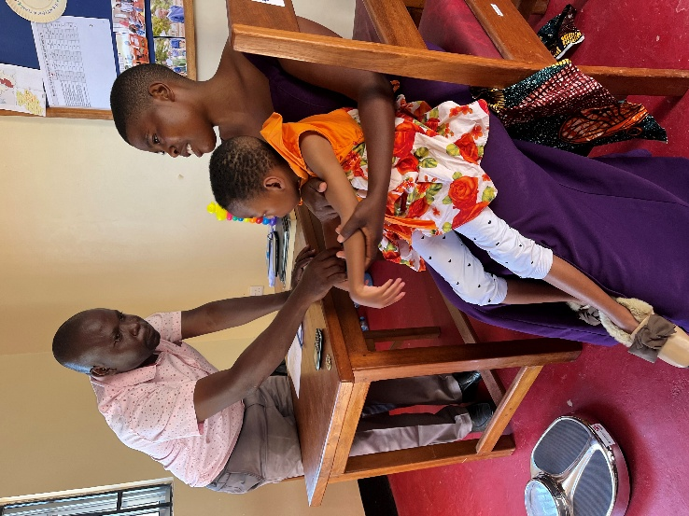

A young child is assessed at ESRAC

1. **Assessment:** All children identified with disabilities are then referred to the ESRAC, where a thorough educational needs assessment will be conducted by the multi-disciplinary team. The multi-disciplinary team has a medical Doctor, social welfare officer, and 3 Teachers specialising in Hearing Impairments, Vision Impairments and Intellectual Impairments working together. At the end of the assessment, a child with a disability will be given either a referral report recommending the needed educational support at school or a referral to the hospital for medical intervention before school enrolment.

1. **Provision of correct intervention**

The referral report from the ESRAC will recommend the intervention to support the learning of a child with a disability in an inclusive setting. The intervention is usually in the form of:

1. ***Individualised Education Plan***: The class teacher and a parent prepare the best teaching and learning approach for a child in the inclusive setting at school and at home.
2. ***Improved infrastructure***: The school will use the report to provide an accommodating learning environment for a child with a disability.
3. ***Medical Intervention and Assistive Devices***: Medical practitioners will use the report to provide medical intervention (such as physiotherapy, occupational therapy and surgeries) and assistive devices to a child with a disability.
4. **Monitoring and Evaluation**

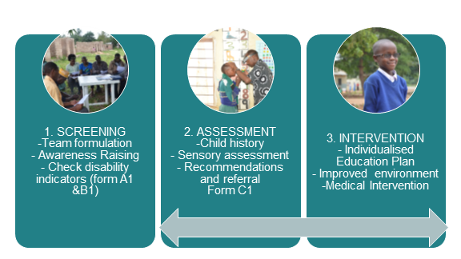Text Box 63, TextboxDistrict Quality Assurers, head teachers and education officers from the ward, district and the national level are supposed to follow up on the educational development of all children with disabilities placed at school. Their reports will be used by the educational administrators to improve the quality of education for those enrolled with disabilities.

**Diagram 1:  Screening and Assessment in Tanzania**

Unfortunately, the above screening and assessment practice usually ends at stage one due to the shortage of functioning ESRACs in the country. The government has only one national ESRAC in Dar es Salaam with a long waiting list. Other ESRACs supported by development partners are located at the council levels in Misungwi DC, Shinyanga DC, Shinyanga MC, and Mbeya MC, which are also overwhelmed, as one interviewee said:

*“The use of the government approach has not been effective due to the lack of budget and shortage of trained personnel at ESRACs. Also, ESRACs do not have full-time dedicated staff. These assessors come only once a week, as a result, not all children with special education needs can be attended to in good time.”*

The quote above shows that the government’s approach to screening, identification and assessment of children with disabilities to assess their education needs has been less effective due to inadequate budget, shortage of assessment centres, shortage of material and equipment and inadequate experts for screening, identification and assessment of children with disabilities.

## Screening, Identification and Assessment: TO51 Approach

The TO51 project introduced two approaches to screening: Community screening for out of school children with disabilities and in-school screening for those attending school but struggling with learning. This has proven to be the best approach with maximum efficiency on both the identification of children with disabilities and education support as it is bringing together the existing governance structure from the Community Development, Health, and Education departments at the council level.

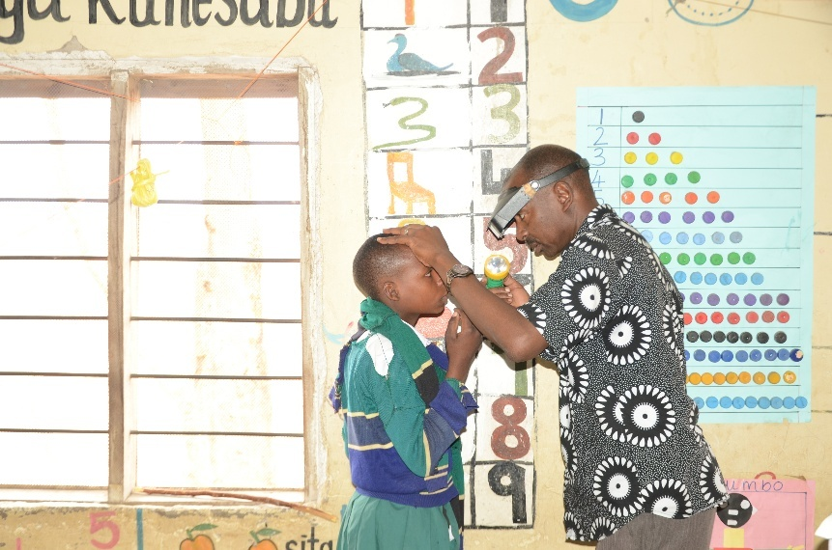**Community Screening:** The DID TO51 Project in partnership with locally based Organisations of Persons with Disabilities (OPDs) revived the disability committees at the village levels in September 2023 in 15 wards. The Village Disability Committee is a part of the village structure recognised by Section 4(1) of the Persons with Disabilities Act 2010 to coordinate and support all disability issues in the community. Therefore, their involvement in the screening and identification of children with disabilities is not only important but also crucial in following up on their educational progress. At the end of the screening exercise, the disability committee fills in the identification Form10 per identified child with a disability. Then the OPD checks for accuracy and sends the report to the ESRAC for educational assessment of the identified child before school enrolment.

A young boy receives eye screening in a classroom

For the maximum impact to be achieved, the DID TO51 project team with the OPDs conducted the screening and identification training to the Village Disability Committees using the Screening and Assessment guideline from MoEST. The trained members are now able to accurately conduct community screening and identification with less technical support from the project. This has been proven by the DID TO51 October-December 2024 project report, which revealed the screening and identification activity conducted by the Village Disability Committees in 15 villages with no support from the project. 34 Out of school children with disabilities were found through this exercise. This has proven that the engagement of people from the same community builds trust and ownership of the activity, and with that sustainability of the intervention.

**Diagram 2: TO51 Community Screening approach**

*“Being sensitive to people’s culture is the best practice of this project. Although many people in this community had a belief that disability is a result of a curse, this project did not blame them for such a belief. Rather, it respected their cultural beliefs and slowly educated them until they were able to change their perceptions towards disabilities.”* (Community Leader, Misungwi DC).

**In school Screening:** The DID TO51 project built the capacity of 147 teachers from 49 primary schools to understand disability and the importance of screening and assessment for the education of children with disabilities. The training covered the knowledge and skills to identify and understand different types of disabilities. They were also trained to use the observation methods and the Washington Group Questions (WGQ) approach to screen for learners with disabilities in their classes.

All children suspected with any disability are then referred to the ESRAC for a comprehensive educational assessment and further support. This can be a continuous back and forth process depending on the nature of disability and the education support needs.

**Diagram 3: In-School screening**

**Assessment:** Educational assessment for children with disability is conducted at the ESRAC per the MoEST's guidance. The DID TO51 project funded the renovation and equipping of three ESRACs at the council level to bring services closer to the community and schools.

All children referred from both the community and schools undergo the 1st stage screening by the multi-disciplinary team. They will assess the child’s vision, hearing, intellectual and physical well-being, and take the child’s history from the parent or guardian. The detailed referral form11 will then be filled out and sent to school or to the health facility if a child needs medical attention.

A child receives a hearing assessment at an ESRAC

2nd Stage assessment is conducted for only those children with disabilities requiring further assessment by the specialists at the health facility or social welfare office. A referral form from the ESRAC must be returned by the referral department to confirm that a child has been attended to and is ready for school, so that the multi-disciplinary team can give their education support recommendations to the school.

**Diagram 4: The DID TO51 Screening, Assessment and Referral pathway**

The DID TO51 project adapted the government approach and qualified it by employing the holistic method which harmonised the screening and assessment procedure from the MoEST with the existing inter-sectoral referral systems and support at the council. The success of this approach has been due to health, social welfare, community development, and education departments speaking the same language as the community- “disability cannot stop a child to learn”.

*“…It is important for in-school screening to be well linked with the community and ESRACs. Children at school come from the community, so when the teacher screens the child, s/he must obtain some additional information from parents and the community regarding the child’s disability. Likewise, when teachers screen pupils and find that they require further assessment, they refer them to ESRACs which establishes the nature of the disability, its magnitude and the required intervention. After assessment, children are referred back to schools where teachers prepare individualized education plans based on the child’s identified needs.”* (ESRAC team member, Misungwi)

While the government uses a linear approach from screening to assessment and school placement; The DID TO51 project has shown the best practice by demonstrating that depending on the identified disability a child can go back and forth between the ESRAC, school and medical referrals. In addition to that, some government officials will be needed to facilitate this exercise. For example, at the community level, a social welfare officer will work with the Village Disability Committee during the screening, s/he is also supposed to work in close collaboration with the Ward Education Officer to ensure that the identified child gets both social and educational support from the community and at the ESRAC. On the other hand, when a teacher identifies a child at school, s/he is not only taking a child to the ESRAC for detailed assessment rather s/he will also communicate with the respective parents, village leaders and the Village disability Committee which is mandated to follow up and support a child with a disability making sure that s/he receives all the necessary and available services, including education.

*“Frankly speaking, in-school screening is well linked with community and the ESRAC. When the school asked me to take my child to ESRAC for assessment, I was unsure whether the ESRAC staff could accept us. But when I went there, they warmly welcomed us and assessed my child.”* (Parent of a child with a disability, Shinyanga DC)

## 

## Lessons Learned from the in-school screening, identification and assessment approach

Some of the key learning that has been identified through the TO51 project include the following:

* 1. ***In-School Screening and Identification Process***

The In-School Screening and Identification process serves as the primary and crucial step in supporting learning for children with disabilities at school. Supporting learning for children with disabilities and ensuring that interventions are properly implemented in the classroom starts with teachers being curious about how they can better support these children with disabilities, hence realising the importance of assessment and being eager to wait for the assessment results. Equipping teachers with screening and identification skills paves the way for further assessment and the provision of appropriate educational interventions for children with disabilities.

However, a challenge identified is the inconsistent use of government-recommended disability screening and identification tools by mainstream teachers in the project schools. Although these tools are officially endorsed and designed to support early identification of learners with disabilities, and teachers have been trained to use these tools during the project, many of them cite the lack of time and capacity to utilize these tools for comprehensive screening in the classroom. As a result, many teachers rely on informal observations, which are subjective and may fail to capture the diverse and often subtle indicators of disability. This leads to the under-identification or exclusion of children in need of support which indicates a failure to uphold its commitment to inclusive education and the "leave no one behind" pledge of the Sustainable Development Goals (SDGs). This is an especially great risk when classrooms have large numbers of pupils, often exceeding 100 per class.

An additional study (2025) conducted with a sample of schools (6) which are part of the TO51 project, screened 852 children in Standard 4 to Standard 6 using the MoEST approved screening tools. The study revealed that 166 children were identified as potentially living with a disability and requiring an assessment at the ESRAC. At the time of writing of this report, some of these children are yet to be assessed by the ESRAC centre, so no figures can yet be provided on how many of the 166 children went on to receive educational support and / or referrals. What the study did show, is that by using observations only, the risk of not identifying children in need of an assessment is high.

A mural on the wall of Mitindo ESRAC

In general, it has been identified that many teachers lack the practical support and sustained professional development required to apply these screening and identification tools effectively in everyday classroom settings. In practice, teacher training is often delivered as a one-time event, with less follow-up coaching, mentoring, or peer learning opportunities. This creates a gap between knowledge and application, leaving teachers uncertain or ill-equipped to integrate screening tools into their routines.

* 1. ***Unique Needs of Every Child with a Disability***

Every child with a disability is unique; thus, screening and identification should include a comprehensive assessment to identify their specific learning needs. It has been observed that some teachers screen and identify children with disabilities at their schools and even add these children to a list of children with disabilities. However, they often do not recognise the importance of a comprehensive assessment, as their assumptions lead them to believe that all interventions for disabilities are the same. They might not fully understand the importance of referring a child to ESRAC if it is already clear that they have either physical disabilities, albinism, or intellectual impairments. This requires further sensitisation and training of teachers and others conducting screening.

Schoolchildren in an inclusive classroom

* 1. ***Effective referral pathways require a dedicated person for follow-up***

Currently, the ESRAC multi-disciplinary team works only one day a week, which means this is the only time the team invests in assessing children with disabilities, with minimal or no time for follow-up for referrals provided, especially for those that were addressed previously. This is a significant gap in the function of the ESRAC. The impact of the ESRAC could be manyfold if the ESRAC was running throughout the week, which would allow more time for assessments, referral follow ups with social services and health departments, as well as teacher support in the classroom.

* 1. ***Inter-sectoral referrals***

Inter-sectoral referrals from ESRAC are currently not being recognised in health facilities and social welfare services.

This was a big challenge faced by parents and children referred for medical and social services from the ESRAC. The referral form from the Screening and Assessment guidelines from the MoEST is not recognised by the health care providers and other service providers in the country. The DID TO51 project team had to engage the office of the District Medical Officer in Misungwi and Shinyanga for health facilities to accept the children referred from the ESRAC. The medical Doctor in the multi-disciplinary team was instrumental by adding extra effort to liaise with the district hospital so that the children with disabilities can be accepted for medical interventions once referred by the ESRAC.

*“This project has done many good things to our community. However, follow up and feedback mechanism for the referrals has been a major challenge.”* (Representative of OPD, Misungwi DC)

* 1. ***Positive Interaction and collaboration between teachers and parents***

A key to the education success of a child with a disability. In Tanzania where many parents still believe that it is the role of teachers and schools to educate a child; the DID TO51 project has proven it differently. Parental engagement from the screening of a child with a disability all the way through assessment and subsequent school placement has brought parents closer to understanding the abilities of their children and their roles in supporting a child to reach their education milestones. This has been shared by the participants in this project after seeing their children excelling in education despite their previous thoughts about their child with a disability. One parent said:

*“I sincerely admit that this project has improved our interactions and collaboration with teachers. Before this project, a teacher could request a parent to go to school to discuss issues regarding the child, but none would respond. However, this project has made teachers and parents become one when it comes to supporting children with disabilities.”* (Parent of a child with disability, Misungwi, DC)

* 1. ***Local leaders and community members know where to find children with disabilities.***

The DID TO51 project took time to talk and engage local leaders and other influential members on disability issues. Thus, created trust in a community where people with disabilities are often hidden because disability is believed to be a curse. The essence of ownership among the stakeholders, gives more reasons for the councils to take up and sustain this approach.

*“This project has promoted relationships among different stakeholders, including teachers, parents, community members, and the ESRAC multi-disciplinary team. The success of this project in screening, identifying and assessment of children with disabilities is attributed to the collaboration among different stakeholders that the project established.”* (representative of persons with disabilities)

*“The involvement of Village Disability Committees has instilled great trust among parents. They trust their village leaders, and the information they provide about their children, they provide at peace, knowing we are here to support them as well we are people with disability as their children.”* (OPD Member, Misungwi)

Motivating people to understand the importance of disability committees made it easier to facilitate its formulation by the people. This has been the best tool employed by the project to get more out of school children with disabilities screened, identified and referred for assessment.

*“Building the capacity of committees of people with disabilities on screening and identification of children with disabilities as well that of the ESRAC multi-disciplinary team on assessment is one of the best practices of this project. By so doing, the project has enabled more children with disabilities to be identified early and be provided with appropriate intervention and support.”* (Headteachers, Shinyanga DC)

* 1. ***Teacher training on screening and disability is crucial for sustainability***

Teachers engaged in the study expressed their relief after the screening training that was conducted by the DID TO51 project. Most teachers had not only experienced challenges in screening and identifying children with disabilities in their classrooms but also in understanding and supporting children with disabilities and managing an inclusive classroom.

Representatives of OPDs gather at the ESRAC

*“…The in-school screening and identification has enabled many teachers to understand the screening and identification of children with disabilities. The training enabled our teachers to design their instruction, teaching and learning materials in ways that enhance the learning of children with disabilities. This approach has also helped schools to receive various materials and tools such as glasses, hearing aids and wheelchairs for children with disabilities.”* (Headteacher, Shinyanga MC)

## Recommendations for future programming on In-school screening, identification and assessment

 The DID TO51 project is an adaptive project designed and implemented in partnership with the government and people with disabilities. This means the results and lessons from this project are practical and relevant for the better future of education for children with disabilities in Tanzania, and possibly beyond. The following are the recommendations for future programming on in-school screening, identification and assessment.

1. ***Engagement of community leaders and members***

Engagement of community members such as community leaders and people with disabilities in the screening and identification of children with disabilities has been a key factor for the success of the project. They can raise awareness at a local level and know the communities where they can screen and identify children. It is thus recommended for any future programming on in-school screening, identification and assessment to consider engaging members from the local community, including people with disabilities, through OPDs and Disability Village Committees.

*“People’s traditional customs and cultural beliefs have a profound impact on the acceptance of the project and its related activities. It is recommended that future programming on in-school screening, identification and assessment should include cultural sensitivity as key aspect to consider.”* (Interviewee)

1. ***Strengthening the referral mechanism between the education and health sector***

Effective referral process requires a well-established feedback mechanism that enables each actor to make follow-ups and understand the progress of the recommended intervention and support. For an effective referral process, future programming on in-school screening, identification and assessment should not only consider setting aside a budget for follow up but also to support the government in aligning the referral system between the health and education sector.

*“I think the composition of the ESRAC team and the follow up and feedback mechanism in the referral process are the areas that require improvement. I have noted that the follow up of the referred cases is often not done by the ESRAC team partly due to the lack of budget. The ESRAC team also lacks some key experts including a physiotherapist and a language and communication expert.”* (Community Leader, Shinyanga MC)

1. ***Mainstream teachers need more support in screening children at school***

To ensure timely and accurate identification of children with disabilities within mainstream classrooms, teachers must receive sustained, practical support beyond one-off training sessions. This includes structured continuous professional development (CPD) opportunities such as coaching, mentoring, peer learning, and hands-on guidance tailored to real classroom contexts. Such support mechanisms will equip teachers with the necessary skills and confidence to effectively screen, identify, and refer children with disabilities for appropriate interventions. Deliberate efforts should be directed to ensure that teachers use the government approved screening tools. As without utilising the approved tools and solely relying on observations, teachers risk missing children with disabilities in their screening and identification process. Embedding these CPD approaches within the education system will significantly enhance early identification efforts and promote a more inclusive learning environment for all learners.

Teachers continue their professional development

1. ***ESRAC requires at least one full-time multi-disciplinary member to enhance the full capacity***

To enhance the effectiveness of services at the ESRAC Center, it is recommended that the government assign either a full-time staff member or ensure that existing staff have increased time at the ESRAC to support coordination and follow-up activities. Currently, the multi-disciplinary team operates only one day a week, limiting the time available for assessing children with disabilities and resulting in minimal or no follow-up on referrals. Having a dedicated presence at the ESRAC, would ensure more consistent support, improved communication, and better implementation of interventions, ultimately leading to more responsive and effective services for children with disabilities.

Schoolchildren use assistive mobility devices

1. ***Leverage the TO51 project approach, its impact, and key learnings to inform national scale-up by strengthening existing community structures, expanding teacher training on screening and identification, and enhancing the capacity of ESRACs at council levels through improved coordination***

The study revealed strong perceptions of sustainability, with 87.5% of participants expressing confidence in the long-term viability of the ESRAC approaches. As an ESRAC team member commented:

*“The approaches and operations of this project will continue even when the project is no longer here. Because we work very closely with the office of the District Executive Directors and the Special Education Department, I believe that the government will continue whatever this project has put in place.”* (ESRAC Team Member, Shinyanga, DC)

Given this broad confidence in the sustainability of ESRAC’s work, we believe the initiative holds strong potential for replication and scale-up in other regions across the country.

## References

* Masanja, M. M., Imori, M. W., & Kaudunde, I. J. (2020). Factors Associated with Negative Attitudes towards Albinism and People with Albinism: A Case of Households Living with Persons with Albinism in Lake Zone, Tanzania. Open Journal of Social Sciences, 8, 523-537. https://doi.org/10.4236/jss.2020.84038
* The United Republic of Tanzania (URT), Ministry of Education, Science and Technology 2014, Education and Training Policy, 2023 Edition.
* The United Republic of Tanzania (URT), Ministry of Education, Science, and Technology, Education Sector Development Plan 2025/26 – 2029/30
* The United Republic of Tanzania (URT), Ministry of Education, Science, and Technology, National Strategy of Inclusive Education 2021/22-25/2026
* The United Republic of Tanzania (URT), Ministry of Education, Science, and Technology, The National Guideline on Screening and Assessment for Children with Special Needs, 2023
* The United Republic of Tanzania (URT), Ministry of Finance, Tanzania National Bureau of Statistics and President’s Office - Finance and Planning, Office of the Chief Government Statistician, Zanzibar. The 2022 Population and Housing Census: Tanzania Basic Demographic and Socio-Economic Profile Report; Tanzania, April 2024.
* The United Republic of Tanzania (URT), The Persons with Disabilities Act, 2010
* The United Republic of Tanzania (URT), President’s Office- Regional Administration and Local Government; Pre Primary, Primary, Secondary, Adult and Non formal Education statistics, 2023
* The United Republic of Tanzania (URT), President’s Office- Regional Administration and Local Government; Pre Primary, Primary, Secondary, Adult and Non-Formal Education Statistics, 2020
* The United Republic of Tanzania (URT), President’s Office- Regional Administration and Local Government; The Guideline for the Establishment and Operation of Educational Support Resource and Assessment Centers, 2022
* UNICEF (<https://www.unicef.org/education/inclusive-education>)
* United Nations (2024). Disability and development report 2024: accelerating the realization of the Sustainable Development Goals by, for and with persons with disabilities. New York.
* Comparative Study report on In-School Screening, Identification, and assessment of Children with Disabilities, Gerald Tuppa – Sense International Tanzania, (2025)